SCADA project
HMI graphical interface

Topic: HMI  Author: C Guardiola, UPV  Date: 26/01/2024 | Reviewer:  Date:
General description. The HMI provides an interface for the APC operator. The HMI runs in the PC as is not intended for general calibration of the low-level controllers (this may be done through the VIs control panels). The HMI has three screens, in line with the control room monitor setup (A. main screen, B. system screen, and C. errors and diagnostics screen).
While developed in LabVIEW (LV) the HMI can be compiled and runs standalone without the need of a LabVIEW license. The HMI communicates via LV shared variables with the CRIO9049 and CRIO9056, and also includes the Modbus TCP master for communication with the membrane control PLC by MTR.
Main screen. Main screen is centered on the engine and combustion. It allows controlling the APC state, the dynamometer, the combustion settings, some of the system references, visualizing the cylinder pressure and come derived quantities, provides a general outlook of the errors, and has the interface for the data logging.
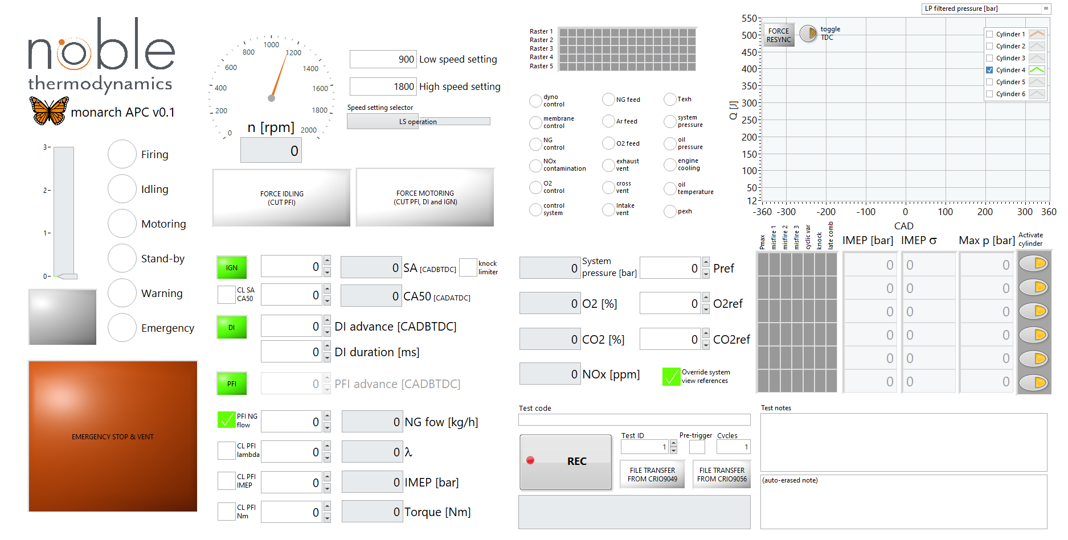
Figure 1. (A) Main screen.

Main functions of the main screen are next annotated:

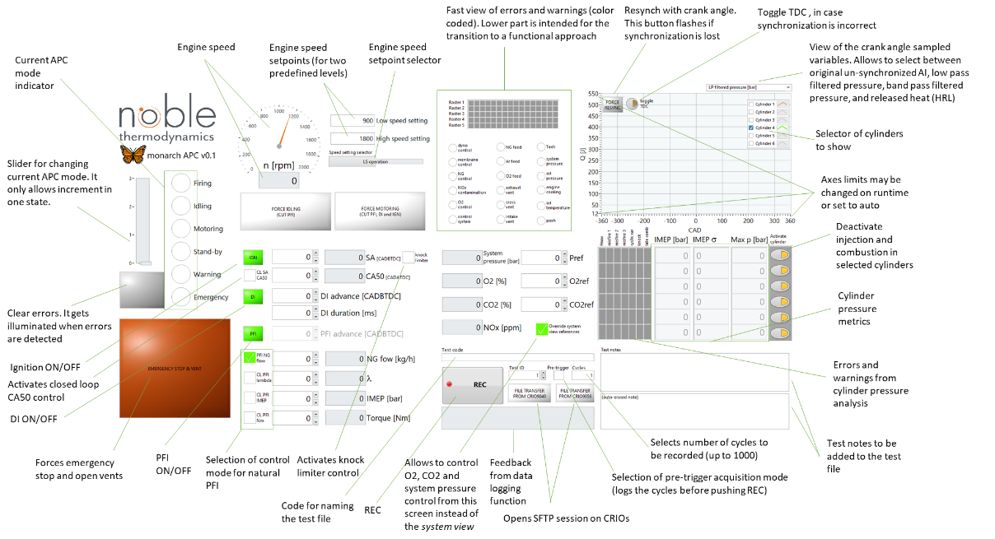
Figure 2. (A) Main screen functions
System screen. The system screen provides a fast reference for most sensors and actuators (injection and ignition settings are in the main screen). It provides a fast visual of the system and allows to operate the switches and to activate/deactivate the different control loops. For clarity, variables names are only shown on hovering over the indicator (then the PNID identification is shown).
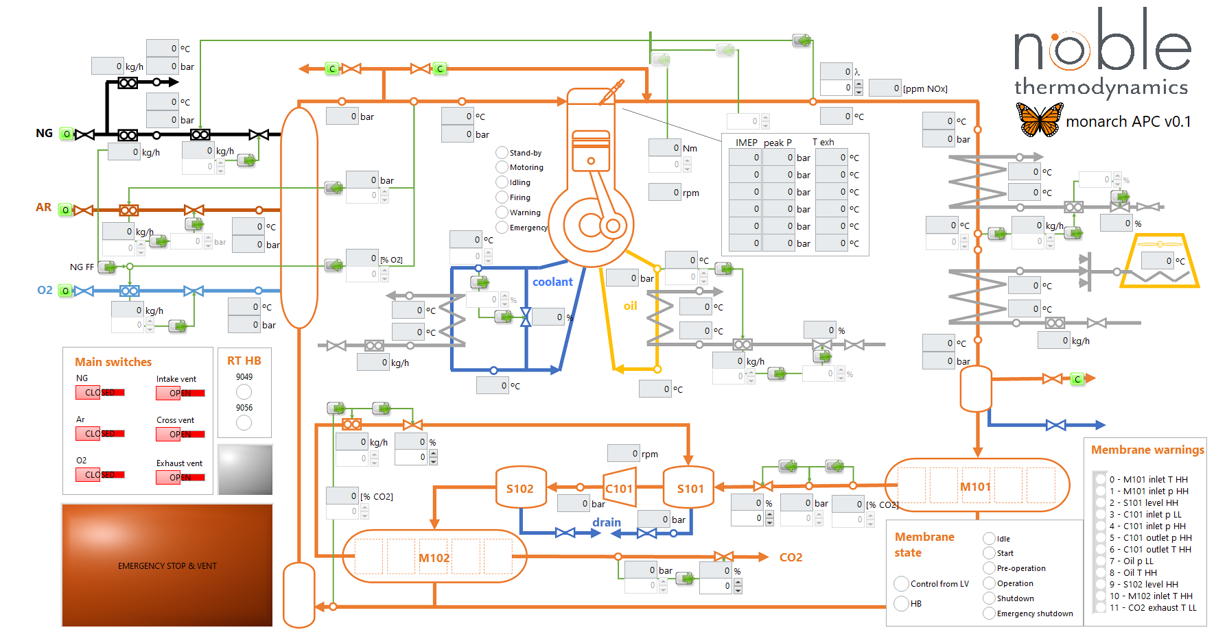
Figure 3. (B) System screen
Main functions of the system screen are next annotated:
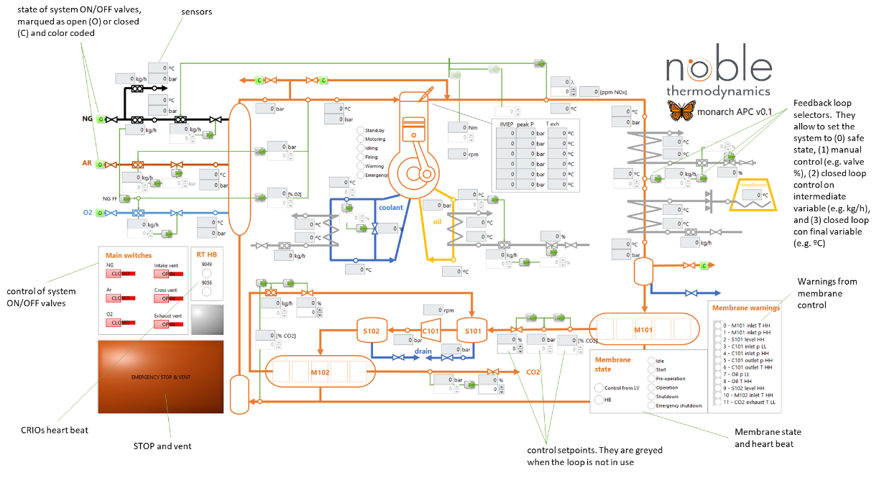
Figure 4. (B) System screen functions
Errors and warnings screen. Provides a visual of the system errors, and allows to modify the level triggering system transitions to idle, motoring or emergency modes. This screen has three tabs: first tab is for general overview of the errors at the AI and system level; second tab is for editing the thresholds for the AI and system error; and third tab is for visualizing and modifying the thresholds for the cylinder pressure related errors. A visual color coded overview of the errors is provided on the left with independence of the selected tab. Color coding is:
- Green value is ok.
- Yellow informative warning.
- Orange system is set to idle.
- Red system is set to motoring.
- Black system is set to emergency (stop and vent).
Yellow errors are informative and self-cleared, the rest are persistent and need the operator to clear them through the clear button on either this screen or the main screen.

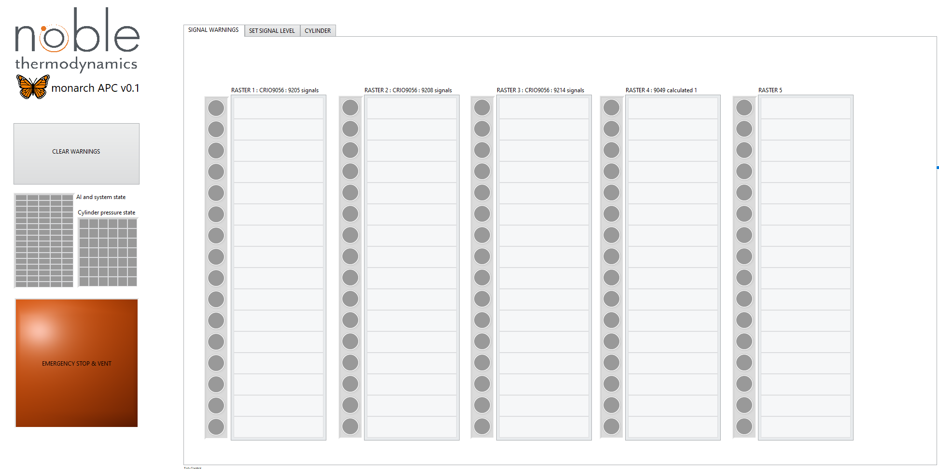
Figure 5. (C.1) Errors and diagnostics screen: general overview of signals and system errors.
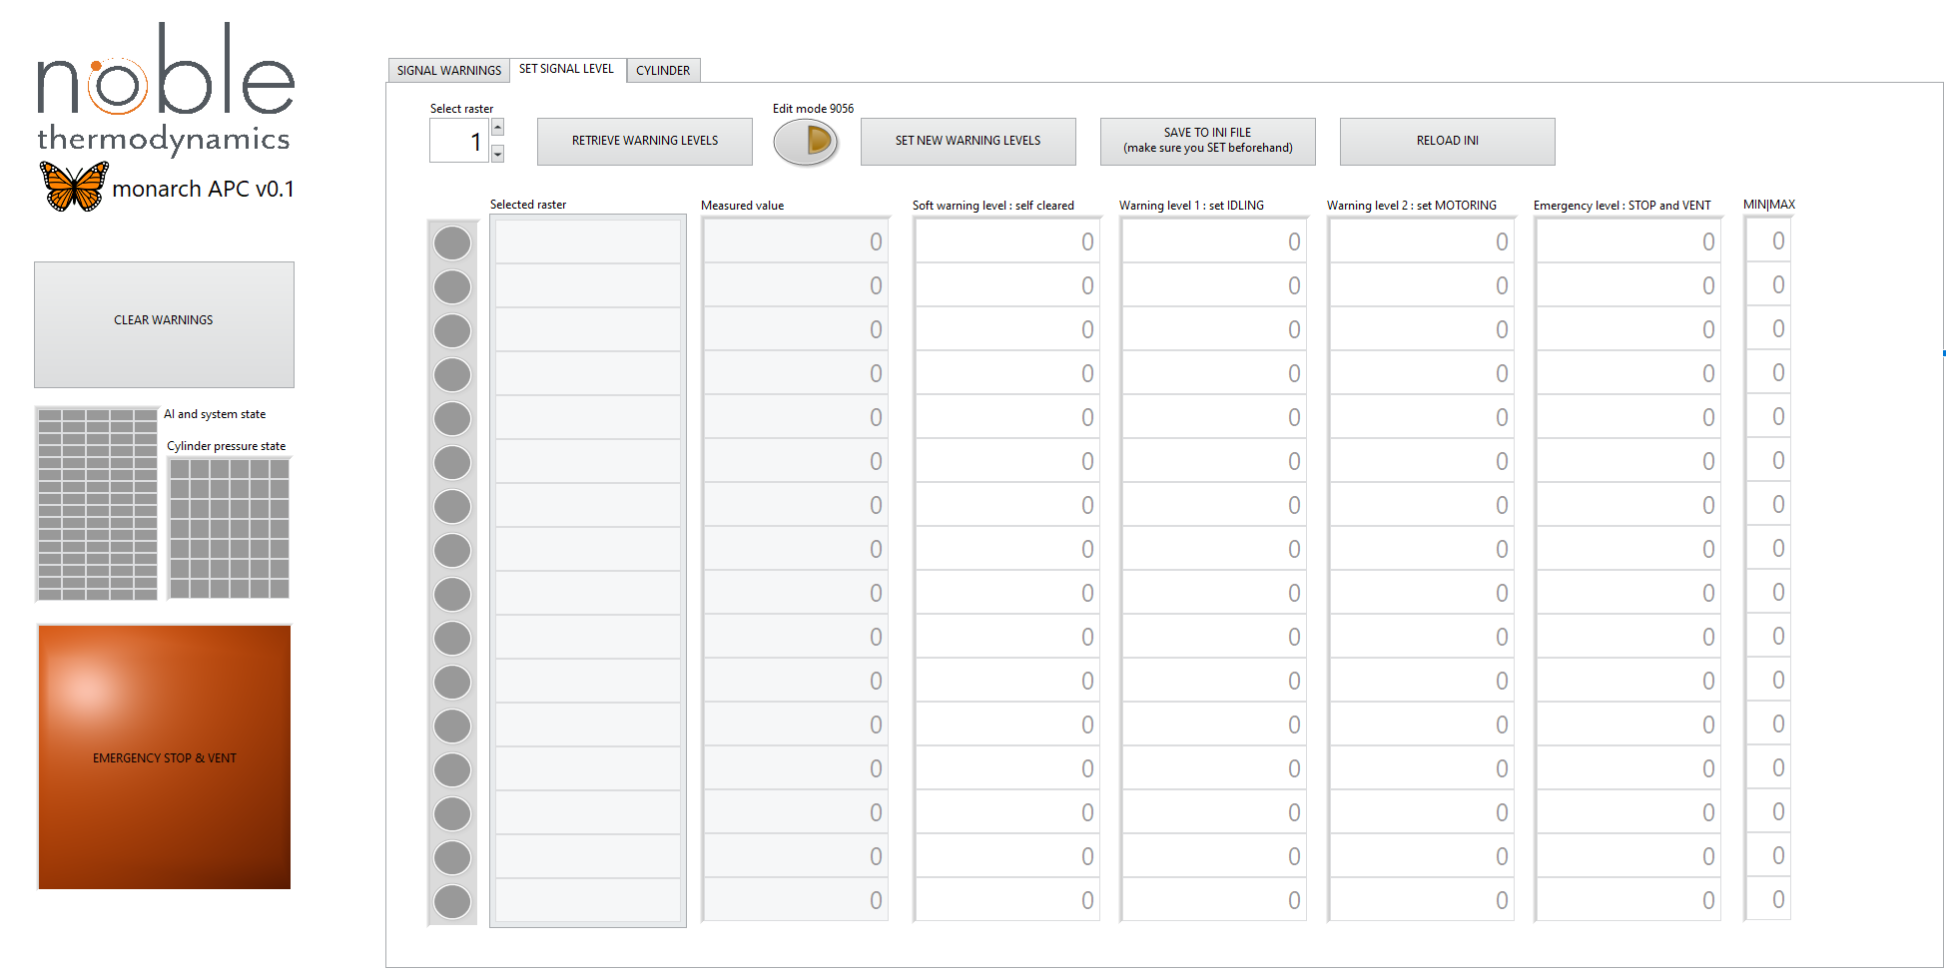
Figure 6. (C.2) Errors and diagnostics screen: threshold edition of signal and system errors.

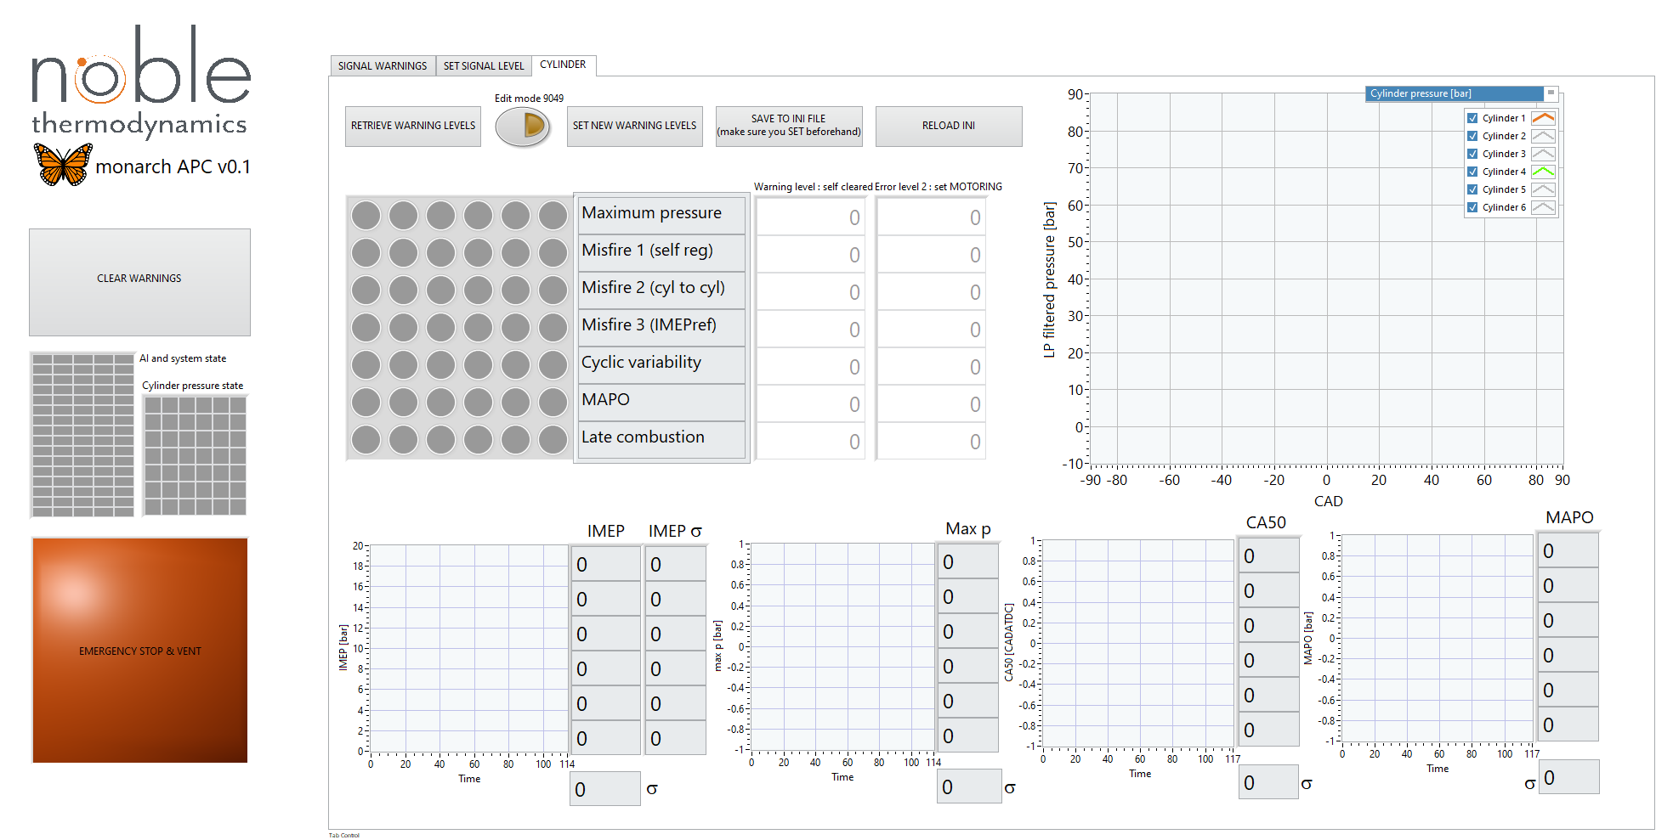
Figure 7. (C.3) Errors and diagnostics screen: cylinder pressure errors.
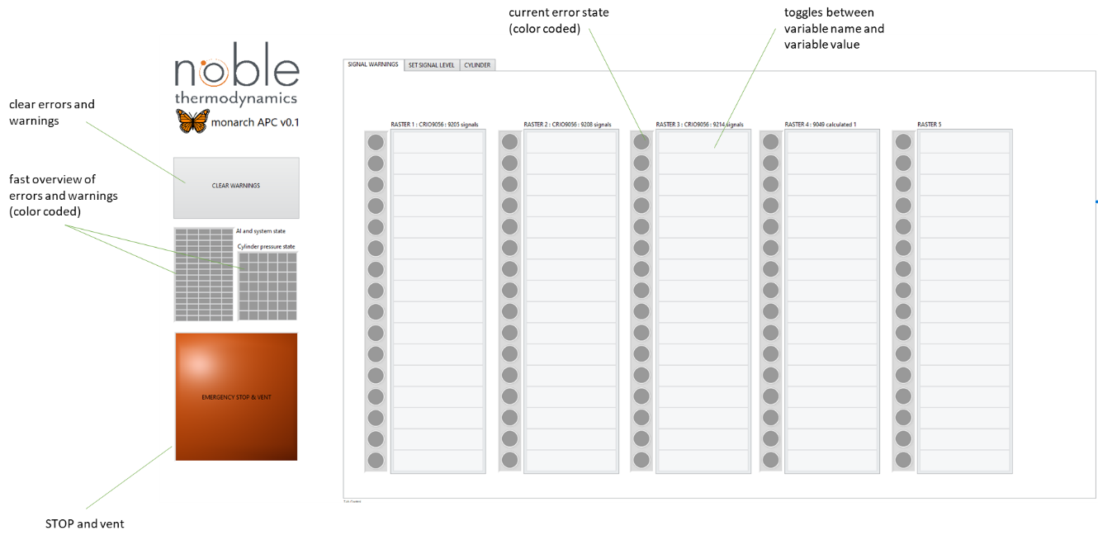
Figure 8. Functions of the general overview of signals and system errors tab (C.1).

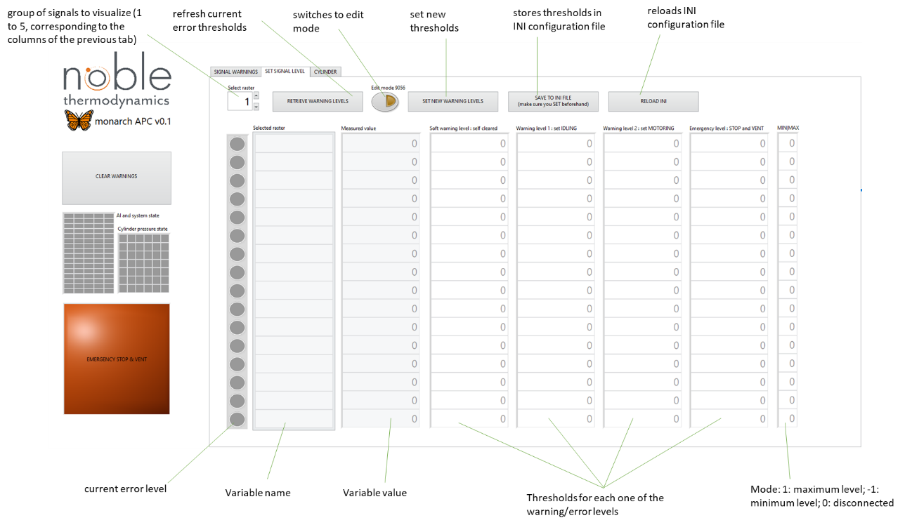
Figure 9. Functions of the Errors threshold edition of signal and system errors tab (C.2).

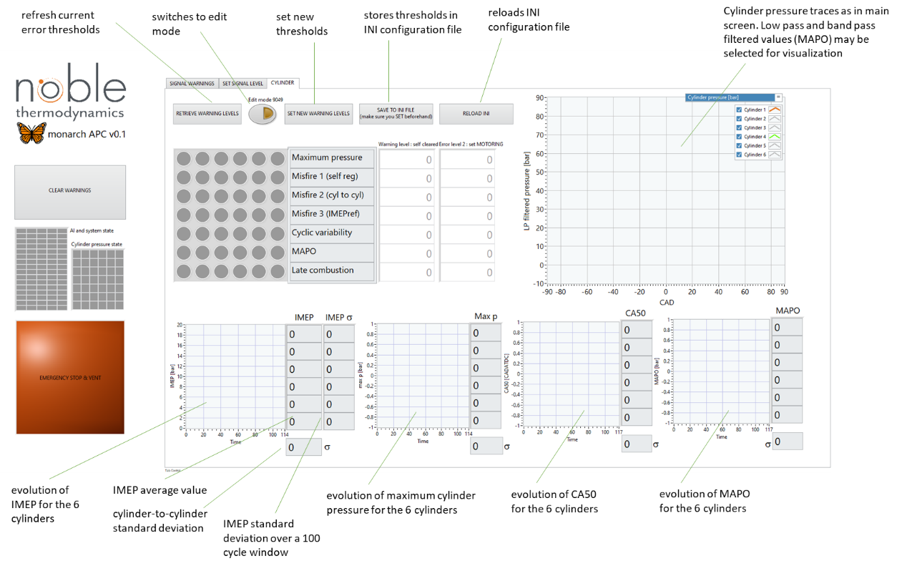
Figure 10. Functions of the cylinder pressure errors tab (C.3).

