CG Scale configuration

https://github.com/guillaumef/cg-scale-wifi-oled

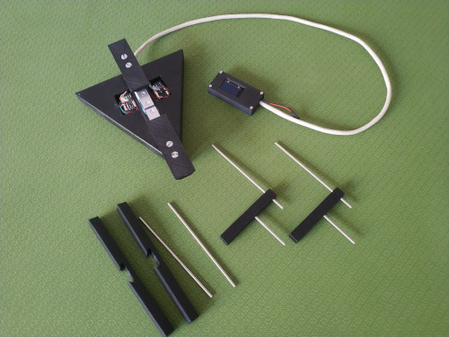

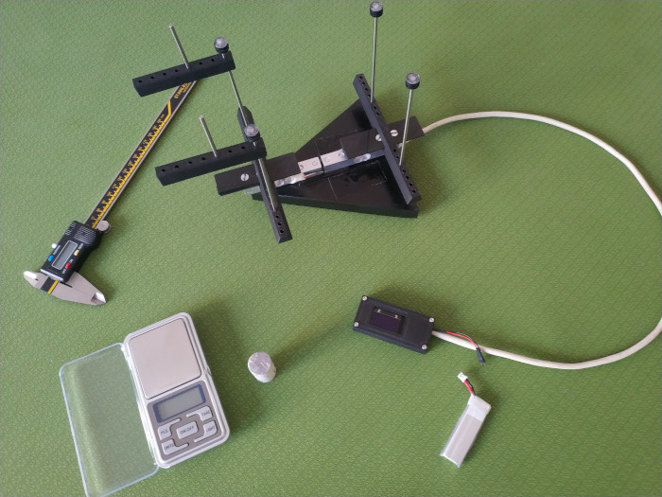

First run

Set the scale stable and connect the power of the ESP32.
The first run is displaying:
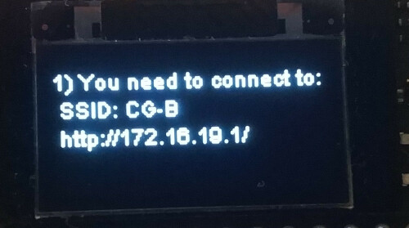

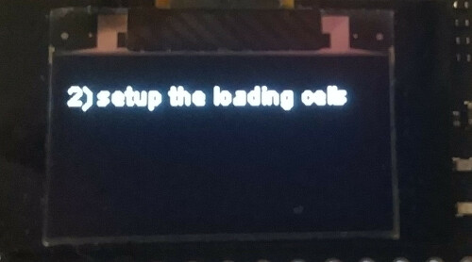

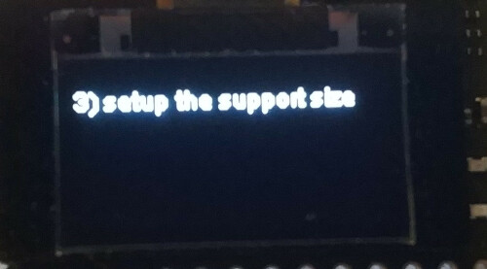

The ESP32 board opened a Wifi Hotspot named ‘CG-B’.
You can connect your phone/laptop on this SSID (no password).
Your phone/laptop is not going to detect any internet connection, this is normal, stay connected and use your browser to go to the provided address:
http://172.16.19.1/

Configuration

Left-Top icon holds the menu. Select ‘Configuration’.
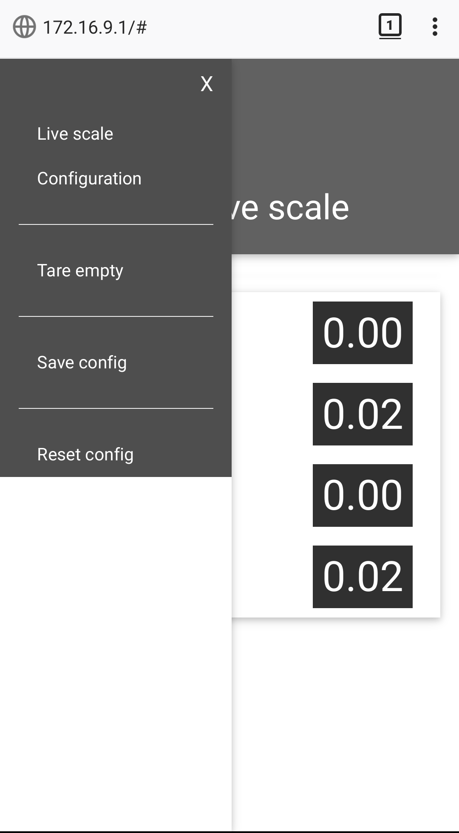

And this page is displayed:
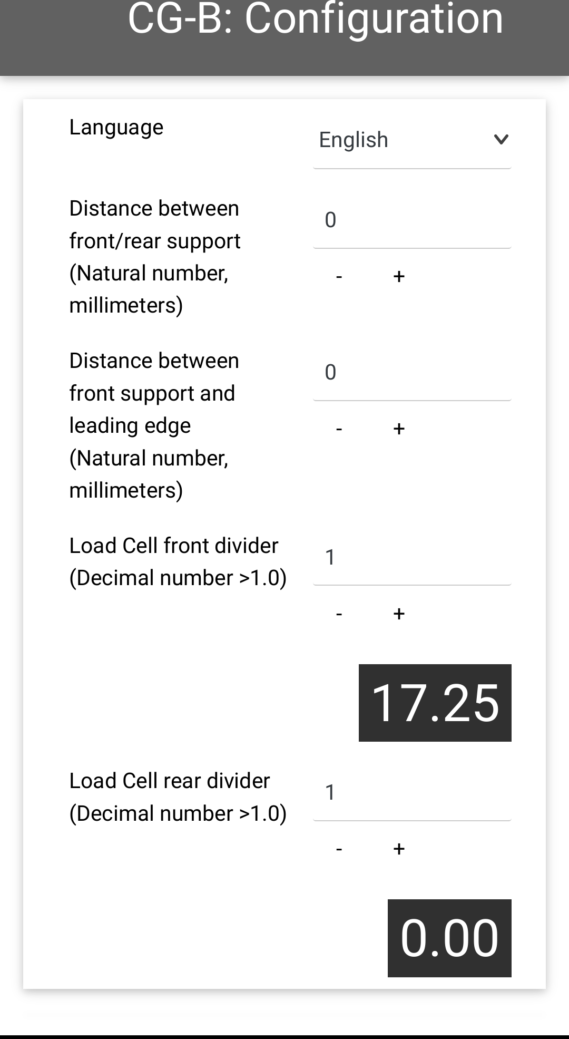

You have 4 items to configure.
The ~invariable~ ones are the Dividers. We are starting by those.
They are providing to each LoadingCell a common scale to work on. I am using the Gram metric system unit.
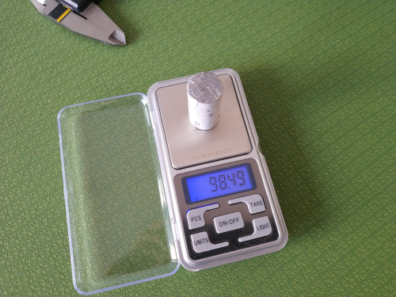
- Take a working precision scale and measure a small heavy object (>200gr).

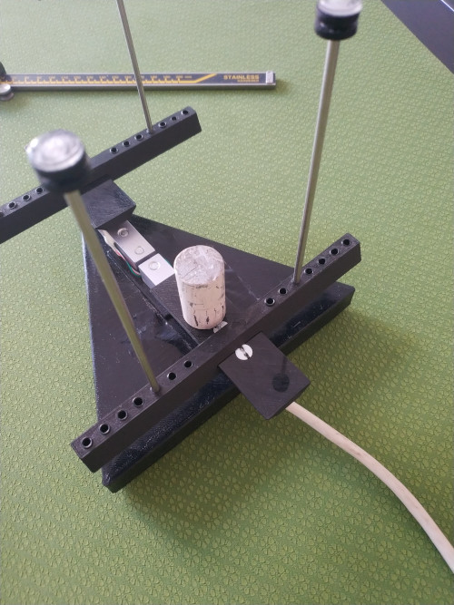

- Put this object on a load cell.

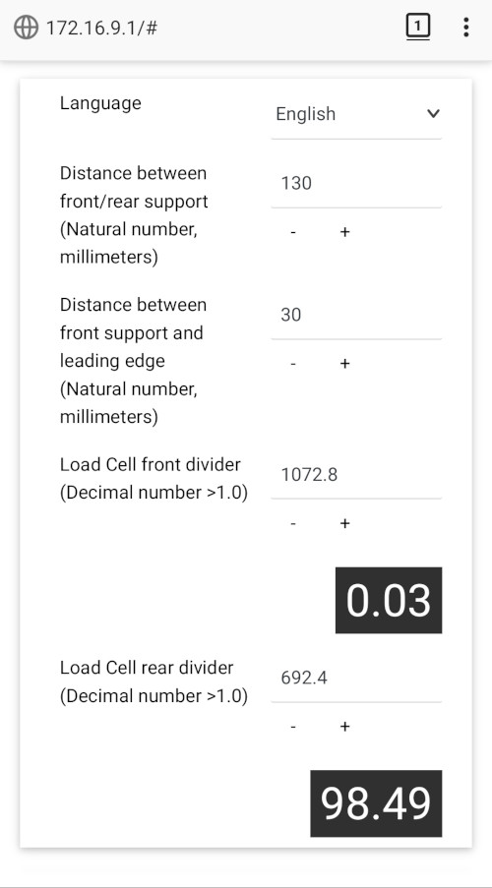

- You should see a huge increment in the rear LoadingCell display.
Change the divider to match the real object weight, typical values are between 500 and 1000.

- Make the same steps 2-3 for the front LoadingCell
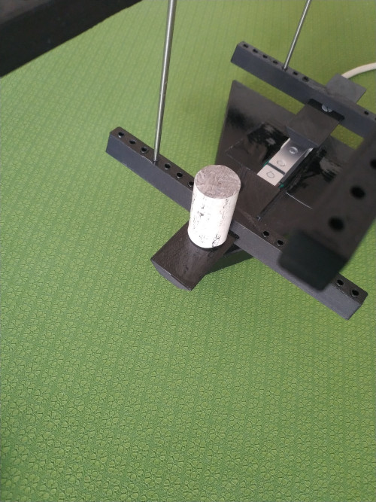
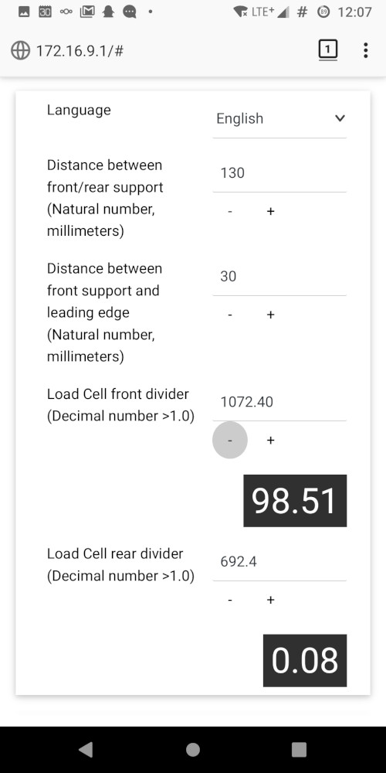

- You can save the configuration now (Left-Top menu)

- This step concerns the more frequent configuration items:
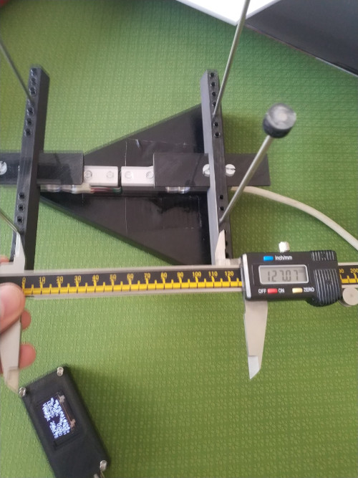
  - front rod to rear rod distance:

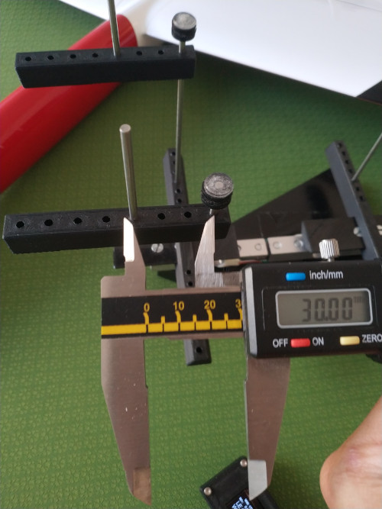

  - LeadingEdge rod to front rod distance, this one is easy because each hole is at 10mm from the next one.

  - Report the values in the configuration and you are ready.
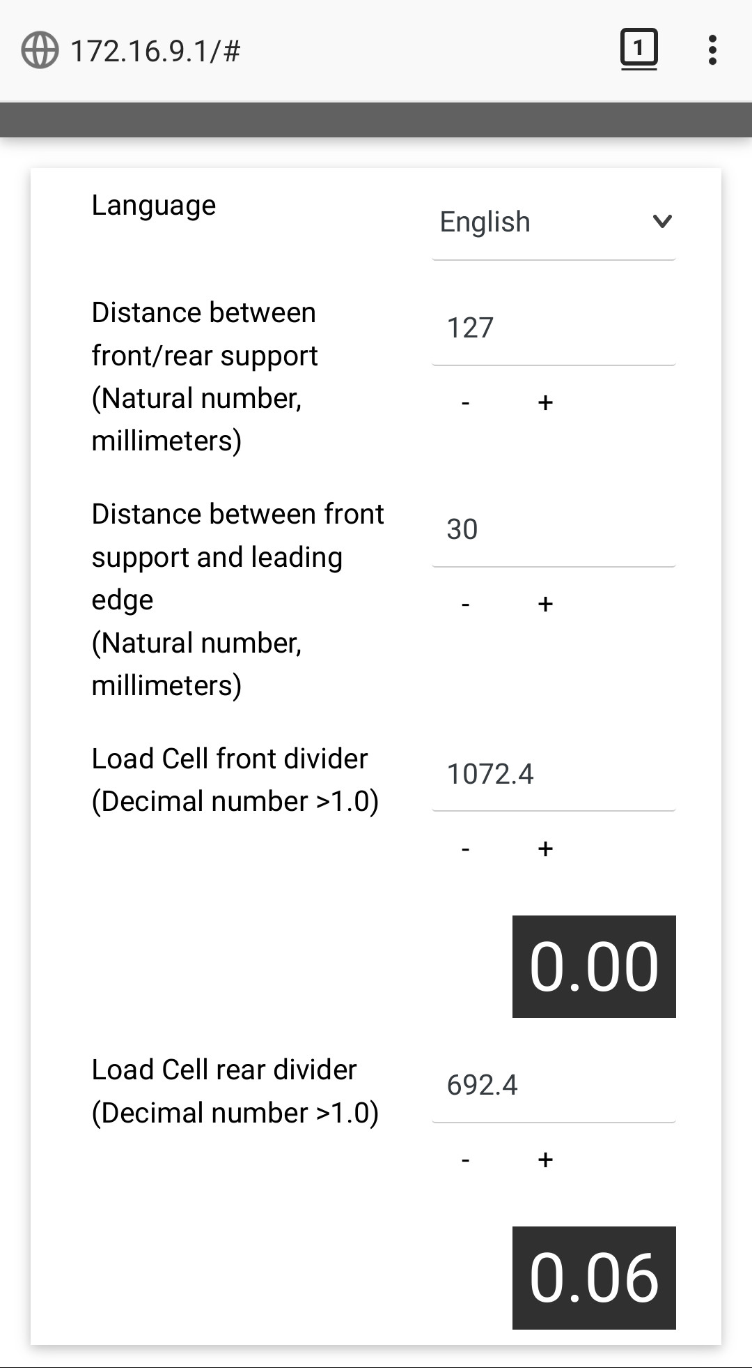

- You can save the configuration if you want to keep those two distances or simply set them for the current runtime.

General: Tare

With the empty scale:
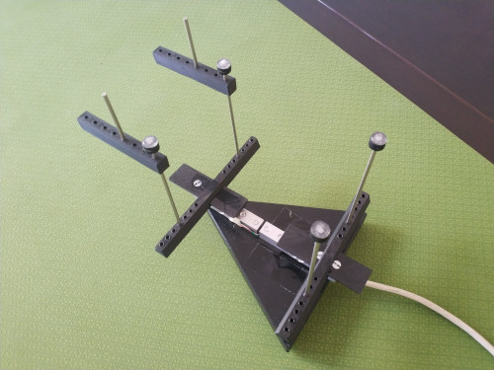

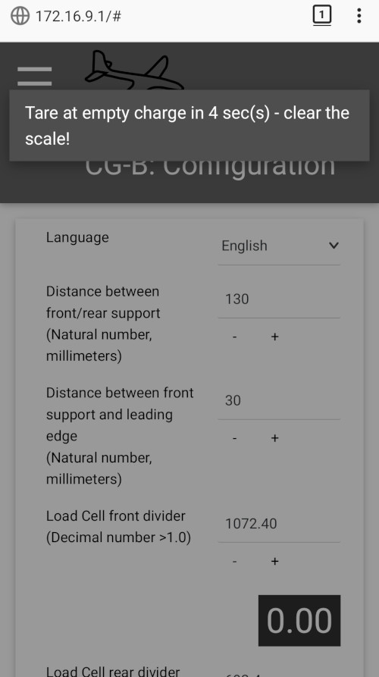
Click on the Top-Left menu and ‘Tare Empty’.

A countdown is triggered and you have 5 seconds to clear the scale.

The interface tells you when the tare is done (~ 10 seconds for the total procedure).

Usage

Your CG scale is now fully operationnal, you can put a model on the support rods with the LeadingEdge of the wing against the LE rod.

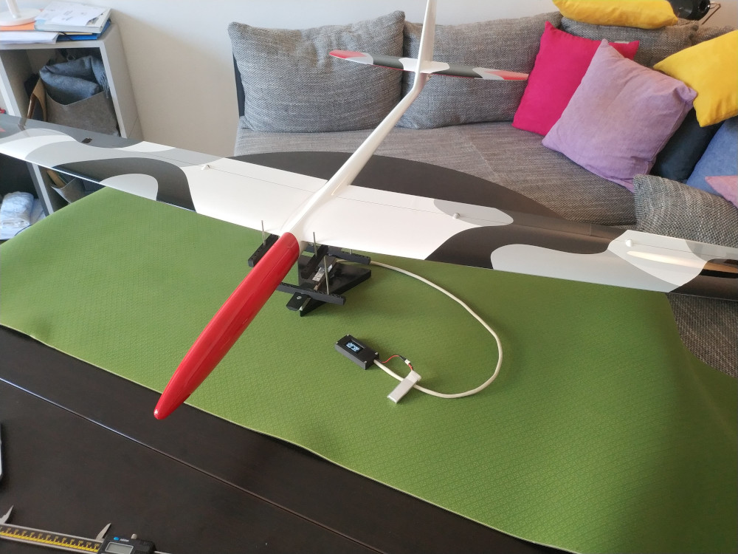

On the standalone OLED display of the ESP32, you will see a display like this one:
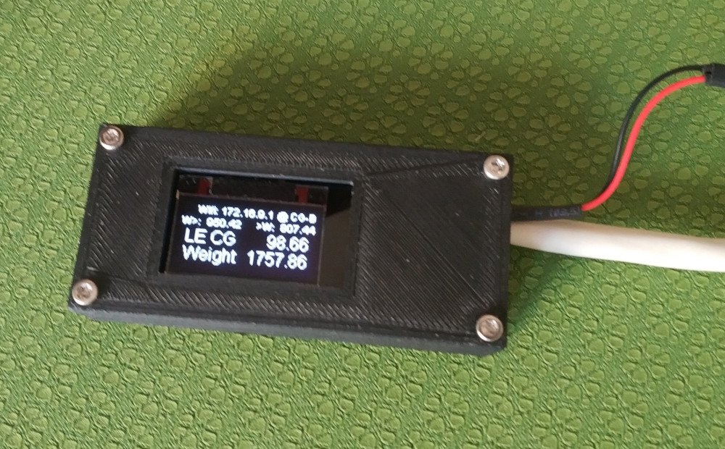
The ‘live scale’ menu item on your wifi client:
