SESSION 2: “PivotTables and Conditional Formatting”
Session objectives:
- Know how to create and manipulate a PivotTable (count, sum, filter)
- Know how to present a PivotTable using professional formatting
- Create a PivotChart
- Know how to use conditional formatting
Session timing:
Administrative phase: 10 min
Teaching phase: 85 min
- Exercise S3.1: Introduction to PivotTables (20 min)
- Exercise S3.2: Introduction to PivotCharts (10 min)
- Exercise S3.3: Direct application using PivotTables and PivotCharts (20 min)
- Exercise S3.4: Conditional formatting (10 min)
Application phase: 85 min
- The Food Truck exercise: Application exercise with in-class correction
Every morning, a food truck goes to a market in Angers. After three months of testing, it will analyse which markets are the most profitable.
To do this, I have divided the case study into three stages:
- A market summary: learning how simple Excel formulas work. The challenge is to build a coherent model in which parameters can be changed to observe the resulting changes.
- An order invoice, including options, a 20% student discount on pizzas, and a delivery charge. This stage introduces conditional formulas using the =IF function in Excel.
- Statistics from the three months of markets: how to compare and summarise information using PivotTables and PivotCharts.
Break – Session materials:
- Word teaching guide: Excel Fundamentals S3
- Exercise S2.1: Excel file (to be given to students)
- Exercise S2.1 - Answer key: Excel file (to be given to instructors)
- Exercise S2.2: Excel file (to be given to students)
- Exercise S2.2 - Answer key: Excel file (to be given to instructors)
- Exercise S2.3: Excel file (to be given to students)
- Exercise S2.3 - Answer key: Excel file (to be given to instructors)
- Exercise S2.4: Excel file (to be given to students)
- Exercise S2.4 - Answer key: Excel file (to be given to instructors)
- The Food Truck: Main Excel case-study file
- The Food Truck – Answer key
- Exercise S2.1: Introduction to PivotTables
Using Exercise S2.1, instructors will use this file to complete the four worksheets while explaining how to create a PivotTable.
A completed version of this exercise is available for instructors: Exercise S2.1 - Answer key
- In Worksheet 1: data in cells A1:C255
- Note: this is a useful opportunity to demonstrate how to freeze and unfreeze panes when working with a large dataset.
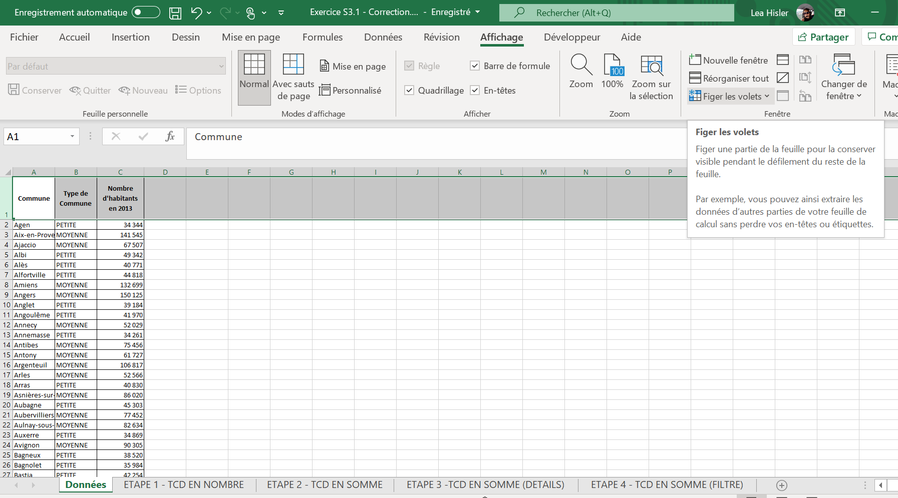
- In Worksheet 2: demonstrate a PivotTable using Count
- In Worksheet 3: demonstrate a PivotTable using Sum
- In Worksheet 4: demonstrate a PivotTable using Sum with additional detail
- In Worksheet 5: demonstrate how to add a filter to a PivotTable
Using this exercise, explain the main components and options of a PivotTable:
  - The different ways of summarising values in the table: Sum, Count, or even Average
  - The available row options
  - The available filter options
  - The available sorting options within a PivotTable

Using Worksheet 2, which contains the Count PivotTable, you can explain professional formatting.
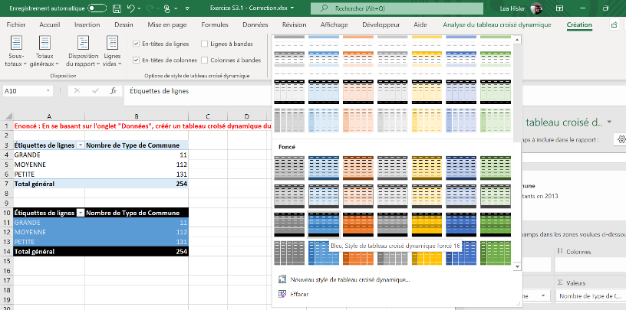
- Formatting using a predefined style

- Number formatting
- Sort in ascending order by count

- Exercise S2.2: Introduction to PivotCharts
In this exercise, we will focus on PivotCharts rather than standard Excel charts, as standard charts will be covered in a Data Description practical session on the graphical representation of statistical variables.
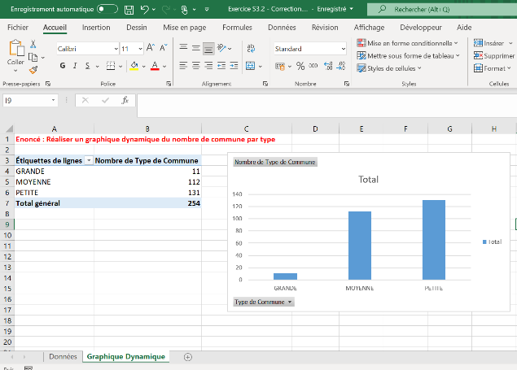
Using Exercise S2.2, instructors will use this file to create a PivotChart. A completed version is available for instructors: Exercise S2.2 - Answer key.

- Exercise S2.3: PivotTables and PivotCharts
Using Exercise S2.3, students will practise the concepts covered previously. A completed version is available for instructors: Exercise S2.3 – Answer key.
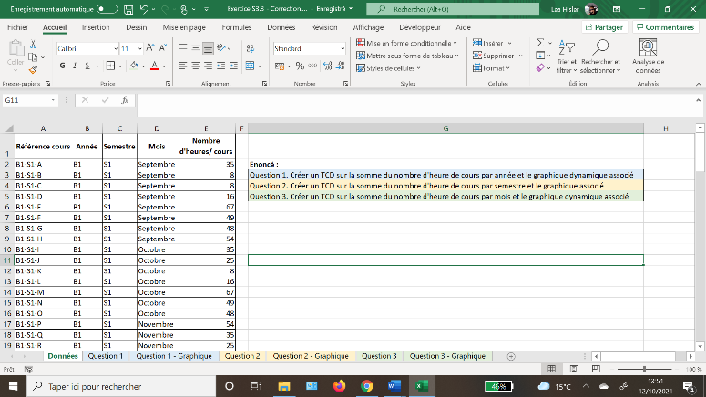
The objective of this exercise is to give students hands-on practice with PivotTables and PivotCharts. It is recommended to allow 10 minutes for the exercise and approximately 10 minutes for the in-class correction.

- Exercise S2.4: Conditional Formatting
Using Exercise S2.4, instructors will use this file to demonstrate conditional formatting. A completed version is available for instructors: Exercise S2.4 – Answer key.
In this exercise:
  - Display values above €3,000 in green
  - Display values below €2,000 in red
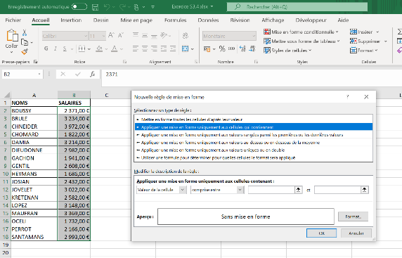
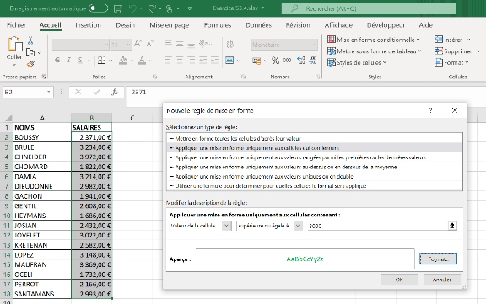
It is important to explain the value of conditional formatting, particularly when a dataset contains many rows and columns. You can also change the value in cell B2 to demonstrate how the formatting updates automatically.
2
1

4
3
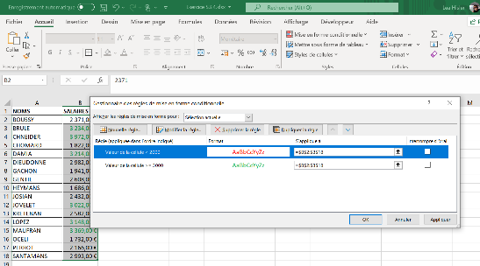
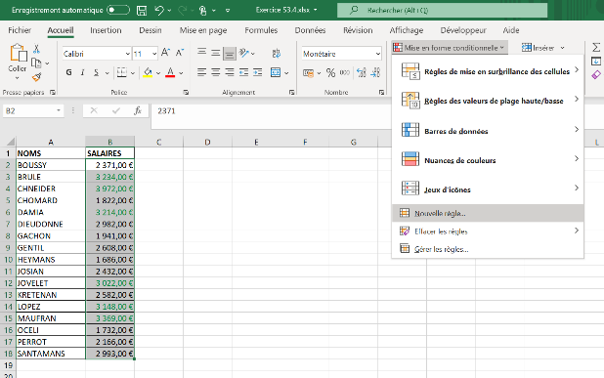

- Application exercises – The Food Truck (45 min)
Using The Food Truck file, students will apply the concepts covered earlier in the session. A completed file, The Food Truck – Answer key, is available.
It is strongly recommended to give students 20 minutes to complete the exercise and reserve 15 minutes for a whole-class correction.
- Session 3 – Worksheet 1: Data
This worksheet contains the data required to create the PivotTables and PivotCharts.

- Session 3 – Worksheet 2
The objective is to create three PivotTables.
- Question 1: Create a PivotTable showing revenue by market and present it using professional formatting.
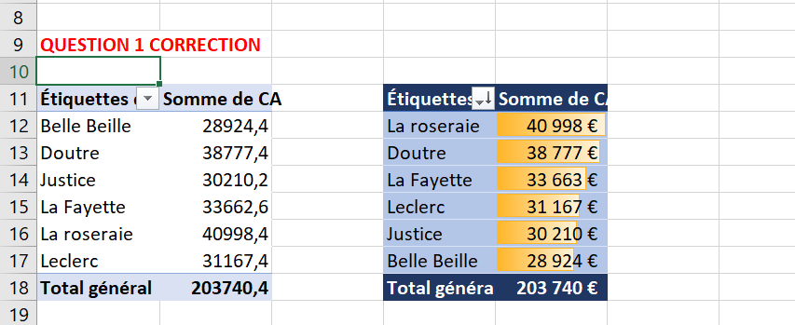
The first PivotTable uses the default format, while the second uses different formatting:
Style: dark blue
Sort by total revenue in descending order
Format numbers in euros with no decimal places
To display the yellow data bars in the background, select the values and apply conditional formatting as follows:
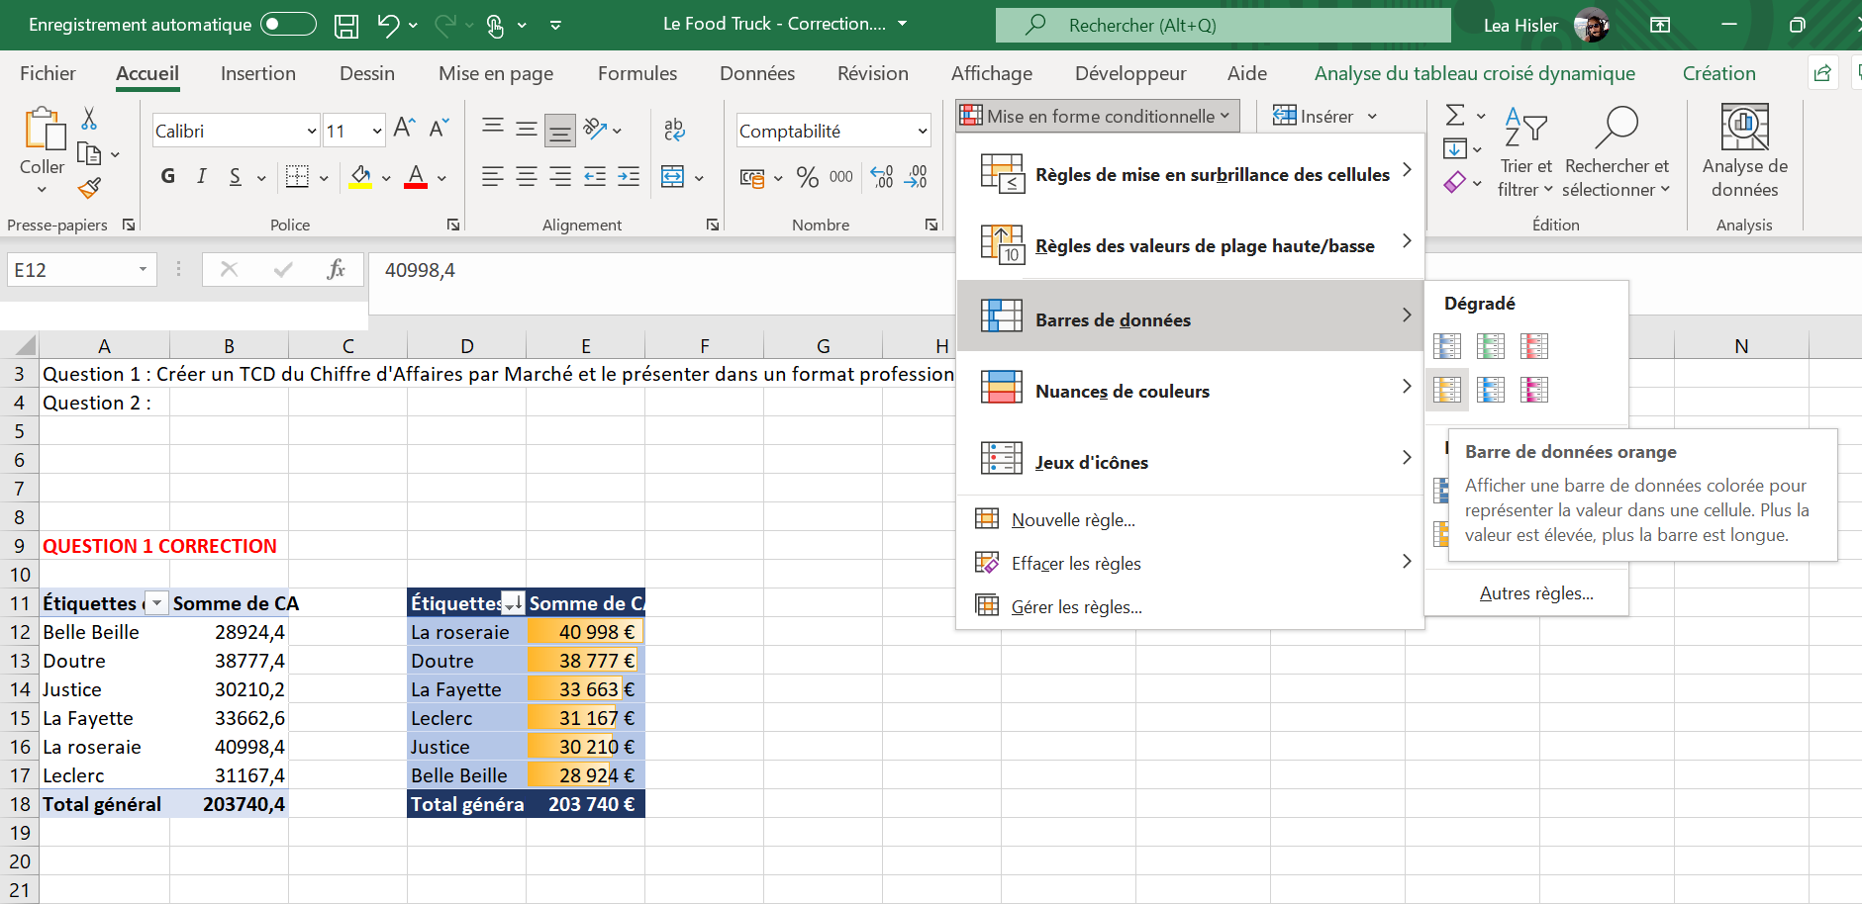

- Question 2: Create a PivotTable showing profit and costs by market and present it using professional formatting.
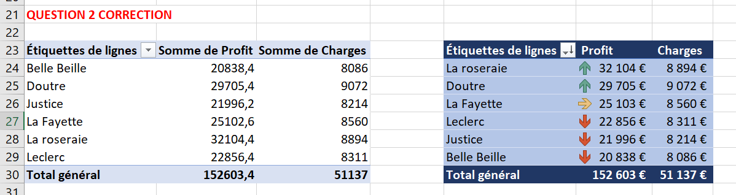

The first PivotTable uses the default format, while the second uses different formatting:
Style: dark blue
Rename the headings so that “Profit” replaces “Sum of Profit” and “Costs” replaces “Sum of Costs”:
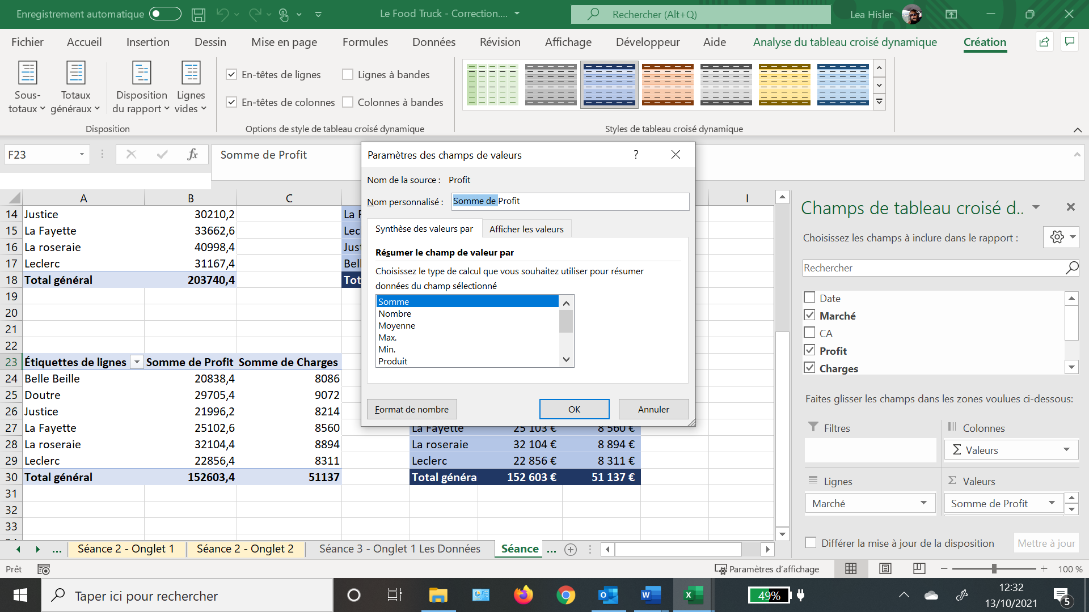
Sort by total profit in descending order
Format numbers in euros with no decimal places
To display the coloured arrows, select the profit values and apply conditional formatting.

For a more advanced analysis, you can also insert a slicer (TO BE DEMONSTRATED DURING THE CORRECTION). In this case, the slicer will be MONTH. Insert the slicer as follows:
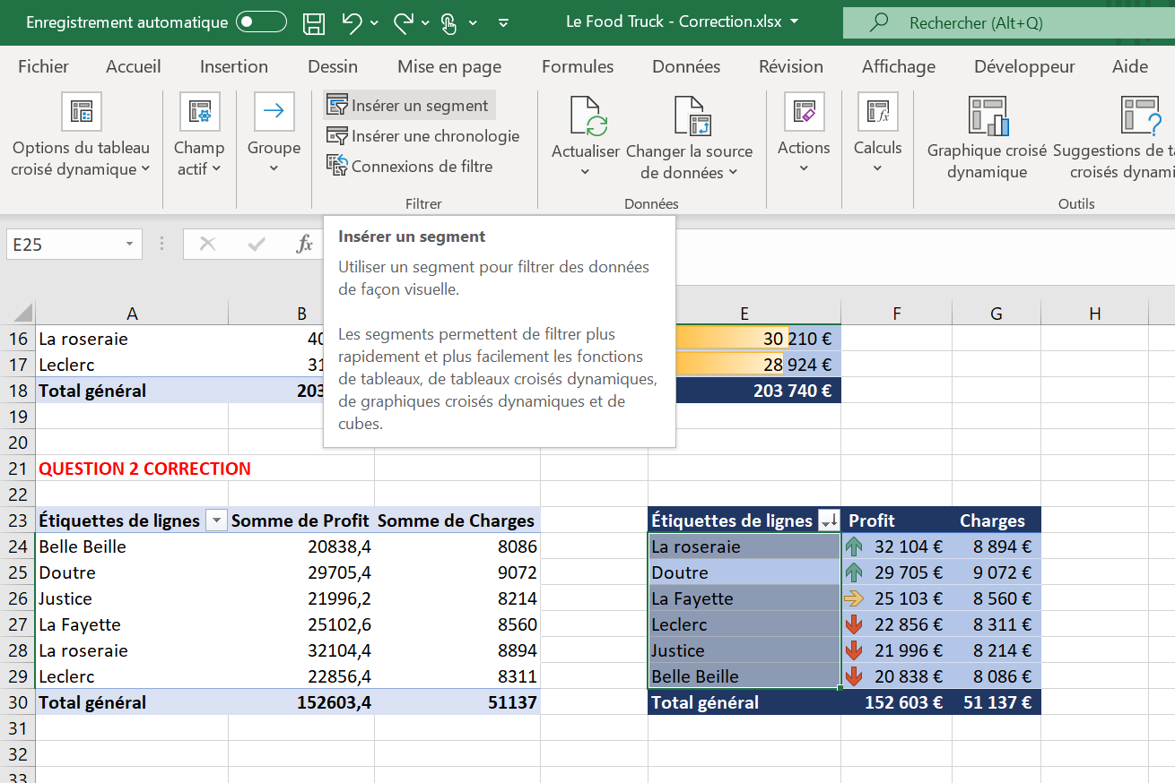

- Question 3: Create a PivotTable showing revenue, profit, and costs by month, present it using professional formatting, and add a PivotChart displaying the three measures by month.
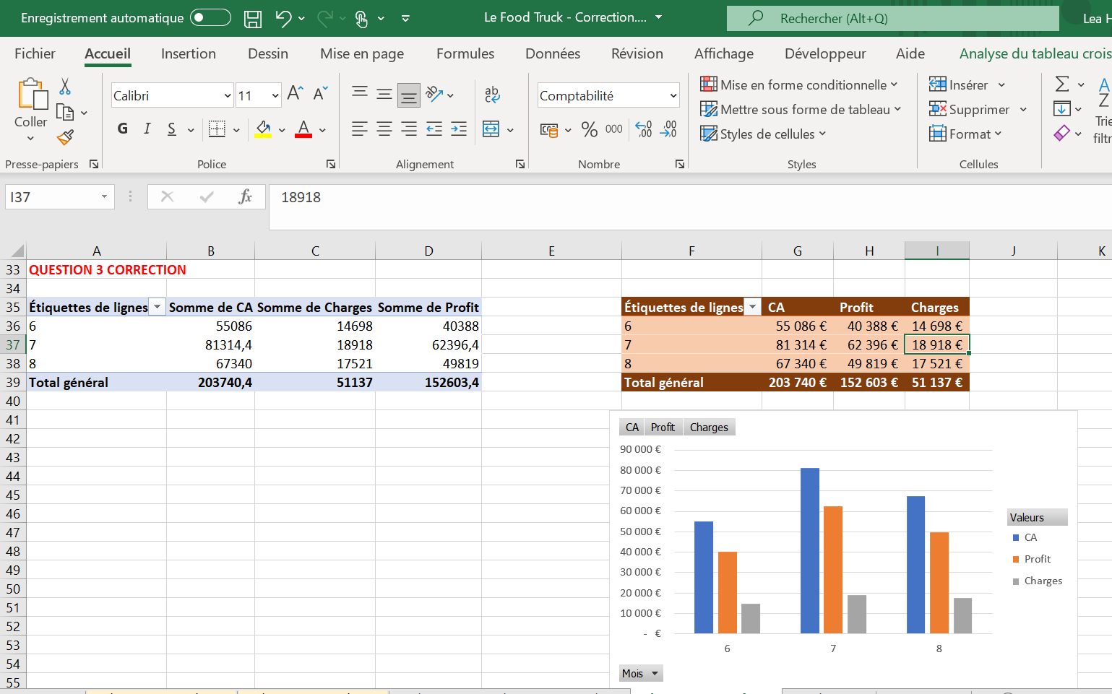

For a more advanced analysis, you can also insert a slicer (TO BE DEMONSTRATED DURING THE CORRECTION). In this case, the slicer will be MARKET.

