Google Services ( by guillaume.jay@gmail.com)

- You must create a an application on https://console.developers.google.com
- You must create for this application a new Client ID, of type Service Account .
- You must then for this Service Account generate the P12 Key : don’t lose the resulting file and password
- The s
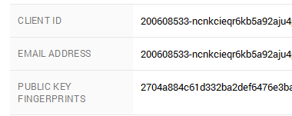
- You must create an Analytics class, using the right constructor :

Analytics myAnalytics = new Analytics(applicationName, keyFile, serviceEmail, password);

- ApplicationName is used in the UserAgent header.
- keyFile is the full path to the P12 file you generated earlier.
- serviceEmail has been generated automatically when you created a Service Account
- password was given to you when generating a P12
- You have to fill a RequestParameters class with the required values

