A NEURAL NETWORK MODEL OF AVERSIVE BEHAVIOR

B.S. Zanutto
Dept. Electronics, Universidad de Buenos Aires; IBYME-CONICET. Paseo Colón 850, 1063 Buenos Aires, Argentina. silvano@fi.uba.ar.

S.E. Lew
Dept. Electronics; Universidad de Buenos Aires. Paseo Colón 850, 1063 Buenos Aires, Argentina. sergiolew@hotmail.com.

Abstract

A neural network model of aversive behavior is proposed. It has one neuron for each possible response of the animal (R), and from neurobiological bases we assumed that there is a prediction of the unconditioned stimulus (US). It is computed by another artificial neuron. The inputs of response neurons are: the prediction, the short-term memory of the conditioned stimuli (CSs) and of the US. Based on Hebbian or anti-Hebbian learning, depending on the prediction of the US, the synaptic weights of the response neurons are calculated. The short-term memories of CSs, of the US and of the Rs are inputs of the neuron that computes prediction. The synaptic weights of this neuron are calculated based on the delta rule. Finally, animals execute any response higher than a threshold. While the neurobiology underlying aversive behavior may be very complex, the dynamic process that governs aversive behavior is simple, responses are associated with the input stimuli by the Hebbian rule if the prediction of the unconditioned stimulus is lower than a threshold, and by the anti-Hebbian rule if it is higher. The simulations of the model and the experimental data are compared. This network can be applied to control autonomous systems.

Keywords: learning algorithms and training; avoidance behavior; operant conditioning; two-factor theory.

Introduction

The purpose of the present work is to develop hypotheses explaining operant behavior, mainly escape and avoidance. There are a few theories of these behaviors, but there is no agreement on their hypotheses. According to Mowrer [1], one of the most important figures in the development of the two-factor theory, the avoidance response is reinforced by the reduction in fear due to the lack of the fear-eliciting CS. In the one-factor theory [2], the avoidance of a shock can serve as reinforcer. There are also other theories of aversive behavior, Seligman and Johnston [3] proposed a cognitive theory of avoidance. They assumed that during the acquisition phase, animals develop two expectancies, i) no shock will occur if a response is made, and ii) shock will occur if a response is not made; and the behavior will not change until at least one of the expectations is violated. However, Seligman and his colleagues [4][5] have proposed that under certain circumstances, animals develop the expectation that their behavior has little effect on their environment, and that this expectation may generalize to a wide range of situations. They called this effect learned helplessness.
Formal models and spatially adaptive neural networks based on behavioral and neurobiological data, are an
adequate tool to develop hypotheses accounting for the experimental data. There are neural substrates of prediction and reward, such as the involvement of dopamine neurons of the ventral tegmental area and sustantia nigra, identified with the processing of rewarding stimuli [6]. Behavioral experiments also suggest that learning is driven by changes in the expectation about the future salient events, mainly reward and punishment. A few quantitative theories have formalized these phenomena, and only a few of them are able to describe the most relevant features that characterize escape, avoidance and imitative learning [7][8]. In the present work, we are interested in finding simple and biological plausible hypotheses to explain the experimental observations of these behaviors.

A neural network model of aversive behavior

The model presented here accounts for experimental data of learning animals, particularly in a shuttle box.
The model is presented in Fig. 1: there is an artificial neuron computing that we will term as “prediction”, and additional neurons, one for each response. The neuron computing the prediction (P) has several inputs, all of them traces representing the short-term memory of the conditioned stimuli (TCS[i]), the unconditioned stimulus (TUS), and the responses (TR[j] ). The synaptic weights (V) of this neuron are calculated based on the delta rule [9], formally the same as in the Rescorla-Wagner model [10]. The response neurons have as inputs: P, the traces of the conditioned stimuli (TCS[i]) and of the unconditioned stimulus (TUS). The synaptic weights of the response neurons are calculated by Hebbian [11] or anti-Hebbian learning, depending on P. Finally, animals will perform any response higher than a threshold. The equations used in the model are:
The trace (TS) of a stimulus S is

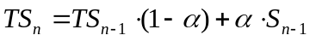 (1)

Figure 1: Neural network model, there is an artificial neuron computing the prediction (P), and additional neurons, one for each response. The neuron computing P has several inputs, all of them traces representing the short-term memory of the conditioned stimuli (TCS[i]), the unconditioned stimulus (TUS), and the responses (TR[j]). The synaptic weights V[CS[i]], V[R[j]] and V[US] represent the associations between the inputs and P. The response neurons have as inputs P and the traces TCS[i] of the conditioned stimuli (CS[i]) and TUS the trace of the unconditioned stimulus (US). The synaptic weights W[R[j],TS], are associations between P, TCS[i] and TUS, and the response neurons R[j].

Where S is: CS[1], CS[2], ...,US or R[1], R[2],...; n is the time unit and α is a constant. It can take two values, αi to control the increase of TS when S takes a value grater than zero, and αd to control the decay when S goes to zero.
The prediction (P) is calculated as:

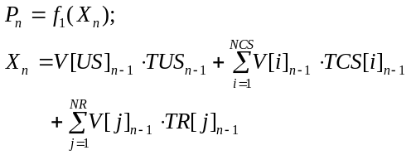 (2)

Where V represents the synaptic weights of the neuron that computes the prediction, these are the associations between the inputs and P.
f₁ is a sigmoid given by:

i: conditioned stimulus index
j: responses index
NCS: is the number of conditioned stimuli,
NR: is the number of the possible responses,

The output of the response neurons (R[j]) is calculated as:

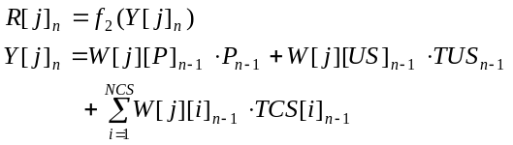 (3)
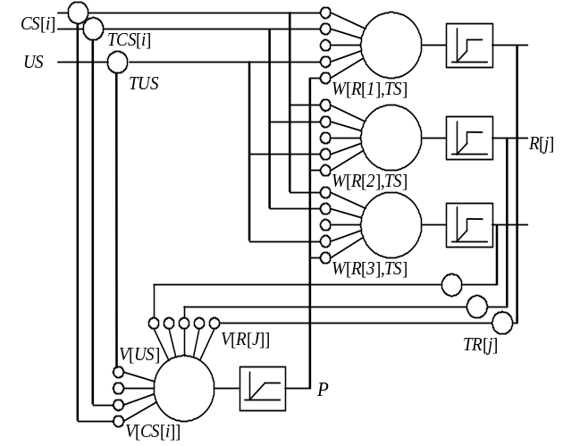

Where W represents the synaptic weights of the neuron that computes R[j].
f₂ is a sigmoid given by:

i: conditioned stimulus index
μ : is the threshold.

The synaptic weights (V) of the prediction neuron are calculated based on the delta rule and their values are bound between –1 and 1 with a sigmoid function as follows:

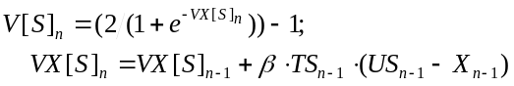 (4)

Where β is a constant.
The synaptic weights of response neurons are calculated by Hebbian or anti-Hebbian learning depending on P, and the values are bound between –ϕ and ϕ with a sigmoid function as follows:

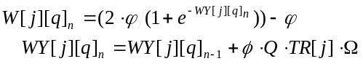 (5)

Where Q is: P, TUS or TCS[i] and the respective index q is: P, US or i; ϕ, φ, λ and Ω are constants. If P < λ then Ω = λ, otherwise Ω = - λ;

Computer simulation

We compared the behavior of this model with the experimental data. The model simulates the behavior of animals in a shuttle box, each trial lasting 60 sec. Animals can make different responses: escape, avoidance, and others (grooming, vocalizations, etc.). We assume animals are in a context; in the present model this can be stated as a CS present all the time. In order to simplify the figures, this contextual stimulus is considered as an input only when there are no other CSs present. This procedure is made for simplification purposes, and its absence/presence does not affect results. Animals start each trial in one side of the box and a CS is turned on, if after 10 sec. the animal has not crossed to the other side, a shock (US) is delivered until the animal crosses and the trial is finished, or until the trial is completed (60 sec.) If at random time (less than 20 sec.) no response is made, one neuron is chosen at random and a fixed value η is added to its output, if it is higher than the threshold μ, the response is executed. It is to simulate animals making random responses.
Fig. 2, shows the simulation of the acquisition phase of the escape response [4]. In order to simplify the figure, only the synaptic weights associated to the escape response are shown. This response is learned once the animal escapes immediately after the US is applied. The synaptic weight V[US] of the prediction neuron is fixed to .1 (from two-factor theory point of view, this means that the US provokes fear). Previous models included this hypothesis [12]. The other associations of the neuron computing P are updated by the delta rule; after learning the escape response V[R[1]] is the only negative association. The higher W are those associated with the escape response R[1]. Under these conditions, when the input signal is the US, the animal will escape. In all the simulations where the escape response is trained, the US intensity is 0.75.

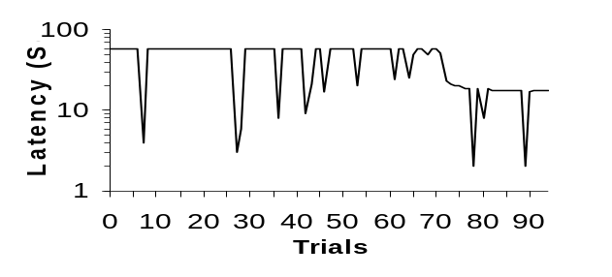
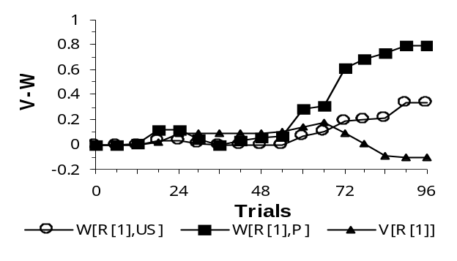
Figure 2: Shows the simulation second by second of the acquisition of the escape response (R[1]). The response latency, and the synaptic weights V and W are shown. Each mark represent the mean value of 5 trials, the constants are: αi=0.25, αd=0.01, β=0.02, μ=0.35, ϕ=0.8, φ=0.1, λ=0.6 and η=0.75. Constants are the same for all the simulations.

Learning of delay avoidance response [13] and a more difficult case - when avoidance response is different from the escape response [14] - are both simulated. Fig. 3. shows the latter: CS[1] is the conditioned stimulus, R[1] is the avoidance response and R[2] is the escape response. The avoidance response is typically learned in 5 to 20 trials, but it takes longer when the responses (avoidance/escape) are different. The V[R[1]] and V[R[2]] are minor that zero, being V[R[1]] the most negative. From the weights W and with the equation (3) it can be seen that when CS[1] is applied, the animal is going to avoid the US. If the noise did not allow making this response, then the animal is going to escape when US is applied. In all the simulations where the avoidance response is learned, the US intensity is 1.
Many experiments were carried out to prove that the avoidance behavior is explained by the two factor theory. Two of the most relevant are those of Rescorla and LoLordo [15], and Overmier and Bull [16].

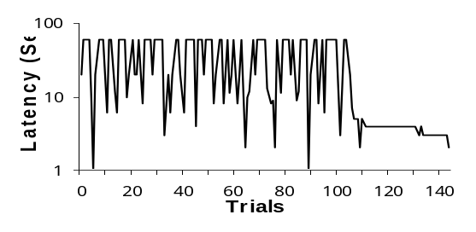
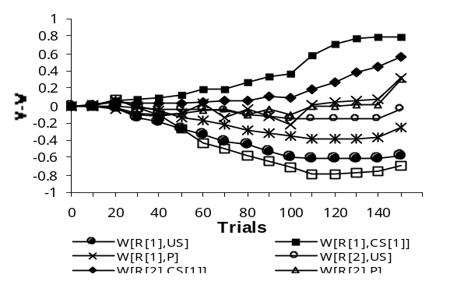

Figure 3: Learning of different escape and avoidance responses. CS[1] is the conditioned stimulus, R[1] is the avoidance response and R[2] is the escape response. Constants as Figure 2.

In the first experiment, after the animal learned excitatory or inhibitory classical CS-US associations, presenting the CS during the performance of avoidance it can modulate the ongoing rates of the avoidance response. Fig. 4 shows the simulation, an animal is exposed for 200 trials to a CS[1] in the presence of an US, and to a CS[1] and a CS[2] in the absence of the US, while the avoidance response is blocked. Once the synaptic weights are stabilized, the animal is trained in delay avoidance with CS[3], but this phase is interrupted before the percentage of avoidance response reaches the maximum value in order to get positive modulation. This phase lasts 10 trials. Finally, the animal is tested with the CS[3] together with the excitatory CS[1], and CS[3] together with the inhibitory CS[2], but the US is never presented. It can be seen that after trial 210, in the first case the animal almost always crosses, and in the second case almost never. The V[CS[2]] is negative (it predicts no US). In can be seen that the W[R[1],P] is the biggest synaptic weight, follows W[R[1],CS[3]] and smaller than the previous ones is W[R[1],CS[2]]. In this way, P can modulate the avoidance response.
The second experiment mentioned above is the one from Overmier & Bull. Fig. 5 shows an animal trained to generate an avoidance response with CS[1] during 20 trials. In the following phase, until trial 120, while the avoidance response is blocked, the unreinforced CS[1] and a reinforced CS[2] are presented. Finally, in the test phase, the animal is allowed to cross to the other side. 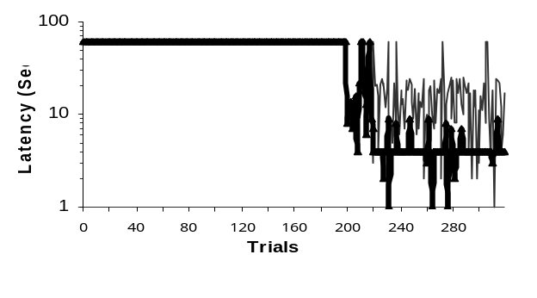 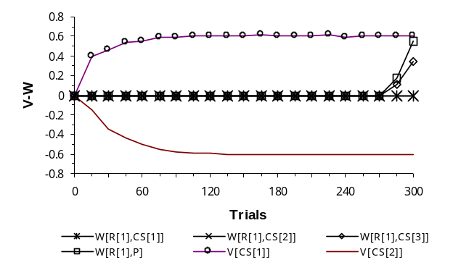

Figure 4: Modulation of the avoidance response. In the simulation the animal is exposed for 200 trials to a CS[1] in the presence of a US, and to CS[1] and CS[2] in the absence of the US, while the avoidance response (R[1]) is blocked. In the second phase the animal is trained in delay avoidance with CS[3], for 10 trials. Finally, the animal is tested with the CS[3] together with the excitatory CS[1], and CS[3] together with the inhibitory CS[2], but the US is never presented. It can be seen in the latency figure that after test 210, in the first case (thick line) the animal crosses almost always, and in the second case almost never (thin line). Constants as Figure 2.

While CS[1] does not elicit avoidance responses, CS[2] does. The V[R[1]] is the only negative weight, in the second phase, the V[CS[1]] association is extinguished and V[CS[2]] is positively associated. The W[R[1],P] is the highest association. Since the value of V[CS[2]] approaches to 1, when CS[2] will be presented, the prediction will have a value close to 1, and the avoidance response will be executed.
Fig. 6, shows the simulation of learned helplessness. This experiment has two phases: in the first one (100 trials) the animal is exposed to an inescapable shock US. In this phase all the V are positive and all the Ws are near zero or negatives. In this way in the second phase (test) the animal does not learn the escape response.
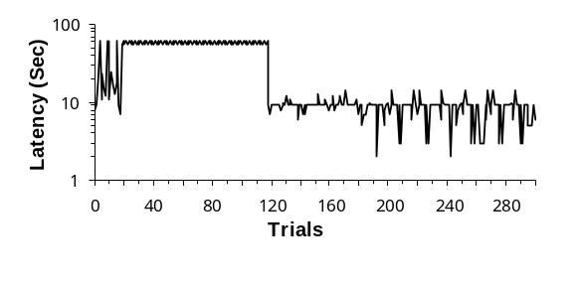
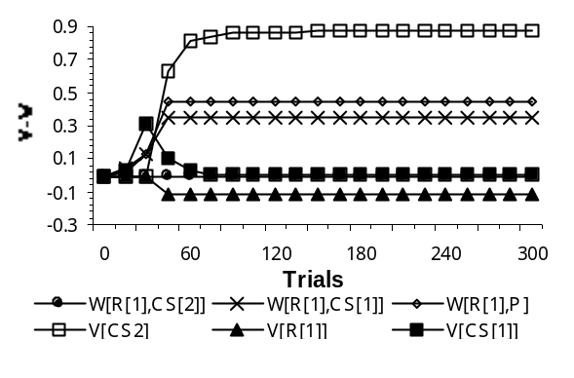
Figure 5: Transfer of control from CS[1] to CS[2]. An animal trained to generate an avoidance response (R[1]) with CS[1] during 20 trials. In the following phase, until trial 120, while avoidance response is blocked, the unreinforced CS[1] and a reinforced CS[2] are presented. Finally, in the test phase, the animal is allowed to cross to the other side, whereas the CS[1] does not elicit avoidance responses, CS[2] does. Constants as Figure 2.

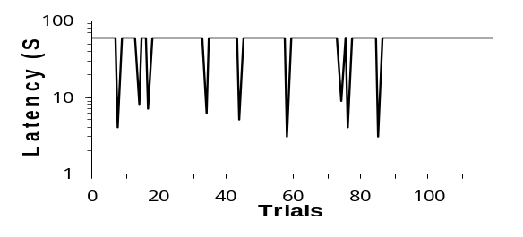
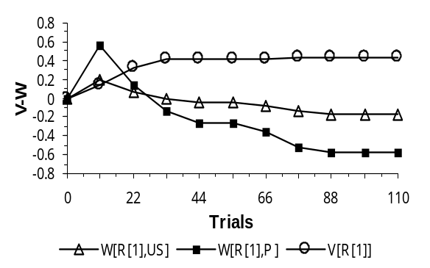
Figure 6: Learned helplessness. This experiment has two phases: in the first phase of 100 trials, the animals are exposed to an inescapable shock US. In the second phase the animal can not learn the escape response (R[1]). Constants as Figure 2.
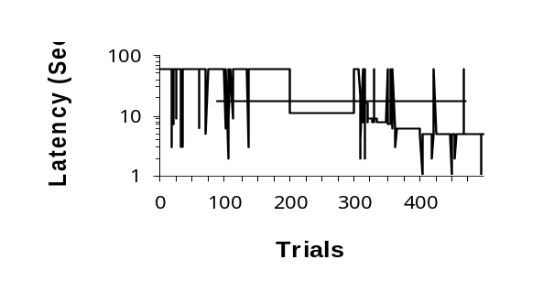
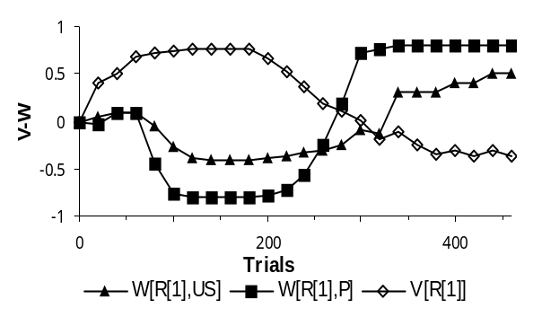
Figure 7: Learned helplessness and reversal, during the first 200 trials, the animal is exposed to the inescapable shock and in the following 100 trials, the animal is forced to escape (R[1]). During the test phase, the animal learns the escape response. Constants as Figure 2.

Learned helplessness can be reversed: if after being exposed to the inescapable shock, animals are forced to experience the escape contingency, animals learn to escape from a shock [17]. Fig. 7 shows the simulation of this procedure, during the first 200 trials, the animal is exposed to the inescapable shock and in the following 100 trials, the animal is forced to escape. In this way, the synaptic weights V associated with the escape response R[1] reached negatives values, and all the W associate to R[1] reached slightly positive values. In this way, animals learned the escape response during the test phase.

Discussion

The model of the aversive behavior proposed here is a real time neural network with one neuron computing each possible response of animals, and from neurobiological bases we assume another neuron computes the prediction of the unconditioned stimulus. As can be seen in the figures, the synaptic weights of the prediction neuron associated with avoidance and with escape responses are negative. In agreement with Gray [18], it can be interpreted as a "safety signal" that animals try to approach [7]. Gray proposed that avoidance responses become conditioned inhibitors of fear. In our approach the prediction is decreased when animals make these responses. Whenever the prediction is lower than a threshold, the synaptic weights of the active response neurons increase their values according to the Hebbian law, meaning that the associations of the response the animal is performing predicts no US. If the prediction is higher than a threshold, the same synaptic weights decrease (anti-Hebbian learning). We showed how the model explains experiments to support the two-factor theory, it also explains the Herrnstein & Hineline [19] experiment to support the one-factor theory. By pressing a lever, a rat could switch from a random time schedule that delivered shocks at a high rate, to one that delivered shocks at a slower rate. Whenever the animal in the random time schedule that delivered shocks at a high rate presses the lever, he switches to the other schedule, and the animal remains in that condition until he receives the next shock. The optimal condition for the animal is to press the lever each time a shock is delivered, since it minimizes the number and rate of received shocks. Consequently, the probability of a shock is higher if the rat had not recently pressed the lever, in terms of our model this parallels learning escape. It is not difficult to see that if the function to switch from the Hebbian to the anti-Hebbian rule is controlled by a function of US, instead of by the prediction, then escape and avoidance can be learned without prediction. However, in this case it is not clear how to learn modulation of avoidance without the prediction or a similar function. This means that the one factor theory can explain some experiments, but not others. This model can also explain imitation in the same terms as Schmajuk & Zanutto [7], when the demonstrator is trained in avoidance, the US for the observer is to perceive the demonstrator’s responses and manifestation of pain. As was seen in the test phase of the reversal of learned helplessness, once the synaptic weights to compute the prediction are learned, the correct response is acquired.
This model can explain the most relevant feature of the quantitative models mentioned in the introduction with simpler hypotheses. Since this neural network is simple and works in real time, it is applicable to autonomous systems.

Conclusion

The dynamic process that governs aversive behavior is simple, responses are associated with the input stimuli by the Hebbian rule if the prediction of the unconditioned stimulus is low, and by the anti-Hebbian rule if it is high. This network can be applied to control autonomous systems.

Acknowledgments

The authors are thankful to Andres Lemoine and Sean Patterson for their comments on the manuscript.

References

[1] O.H Mowrer, On the dual nature of learning, a reinterpretation of conditioning and problem solving, Harvard Educational Review, 17, 1947, 102-148.
[2] R.J. Herrnstein, Method and theory in the study of avoidance, Psychological Review, 76,1969, 49-69.
[3] M.E.P. Seligman and J.C. Johnston, A cognitive theory of avoidance learning. In: F. J. McGuigan and D. B. Lumsdenm (Eds.) Contemporary approaches to conditioning and learning (Washington D.C.: Winston-Wiley, 1973).
[4] S.F. Maier and M.E.P. Seligman, Learned helplessness: Theory and evidence. Journal of Experimental Psychology: General, 105, 1976, 3-46.
[5] J.B. Overmier and M.E.P. Seligman, Effects of inescapable shock upon subsequent escape and avoidance responding, Journal of Comparative and Physiological Psychology, 63, 1967, 28-33.
[6] W. Schultz, P. Dayan and R. Montague, A neural substrate of prediction and reward, Science 275, 1997, 1593-1598.
[7] N. Schmajuk and B.S. Zanutto, Escape, avoidance and imitation: A neural network approach, Adaptive Behavior, 6, 1997, 63-129.
[8] N. Schmajuk, D. Urry and B.S. Zanutto, The frightening complexity of avoidance: a neural network approach. In: C. Wynne and J. Staddon (Eds.) Models of Action: Mechanisms for Adaptive Behavior (New Jersey, London: Lawrence Erlbaum Associates, Inc Publishers, 1998) 201-238.
[9] B. Widrow and M.E. Hoff, Adaptive switching circuits, 1960 IRE Western Electrical Show and Convention Record, Part 4, 1960, 96-104.
[10] R.A. Rescorla and A.R. Wagner, A theory of Pavlovian conditioning: Variations in the effectiveness of reinforcement and nonreinforcement. In: A.H. Black and W.F. Prokasy (Eds.) Classical conditioning II: Current research and theory (New York: Appleton-Century-Crofts, 1972)
[11] D.O. Hebb, The Organization of Behavior, a neuropsychological theory (New York: Wiley, 1949).
[12] R.S. Sutton and A.G. Barto, Toward a modern theory of adaptive networks: Expectation and prediction, Psychological Review, 88, 1981, 135-170.
[13] L.J. Kamin, The gradient of delay of secondary reward in avoidance learning, Journal of Comparative and Physiological Psychology, 50, 1957, 445-449.
[14] R.C. Bolles, Avoidance and escape learning: simultaneous acquisition of different responses, Journal of Comparative Psychology and Physiological, 68, 1969, 355-358.
[15] R.A. Rescorla and V.M. LoLordo, Inhibition of avoidance behavior, Journal of Comparative and Physiological Psychology, 59, 1965, 406-412.
[16] J.B. Overmier and J.A. Bull, On the independence of stimulus control of avoidance, Journal of Experimental Psychology, 79, 1969, 464-467.
[17] M.E.P. Seligman, R.A. Rosellini and M.J. Kozak, Learned helplessness in the rat: time course, immunization and reversibility, Journal of comparative and physiological psychology, 88, 1975, 542-547.
[18] J.A. Gray, The psychology of fear and stress (London: Weidenfeld and Nicholson, 1971)
[19] R.J. Herrnstein and D.H. Hineline, Negative reinforcement as shock-frequency reduction, Journal of the Experimental Analysis of Behavior, 9, 1966, 421-430.

