Despliegue de Aplicaciones Web:
Hosting Services
Alumno: Fara Santeyana, María Guillermina.
NIA: 13298631. Curso: 2do DAW.
Instituto: I.E.S La Sènia.
Año: 2025-2026.

Upload a full website to AwardSpace. It should have several files (images, CSS...).
For this task I used the website created for my Lenguaje de Marcas course. I used .html and .css files and images with the .jpeg and .avif extension.
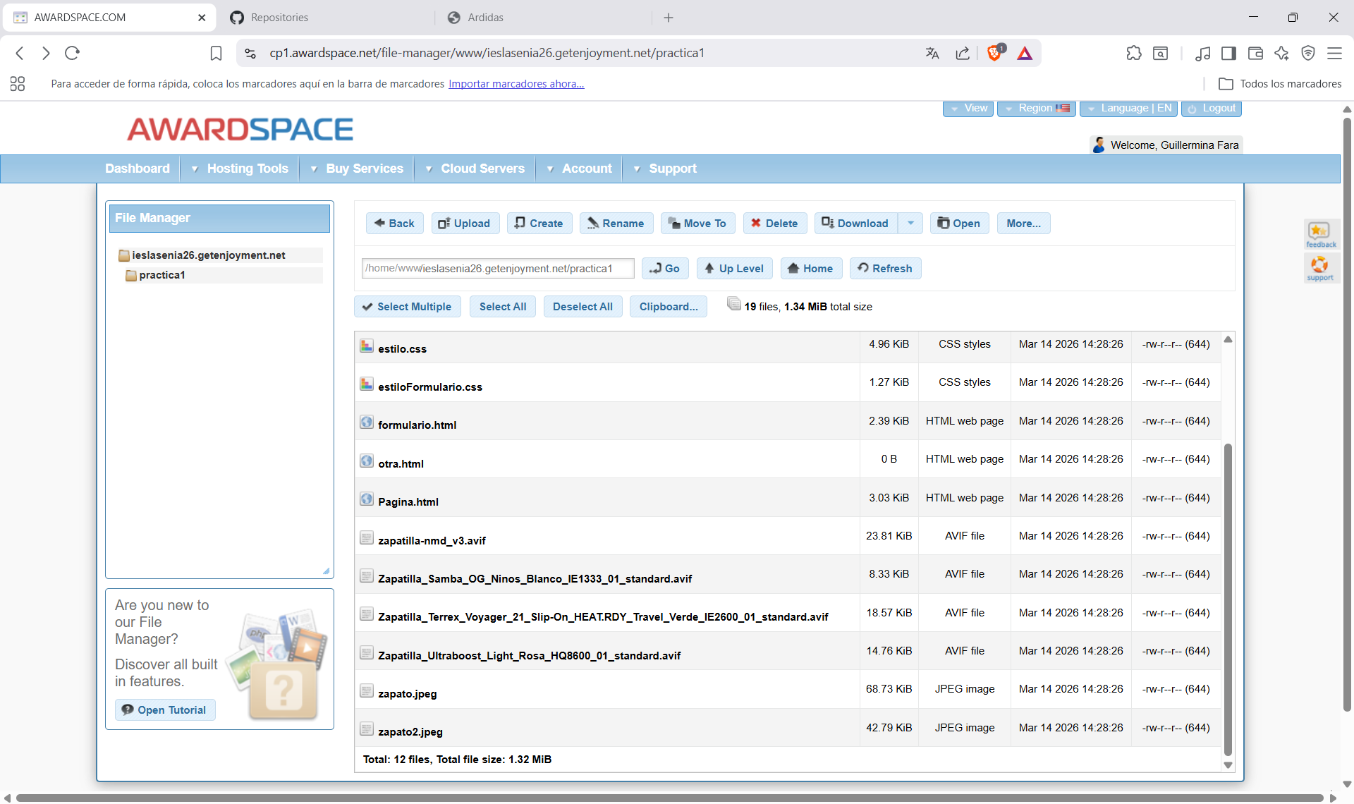

The website obtained is the following:
