- On the /Results page, only the very first time 2 files are compare the name of the session should be set to the second filename, after which each time a file is added to the session this event should no be changing the session name.
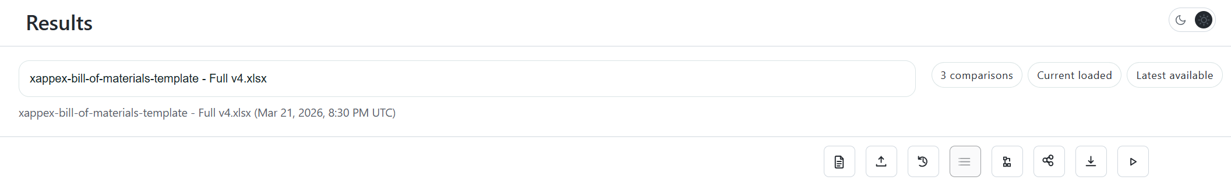

- The row of buttons, where “current file comparison” is should move to the on the same row as the row with the file name.
- On the grid displaying the parts/rows on the impact column, the actual impact should be displayed on a pill as opposed to a textbox, this pill should have the same style as the rest of the pills in the system but should have the color coding representing the actual impact.
- Also on the grid, right underneath the indication of the impact, there is an indicator that there are more taxonomy entries that are impacted (+1), on mouse over, the tooltip should list all the impacts.
- The view impact button should be glowing to indicate that is clickable, this glowing should be similar to the glowing we use on the “Run” button of the /Compare page.
- The pill representing the progress indicator its too large for the amount of information, make it look better, and perhaps add a little bit of color to indicate the progress, also the “Showing …“ indicates the total number of rows, I do not need to see it again in the progress pill.
- Can you add tooltips to the pills on the top right side of the page, the tooltips should have a brief explanation on what each pill represents. When assessing what to add as the tooltip make sure that the engineering support staff or the purchasing staff can understand what this is for.


