This is the old page that will be replaced by the new look and feel, it will be a crash and burn, all aesthetics needs to change make sure that the old look and feel is not preserved, but translate the controls, if no controls have been defined in the html use the “docs\DESIGN_CONCEPT.md” to complete the new look and feel.  For the html design, the pages for dark and light can be found below:  “artifacts\mockup-admin-dark.html”.  “ artifacts\mockup-admin-light.html”. | All the functionality from the current /admin should be translated to the new look and feel, instead of having expanding sections, all the options should be listed in the new Admin menu, and instead of displaying the description of the section add the description to the tooltip. Merge “Audit Exports and Archive” and “Retention Cleanup” into a single option called “Audit Log” and generate a new tooltip description. Mapping, “Access and Roles” is “User Management”, all functionality should be move to the new look and feel.
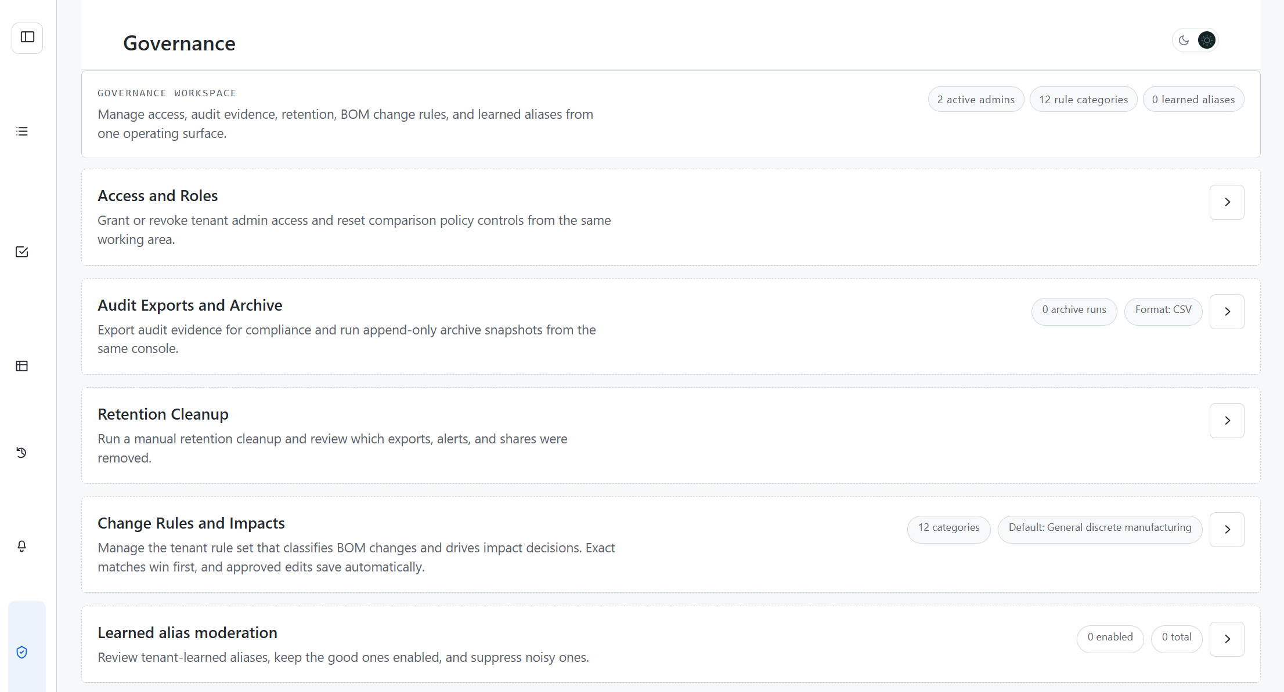 | 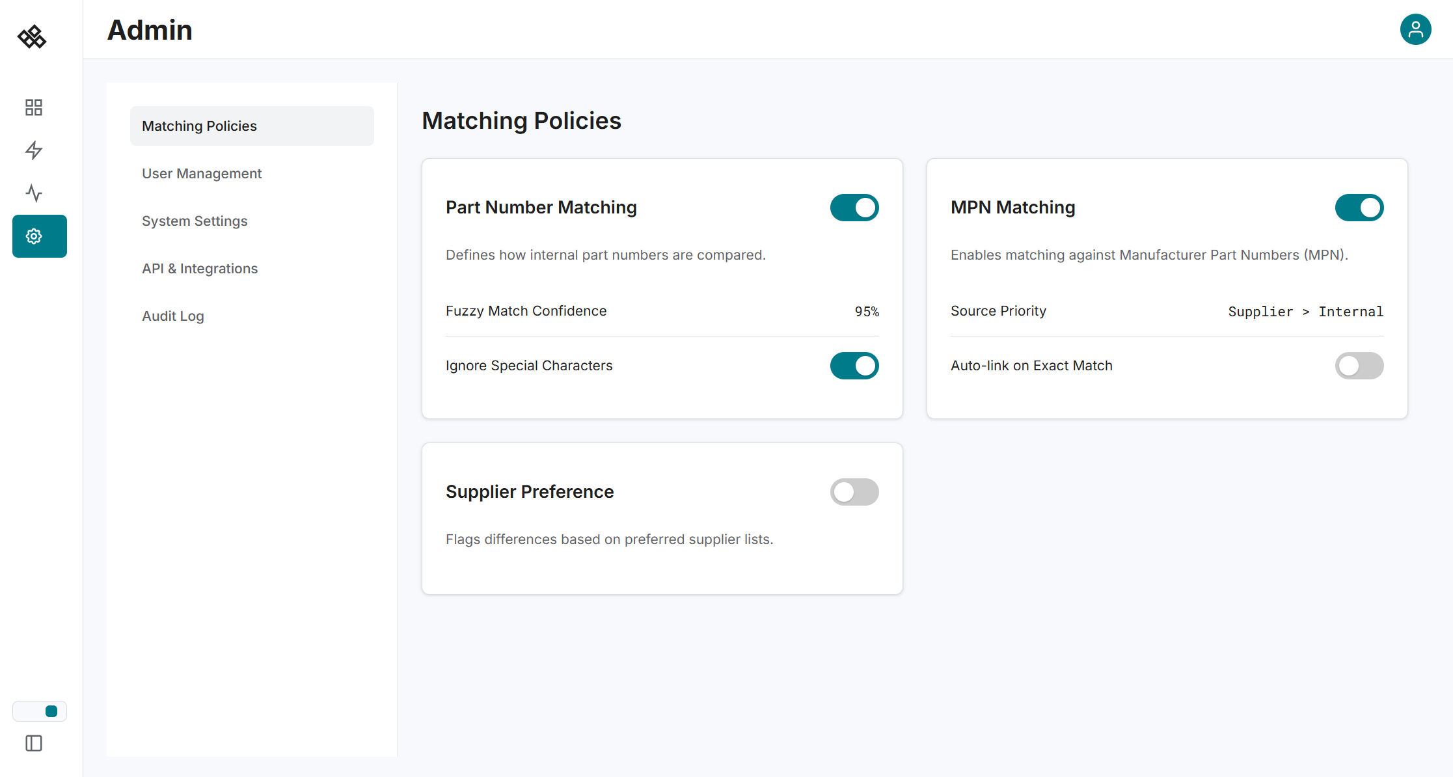

At this point do not move change the left navigation. Only changes happening is the header section and the body section.
The dark and light toggle should now use the look and feel of the new page, and for now leave in the same location as the old toggle.

