**Modelos de computación**

PRÁCTICA 4

*Christian Andrades Molina*

**1.- Dados los alfabetos *A* = {0,1,2,3} y *B* = {0,1} y el homomorfismo *f* de *A*\* a *B*\* dado por: *f*(0)=00, *f*(1)=01, *f*(2)=10, *f*(3)=11. Resolver las siguientes cuestiones:**

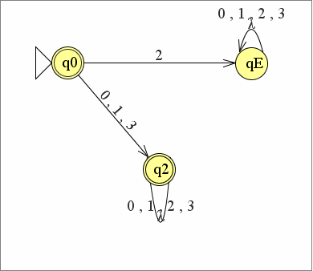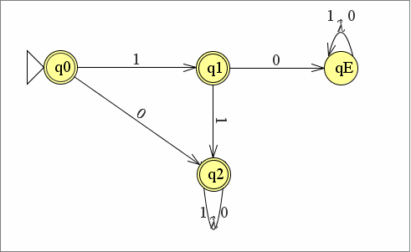**a. Sea *L*1 el conjunto de palabras de B* tales que no comienzan con la subcadena 10. Construir un autómata finito determinista que acepte *f* -1(*L*1).**  
  
  
  
  
  
  
  
  
  
**b. Construir un autómata finito determinista que acepte el lenguaje *L*2= {uu-1 / u ∈ B*}.**

Ɐn є N1ⱻw є L2 con |w| <= n, w = 0^n 1^n 1^n 0^n con |w| = 4N >= N. Para toda descomposición de w = xyz con |y| >= 1 y |xy| <=n …  
  
a) X = 0^r  
b) Y = 0^s, S>=1  
c) Z = 0^n-r-s 1^n 1^n 0^n  
  
ⱻi con x y^i z podemos tomar el siguiente caso:  
  
- i =2 🡪 x y^2 z = 0^r 0^s 0^s 0^n-r-s 1^n 1^n 0^n = **0^n+s 1^n 1^n 0^n no pertenece a L2**  
  
No es un lenguaje regular y no podemos crear un autómata finito para este caso.

**c. Sea *L3* el conjunto de palabras de A* definido como *L*3= {0k3k / 1≤ k ≤20}. Construir una expresión regular que represente a *f*(*L*3).**  
  
L3 є A* tiene la siguiente expresión regular: 0 ( E + ( 0 ( E + ( 0 ( … 20 veces …) 3 )) 3 )) 3.  
*f*(*L*3) sería el siguiente = 00 ( E + ( 00 ( E + ( 00 ( … 20 veces …) 11 )) 11 )) 11.

**2.- Sea *L4* el conjunto de palabras de B* que contienen la subcadena 11. Sea *L5* el**

**conjunto de las palabras de B* de longitud múltiplo de tres. Construir el AFD minimal**

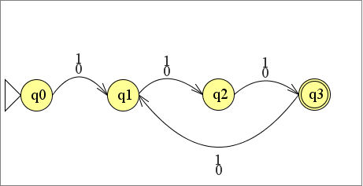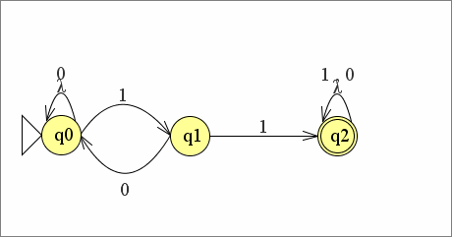**que acepte el lenguaje *L4* ∩*L5*.**- Palabras que contienen la subcadena 11:   
  
- Palabras de longitud múltiplo de 3:   
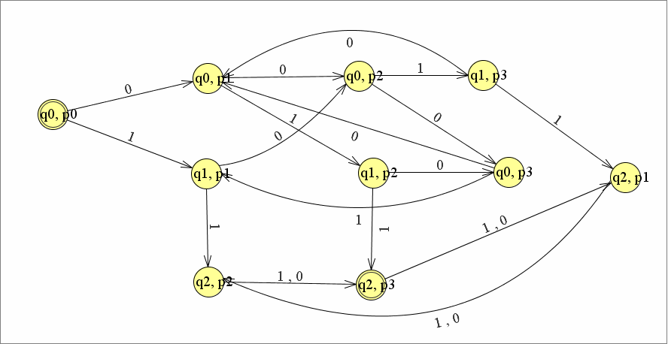- L4 ∩ L5:  
  
**3.- Calcular el AFD Minimal que acepte el mismo lenguaje que el siguiente AFD.**

**Utilizar el algoritmo de minimización visto en clase.**

1) Eliminamos estados inaccesibles: en este caso será el estado q2

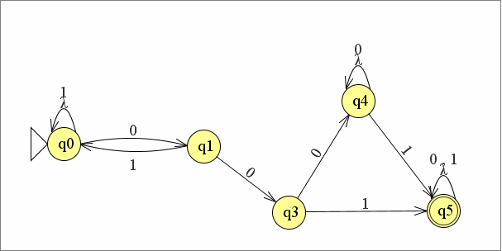2) Resultado:   
  
3) Ejecutamos el algoritmo:  
  
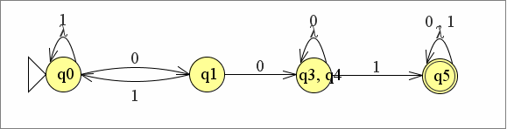

|  |  |  |  |  |
| --- | --- | --- | --- | --- |
|  | **Q5** | Q4 | Q3 | Q1 |
| Q0 | X | X | X | X |
| Q1 | X | X | (q1,q3) X |  |
| Q3 | X |  |  |  |
| Q4 | X |  |  |  |

|  |  |  |
| --- | --- | --- |
|  | 0 | 1 |
| Q0 | Q1 | Q0 |
| Q4 | Q4 | Q5 |

|  |  |  |
| --- | --- | --- |
|  | 0 | 1 |
| Q0 | Q1 | Q0 |
| Q3 | Q4 | Q5 |

|  |  |  |
| --- | --- | --- |
|  | 0 | 1 |
| Q0 | Q1 | Q0 |
| Q1 | Q3 | Q0 |

|  |  |  |
| --- | --- | --- |
|  | 0 | 1 |
| Q1 | Q3 | Q0 |
| Q4 | Q4 | Q5 |

|  |  |  |
| --- | --- | --- |
|  | 0 | 1 |
| Q0 | Q1 | Q0 |
| Q3 | Q4 | Q5 |

|  |  |  |
| --- | --- | --- |
|  | 0 | 1 |
| Q3 | Q4 | Q5 |
| Q4 | Q4 | Q5 |

**Q3 == Q4**

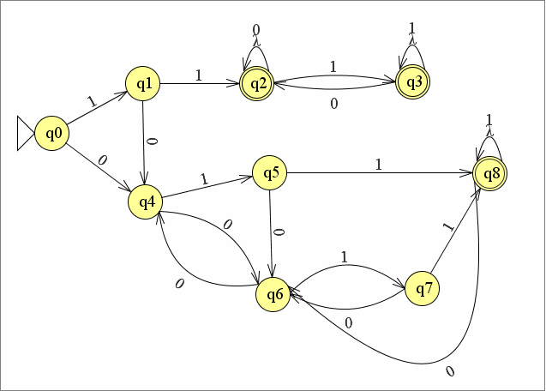

1) Eliminamos estados inaccesibles: ninguno.  
2) Ejecutamos el algoritmo:

|  |  |  |  |  |  |  |  |  |
| --- | --- | --- | --- | --- | --- | --- | --- | --- |
|  | **Q8** | Q7 | Q6 | Q5 | Q4 | **Q3** | **Q2** | Q1 |
| Q0 | X | X | X | X | X | X | X | X |
| Q1 | X | X | X | X | X | X | X |  |
| **Q2** | (q1,q7) (q1,q5) X | X | X | X | X |  |  |  |
| **Q3** | X | X | X | X | X |  |  |  |
| Q4 | X | X | (q1,q7)(q1,q5) X | X |  |  |  |  |
| Q5 | X |  | X |  |  |  |  |  |
| Q6 | X | X |  |  |  |  |  |  |
| Q7 | X |  |  |  |  |  |  |  |

**Q5 == Q7 & Q2 == Q3**

|  |  |  |
| --- | --- | --- |
|  | 0 | 1 |
| Q0 | Q4 | Q1 |
| Q7 | Q6 | Q8 |

|  |  |  |
| --- | --- | --- |
|  | 0 | 1 |
| Q0 | Q4 | Q0 |
| Q6 | Q4 | Q7 |

|  |  |  |
| --- | --- | --- |
|  | 0 | 1 |
| Q0 | Q4 | Q0 |
| Q5 | Q6 | Q8 |

|  |  |  |
| --- | --- | --- |
|  | 0 | 1 |
| Q0 | Q4 | Q0 |
| Q4 | Q6 | Q5 |

|  |  |  |
| --- | --- | --- |
|  | 0 | 1 |
| Q0 | Q4 | Q0 |
| Q1 | Q4 | Q2 |

|  |  |  |
| --- | --- | --- |
|  | 0 | 1 |
| Q1 | Q4 | Q2 |
| Q7 | Q6 | Q8 |

|  |  |  |
| --- | --- | --- |
|  | 0 | 1 |
| Q1 | Q4 | Q2 |
| Q6 | Q4 | Q7 |

|  |  |  |
| --- | --- | --- |
|  | 0 | 1 |
| Q1 | Q4 | Q2 |
| Q5 | Q6 | Q8 |

|  |  |  |
| --- | --- | --- |
|  | 0 | 1 |
| Q1 | Q4 | Q2 |
| Q4 | Q6 | Q5 |

|  |  |  |
| --- | --- | --- |
|  | 0 | 1 |
| Q2 | Q2 | Q3 |
| Q8 | Q6 | Q8 |

|  |  |  |
| --- | --- | --- |
|  | 0 | 1 |
| Q2 | Q2 | Q3 |
| Q3 | Q2 | Q3 |

|  |  |  |
| --- | --- | --- |
|  | 0 | 1 |
| Q3 | Q2 | Q3 |
| Q8 | Q6 | Q8 |

|  |  |  |
| --- | --- | --- |
|  | 0 | 1 |
| Q4 | Q6 | Q5 |
| Q7 | Q6 | Q8 |

|  |  |  |
| --- | --- | --- |
|  | 0 | 1 |
| Q4 | Q6 | Q5 |
| Q5 | Q6 | Q8 |

|  |  |  |
| --- | --- | --- |
|  | 0 | 1 |
| Q5 | Q6 | Q8 |
| Q7 | Q6 | Q8 |

|  |  |  |
| --- | --- | --- |
|  | 0 | 1 |
| Q5 | Q6 | Q8 |
| Q6 | Q4 | Q7 |

|  |  |  |
| --- | --- | --- |
|  | 0 | 1 |
| Q6 | Q4 | Q7 |
| Q7 | Q6 | Q8 |

