**Welcome to Tastewise!**

Some guidelines before you begin:

* There is a **48 hours time limit** for this assignment. Please take that into account before starting
* When you’re done, share your assignment with [meirav@tastewise.io](mailto:meirav@tastewise.io) and yuval@tastewise.io
* If you have any questions regarding this assignment, feel free to ask via email

Best of luck!

At Tastewise, we are interested in understanding consumer preferences regarding food and beverages. We have analyzed millions of data points using language models to learn about what people eat and drink through social media, menus, and recipes.

1. Based on the data provided below, which three nutritional elements matter most to people when they eat salads? Explain why you chose them.

- Share: % of mentions in Instagram posts discussing salads

- Benchmark: % of mentions in Instagram posts discussing any type of food or beverage

- YoY Change: % yearly change in mentions in Instagram posts discussing salads

| **Claim** | **Share (%)** | **Benchmark (%)** | **Change YoY (%)** |
| --- | --- | --- | --- |
| Protein | 6.29 | 1.80 | -12.87 |
| Carbohydrates | 3.87 | 4.54 | 25.67 |
| Fiber | 1.47 | 0.33 | 0.34 |
| Superfood | 1.34 | 1.90 | 8.70 |
| Whole Grains | 1.22 | 2.80 | 39.29 |
| Healthy Fat | 0.94 | 1.12 | -17.36 |
| Vitamins | 0.91 | 0.38 | 26.52 |
| Fat Content | 0.77 | 0.88 | -21.68 |
| Antioxidants | 0.67 | 0.92 | 30.55 |
| Minerals | 0.5 | 0.55 | 26.84 |
| Probiotics | 0.3 | 0.09 | 31.40 |
| Vitamin C | 0.27 | 0.10 | 14.17 |
| Iron | 0.25 | 0.14 | 8.84 |
| Cholesterol | 0.19 | 0.07 | 68.03 |
| Omega 3 | 0.19 | 0.06 | 13.26 |

2. What are the main take-aways from the graph below:

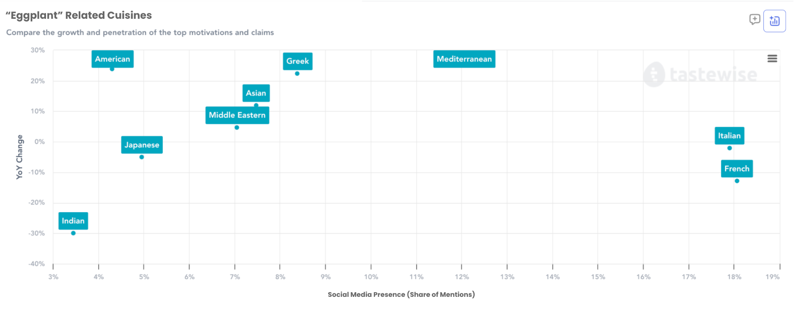

*The graph above presents the social media popularity and yearly change of the term “eggplant” mentioned with different cuisines*

3. Tastewise is enabling clients to explore which occasions are mentioned together with an ingredient of their choice based on social media data.

A candy company decided to develop a new healthy treat based on bananas and dates.   
They looked up “dates” on the Tastewise platform to find out when they should launch this new product.  
Please explain the results below.

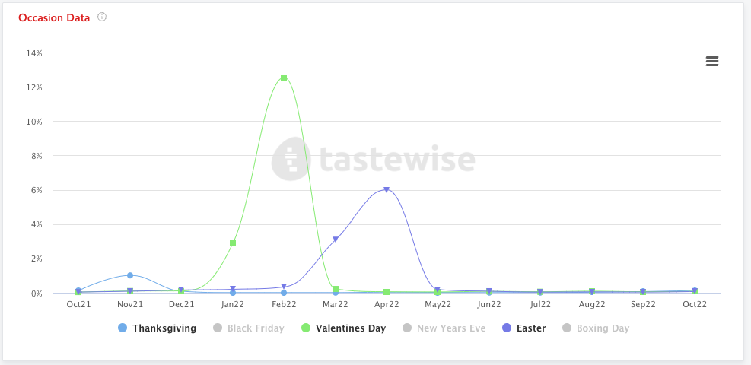

*The graph above presents the monthly social media popularity of the term “date” mentioned with different occasions, over a year period*

4. Which item out of the five below shows the highest opportunity and why?

*The graph above presents the frequency of item appearance in recipes (dark purple bars) vs. recipes popularity (light purple).*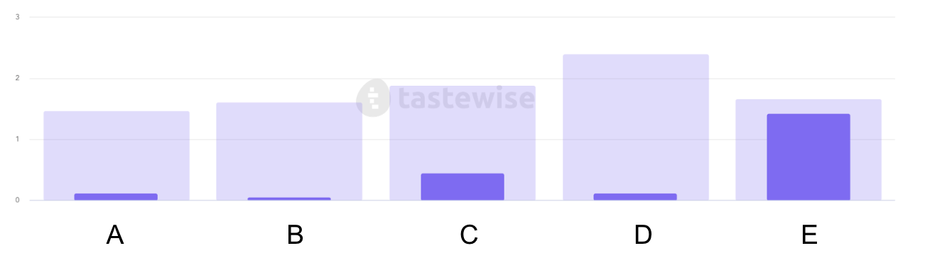

5. The below table includes statistics about pizza toppings. Use the data in any way you want to help a new salad place decide which pizza toppings they should offer on their menu

| **ingredient** | **Menu offering %** | **Social Media mentions %** | **Social Media mentions Growth %** |
| --- | --- | --- | --- |
| Tomato | 53.64 | 3.92 | -14.8 |
| Mushroom | 39.75 | 2.94 | -18.3 |
| Olive | 42.11 | 2.35 | 5.5 |
| Spinach | 27.13 | 1.16 | -23.3 |
| Cauliflower | 4.49 | 1.04 | -24 |
| Gherkin | 2.83 | 0.5 | 34.5 |
| Pumpkin | 0.29 | 0.48 | 5.6 |
| Celery | 1.29 | 0.1 | 5.2 |
| Pickled Onion | 0.46 | 0.1 | 4.9 |
| Dill Pickle | 0.44 | 1.5 | 35.8 |
| Red Bell Pepper | 1.02 | 0.07 | 1 |
| Baby Arugula | 0.61 | 0.02 | 7.3 |

6. The following concepts are trending for “pesto”:

Topics -

* Cuisines: Mexican, Middle Eastern, Sicilian
* Tastes: Zesty, Nutty, Spicy
* Experience: Authentic, Versatile, Hearty
* Nutrition: Healthy Fats, Antioxidants

Ingredients -

* Everything Bagel
* Thai Basil
* Sumac
* Pistachio
* Pecan
* Hazelnut
* Chipotle
* Chili
* Sicilian Lemon

Which Ingredients would be good candidates for a new flavored Pesto spread, and why?