CSCI 1300 ASSIGNMENT 3 – RESPONSIVE REDESIGN

PART 1: IDENTIFYING USABILITY PROBLEMS FOR PENNY JUICE WEBSITE (https://www.pennyjuice.com/)
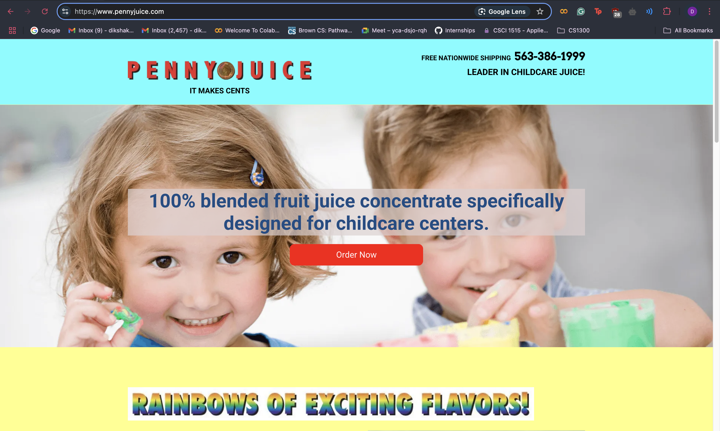
Rationale:
I chose the Penny Juice website because it's a business-oriented site with clear purpose (selling concentrated juice to childcare centers) but suffers from significant usability issues despite its simple goal. The outdated design and cluttered interface provide numerous opportunities for meaningful improvement.

Usability Problems:
LEARNABILITY | MEMORABILITY | EFFICIENCY | CONCEPTUAL MODEL ISSUES
- Animated GIFs, flashing elements, and clashing colors create a confusing homepage experience.  - Key information is buried beneath decorative elements.  - Overlapping, illogically sequenced content categories confuse site navigation. | - Inconsistent page structures force users to relearn the interface repeatedly.  - Lack of visual indicators for visited sections or completed actions.  - Related information is scattered across pages without logical connections, hindering information retrieval. | - No direct search functionality, forcing menu navigation for specific information.  - Order forms have confusing layouts and require unnecessary information. | - Childlike aesthetic clashes with B2B e-commerce purpose for childcare professionals.  - Navigation structure fails to match how childcare professionals purchase juice concentrate.

WebAIM WAVE Results:
- Errors: Multiple images missing alternative text, making content inaccessible to screen readers
- Contrast Issues: Poor color contrast between text and background in multiple sections, making content difficult to read
- Missing Form Labels: Form fields lack proper labels, creating barriers for users with screen readers
- Empty Links: Several links have no descriptive text
- Deprecated HTML: Use of outdated HTML practices that affect assistive technology compatibility
- Missing Document Structure: Lack of proper heading hierarchy and structural elements
I agree with the WAVE findings. The website has significant accessibility issues that would prevent users with disabilities from effectively navigating and using the site. The reliance on visual elements without proper text alternatives is particularly problematic for visually impaired users, while the inconsistent navigation and poor structure would create difficulties for anyone using keyboard navigation or screen readers.

PART 2: VISUAL REDESIGN
Visual Design Style Guide:
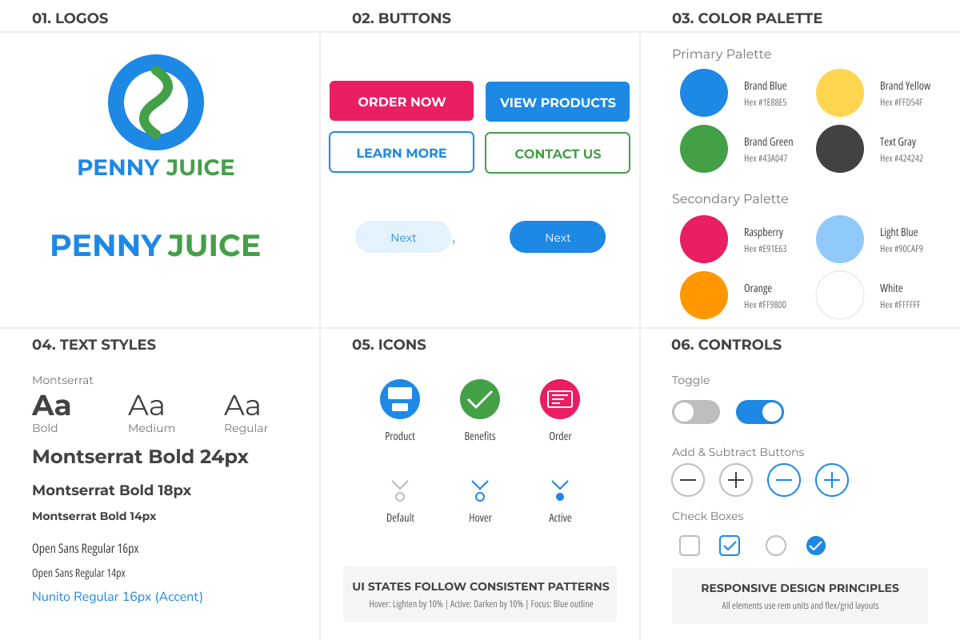

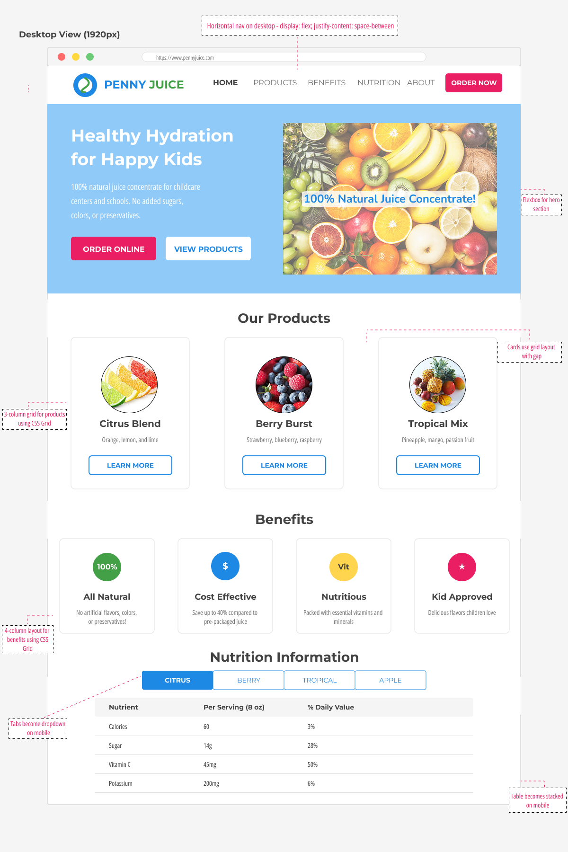
Desktop View Mockup:

Tablet View Mockup:
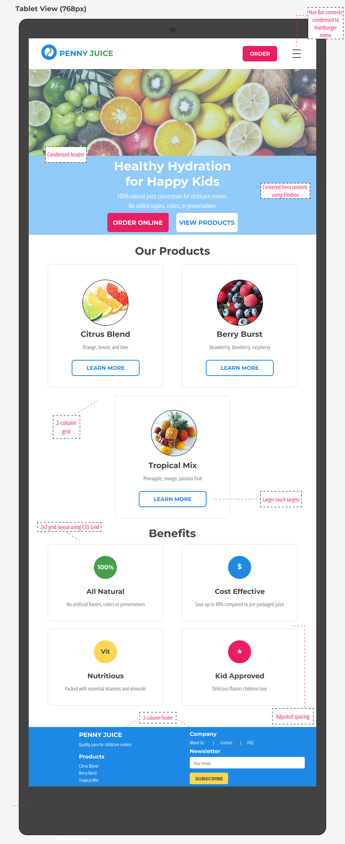



Mobile View Mockup:
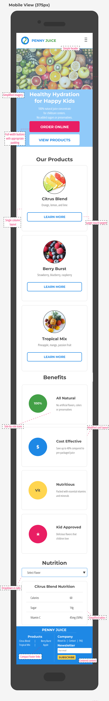
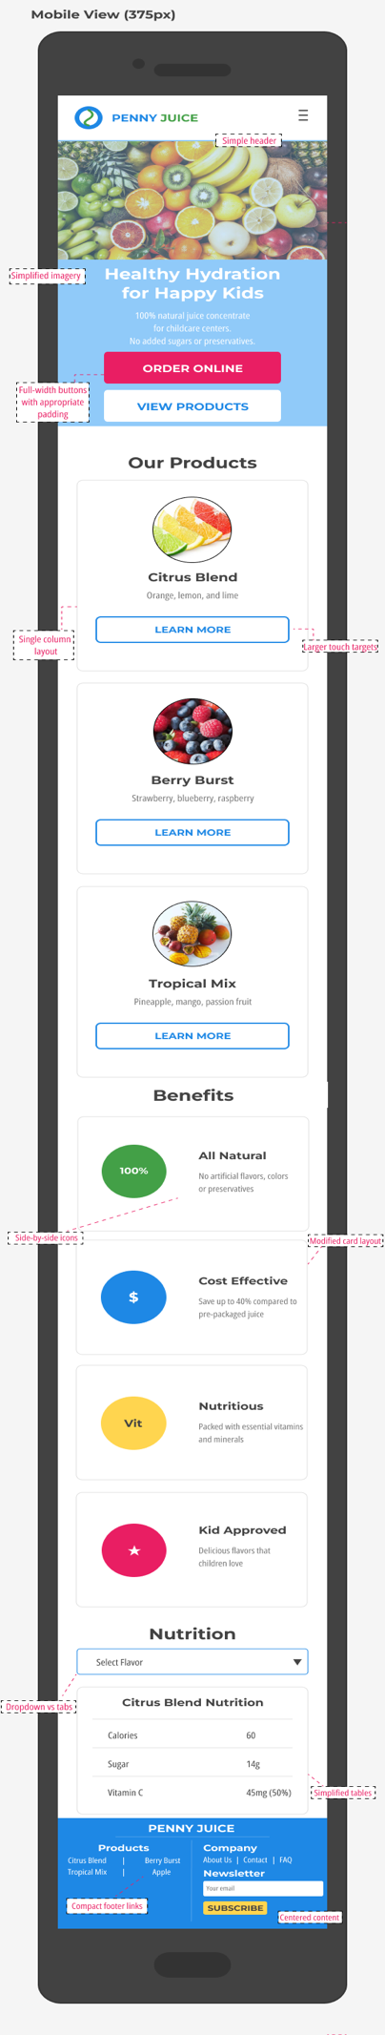

Additional anecdotes about my design:
- Clear visual hierarchy with logical information flow, consistent headings, and prominent CTAs
- Responsive navigation that adapts across devices while maintaining a consistent mental model
- Clean, professional aesthetic balancing child-friendly elements with B2B presentation
- Enhanced accessibility through high contrast text, proper color usage, and appropriately sized touch targets

