Summative Assessment CPU4103

Name: Guilherme Barbosa de Carvalho Student id: G1428943

GitHub Repository: https://github.com/guingster/cpu4103-crownfield-eye-hospital

Assessment information | Details
Module code | CPU4103
Module name | Introduction to Database
Module leader | Puna-Rimam Maiyaki
Level | 4
Assessment format | Collaborative database build with individual report and recorded presentation
Assessment weighting | Individual report 50% | Individual presentation and code verification 50%
Report length | 1,500 words +- 10%
Presentation | 8 to 12 slides | 8 to 10 minutes
Group size | 2 to 3 students
Cohort | June 2025
Submission deadline | Monday 9th November 2026

1. Introduction
The transition from analogue to digital in healthcare is a critical step towards improving operational efficiency and patient safety. The Crownfield Eye Hospital NHS Foundation Trust, within the fictional scenario of this project, faced administrative bottlenecks due to a reliance on paper-based records, Word documents, and unstructured Excel spreadsheets. This report documents the complete development cycle of a relational database prototype designed by Flytech Ltd to replace these inefficient processes. The scope of the project encompasses conceptual modelling, physical implementation in MySQL, and data manipulation using advanced SQL.
During development, certain assumptions were made to guide the modelling: it was assumed that clinicians can attend multiple clinics, but each appointment is allocated to one specific clinic. Furthermore, it was assumed that a patient could receive multiple diagnoses and several prescriptions during a single medical appointment.
The initial construction of the schema was a collaborative effort, but my individual contribution focused heavily on the physical implementation (DDL), the formulation of complex analytical queries (DQL), and the application of security mechanisms and transactions (TCL). This document will detail the rationale behind the design choices, the normalisation strategy, and the critical evaluation of the final system.

2. Analysis and design (Task A)
The starting point of the project was the analysis of an unnormalised ophthalmology dataset provided in the assessment brief. The analysis of this spreadsheet revealed severe database anomalies:
2.1 Dataset Analysis and Anomalies
- Insertion Anomalies: It was not possible to register a new clinician or clinic without a patient being scheduled, as there were no independent tables.
- Update Anomalies: Changing a clinic's address or a patient's postcode would require scanning and updating multiple rows, increasing the risk of inconsistency.
- Deletion Anomalies: If a patient's appointment was cancelled and the row deleted from the spreadsheet, the patient's data would be permanently lost from the system.
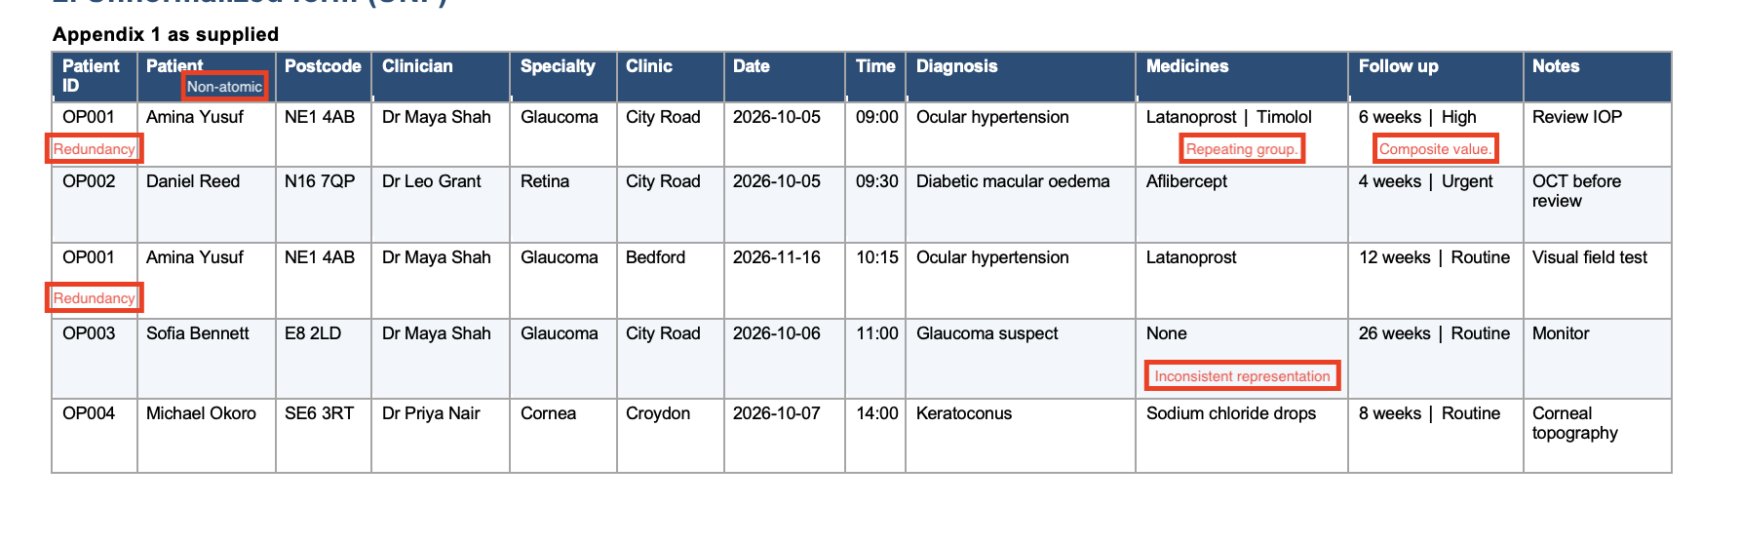
2.2 Normalisation Process (UNF to 3NF): To resolve this, the normalisation process was strictly applied. In the First Normal Form (1NF), we ensured that all attributes were atomic, eliminating repeating groups by separating the full name into first_name and last_name, splitting follow-up details into weeks and priority, and ensuring each prescribed medicine occupied a separate row under the composite key (appointment_id, medicine).
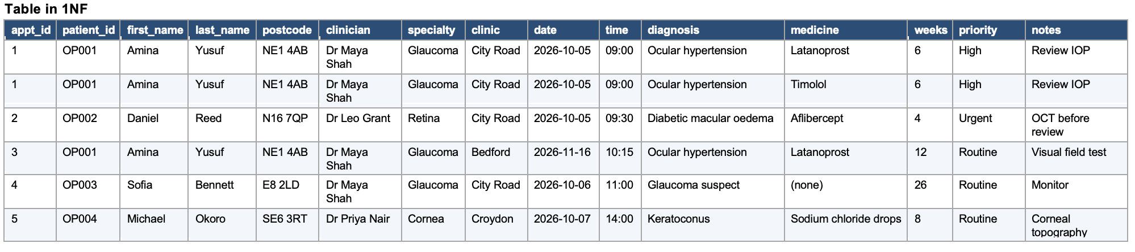
In the Second Normal Form (2NF), we removed partial dependencies from the composite key by decomposing the table into Appointment and AppointmentMedicine, as appointment attributes depend solely on appointment_id rather than on the medicine. 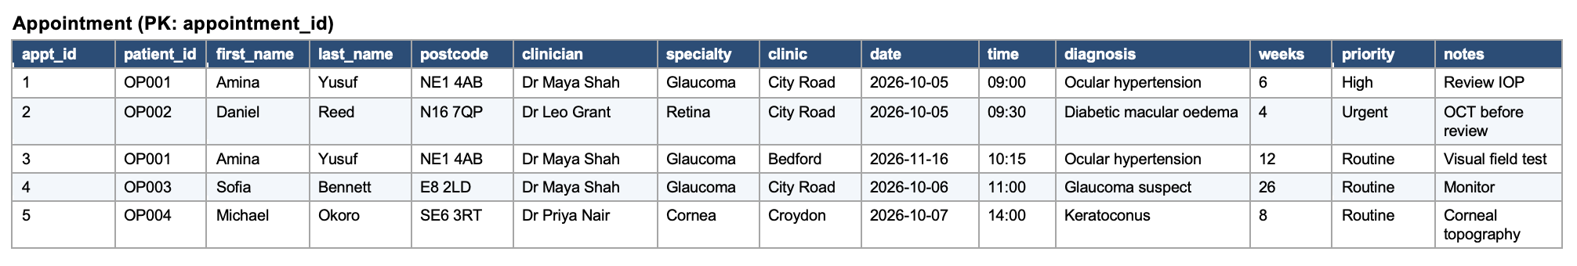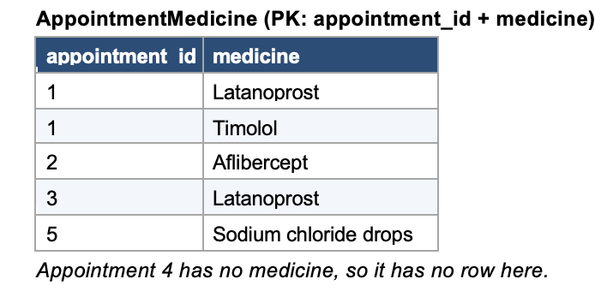
Finally, in the Third Normal Form (3NF), we eliminated transitive dependencies and applied the hospital's business rules: patient details (such as postcode), clinicians, and clinics were moved into independent tables (patients, clinicians, and clinics), whilst AppointmentMedicine and clinical records were decomposed into prescriptions, medicines, prescription_medicines, diagnoses, and follow_up_plans.
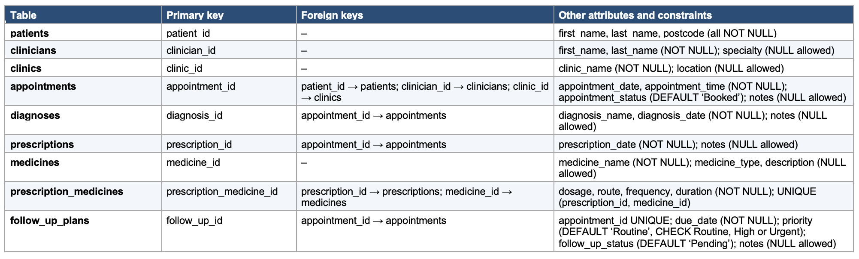

2.3 Entity-Relationship Modelling (ERD)
The conceptual Entity-Relationship Diagram was constructed using Chen notation with relationship diamonds to visually outline the core clinical business rules, whilst the subsequent Logical and Physical diagrams were developed using Crow's Foot notation. The appointments entity acts as the central transactional table. The cardinality was strictly defined: one patient (1) can have many (M) appointments, but each appointment belongs to only one (1) patient. Similarly, one-to-many (1:M) relationships were established between appointments and diagnoses. No many-to-many (M:N) relationships were left in the logical model, ensuring that there were no orphaned tables and that structural integrity was maintained. Following the conceptual model, the logical and physical diagrams were developed to explicitly define data types, primary keys (PK), and foreign key (FK) constraints.
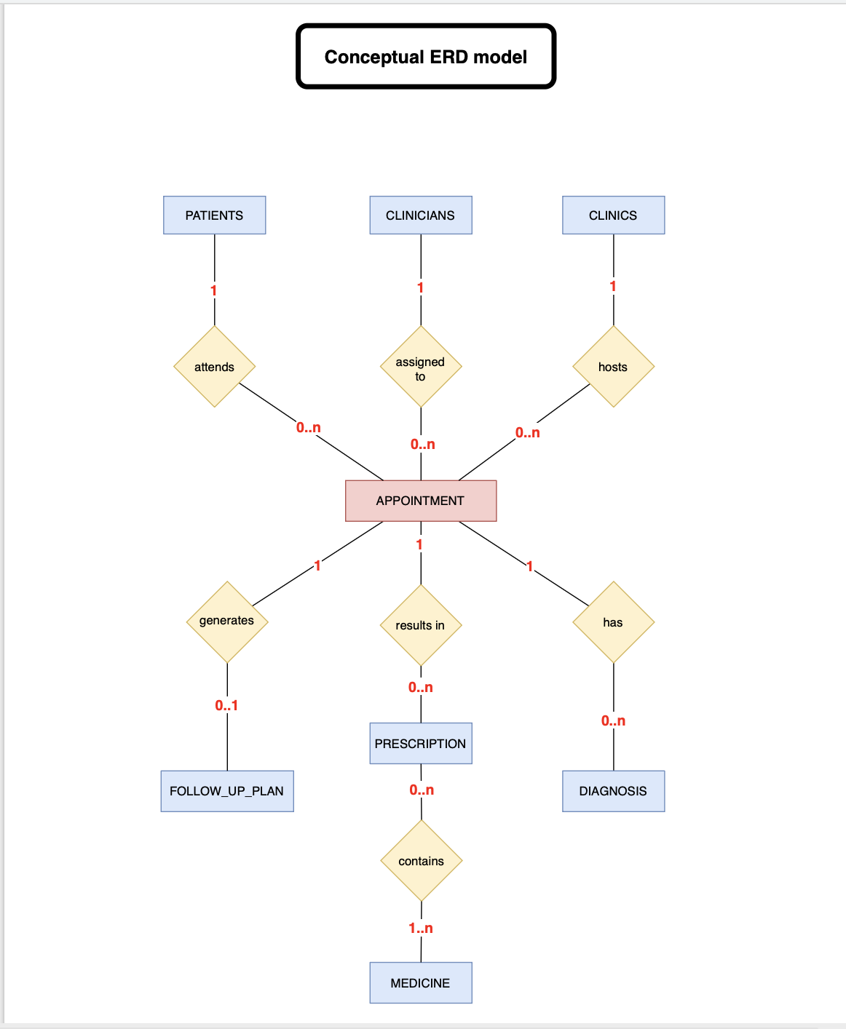
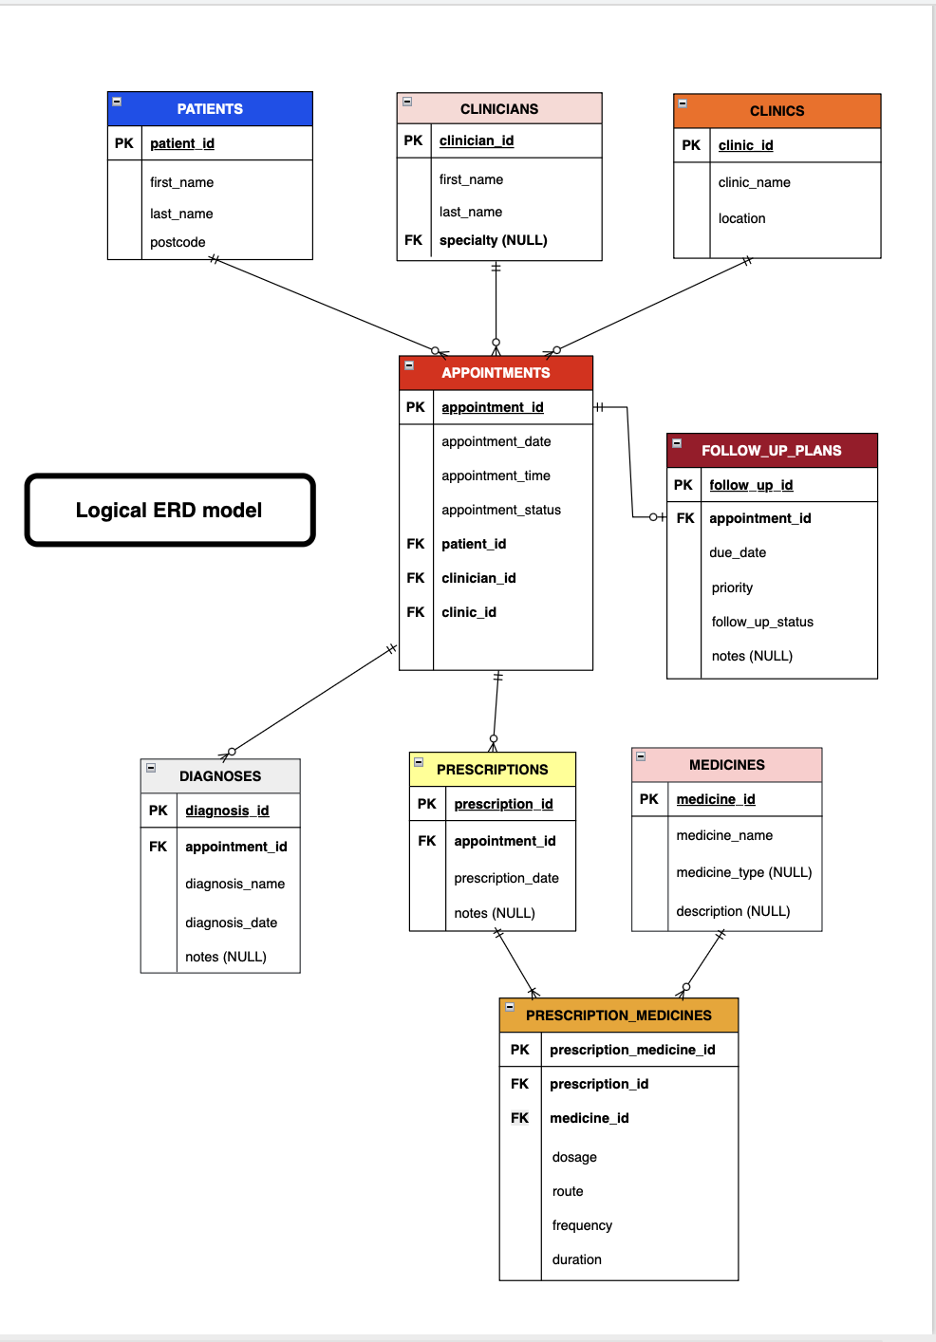

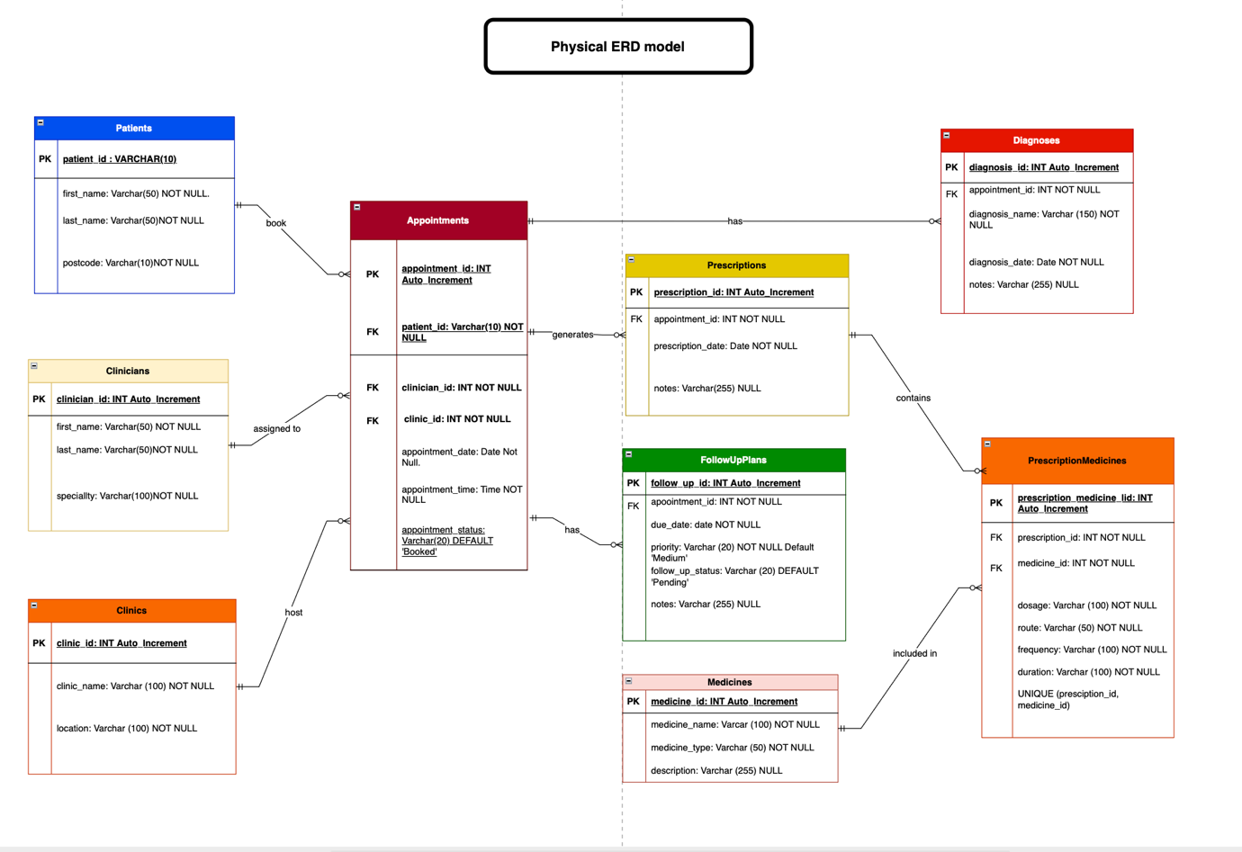

3. Implementation and Testing (Task B)
3.1 DDL Schema and Constraints: The transition from the logical model to the physical implementation was carried out in the MySQL environment. The DDL script (01_schema.sql) was written with consistent naming conventions (using snake_case). Data types were chosen carefully: VARCHAR for variable text fields such as names to optimise space, native DATE and TIME for appointments, and INT for clinic and clinician IDs. Integrity constraints were the pillar of this stage. The PRIMARY KEY constraint was declared in all tables to ensure the uniqueness of records. FOREIGN KEY constraints were fundamental to link the appointments table to patients, clinicians, and clinics. Furthermore, I utilised NOT NULL constraints in critical fields (such as appointment dates and mandatory foreign keys) to prevent the entry of incomplete operational records. 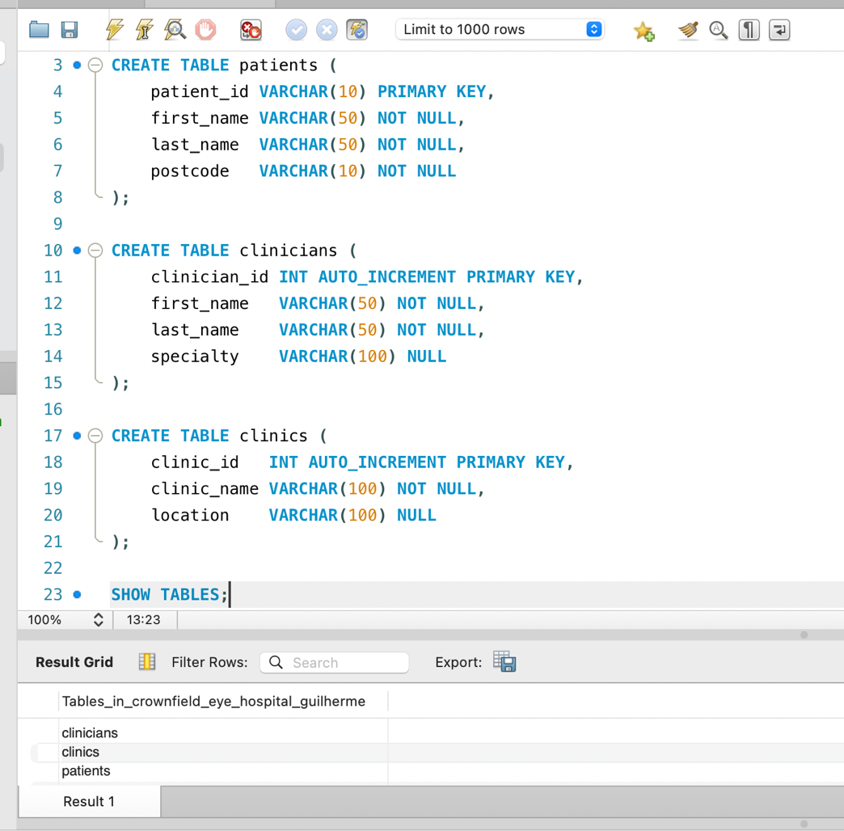 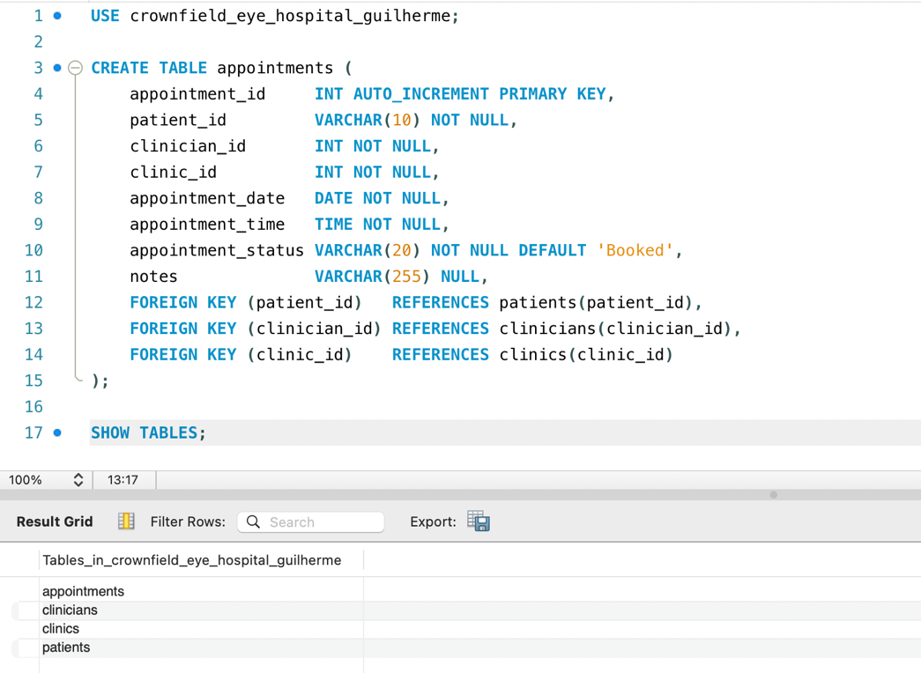

3.2 Data Population: For the testing phase, I populated the relational schema with a total of more than 10 coherent synthetic records across the entity tables using INSERT INTO commands. The insertion hierarchy was strictly respected (independent tables first) so as not to violate foreign key constraints.
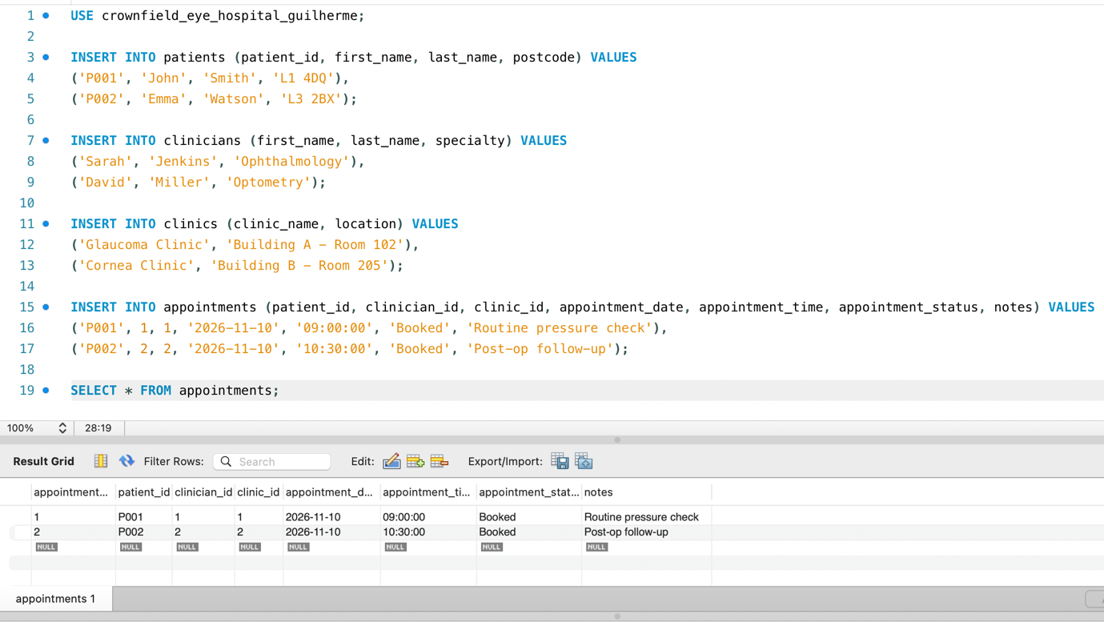
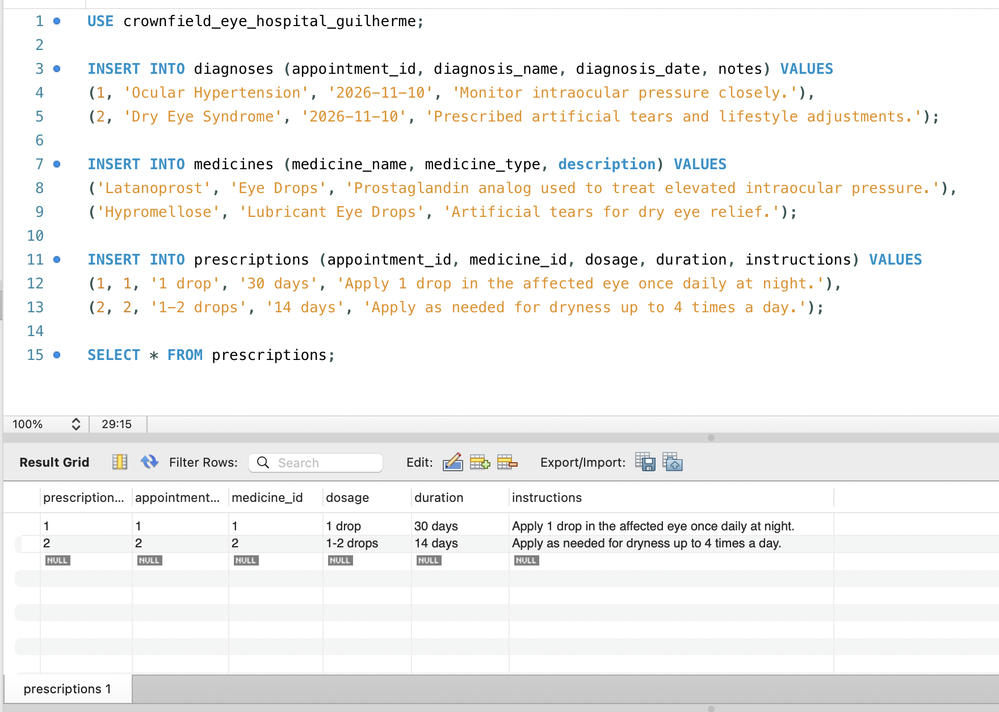
3.3 Referential Integrity: The robustness of the database was tested by executing a controlled DELETE operation on a clinician who had active appointments. As expected, MySQL rejected the deletion due to the foreign key constraint, proving that referential integrity is actively protecting the database against the accidental deletion of vital data.

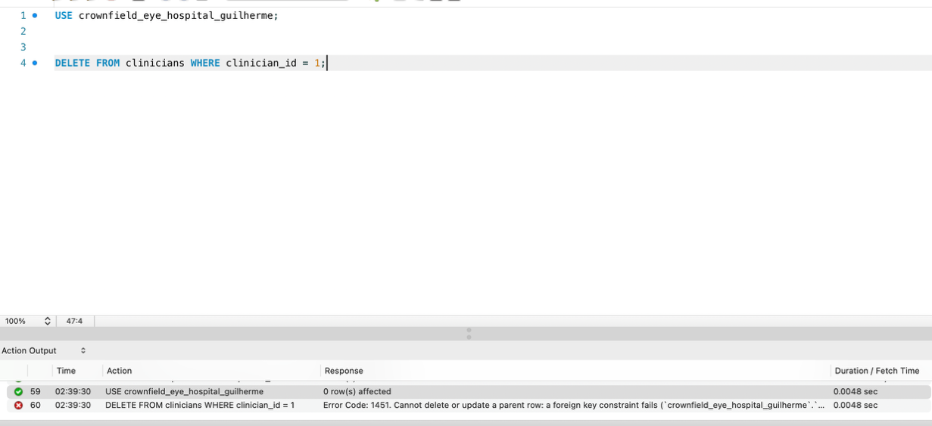

4. Individual SQL Queries (Task C)
With the database structured and populated, I focused on demonstrating the capacity for data manipulation and retrieval through six individual SQL queries, designed to answer specific business questions for the hospital:

4.1 Aggregate Query (GROUP BY and ORDER BY): This query was developed to evaluate clinical attendance volume across hospital facilities. I utilised the COUNT () function alongside GROUP BY and a LEFT JOIN to calculate the total appointments per clinic, including facilities with low bookings. The ORDER BY COUNT (a.appointment_id) DESC clause ranks facilities hierarchically by patient demand, assisting hospital administration in capacity planning and resource allocation.

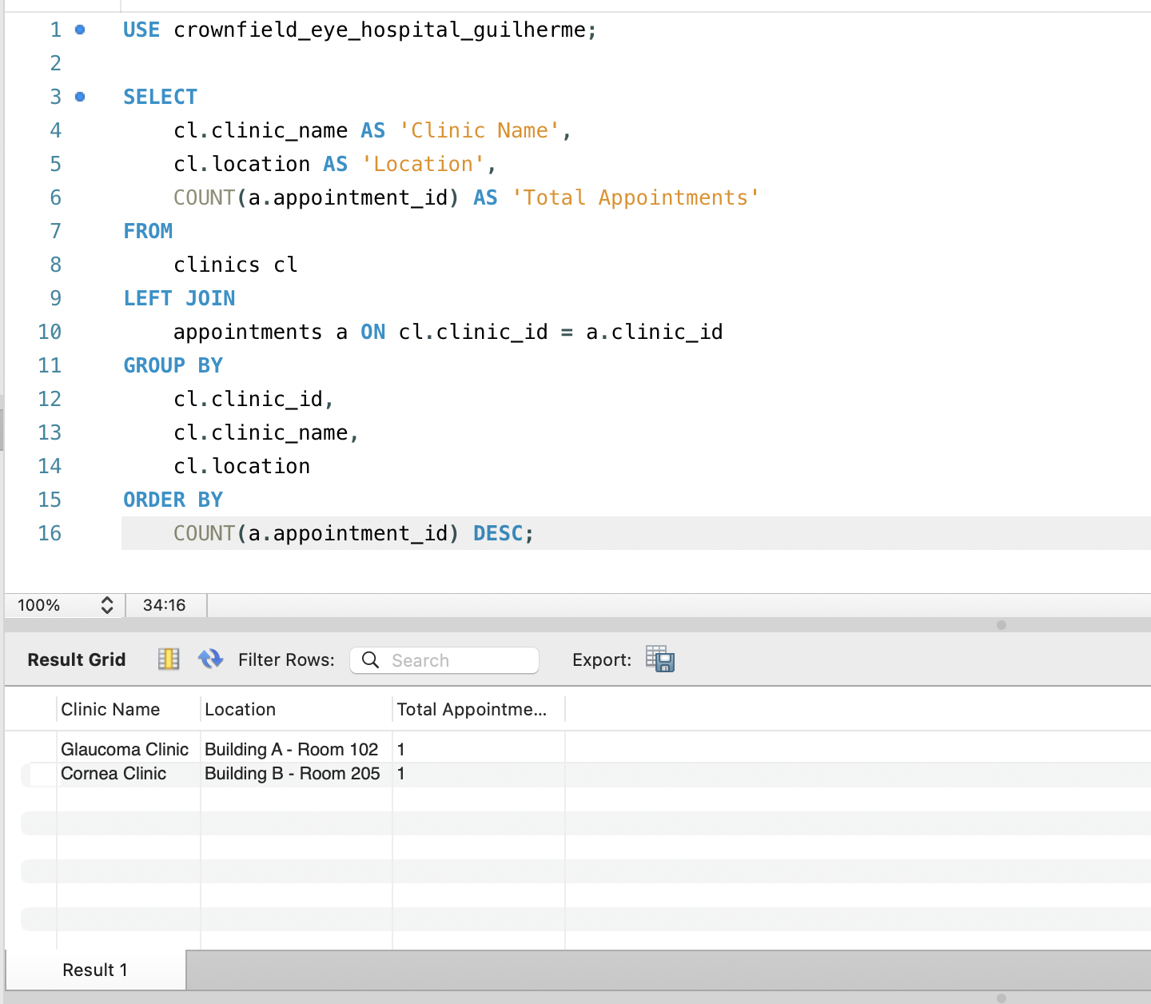

4.2 Multiple Join Schedule Report (INNER JOIN): To generate an operational daily schedule for reception staff, I utilised INNER JOIN to link the appointments, patients, and clinicians tables. This query resolves numerical foreign keys into human-readable data, outputting patient and clinician full names, appointment date, time, and current booking status in a consolidated view.

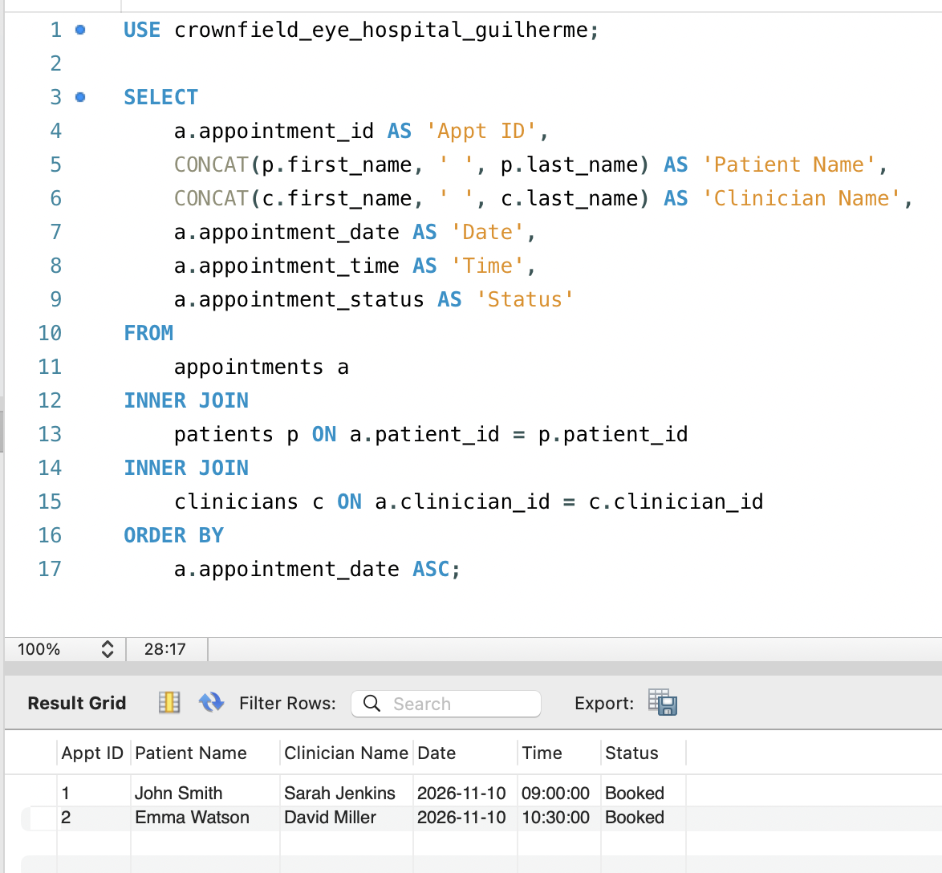

4.3 Non-Pharmacological Audit Report (LEFT JOIN): I implemented an outer join hierarchy using LEFT JOIN between appointments, prescriptions, and medicines. This query ensures complete audit visibility by retaining all patient consultation records within the report, preserving appointment details even when an encounter concludes without a pharmacological prescription.

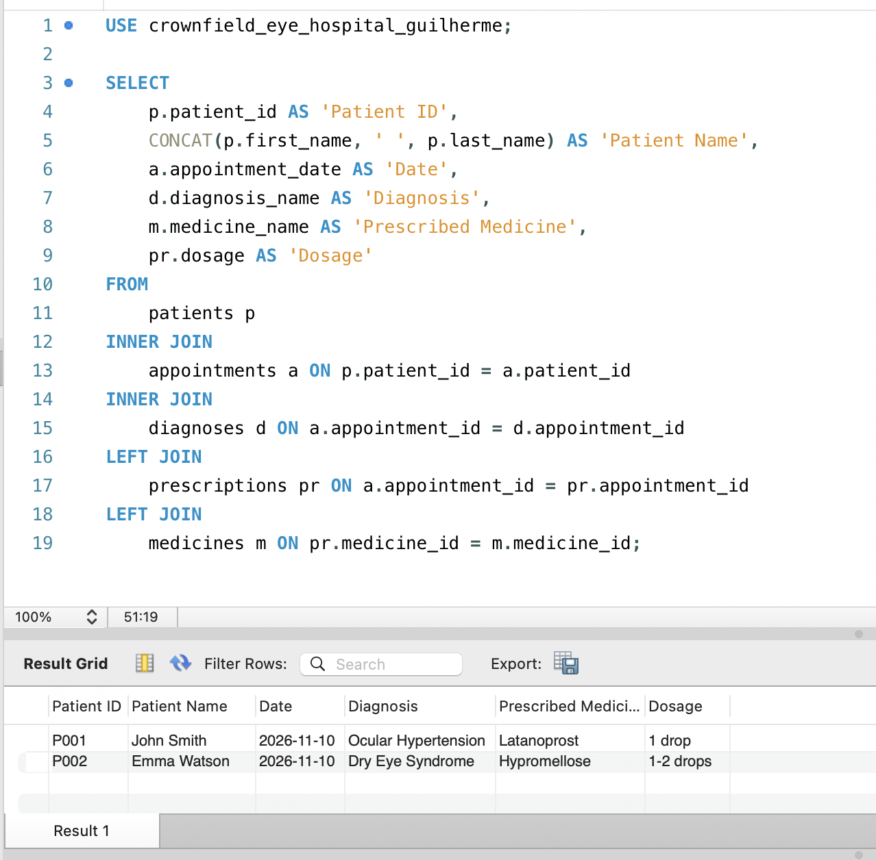

4.4 Dynamic Subquery for Latest Appointment: I utilised a scalar subquery in the WHERE clause to dynamically retrieve the patient associated with the most recent clinic booking. Rather than hardcoding identifiers, the inner query isolates the target record using ORDER BY appointment_date DESC, appointment_time DESC LIMIT 1, enabling the outer query to return the corresponding patient details.

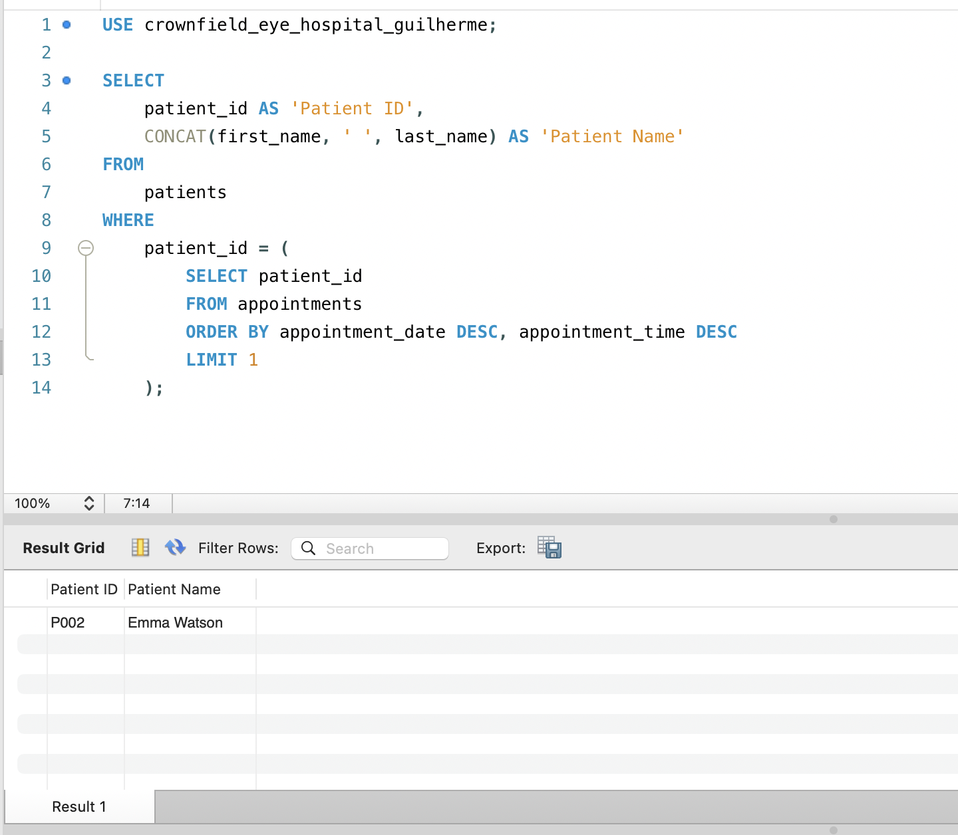

4.5 Patient History Stored Procedure: I created a Stored Procedure named GetPatientHistory that accepts the patient ID as an input parameter (IN p_id VARCHAR (10)). When called with CALL GetPatientHistory('P001'), it immediately returns all past appointments for that patient. This reduces code repetition on the application side and improves performance.

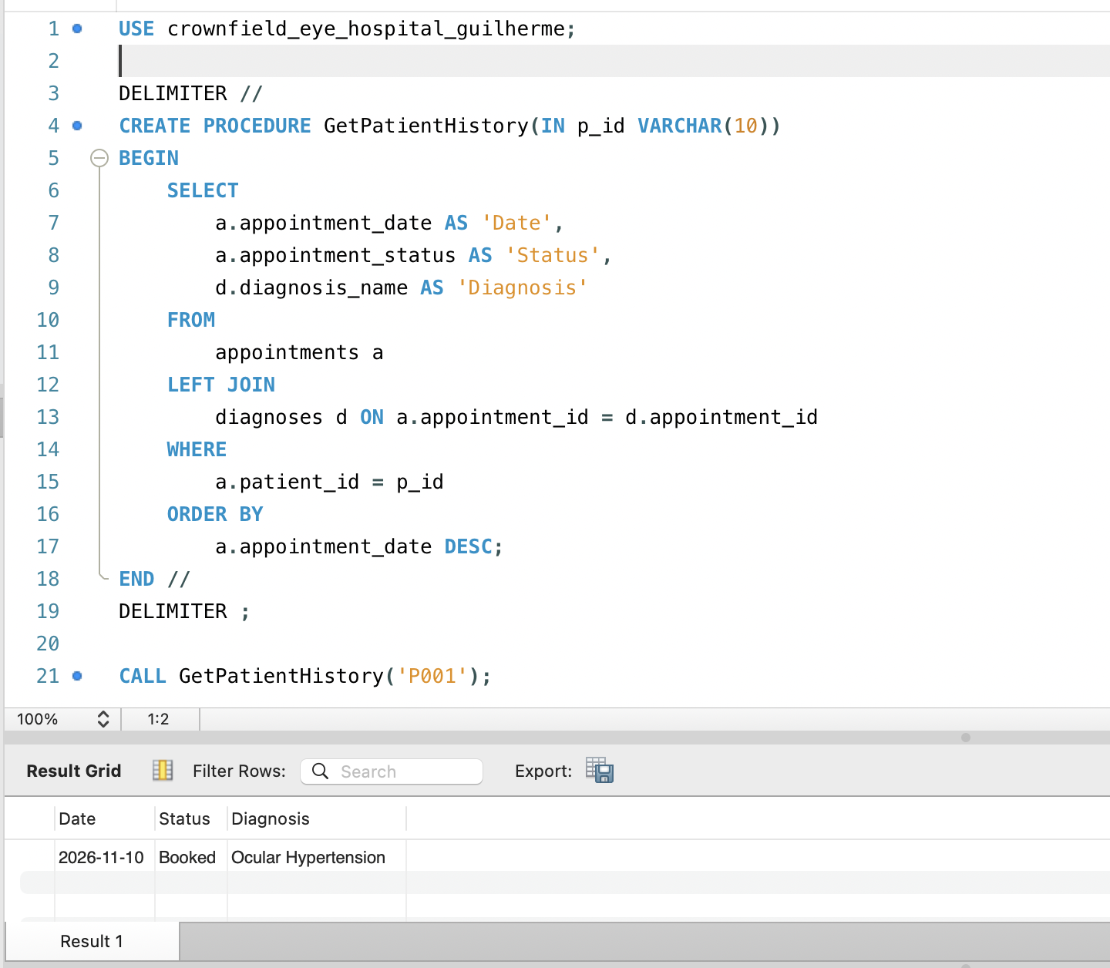

4.6 Business Rule Enforcement Trigger: To enforce a hospital rule, I developed a BEFORE INSERT Trigger on the appointments table. Before a row is saved, the script verifies if the provided date is earlier than the current date (CURDATE ()). If it is, the Trigger aborts the operation and issues an error message indicating that "Cannot book an appointment in the past". This delegates validation directly to the database.

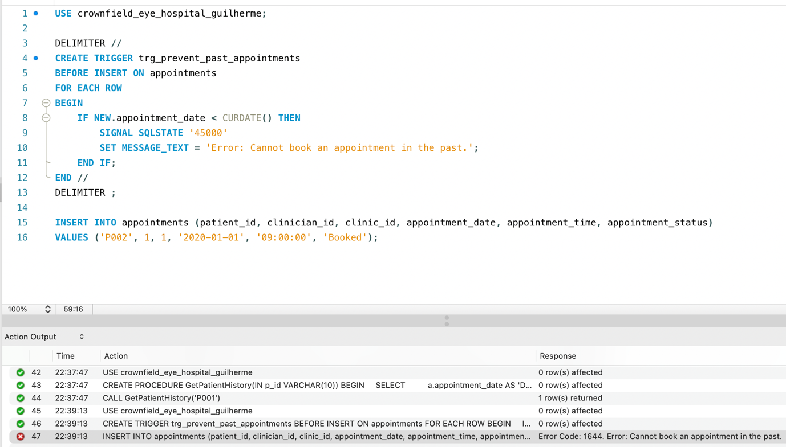

5. Security and transactions (Task D)
5.1 Role-Based Access Control (RBAC): The management of a healthcare database requires strict adherence to security protocols. The model was designed following the principle of least privilege. I created specific roles: the 'Administrator' user has full permissions (ALL PRIVILEGES), whilst the 'Receptionist' role was granted SELECT, INSERT, and UPDATE permissions on the appointments table alongside read-only SELECT access on patients, strictly withholding destructive privileges such as DELETE.

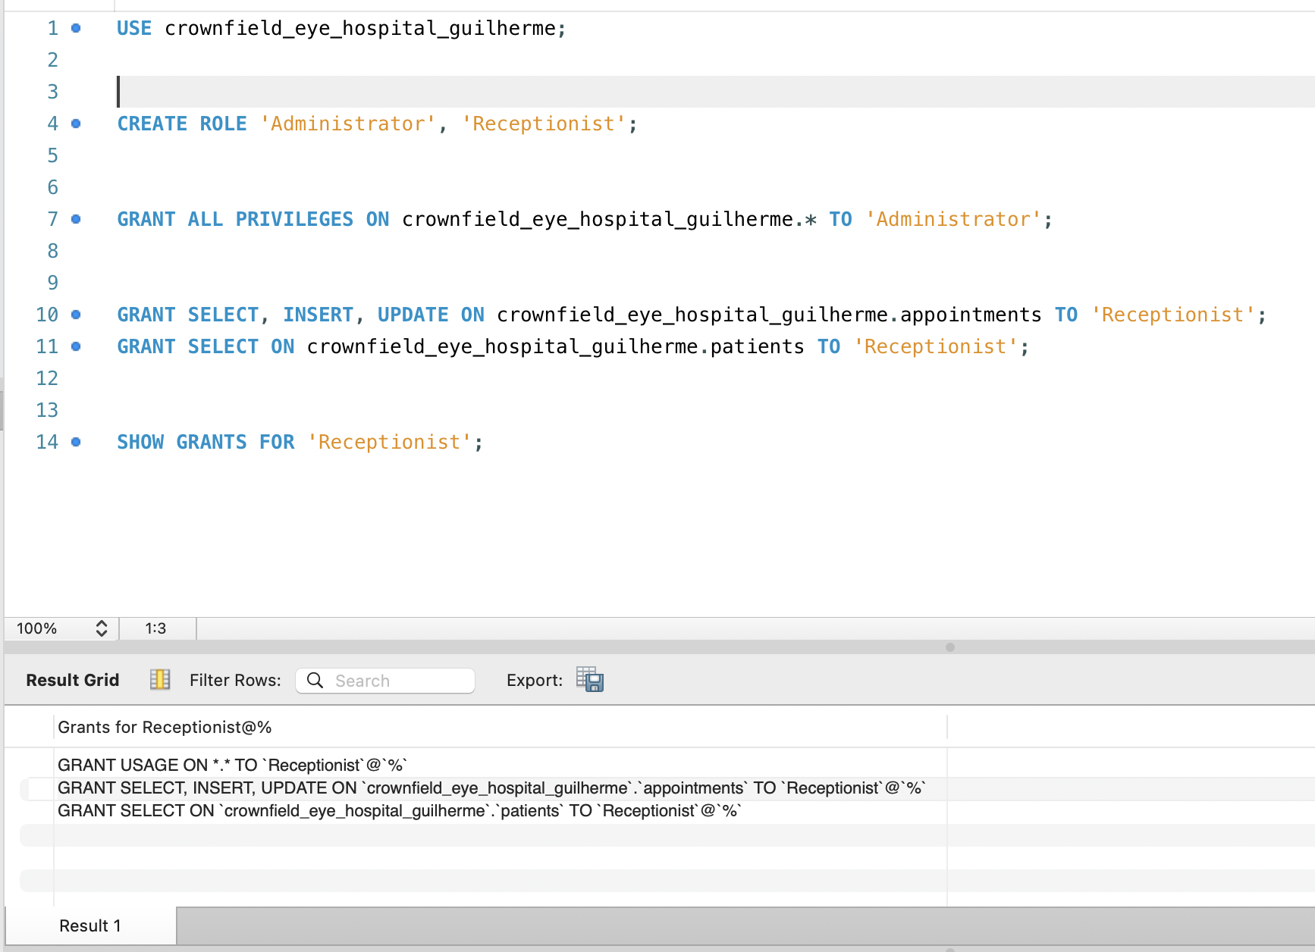

5.2 Data Protection and SQL Injection Defence: For data protection (Task D2), I highlighted the importance of hash algorithms (such as SHA-256) to protect sensitive information, ensuring that even DBAs cannot read confidential data directly. Furthermore, I documented the use of Prepared Statements (parameterised queries) in database interactions as the primary technical defence against SQL Injection attacks, preventing malicious inputs from manipulating the query structure.
5.3 Transaction Control and ACID Compliance: ACID transaction compliance was demonstrated using the START TRANSACTION and ROLLBACK commands. To prove engine-level rollback capabilities, a test patient record ('P099') was inserted within an active transaction and immediately rolled back. A subsequent SELECT query returned an empty result, verifying that uncommitted transactions leave no orphaned records or partial state changes in persistent storage.

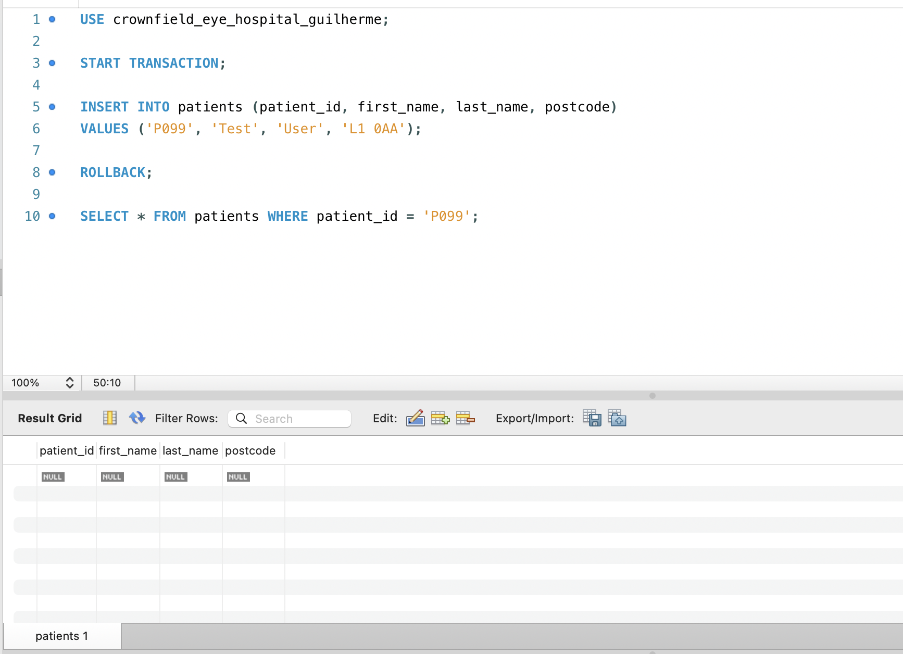

6. Evaluation and reflection
6.1 System Evaluation and Production Limitations: The developed relational prototype fully meets the needs described in the Crownfield Eye Hospital scenario. The use of the third normal form eliminated the flaws identified in the original Excel-based records, reducing storage waste and preventing data obsolescence. The security tools and transaction controls proved that the system could operate robustly in a critical medical environment.
Despite the success of the prototype, there are limitations to be overcome prior to a production deployment. The first is the absence of an alteration history (audit tables). In a real healthcare scenario, tracking who altered a diagnosis and when is legally required. The second structural limitation is the absence of an automated Disaster Recovery plan. Although the system protects data against accidental deletions, for future iterations, the implementation of full and differential backup routines, stored encrypted on off-site servers, is strictly necessary. This measure would ensure that, in scenarios of catastrophic hardware failure or ransomware attacks, the ophthalmological history could be fully restored, ensuring the uninterrupted continuity of care.

6.2 Personal Reflection and Learning Outcomes: Working on this project deeply consolidated my technical capability. The process solidified my understanding that good database design occurs even before opening MySQL (LO1). Furthermore, practising advanced SQL, including procedures and triggers, gave me the confidence to manipulate and protect data efficiently (LO2 and LO3). The experience of debugging foreign key constraints was challenging, but crucial to understanding the importance of sequential planning of data dependencies.

7. References

- Connolly, T. and Begg, C. (2014) Database Systems: A Practical Approach to Design, Implementation, and Management. 6th edn. Pearson.

- Coronel, C. and Morris, S. (2018) Database Systems: Design, Implementation, & Management. 13th edn. Cengage Learning.

- MySQL (2026) MySQL 8.0 Reference Manual. Available at: https://dev.mysql.com/doc/refman/8.0/en/ (Accessed: 8 November 2026).

