# Ux

LESSON 0

Inicio:

**El usuario ha de ser nuestro Foco.**

**Identificar a nuestro usuario**, dejando de lado los demás usuarios,

Cuestionario:

* El producto No es para todo el mundo
* Parámetros que ha de cumplir quien quiera el producto
* Si no los cumple, no le interesa

Es una forma de CRIBAR Y enteder Quién son nuestros usuarios. A partir de ahí se les pueden hacer **recomendaciones personalizadas y focalizadas.**

Dirigirse a todo el mundo es una **Pérdida de Tiempo.**

**Ejercicio:**

* **Dear Customer/User, I would like to tell you that**
* The webpage of the artist Feli Portes **suits you if you are** sensitive to the current tendencies of Art and like Sculpture and Paintings with traditional techniques, **However, if you are** not interested in Art at all, or you are looking for new techniques in Art like digital paintings  **then we are sorry that this product/service is not appropriate for you.**

LESSON 1

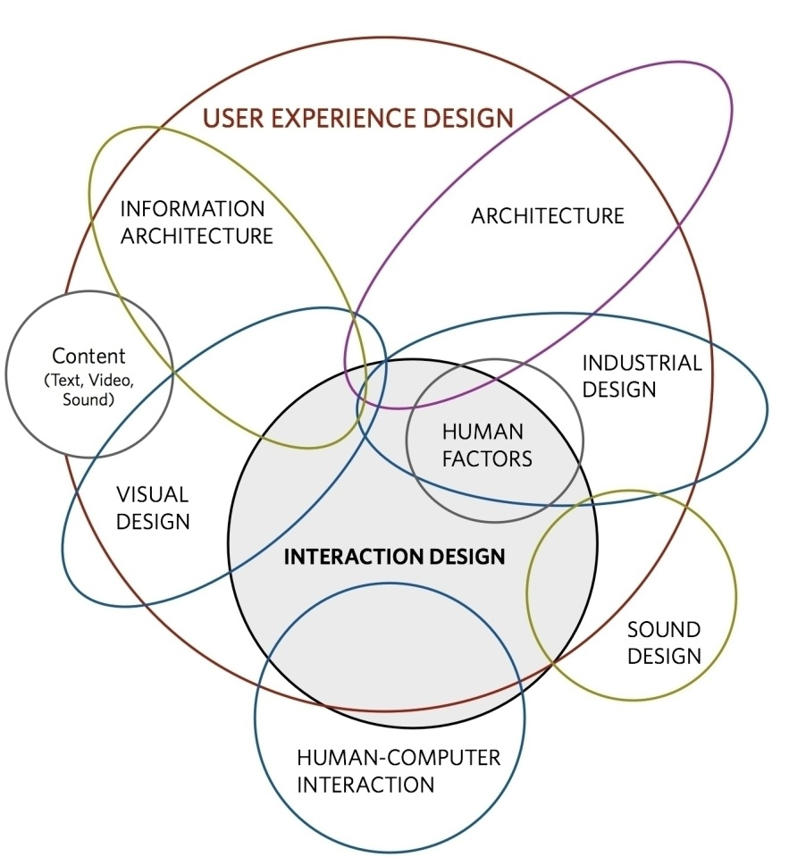

**User experience** can be defined as, "*a person's perceptions and responses that result from the use or anticipated use of a product, system or service"* Whilst the term 'user experience' is generally applied to the positive, neutral and negative emotions felt whilst interacting with computer systems and user interfaces. user experience encompasses many different disciplines,

user experience is the key to the success of a product.

**Interaction design** is at the heart of the user experience as so much is dependent on the interactive qualities of a design.  For example, most web users are constantly clicking, typing, switching between windows, opening documents and applications.

Therefore, **it is the role of the designer to accommodate these constant, intentional shifts and** **provide the necessary features for smooth and simple interactions and transitions.**

The Rise in UX

In website design, it has become important to combine the interests of different stakeholders: **marketing, branding, visual design, and usability**. Marketing and branding people needed to enter the interactive world where usability was important. Usability people needed to take marketing, branding, and aesthetic needs into account when designing websites**. User experience provided a platform to cover the interests of all stakeholders**: **making web sites easy to use, valuable, and effective for visitors.** This is why several early user-experience publications focus on website user experience.

Usability and the User Experience

**A design lives and dies by its ability to accommodate the limitations of human action and cognition**.

The limits of human cognition and action have resulted in the development of a number of design guidelines and principles, which are intended to inform the design process. *Usability*, which refers to the ease and pleasure associated with a *user experience*, is the sum of these guidelines and principles. Usability emphasises these factors to ensure products do not exceed the users' capabilities.

1.2 USABILITY

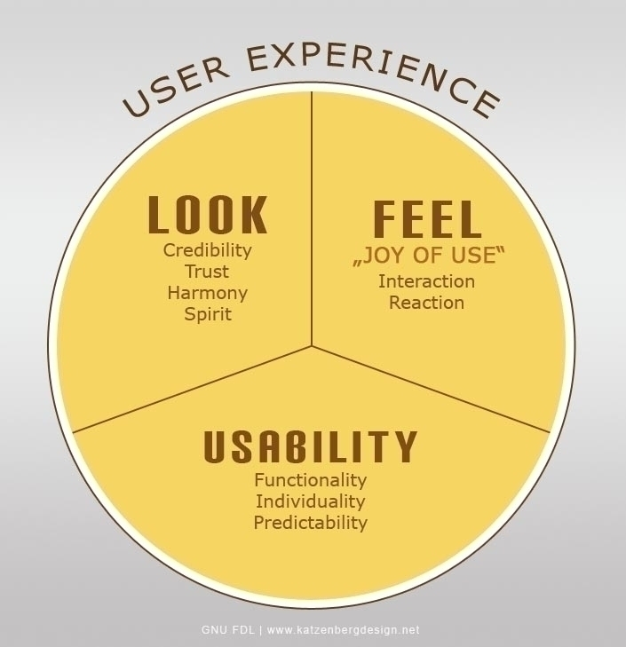

Components:

1. Learnability
2. Efficiency

time taken to achieve the user´s goal)

1. Memorability

The degree to which a user is able to interact with the design without having to refresh their memory of the steps required to complete their tasks.

1. Error
2. Satisfaction

The level of enjoyment derived from interacting with a design.

and other attributes, such as:

1. **Functionality**, also referred to as **Utility** - The availability of design features needed by the user to fulfil their system or device-constrained goals, both quickly and accurately.
2. **Individuality** - The capacity to personalise and customise the design to suit the user's specific wants or needs.
3. **Predictability** -The user should be able to accurately predict what will happen following most, if not all, interactions

Measuring Usability

five usability dimensions

1. **Effective** -**Eficaz** The level of accuracy and completeness the user is able to achieve when carrying out their tasks.  
   2. **Efficient** -**Eficiente** The time in which users are able to complete their goals to the desired standard.  
   3. **Engaging** - The enjoyable qualities of the user experience. Does the tone and style match the user's expectations?  
   4. **Error Tolerant** - The degree to which the design prevents errors and allows users to correct mistakes so they can quickly resume from their pre-error state.   
   5. **Easy to learn** - The ease with which the user is able to navigate, interact and carry out their desired functions. In addition, the user's ability to gain further understanding of the system's capabilities.

TEMA 5

PRINCIPIOS DE USABILIDAD:

SIMPLICIDAD:

Podemos conseguir la “simplicidad” mediante:

* Limitando las opciones:

Centrándose en la acción u objetivo principal del usuario.

* Reduciendo “el abismo antes de la ejecución”

Referido a la diferencia entre lo que el usuario quiere conseguir y lo que el sistema/objeto permite hacer.

Si el utensilio/objeto/sistema es simple, permite más fácilmente la **Automatización** de la tarea

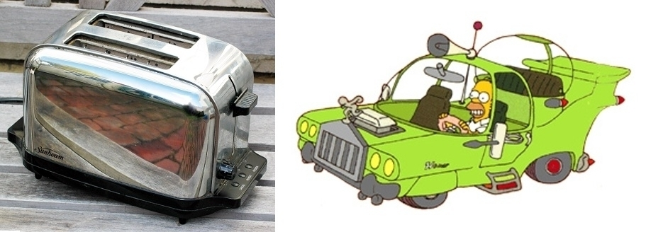

CONSISTENCIA:

La consistencia en el diseño