**Objective**

In this challenge, we implement a calculator that uses binary numbers. Check out the attached tutorial for learning materials.

**Task**

Implement a simple calculator that performs the following operations on binary numbers: addition, subtraction, multiplication, and division. Note that division operation must be integer division only; for example,1001/100=10,1110/101=10 and 101/1=101 .

The calculator's initial state must look like this:

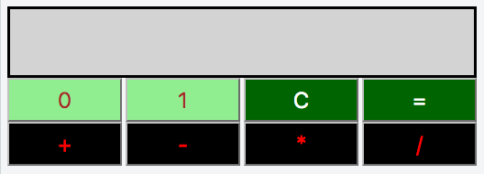

* *Element IDs. Each element in the document must have an id, specified below:*

| **innerHTML** | **id** | **Description/Behavior** |
| --- | --- | --- |
|  | res | Contains the result of button presses. |
|  | btns | A button container that displays all eight calculator buttons. |
| 0 | btn0 | A button expressing binary digit . |
| 1 | btn1 | A button expressing binary digit . |
| C | btnClr | A button to clear the contents of . |
| = | btnEql | A button to evaluate the contents of the expression in . |
| + | btnSum | A button for the addition operation. |
| - | btnSub | A button for the subtraction operation. |
| * | btnMul | A button for the multiplication operation. |
| / | btnDiv | A button for the integer division operation. |

* *Styling.* The document's elements must have the following styles:
  + body has a width of 33%.
  + res has a background-color of lightgray, a border that is solid, a height of 48px, and a font-size of 20px.
  + btn0 and btn1 have a background-color of lightgreen and a color of brown.
  + btnClr and btnEql have a background-color of darkgreen and a color of white.
  + btnSum, btnSub, btnMul, and btnDiv have a background-color of black, a color of red.
  + All the buttons in btns have a width of 25%, a height of 36px, a font-size of 18px, margin of 0px, and float value left.

The .js and .css files are in different directories, so use the *link* tag to provide the CSS file path and the *script* tag to provide the JS file path:

<html>

<head>

<link rel="stylesheet" href="css/binaryCalculator.css" type="text/css">

</head>

<body>

<script src="js/binaryCalculator.js" type="text/javascript"></script>

</body>

</html>

