Soluções para Rifa
project Management plan
Version <1.0>
<25/11/2009>

VERSION HISTORY
Version # | Implemented  By | Revision  Date | Approved  By | Approval  Date | Reason
1.0 | M. Túlio | 25/11/2009 | Dosea | 26/11/2009 | Primera versão do Documento

TABLE OF CONTENTS
1 Introduction 3
1.1 Purpose of Project Management Plan 3
2 Executive Summary of Project Charter 3
3 Scope Management 3
3.1 Work Breakdown Structure 3
3.2 Change Control Management 3
4 Schedule/Time Management 3
4.1 Milestones 3
4.2 Project Schedule 4
5 Cost/Budget Management 4
6 Human Resource Management 4
7 Risk Management 4

Introduction

Purpose of Project Management Plan
O publico alvo, ou interessados, do projeto Soluções para Rifa são os patrocinadores e a equipe do projeto.

Executive Summary of Project Charter
O projeto foi aprovado pelos stackhlodes o qual está ciente das prioridades, das restrições do projeto, do tempo de execução, dos riscos, dentre outros, contidos no Plano de gerenciamento do Projeto.

Scope Management
Plano de Gerenciamento de Escopo

Work Breakdown Structure

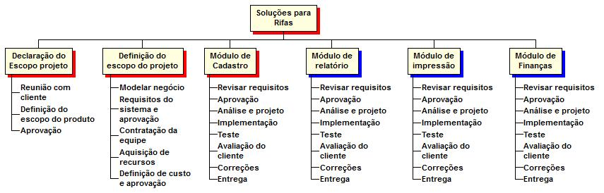

Change Control Management
Plano de Gerenciamento das Configurações

Schedule/Time Management

Milestones
The table below lists the milestones for this project, along with their estimated completion timeframe.
Milestones | Estimated Completion Timeframe
Plano de Gerenciamento do Projeto | Atualizado Semanalmente
Reuniões com Stackholdes | Semanalmente

Project Schedule
Cronograma

Cost/Budget Management
Planilha de custos

Human Resource Management
Planilha de custos

Risk Management
Plano de Gerenciamento de Riscos

Appendix A: Project Management Plan Approval
The undersigned acknowledge they have reviewed the <Project Name> Project Management Plan and agree with the approach it presents. Changes to this Project Management Plan will be coordinated with and approved by the undersigned or their designated representatives.
[List the individuals whose signatures are desired. Examples of such individuals are Business Steward, Project Manager or Project Sponsor. Add additional lines for signature as necessary. Although signatures are desired, they are not always required to move forward with the practices outlined within this document.]

Signature: |  | Date:
Print Name:
Title:
Role:

Signature: |  | Date:
Print Name:
Title:
Role:

Signature: |  | Date:
Print Name:
Title:
Role:

APPENDIX B: REFERENCES
[Insert the name, version number, description, and physical location of any documents referenced in this document. Add rows to the table as necessary.]
The following table summarizes the documents referenced in this document.
Document Name and Version | Description | Location
<Document Name and Version Number> | [Provide description of the document] | <URL or Network path where document is located>

APPENDIX C: KEY TERMS
[Insert terms and definitions used in this document. Add rows to the table as necessary. Follow the link below to for definitions of project management terms and acronyms used in this and other documents.
http://www2.cdc.gov/cdcup/library/other/help.htm
The following table provides definitions for terms relevant to this document.
Term | Definition
[Insert Term] | [Provide definition of the term used in this document.]
[Insert Term] | [Provide definition of the term used in this document.]
[Insert Term] | [Provide definition of the term used in this document.]

APPENDIX D: SUMMARY OF SPENDING
[You may double-click on the table to edit it according to the information applicable to this project.]
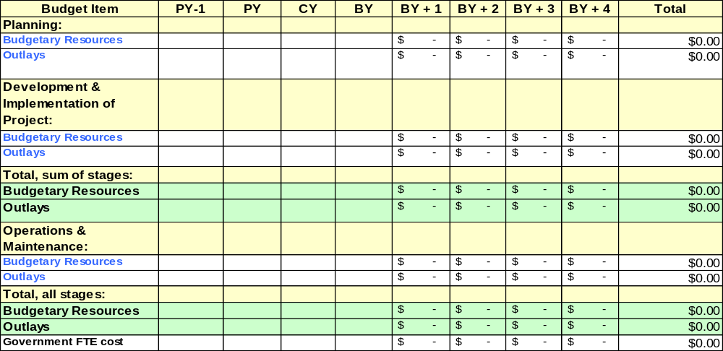PY: Previous Year; CY: Current Year; BY: Budget Year

