Ejercicios de INNER JOIN en SQLite
INNER JOIN con 2 tablas
- Obtener los nombres de los clientes y las fechas de sus pedidos.
Consulta SQL:
```sql
-- SELECT Customers.CustomerName, Orders.OrderDate
FROM Customers
INNER JOIN Orders ON Customers.CustomerID = Orders.CustomerID;
```
Captura del resultado:
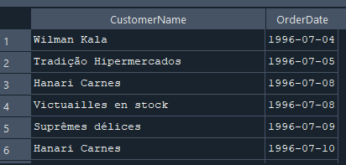
2. Listar los productos y sus respectivas categorías.
Consulta SQL:
```sql
-- SELECT Products.ProductName, Categories.CategoryName
FROM Products
INNER JOIN Categories ON Products.CategoryID = Categories.CategoryID;
```
Captura del resultado:
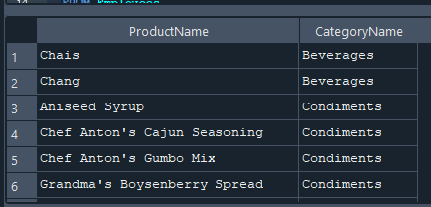
3.Mostrar los nombres de los empleados y las órdenes que gestionaron.
Consulta SQL:
```sql
-- SELECT Employees.FirstName, Employees.LastName, Orders.OrderID
FROM Employees
INNER JOIN Orders ON Employees.EmployeeID = Orders.EmployeeID;
```
Captura del resultado:
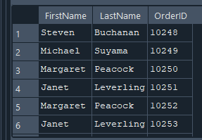
4.Obtener los nombres de los productos y los nombres de sus proveedores.

Consulta SQL:
```sql
SELECT Products.ProductName, Suppliers.SupplierName
FROM Products
INNER JOIN Suppliers ON Products.SupplierID = Suppliers.SupplierID;```
Captura del resultado:
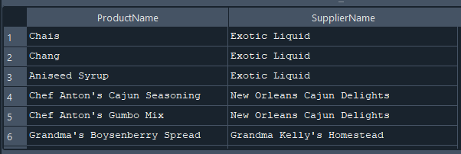
5. Listar los pedidos y los métodos de envío utilizados.
Consulta SQL:
```sql
-- SELECT Orders.OrderID, Shippers.ShipperName
FROM Orders
INNER JOIN Shippers ON Orders.ShipperID = Shippers.ShipperID;```
Captura del resultado:
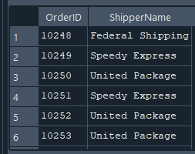
6. Mostrar los detalles de cada pedido y los productos correspondientes.
Consulta SQL:
```sql
-- SELECT OrderDetails.OrderID, Products.ProductName, OrderDetails.Quantity
FROM OrderDetails
INNER JOIN Products ON OrderDetails.ProductID = Products.ProductID;```
Captura del resultado:
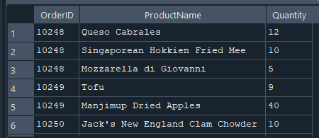
7. Listar los nombres de los clientes junto con los empleados que atendieron sus pedidos.
.Consulta SQL:
```sql
-- SELECT Customers.CustomerName, Employees.FirstName, Employees.LastName
FROM Orders
INNER JOIN Customers ON Orders.CustomerID = Customers.CustomerID
INNER JOIN Employees ON Orders.EmployeeID = Employees.EmployeeID;
```
Captura del resultado:
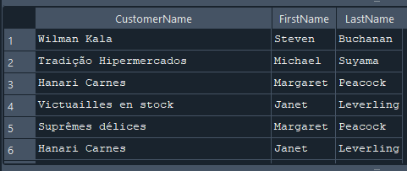
8. Obtener el nombre de los empleados y las órdenes que han atendido.
Consulta SQL:
```sql
--SELECT Employees.FirstName, Employees.LastName, Orders.OrderID
FROM Employees
INNER JOIN Orders ON Employees.EmployeeID = Orders.EmployeeID;
```
Captura del resultado:
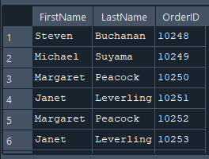
9. Mostrar los productos y sus respectivas unidades de medida.
Consulta SQL:
```sql
-- SELECT Products.ProductName, Products.Unit
FROM Products;```
Captura del resultado:
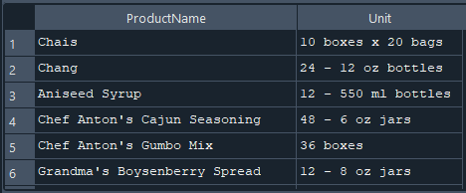
10. Listar los proveedores y los productos que suministran.
Consulta SQL:
```sql
-- SELECT Suppliers.SupplierName, Products.ProductName
FROM Suppliers
INNER JOIN Products ON Suppliers.SupplierID = Products.SupplierID;```
Captura del resultado:
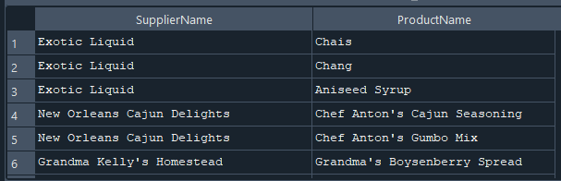
INNER JOIN con 3 tablas
1. Obtener los nombres de los clientes, los pedidos y las fechas en que se realizaron.
Consulta SQL:
```sql
--SELECT Customers.CustomerName, Orders.OrderID, Orders.OrderDate
FROM Customers
INNER JOIN Orders ON Customers.CustomerID = Orders.CustomerID;
```
Captura del resultado:
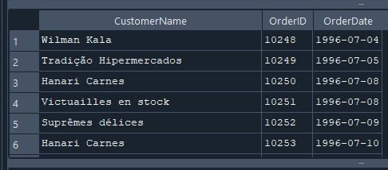

2. Listar los productos, sus categorías y los proveedores.
Consulta SQL:
```sql
-- SELECT Products.ProductName, Categories.CategoryName, Suppliers.SupplierName
FROM Products
INNER JOIN Categories ON Products.CategoryID = Categories.CategoryID
INNER JOIN Suppliers ON Products.SupplierID = Suppliers.SupplierID;
```
Captura del resultado:
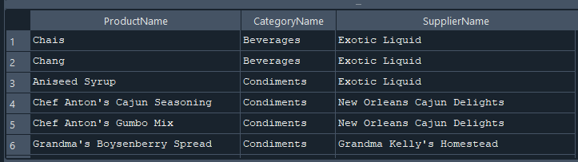
3. Mostrar los empleados, los pedidos que gestionaron y los clientes correspondientes.
Consulta SQL:
```sql
-- SELECT Employees.FirstName, Employees.LastName, Orders.OrderID, Customers.CustomerName
FROM Employees
INNER JOIN Orders ON Employees.EmployeeID = Orders.EmployeeID
INNER JOIN Customers ON Orders.CustomerID = Customers.CustomerID;
```
Captura del resultado:
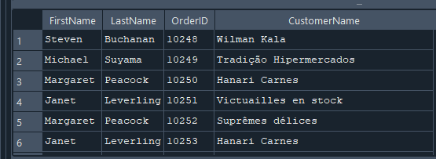
4. Obtener los detalles de los pedidos junto con los productos y sus categorías.
Consulta SQL:
```sql
--SELECT OrderDetails.OrderID, Products.ProductName, Categories.CategoryName, OrderDetails.Quantity
FROM OrderDetails
INNER JOIN Products ON OrderDetails.ProductID = Products.ProductID
INNER JOIN Categories ON Products.CategoryID = Categories.CategoryID;
```
Captura del resultado:
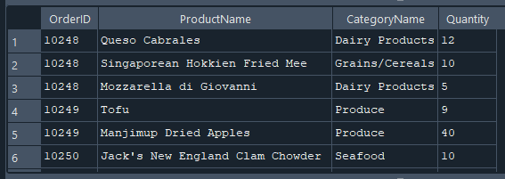
5. Listar los pedidos, los clientes y los empleados involucrados.
Consulta SQL:
```sql
-- SELECT Orders.OrderID, Customers.CustomerName, Employees.FirstName, Employees.LastName
FROM Orders
INNER JOIN Customers ON Orders.CustomerID = Customers.CustomerID
INNER JOIN Employees ON Orders.EmployeeID = Employees.EmployeeID;```
Captura del resultado:
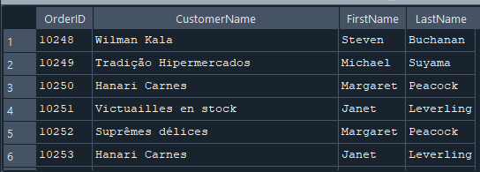
6. Mostrar los productos, sus precios y los proveedores que los venden.
Consulta SQL:
```sql
-- SELECT Products.ProductName, Products.Price, Suppliers.SupplierName
FROM Products
INNER JOIN Suppliers ON Products.SupplierID = Suppliers.SupplierID;```
Captura del resultado:
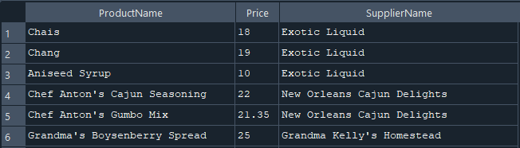
7. Obtener los pedidos, los productos involucrados y sus cantidades.
Consulta SQL:
```sql
-- SELECT Orders.OrderID, Products.ProductName, OrderDetails.Quantity
FROM Orders
INNER JOIN OrderDetails ON Orders.OrderID = OrderDetails.OrderID
INNER JOIN Products ON OrderDetails.ProductID = Products.ProductID;
```
Captura del resultado:
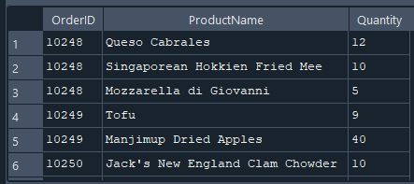
8. Listar los empleados, los pedidos y los métodos de envío.
Consulta SQL:
```sql
-- SELECT Employees.FirstName, Employees.LastName, Orders.OrderID, Shippers.ShipperName
FROM Employees
INNER JOIN Orders ON Employees.EmployeeID = Orders.EmployeeID
INNER JOIN Shippers ON Orders.ShipperID = Shippers.ShipperID;
```
Captura del resultado:
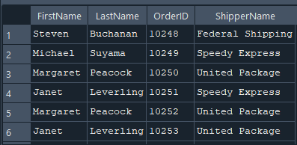
9. Mostrar los clientes, sus pedidos y los productos que compraron.
Consulta SQL:
```sql
-- SELECT Customers.CustomerName, Orders.OrderID, Products.ProductName
FROM Customers
INNER JOIN Orders ON Customers.CustomerID = Orders.CustomerID
INNER JOIN OrderDetails ON Orders.OrderID = OrderDetails.OrderID
INNER JOIN Products ON OrderDetails.ProductID = Products.ProductID;```
Captura del resultado:
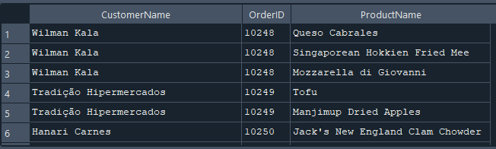
10. Obtener los pedidos, los productos y las categorías de cada producto.
Consulta SQL:
```sql
-- SELECT Orders.OrderID, Products.ProductName, Categories.CategoryName
FROM Orders
INNER JOIN OrderDetails ON Orders.OrderID = OrderDetails.OrderID
INNER JOIN Products ON OrderDetails.ProductID = Products.ProductID
INNER JOIN Categories ON Products.CategoryID = Categories.CategoryID;```
Captura del resultado:
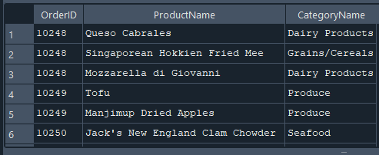
INNER JOIN con 5 tablas
1. Listar los pedidos con la información del cliente, empleado, productos y cantidades.
Consulta SQL:
```sql
-- SELECT Orders.OrderID, Customers.CustomerName, Employees.FirstName, Employees.LastName,
Products.ProductName, OrderDetails.Quantity
FROM Orders
INNER JOIN Customers ON Orders.CustomerID = Customers.CustomerID
INNER JOIN Employees ON Orders.EmployeeID = Employees.EmployeeID
INNER JOIN OrderDetails ON Orders.OrderID = OrderDetails.OrderID
INNER JOIN Products ON OrderDetails.ProductID = Products.ProductID;```
Captura del resultado:
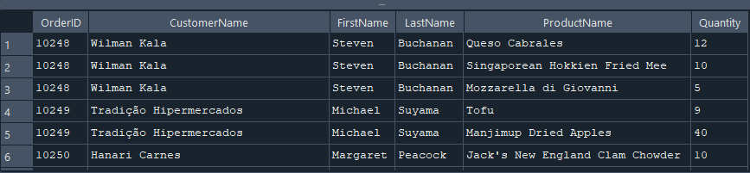
2. Obtener los nombres de los productos, sus categorías, proveedores y pedidos en los que
se incluyen.
Consulta SQL:
```sql
-- SELECT Products.ProductName, Categories.CategoryName, Suppliers.SupplierName, Orders.OrderID
FROM Products
INNER JOIN Categories ON Products.CategoryID = Categories.CategoryID
INNER JOIN Suppliers ON Products.SupplierID = Suppliers.SupplierID
INNER JOIN OrderDetails ON Products.ProductID = OrderDetails.ProductID
INNER JOIN Orders ON OrderDetails.OrderID = Orders.OrderID;
```
Captura del resultado:
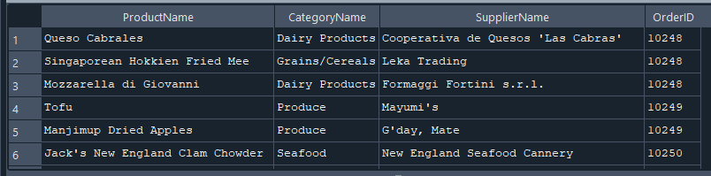
3. Mostrar los pedidos con información del cliente, empleado, transportista y detalles del
pedido.
Consulta SQL:
```sql
-- SELECT Orders.OrderID, Customers.CustomerName, Employees.FirstName, Employees.LastName,
Shippers.ShipperName, OrderDetails.Quantity
FROM Orders
INNER JOIN Customers ON Orders.CustomerID = Customers.CustomerID
INNER JOIN Employees ON Orders.EmployeeID = Employees.EmployeeID
INNER JOIN Shippers ON Orders.ShipperID = Shippers.ShipperID
INNER JOIN OrderDetails ON Orders.OrderID = OrderDetails.OrderID;);
```
Captura del resultado:
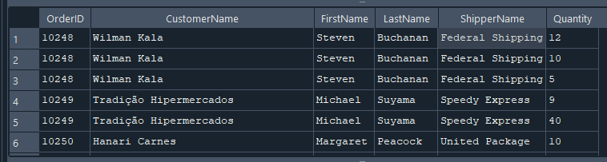
4. Obtener una lista de pedidos con detalles completos de cliente, empleado y productos.
Consulta SQL:
```sql
-- SELECT Orders.OrderID, Customers.CustomerName, Employees.FirstName, Employees.LastName,
Products.ProductName, OrderDetails.Quantity
FROM Orders
INNER JOIN Customers ON Orders.CustomerID = Customers.CustomerID
INNER JOIN Employees ON Orders.EmployeeID = Employees.EmployeeID
INNER JOIN OrderDetails ON Orders.OrderID = OrderDetails.OrderID
INNER JOIN Products ON OrderDetails.ProductID = Products.ProductID;
```
Captura del resultado:
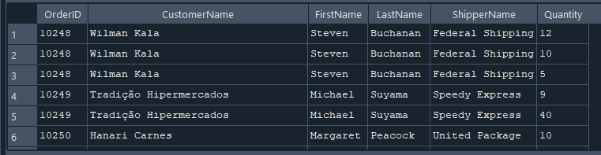
5. Mostrar información de pedidos incluyendo datos del producto y la categoría.
Consulta SQL:
```sql
-- SELECT Orders.OrderID, Products.ProductName, Categories.CategoryName
FROM Orders
INNER JOIN OrderDetails ON Orders.OrderID = OrderDetails.OrderID
INNER JOIN Products ON OrderDetails.ProductID = Products.ProductID
INNER JOIN Categories ON Products.CategoryID = Categories.CategoryID;```
Captura del resultado:
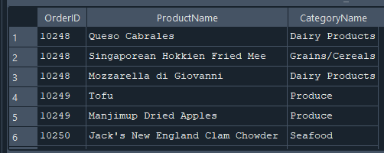
6. Listar los clientes, los empleados que gestionaron su pedido, los productos comprados y
sus proveedores.
Consulta SQL:
```sql
-- SELECT Customers.CustomerName, Employees.FirstName, Employees.LastName,
Products.ProductName, Suppliers.SupplierName
FROM Orders
INNER JOIN Customers ON Orders.CustomerID = Customers.CustomerID
INNER JOIN Employees ON Orders.EmployeeID = Employees.EmployeeID
INNER JOIN OrderDetails ON Orders.OrderID = OrderDetails.OrderID
INNER JOIN Products ON OrderDetails.ProductID = Products.ProductID
INNER JOIN Suppliers ON Products.SupplierID = Suppliers.SupplierID;```
Captura del resultado:
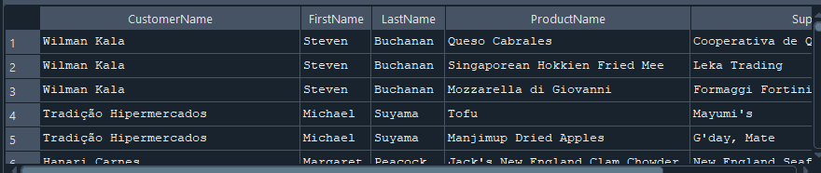
7. Obtener información de los pedidos con los clientes y los productos vendidos.
Consulta SQL:
```sql
--SELECT Orders.OrderID, Customers.CustomerName, Products.ProductName, OrderDetails.Quantity
FROM Orders
INNER JOIN Customers ON Orders.CustomerID = Customers.CustomerID
INNER JOIN OrderDetails ON Orders.OrderID = OrderDetails.OrderID
INNER JOIN Products ON OrderDetails.ProductID = Products.ProductID;
```
Captura del resultado:
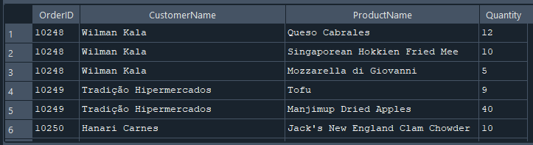
8. Mostrar los pedidos, los clientes y los métodos de envío junto con los productos
comprados.
Consulta SQL:
```sql
-- SELECT Orders.OrderID, Customers.CustomerName, Shippers.ShipperName, Products.ProductName
FROM Orders
INNER JOIN Customers ON Orders.CustomerID = Customers.CustomerID
INNER JOIN Shippers ON Orders.ShipperID = Shippers.ShipperID
INNER JOIN OrderDetails ON Orders.OrderID = OrderDetails.OrderID
INNER JOIN Products ON OrderDetails.ProductID = Products.ProductID;
```
Captura del resultado:
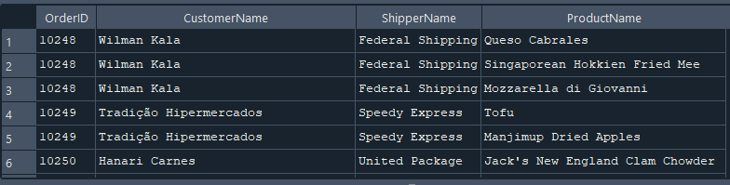
9. Obtener una lista de productos con sus categorías, proveedores y detalles en los pedidos.
Consulta SQL:
```sql
-- SELECT Products.ProductName, Categories.CategoryName, Suppliers.SupplierName, OrderDetails.Quantity
FROM Products
INNER JOIN Categories ON Products.CategoryID = Categories.CategoryID
INNER JOIN Suppliers ON Products.SupplierID = Suppliers.SupplierID
INNER JOIN OrderDetails ON Products.ProductID = OrderDetails.ProductID
INNER JOIN Orders ON OrderDetails.OrderID = Orders.OrderID;```
Captura del resultado:
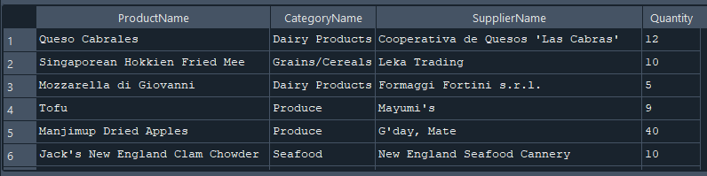
10. Mostrar los empleados, los pedidos, los clientes, los productos y los métodos de envío.
Consulta SQL:
```sql
-- SELECT Employees.FirstName, Employees.LastName, Orders.OrderID, Customers.CustomerName,
Products.ProductName, Shippers.ShipperName
FROM Employees
INNER JOIN Orders ON Employees.EmployeeID = Orders.EmployeeID
INNER JOIN Customers ON Orders.CustomerID = Customers.CustomerID
INNER JOIN OrderDetails ON Orders.OrderID = OrderDetails.OrderID
INNER JOIN Products ON OrderDetails.ProductID = Products.ProductID
INNER JOIN Shippers ON Orders.ShipperID = Shippers.ShipperID;```
Captura del resultado:
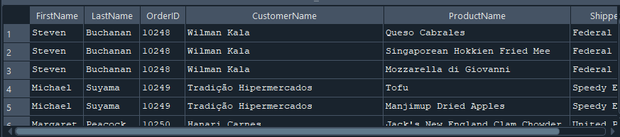
INNER JOIN con 8 tablas
1. Obtener una lista de pedidos con información completa del cliente, empleado,
transportista y productos involucrados.
Consulta SQL:
```sql
-- SELECT Orders.OrderID, Customers.CustomerName, Employees.FirstName, Employees.LastName,
Shippers.ShipperName, Products.ProductName, Categories.CategoryName, Suppliers.SupplierName
FROM Orders
INNER JOIN Customers ON Orders.CustomerID = Customers.CustomerID
INNER JOIN Employees ON Orders.EmployeeID = Employees.EmployeeID
INNER JOIN Shippers ON Orders.ShipperID = Shippers.ShipperID
INNER JOIN OrderDetails ON Orders.OrderID = OrderDetails.OrderID
INNER JOIN Products ON OrderDetails.ProductID = Products.ProductID
INNER JOIN Categories ON Products.CategoryID = Categories.CategoryID
INNER JOIN Suppliers ON Products.SupplierID = Suppliers.SupplierID;```
Captura del resultado:
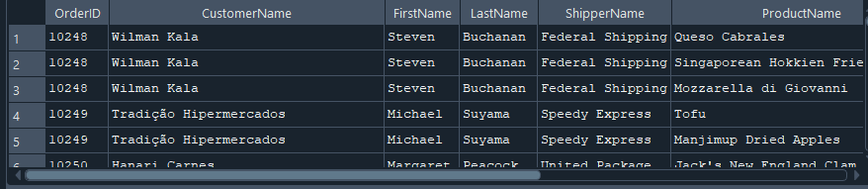
2. Mostrar los clientes con detalles de sus pedidos y los productos adquiridos, junto con los
proveedores.
Consulta SQL:
```sql
-- SELECT Customers.CustomerName, Orders.OrderID, OrderDetails.Quantity,
Products.ProductName, Suppliers.SupplierName
FROM Customers
INNER JOIN Orders ON Customers.CustomerID = Orders.CustomerID
INNER JOIN OrderDetails ON Orders.OrderID = OrderDetails.OrderID
INNER JOIN Products ON OrderDetails.ProductID = Products.ProductID
INNER JOIN Categories ON Products.CategoryID = Categories.CategoryID
INNER JOIN Suppliers ON Products.SupplierID = Suppliers.SupplierID
INNER JOIN Employees ON Orders.EmployeeID = Employees.EmployeeID
INNER JOIN Shippers ON Orders.ShipperID = Shippers.ShipperID;```
Captura del resultado:
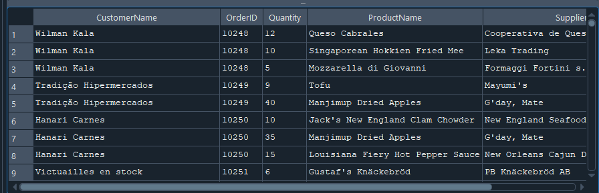
3. Obtener una vista de los empleados y todos los pedidos que han atendido con detalles
completos.
Consulta SQL:
```sql
-- SELECT Employees.FirstName, Employees.LastName, Orders.OrderID, Customers.CustomerName,
Products.ProductName, OrderDetails.Quantity, Shippers.ShipperName
FROM Employees
INNER JOIN Orders ON Employees.EmployeeID = Orders.EmployeeID
INNER JOIN Customers ON Orders.CustomerID = Customers.CustomerID
INNER JOIN OrderDetails ON Orders.OrderID = OrderDetails.OrderID
INNER JOIN Products ON OrderDetails.ProductID = Products.ProductID
INNER JOIN Categories ON Products.CategoryID = Categories.CategoryID
INNER JOIN Suppliers ON Products.SupplierID = Suppliers.SupplierID
INNER JOIN Shippers ON Orders.ShipperID = Shippers.ShipperID;
```
Captura del resultado:
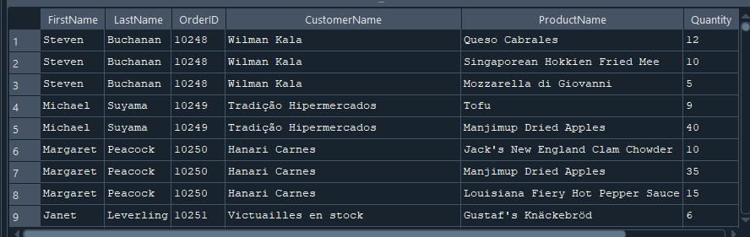
4. Mostrar los detalles de pedidos incluyendo el cliente, empleado, productos y proveedores.
Consulta SQL:
```sql
-- SELECT Orders.OrderID, Customers.CustomerName, Employees.FirstName, Employees.LastName,
Products.ProductName, Suppliers.SupplierName, OrderDetails.Quantity
FROM Orders
INNER JOIN Customers ON Orders.CustomerID = Customers.CustomerID
INNER JOIN Employees ON Orders.EmployeeID = Employees.EmployeeID
INNER JOIN OrderDetails ON Orders.OrderID = OrderDetails.OrderID
INNER JOIN Products ON OrderDetails.ProductID = Products.ProductID
INNER JOIN Categories ON Products.CategoryID = Categories.CategoryID
INNER JOIN Suppliers ON Products.SupplierID = Suppliers.SupplierID
INNER JOIN Shippers ON Orders.ShipperID = Shippers.ShipperID;```
Captura del resultado:
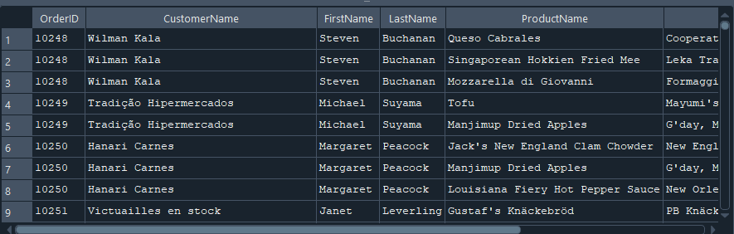
5. Listar todos los pedidos con información detallada de clientes, empleados, productos y
métodos de envío.
Consulta SQL:
```sql
-- SELECT Orders.OrderID, Customers.CustomerName, Employees.FirstName, Employees.LastName,
Products.ProductName, Categories.CategoryName, Shippers.ShipperName
FROM Orders
INNER JOIN Customers ON Orders.CustomerID = Customers.CustomerID
INNER JOIN Employees ON Orders.EmployeeID = Employees.EmployeeID
INNER JOIN OrderDetails ON Orders.OrderID = OrderDetails.OrderID
INNER JOIN Products ON OrderDetails.ProductID = Products.ProductID
INNER JOIN Categories ON Products.CategoryID = Categories.CategoryID
INNER JOIN Suppliers ON Products.SupplierID = Suppliers.SupplierID
INNER JOIN Shippers ON Orders.ShipperID = Shippers.ShipperID;```
Captura del resultado:
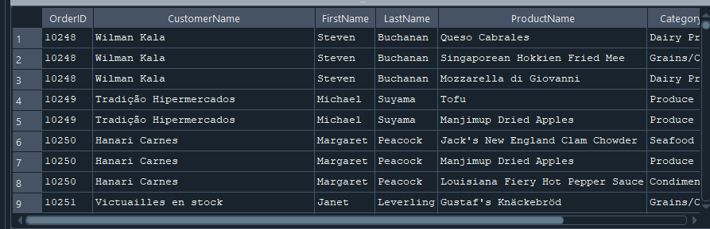
6. Obtener los detalles de pedidos con los productos, proveedores, clientes y empleados
involucrados.
Consulta SQL:
```sql
-- SELECT Orders.OrderID, Customers.CustomerName, Employees.FirstName, Employees.LastName,
Products.ProductName, Suppliers.SupplierName, OrderDetails.Quantity
FROM Orders
INNER JOIN Customers ON Orders.CustomerID = Customers.CustomerID
INNER JOIN Employees ON Orders.EmployeeID = Employees.EmployeeID
INNER JOIN OrderDetails ON Orders.OrderID = OrderDetails.OrderID
INNER JOIN Products ON OrderDetails.ProductID = Products.ProductID
INNER JOIN Categories ON Products.CategoryID = Categories.CategoryID
INNER JOIN Suppliers ON Products.SupplierID = Suppliers.SupplierID
INNER JOIN Shippers ON Orders.ShipperID = Shippers.ShipperID;```
Captura del resultado:
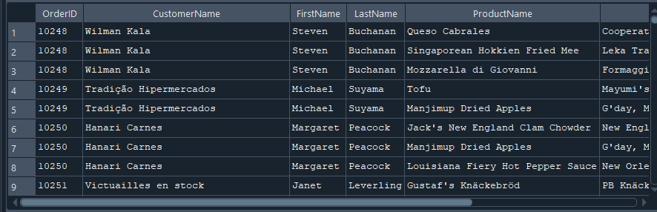
7. Mostrar una lista completa de los pedidos con datos del cliente, empleado, producto,
categoría y proveedor.
Consulta SQL:
```sql
-- SELECT Orders.OrderID, Customers.CustomerName, Employees.FirstName, Employees.LastName,
Products.ProductName, Categories.CategoryName, Suppliers.SupplierName
FROM Orders
INNER JOIN Customers ON Orders.CustomerID = Customers.CustomerID
INNER JOIN Employees ON Orders.EmployeeID = Employees.EmployeeID
INNER JOIN OrderDetails ON Orders.OrderID = OrderDetails.OrderID
INNER JOIN Products ON OrderDetails.ProductID = Products.ProductID
INNER JOIN Categories ON Products.CategoryID = Categories.CategoryID
INNER JOIN Suppliers ON Products.SupplierID = Suppliers.SupplierID
INNER JOIN Shippers ON Orders.ShipperID = Shippers.ShipperID;```
Captura del resultado:
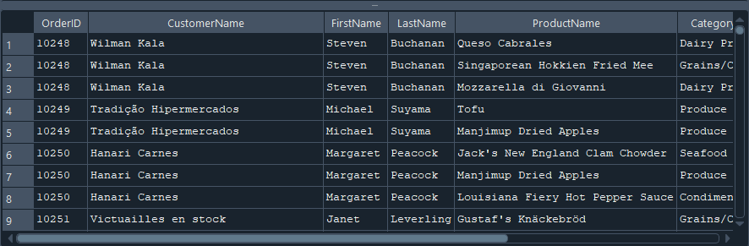
8. Listar las órdenes con detalles completos de los clientes, empleados, transportistas,
productos y sus categorías.
Consulta SQL:
```sql
-- SELECT Orders.OrderID, Customers.CustomerName, Employees.FirstName, Employees.LastName,
Shippers.ShipperName, Products.ProductName, Categories.CategoryName
FROM Orders
INNER JOIN Customers ON Orders.CustomerID = Customers.CustomerID
INNER JOIN Employees ON Orders.EmployeeID = Employees.EmployeeID
INNER JOIN Shippers ON Orders.ShipperID = Shippers.ShipperID
INNER JOIN OrderDetails ON Orders.OrderID = OrderDetails.OrderID
INNER JOIN Products ON OrderDetails.ProductID = Products.ProductID
INNER JOIN Categories ON Products.CategoryID = Categories.CategoryID
INNER JOIN Suppliers ON Products.SupplierID = Suppliers.SupplierID;```
Captura del resultado:
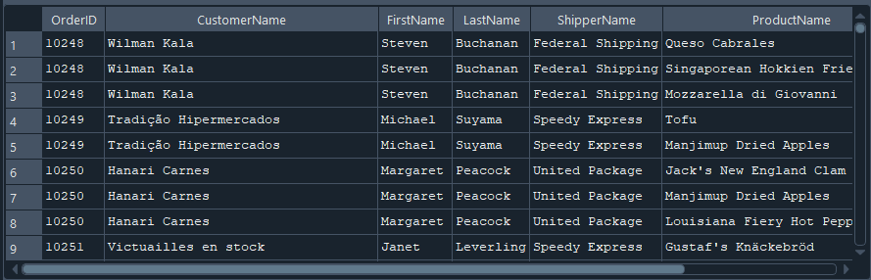
9. Obtener una vista consolidada de la base de datos con pedidos, clientes, empleados,
productos, proveedores y transportistas.
Consulta SQL:
```sql
-- SELECT Orders.OrderID, Customers.CustomerName, Employees.FirstName, Employees.LastName,
Products.ProductName, Suppliers.SupplierName, Shippers.ShipperName
FROM Orders
INNER JOIN Customers ON Orders.CustomerID = Customers.CustomerID
INNER JOIN Employees ON Orders.EmployeeID = Employees.EmployeeID
INNER JOIN OrderDetails ON Orders.OrderID = OrderDetails.OrderID
INNER JOIN Products ON OrderDetails.ProductID = Products.ProductID
INNER JOIN Categories ON Products.CategoryID = Categories.CategoryID
INNER JOIN Suppliers ON Products.SupplierID = Suppliers.SupplierID
INNER JOIN Shippers ON Orders.ShipperID = Shippers.ShipperID;```
Captura del resultado:
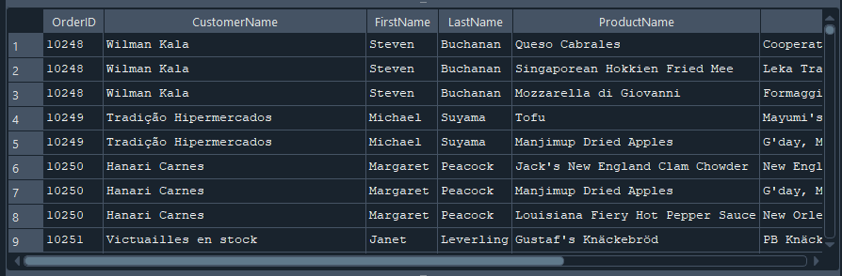
10. Mostrar la relación completa entre órdenes, clientes, empleados, productos,
proveedores, transportistas y detalles del pedido.
Consulta SQL:
```sql
-- SELECT Orders.OrderID, Customers.CustomerName, Employees.FirstName AS EmployeeFirstName,
Employees.LastName AS EmployeeLastName, Shippers.ShipperName, Products.ProductName,
Categories.CategoryName, Suppliers.SupplierName, OrderDetails.Quantity, Products.Price
FROM Orders
INNER JOIN Customers ON Orders.CustomerID = Customers.CustomerID
INNER JOIN Employees ON Orders.EmployeeID = Employees.EmployeeID
INNER JOIN Shippers ON Orders.ShipperID = Shippers.ShipperID
INNER JOIN OrderDetails ON Orders.OrderID = OrderDetails.OrderID
INNER JOIN Products ON OrderDetails.ProductID = Products.ProductID
INNER JOIN Categories ON Products.CategoryID = Categories.CategoryID
INNER JOIN Suppliers ON Products.SupplierID = Suppliers.SupplierID;
```
Captura del resultado:
