 [Translated from Spanish to English - www.onlinedoctranslator.com](https://www.onlinedoctranslator.com/en/?utm_source=onlinedoctranslator&utm_medium=docx&utm_campaign=attribution)



**University of the Armed Forces “ESPE”**

**Specification of**

**Software Requirements**



**MEDICAL CONTROL SYSTEM FOR NATURAL PEOPLE**

Members:

SANCHEZ JHON ALEXANDER GUITAR

GUZMAN LOPEZ JOSE DAVID

INSUASTI LOPEZ JONATHAN ESTEBA

LANDAZURI SEGOVIA MATEO ISRAEL

LINCANGO CRIOLLO JOSE DANIEL



**Index**

1. **Introduction**

1.1. Purpose

1.2. scope and scope

1.3. Personnel Involved

1.4. Definitions, acronyms and abbreviations Definitions

1.5. Summary

1. **General description**

2.1. Desktop App Perspective

2.2. product functionality

2.3 User characteristics

2.4 Restrictions

2.5 Assumptions and dependencies

2.6 Foreseeable evolution of the system

1. **Specific requirements**

3.1 Functional Requirements

3.2. Non-Functional Requirements

1. **Diagram Use Cases**

**5. Application of the Medical Service Registry of Officials**

**6.User interface**

**1. Introduction.**

“Today companies and institutions handle exorbitant amounts of information, hospitals and clinics today are not far behind.

They interact with a large number of people on a daily basis, including staff, doctors and patients.

The security and legitimacy of this information is essential in any of these establishments, for which today it is essential that the files have computerized services.

Thanks to the computerized data of Data Registration, we will be able to have the relationship between the medical record number and the patient's name and surnames through the Patient Master File. With this we get the 'location of the medical record by surnames and name and record number clinic', to facilitate and improve the attention of the clinic.

This program is based on an interface for better data management in the cloud, since without a system it is easy for us to understand the importance of having a good clinical record. It is also of great importance from a legal point of view.”

The medical appointment system aims to achieve with users:

* Identification of patients treated.
* Reduction of errors in the handling of information.
* Record of patient signs and symptoms.
* Record of care acts and decisions made by doctors.
* Appropriate presentation and prescription of care instructions and reports for patients.
* Progressive creation of databases where medical staff can access to help in the clinical decision-making process.

**1.1 Purpose**

* Schedule a medical appointment system through a menu with an interface to register patients and doctors connected to a database to facilitate the management of clinic data.

1. Control of registered patients
2. Control of the doctors assigned to each patient
3. Registration of medical history in a database
4. Date and time of medical appointments
5. Save the data of the administrative part and the patients
6. Delete any recorded data in case an error has occurred

**1.2 Scope and reach**

Due to its main characteristics and in relation to the medical system to which it is focused, the medical appointment system will be called "MedicalPro".

And it is aimed at medical centers to facilitate and improve patient care

* The cost desktop program:
* Login
* Password
* User
* Menu
* patients
* Patient Registration
* Administrative Staff Registry
* Staff registration (Secretary/Doctors)
* Delete patients/administrative
* Save patients/administrative
* Upload the recorded data to a database

**1.3. Personnel Involved**

|  |  |
| --- | --- |
| **Names:** | **john guitar** |
| **Role** | **project leader** |
| **Professional category** | **Engineering student** |
| **Responsibility** | **Review of the general project both the documentation and the code** |
| **Contact information** | **jaguitarra@espe.edu.ec** |
| **Approval** | **YES** |

|  |  |
| --- | --- |
| **Names:** | **daniel lincango** |
| **Role** | **Collaborator** |
| **Professional category** | **Engineering student** |
| **Responsibility** | **Code execution, documentation help** |
| **Contact information** | **jdlincango@espe.edu.ed** |
| **Approval** | **YES** |

|  |  |
| --- | --- |
| **Names:** | **Matthew Landasuri** |
| **Role** | **Code execution, documentation help** |
| **Professional category** | **Engineering student** |
| **Responsibility** | **project review** |
| **Contact information** | **milandazuri@espe.edu.ec** |
| **Approval** | **YES** |

|  |  |
| --- | --- |
| **Names:** | **Jonathan Insuasti** |
| **Role** | **Collaborator** |
| **Professional category** | **Engineering student** |
| **Responsibility** | **Code execution, documentation help** |
| **Contact information** |  |
| **Approval** | **YES** |

|  |  |
| --- | --- |
| **Names:** | **David Guzman** |
| **Role** | **Collaborator** |
| **Professional category** | **Engineering student** |
| **Responsibility** | **Code execution, documentation help** |
| **Contact information** | **jdguzman5@espe.edu.ec** |
| **Approval** | **YES** |

**1.4 Definitions, acronyms and abbreviations Definitions**

|  |  |
| --- | --- |
| Concept | Definition |
| desktop application | A desktop application is one that is installed on the computer or storage system (USB) and we can run it without internet in our operating system, unlike applications in the cloud that are on another computer (server) that we access via network or internet |
| Database | A database is a set of data belonging to the same context and systematically stored for later use. In this sense; A library can be considered a database composed mostly of documents and texts printed on paper and indexed for consultation. |

**1.6 Summary**

“This work presents a solution to medical units (clinics and hospitals) in the control of appointments as well as the management of clinical history through a desktop application, with this it will allow to better improve the process of appointment control and history management. clinical.

The development and implementation of the desktop application contains the following requirements that we are going to mention: administration, appointment scheduling, diagnosis and medical treatment, registration of patients and administrative personnel, database The main objective is to develop a desktop application so that can be accessed from any computer (laptop or PC) that has an internet connection. It was concluded with the desktop application to have better control in the scheduling of medical appointments and registration of clinical history of patients that favor the management of the medical area. The medical staff, after the corresponding training, proceeded to use the desktop application according to the scope established in the collection of information,”

**2. Overview**

**2.1. Desktop App Perspective**

The "MedicalPro" desktop application is an independent software product, which will allow access to authorized persons with a username and password, the display of the menu, the interface to access the menu; On the part of the user application, it has your registration, medical history and information such as your ID number.

**2.2. Product functionality**

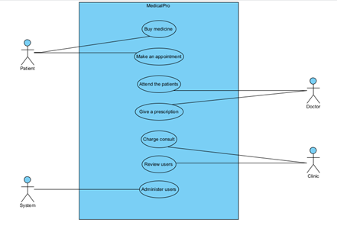

**2.3 User characteristics**

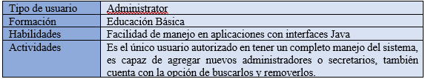

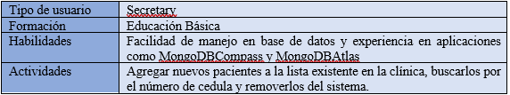

**2.4 Restrictions**

* The system is developed in the Java programming language.
* The information is intended to be stored in the MongoDBAtlas database.
* The system must have the mongodb-driver-3.12.10.jar, jcalendar-1.4.jar libraries incorporated.
* The system must be installed on operating systems such as Windows, Linux and Ubuntu.

**2.5 Assumptions and dependencies**

* The system is designed only for operation on computers, therefore, it is not compatible with Android systems of any kind.
* The system is designed to establish a connection with MongoDBAtlas, in case you choose to use another database, the system connection must be modified.
* The system needs to maintain internet connection for all data changes to be successfully stored.

**2.6 Foreseeable evolution of the system**

The system is designed to store data of the patients that are registered in the care of the clinic, in terms of the data limit that this system can store will be delimited by the database service that is intended to be implemented.

**3. Specific Requirements**

**3.1 Functional Requirements**

Admin Application

RF1: Enter the system

The home screen will ask you to enter the username and password to access.

RF2: Enter new user

When entering, a menu will be displayed, in which you will find the options to add new users or exit the system, when entering from an administrative account this user is the only one that is enabled to register new administrative users.

RF3: Enter administrative user

In this interface the administrator fills in the data of the new user and once finished clicks save, in this same window there are buttons to search for administrative users, this button will show all registered users and specify their type (Administrator or Secretary), finally it also has the option to remove the user, for this you must select the user to remove and click on this option

Secretary application.

RF1: Enter the system

The home screen will ask you to enter the username and password to access.

RF2: Enter new user

Upon entering, a menu will be displayed, in which you will find the options to add new users or exit the system, this user is enabled to register new patients.

RF3: Enter patient

In this interface, the secretary fills in the data of the new user and once finished clicks save, just as in the administrators interface, the secretary has the same functions described above, with which he can search for and delete patients.

**3.2. Non-Functional Requirements**

* The application allows us that the user can interact with the application for data entry.
* The system must allow the user to register patients and administrators.
* The system allows the entry of a new patient by storing the name, paternal surname, paternal surname, identification document, date of admission and diagnosis.
* The system should not present response times greater than 5 seconds.
* The system must have an internet connection via Wi-fi.
* The system must have an availability of 90% High Availability.
* The system must not allow access to unregistered users.

**4. Use case diagrams**

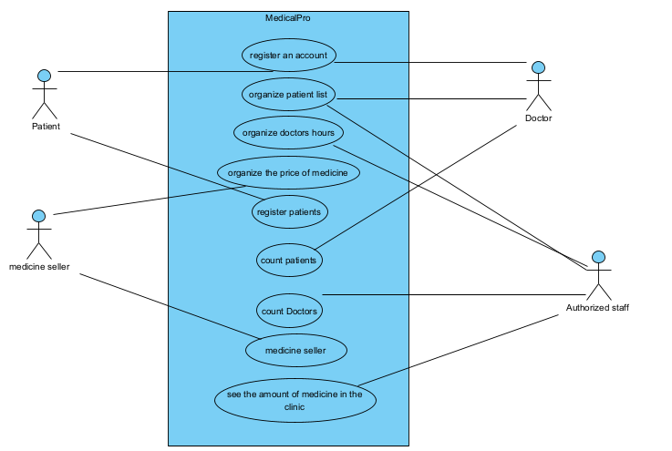

**5. Specification of Use Cases**

5.1. Application of the Medical Service Enter the system

|  |  |
| --- | --- |
| **identifier** | RF1 |
| **Name** | Login to the system |
| **Description** | The system allows the user to enter the system requesting a username and password. |
| **Actors** | User |
| **Preconditions** | The user must have login credentials or can use the trial version. |
| **Preconditions** | Be registered in the users. |
| **Postconditions** | The user is registered and the application will not ask him to register again |
| **normal data flow** | 1. Login to the system with the username and password. 2. Check that there are no empty fields. 3. Validate user. 4. Validate key. 5. The main interface of the application is displayed. |
| **Alternate flows and exceptions** | 1. There are empty fields   If the field is empty   1. The system displays enter missing field. 2. Incorrect password 3. The system displays the message: This user is not registered |

5.2. Application of the Medical Service Registration Enter new user

|  |  |
| --- | --- |
| **identifier** | RF2 |
| **Name** | Enter new user |
| **Description** | The system allows the user to enter a new patient in the system requesting Name, Surname, Identity Card, Pathology, Date of Birth. |
| **Actors** | User - Patient |
| **Preconditions** | The user must have login credentials or can use the trial version to be able to enter patients into the system. |
| **Preconditions** | Be registered in the system users and have access to the system. |
| **Postconditions** | The user is registered and the application will not ask him to register again |
| **Alternate flows and exceptions** | 1. Login to the system with the username and password. 2. Check that there are no empty fields. 3. Validate Name surname, Identity Card, Pathology, Date of Birth. 4. The main interface of the application is displayed. |
| **Alternate flows and exceptions** | 1. There are empty fields   If the field is empty   1. The system displays enter missing field. 2. Wrong ID 3. It does not allow to register another type of data in the field 4. Admission date 5. The system does not support dates prior to the day of execution |

5.3. Application of the Medical Service Registry of Officials

|  |  |
| --- | --- |
| **identifier** | RE 3 |
| **Name** | Register Patient |
| **Description** | The system allows user registration by entering the following data:  Name, surname, Identity Card, Pathology, Date of Birth |
| **Actors** | Official |
| **Preconditions** | The official must be registered in the application |
| **Preconditions** |  |

|  |
| --- |
| **normal flow of events** |
| 1. The system displays the login window with the username and password fields, in addition to the login button.  2. The wizard enters the corresponding username and password.  3. Validate that there are no empty fields  4. Validate password  5. Login |
| **Alternate flows and exceptions** |
|  |

Application of the Medical Service Entry of Common Officials

|  |  |
| --- | --- |
| **identifier** | RE 4 |
| **Name** | Login to the cloud system |
| **Description** | The system allows entering the Mongo Database to add records in which Names are found. |
| **Actors** | Official |
| **Preconditions** | The Official must be registered in the application |
| **Preconditions** |  |

|  |
| --- |
| **normal flow of events** |
| 1. The system displays a menu in the entry of Officials  2. The wizard enters the corresponding username and password.  3. Validate that there are no empty fields  4. Validate password  5. Login |
| **Alternate flows and exceptions** |
| A. There are empty fields  1. The system shows the user a text in red to identify that no data was entered.  2. The system allows you to enter the login data again (returns to the normal flow) |
| B. Wrong password  if the password is wrong  1. The system displays the message “There is no registered Official”.  2. The system allows you to enter the password again in the login window (returns to the normal flow)  3. The system allows the user to exit the system by not entering the users |

|  |  |
| --- | --- |
| **identifier** | RE 5 |
| **Name** | Show Patient List |
| **Description** | The system will show the patients registered in a list in which the names, surnames, identity card, date of birth, pathology are found. |
| **Actors** | Official |
| **Preconditions** | The Official must be registered in the application |
| **Preconditions** | Identify the patient to show or Edit |

|  |
| --- |
| **normal flow of events** |
| 1. The system displays a list of Patients |
| **Alternate flows and exceptions** |
| A. The system will present an empty list with a message with no data in the list  1. The system allows you to enter the login data again (returns to the normal flow) |
| B. Allows you to enter new data to display more data in the list |

**6. User interfaces**

