**CPE343 Object-oriented Analysis and Design**

**Project Design Booklet**

**Topic: Movie Review Social Network**



**Team**

SunnySideUp

**Member**

1. Mr.Jarudet Witchit 59070501008

2. Mr.Nawakanok Muangkham 59070501044

**Present**

Dr. Sally E. Goldin

**Semester 2/2018**

**King Mongkut’s University of Technology Thonburi**

**MRSN Description**

Movie Review Social Network (MRSN) is a java program that imitated common movie review website you can find on the internet. Though text based, MRSN can be used to read review, search, write review, follow reviewer, manage review, register, save to file, add new movie, and discover new movie you might like through our simple random movie function.

As I said MRSN is text based so it will work on terminal only. When search if there are too many search results MRSN will split search results into 5 results per page. Then, user can navigate through each page with easy command. MRSN is state program; output shown to user will varies for each state. User’s action will change MRSN’s state according to state diagram. MRSN provides ultra-encapsulation of data each change in data class will be done through each class managers. Each change in data will be later saved by file managers. User can search for movie by category or name but input to search must almost exactly match with its name or category. Also, user can search for review using reviewer name. Most of the data in MRSN can be edited by user. Finally, MRSN has a very big façade class which handle almost every input and output.

Despite all said MRSN was down scoped from the requirement version. In this version MRSN don’t have movie tag, user can’t sort movie, only menu will show up at main page, the program doesn’t have complex suggestion system, and every part that shown list of something without user asking for it are cut out.

**Use case diagram**

**Class diagram**

**Class description table**

|  |  |  |
| --- | --- | --- |
| **Class** | **Primary responsibility** | **Relationship** |
| **MovieReviewSocialNetwork** | **façade** | **Use every other classes.** |
| **TextFileManager** | **Read/write text file** | **Is superclass of**  **MovieFileManager,**  **ReviewFileManager, and**  **UserFileManager.** |
| **MovieFileManager** | **Read/Create Movie from file** | **Subclass of TextFileManager. Used to read/save file by MovieManager.** |
| **ReviewFileManager** | **Read/Create Review from file** | **Subclass of TextFileManager.** **Used to read/save file by ReviewManager.** |
| **UserFileManager** | **Read/Create User from file** | **Subclass of TextFileManager/**  **Used to read/save file by UserManager.** |
| **Movie** | **Represent movie** | **Is kept by MovieCollection.**  **Is managed by MovieManager.** |
| **MovieCollection** | **Keep all Movie** | **Kept all Movie.**  **Is managed by MovieManager.** |
| **MovieManager** | **Manage Movie** | **Manage Movie and MovieCollection.**  **Use MovieFileManager to get Movie from file.** |
| **Review** | **Represent review of Movie** | **Is kept by ReviewCollection.**  **Is managed by ReviewManager.** |
| **ReviewCollection** | **Keep all Review** | **Kept all Review.**  **Is managed by ReviewManager.** |
| **ReviewManager** | **Manage Review** | **Manage Review and ReviewCollection.**  **Use ReviewFileManager to get Review from file.** |
| **User** | **Represent user who used movie review website** | **Is kept in UserManager and MovieReviewSocialNetwork.**  **Is managed by UserManager.** |
| **UserManager** | **Manage User and handle autentication** | **Manage and keep Users.** |

**Sequence diagrams**

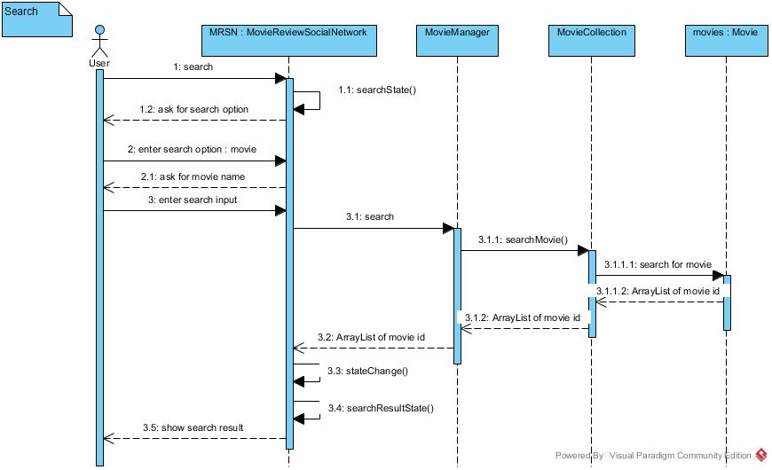

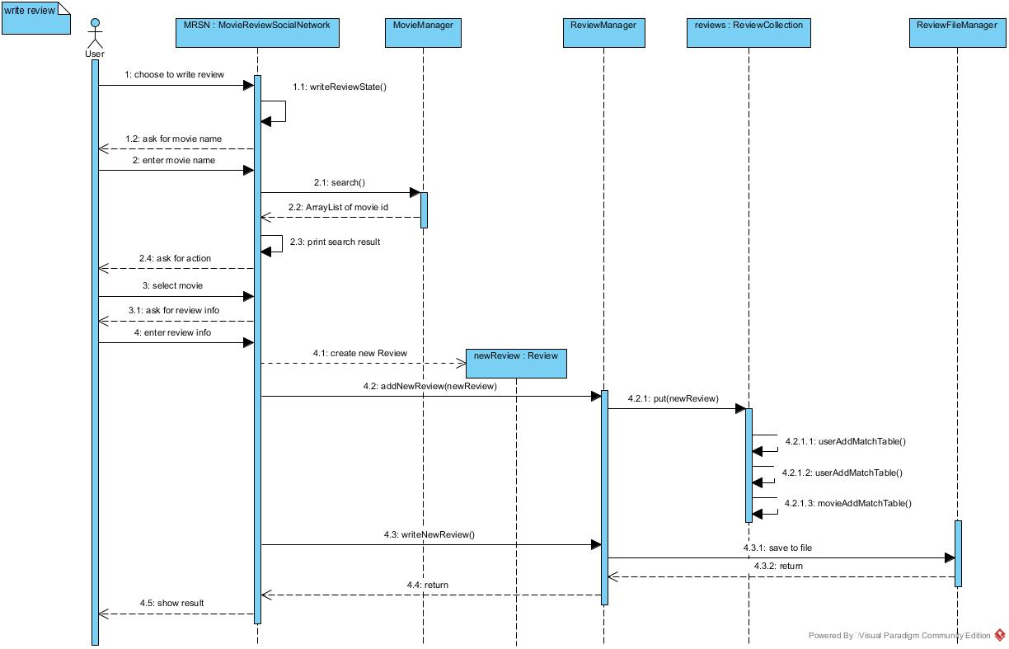

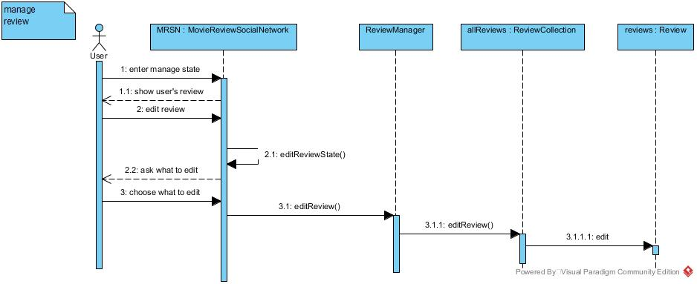

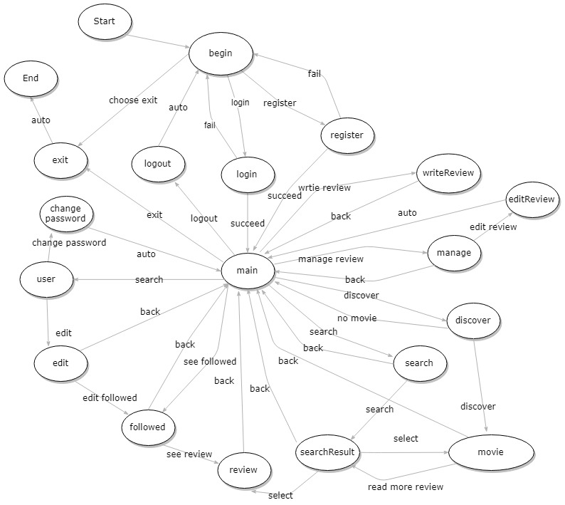State Diagram