Taking Home Automation Off the Cloud
  - My move to Home Assistant and Matter over Thread
Michael Coar
In my recent article about network privacy, I talked about how surprised I was to find so many of my devices phoning home. After tightening up my network, I turned my attention to the smart outlets and bulbs scattered around my house. I wanted the convenience, but I wanted the house to run locally.
The Rolling Stones had the right idea: “Get Off of My Cloud.”
Home Assistant has let me move virtually all of those devices off the cloud and recreate the lighting routines I had in Alexa. It took some sorting out. But now the lights answer to a computer in my house, which seems like a reasonable place to put the computer in charge of my house.

Why a light switch needs the internet
Consider a smart outlet named “Back Yard.” You set it to turn on at dusk and off at midnight, then add voice control. Convenient, right? With a cloud-connected plug such as my old Wyze outlets, you first set up a manufacturer account, then link it to Alexa. Now two companies are involved in operating your light.
When you say, “Alexa, turn on the back yard light,” your Echo sends the audio to Amazon for processing. Amazon then passes the command to the manufacturer’s service, which tells the outlet to switch on. That request can travel a lot farther than the back yard. Along the way, information about your devices and commands is handled outside your home.
Over a few years, I had accumulated more than 20 smart outlets and bulbs in my little house. That is a lot of dependence on someone else’s servers, and a lot of devices to keep secure. If the internet or one of those services goes down, the functions that depend on it can stop working.
Still, I could not shake the question: why should turning on my own light require permission from a server somewhere else?

Enter Home Assistant 
Home Assistant is free, open-source software for managing smart devices from a computer in your house. Think of it as the person running the light switches, except it never complains about having to get up. My goal was to give it devices it could control directly, without sending everyday commands through Amazon or Wyze, or anyplace else in the cloud.
The computer also keeps the schedules. So my lights can still come on at the right time when the internet is down, because both the server providing and the devices receiving those instructions are right here at home.
I manage mine through a web browser or the Home Assistant phone app while connected to my home network. The app does not need cloud access to work at home. I have kept it that way for now.

Matter and Thread without the alphabet soup  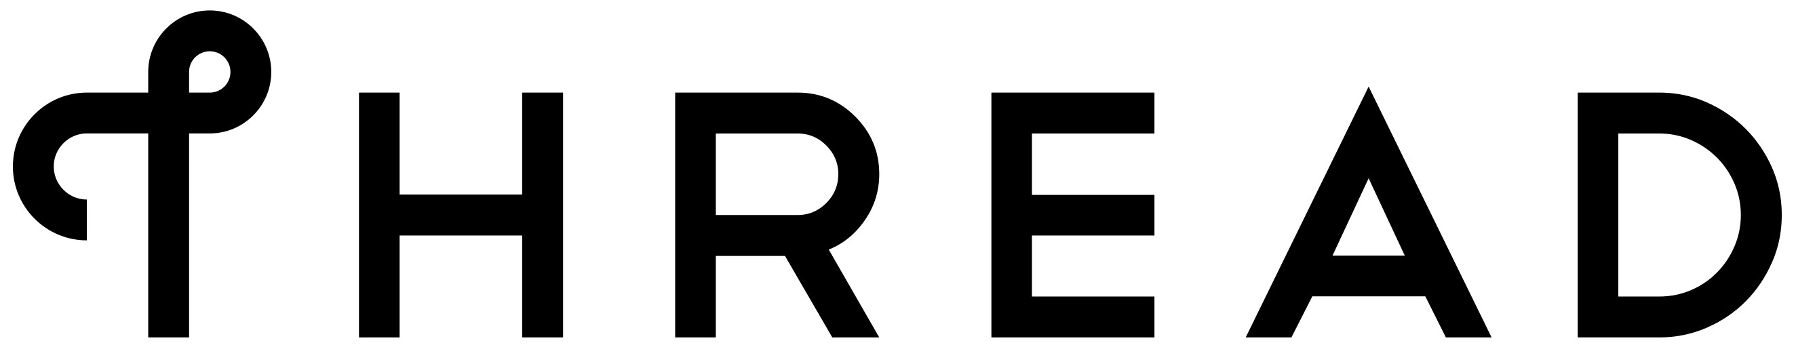
For my replacement outlets and bulbs, I chose Matter over Thread. The names sound more complicated than the idea. Matter is the common language the devices speak. Thread is the wireless connection they use to talk to one another.
In my setup, a small USB radio with an antenna connects to the Home Assistant Server computer. The Home Assistant Server reaches them through that radio and a connecting service called a Thread border router. Think of it as a doorway between Home Assistant and the devices.
Thread also lets devices pass messages along to one another. An outlet farther from the antenna can be reached through a nearby device that relays the message. Many devices that plug into power can do this; battery-powered sensors generally cannot.
The outlets and bulbs use their own wireless network rather than joining my Wi-Fi individually.
The result is fewer individual gadgets on my Wi-Fi and no need for a vendor’s cloud to carry the everyday commands. The devices are still connected to my home system. But they do not appear connected to my WiFi, nor do they show up on my network. While they are not entirely invisible, I have brought their control back inside the house.

The little computer running the house
I installed Home Assistant OS, which is a dedicated operating system, on a used HP EliteDesk mini. This computer’s job is now running the house. I manage it from a browser, so it normally sits there without a monitor, keyboard, or mouse.
Mine has a ninth-generation Core i7, 16 GB of memory, and a 128 GB drive. Way overpowered for switching lamps on and off, but inexpensive. For my purposes, it was a better buy than a new Raspberry Pi setup, and the extra computing power gives me room to do more later.
Two installation annoyances are worth mentioning. I had to turn off a startup security setting called Secure Boot, as required by the Home Assistant OS installation instructions. I also used a DisplayPort dummy plug, a little adapter that makes my HP think a monitor is attached, to get around a startup problem on my machine.
I added the Home Assistant Connect ZBT-2 USB radio and configured it for Thread. That provides the wireless link to my new outlets and bulbs. There is some initial setup involved; plugging in the antenna is not quite the whole job.
Home Assistant can also discover compatible equipment already on the network. Mine found some of my Ubiquiti gear and ecobee thermostats. I could then choose what to add. Finding something does not mean I have to hand it the keys to the house.

Shopping for devices and remembering their names
For my outlets, I wanted to get away from the Wyze cloud connection altogether. IKEA turned out to be a useful source of replacements that use Matter over Thread. The GRILLPLATS is a smart plug, the TIMMERFLOTTE measures temperature and humidity, and KAJPLATS is the smart bulb range.
Of course, now I have to remember whether a TIMMERFLOTTE measures humidity or is the bookcase I bought ten years ago. IKEA apparently believes that learning Swedish should be part of every home improvement project.
I added these devices directly to my Home Assistant setup. To do that, I use the Home Assistant Companion phone app, with Bluetooth enabled and my phone connected to my home network. I scan the device’s setup QR code and follow the pairing instructions. It feels much like adding a device in the familiar smart-home apps.
Once added, I assign devices to rooms. There are labels and other ways to organize things if you want to go nuts, but rooms are enough for me. I am controlling a house, not cataloging a museum.
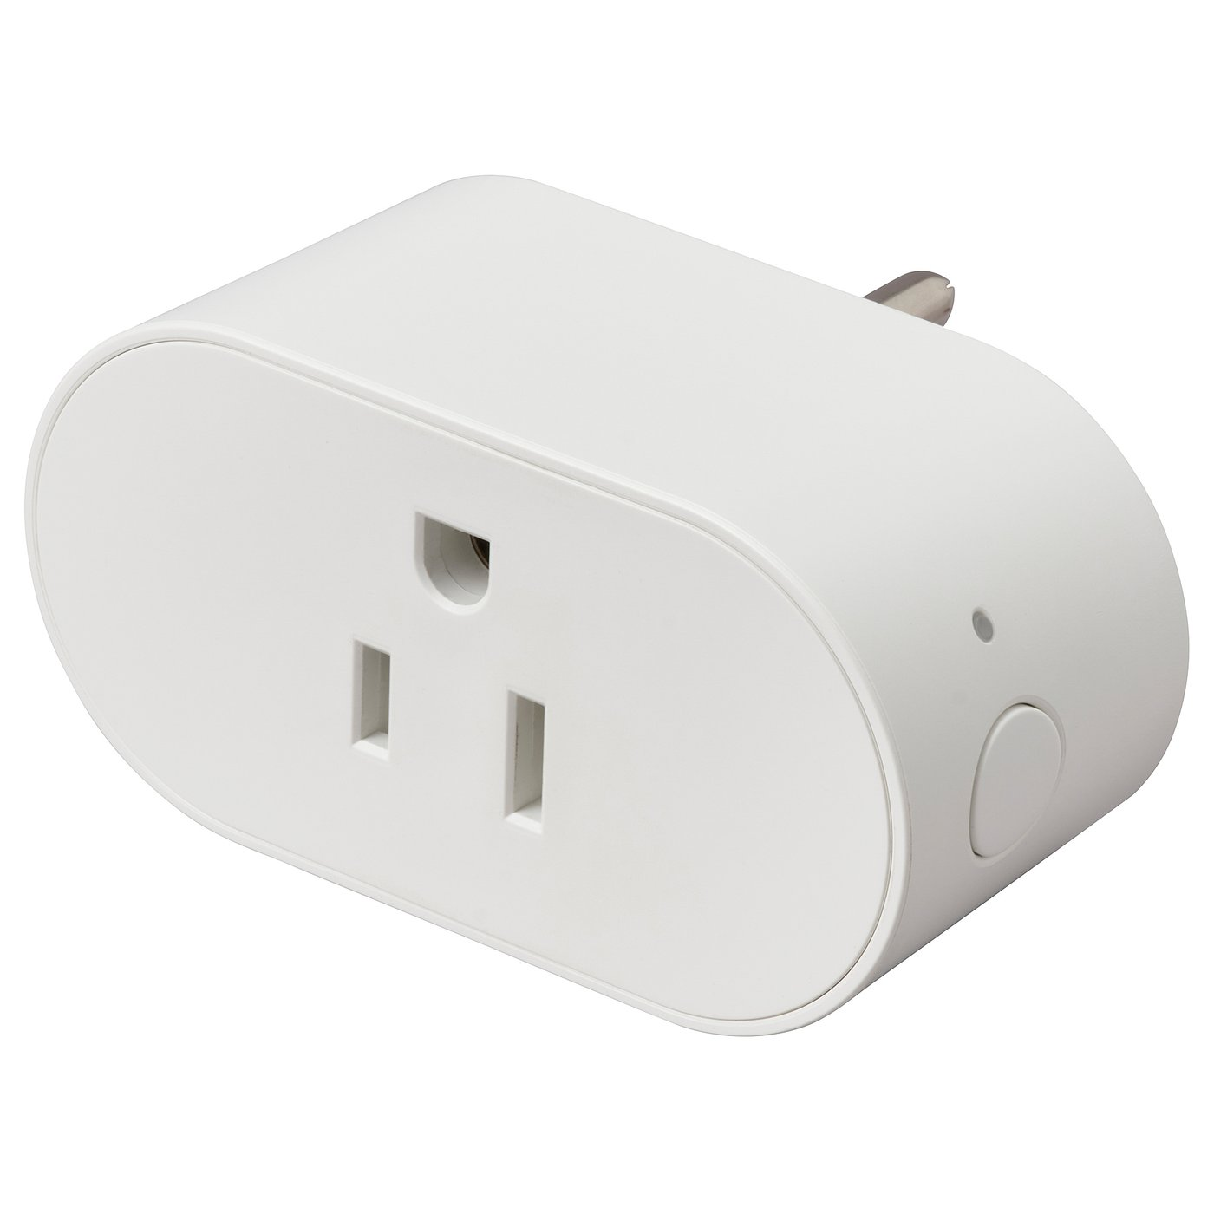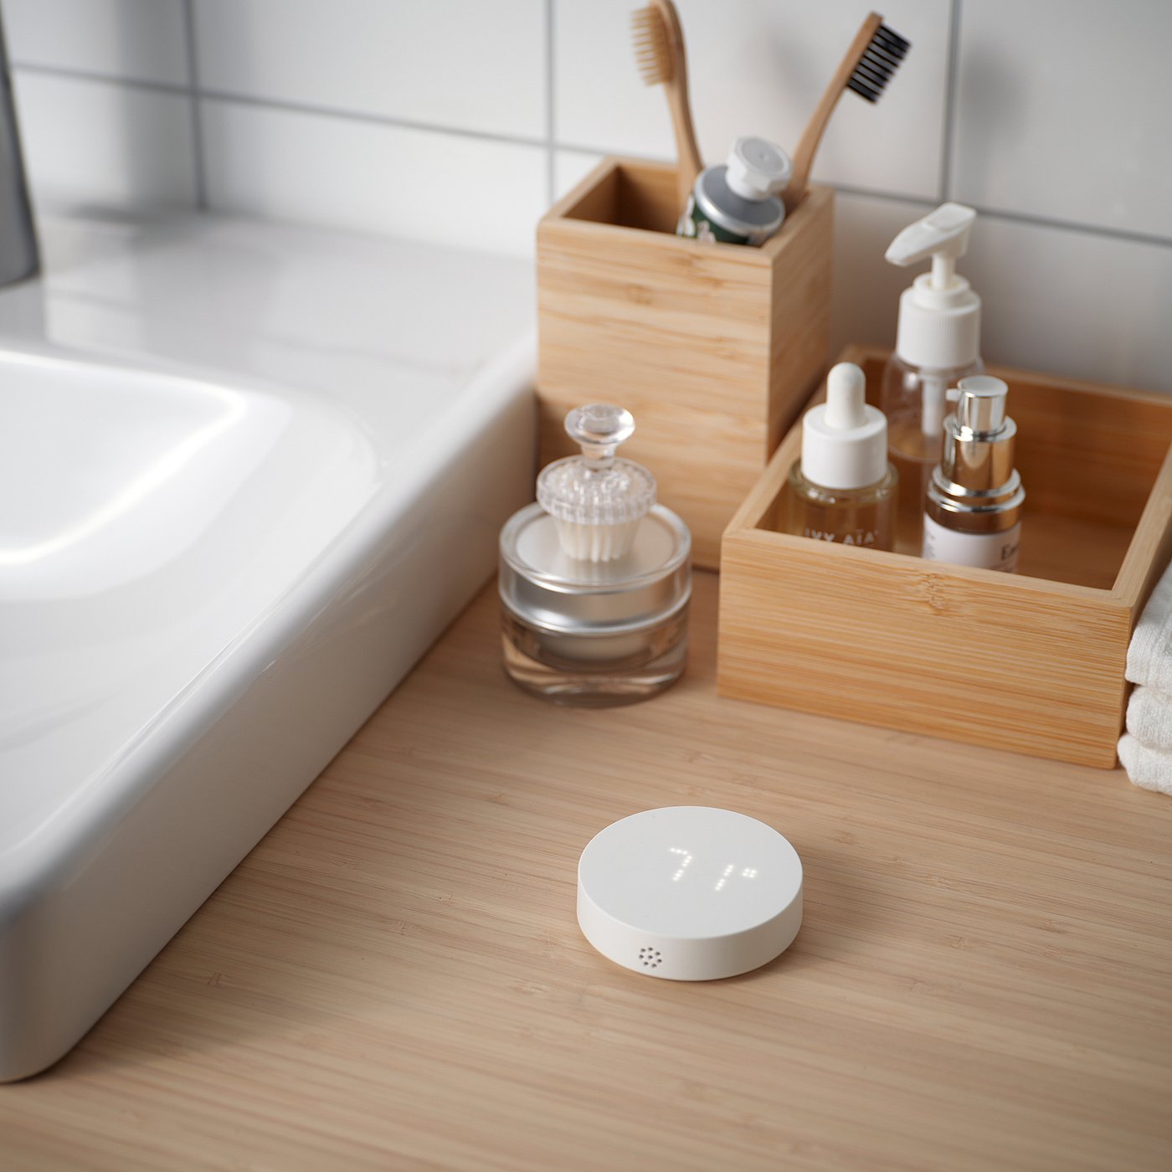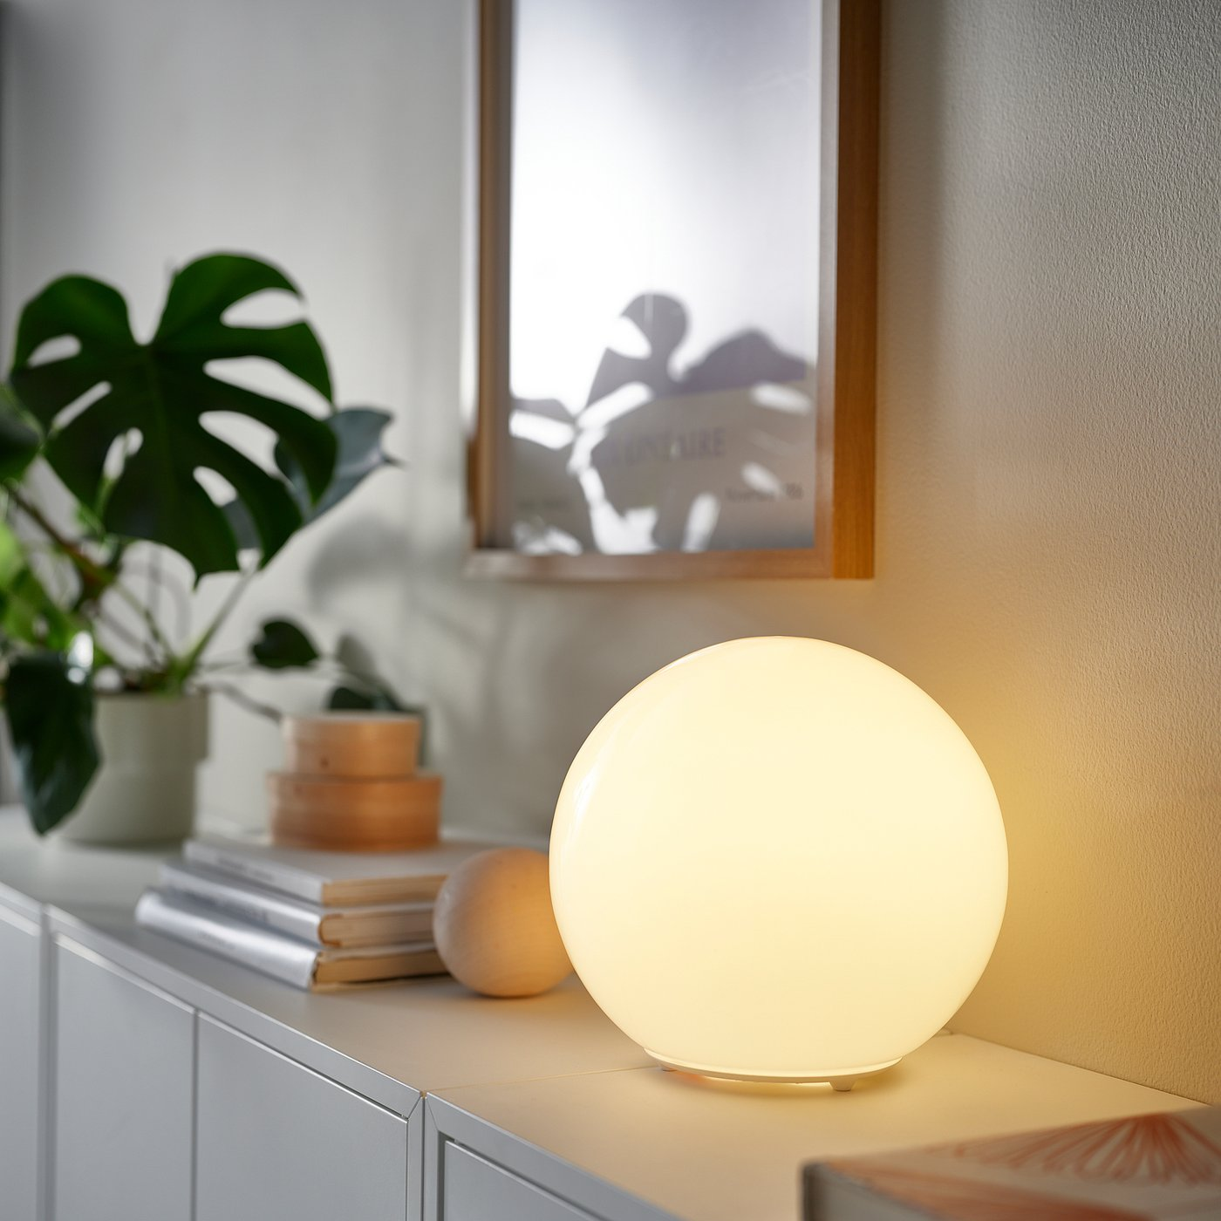
GRILLPLATS TIMMERFLOTTE KAJPLATS
IKEA smart plug, temperature and humidity sensor, and smart bulb shown in a lamp.

Keeping the devices up to date
The devices still need software updates. Home Assistant can offer them when the manufacturer makes them available through the supported Matter update process. I can review and install those updates from Home Assistant.
Downloading an update still involves the internet. But that is different from needing a cloud service every time I turn on a lamp. The everyday operation stays inside the house.

But I want the Christmas lights on at dusk
Yes, it can do that. I can have the Christmas lights come on around dusk and go off at midnight, or choose particular times and days of the week. Home Assistant can use sunset as the starting point and adjust the timing to suit me.
It can also respond to what is happening in the house. A TIMMERFLOTTE could tell it the humidity has dropped, prompting a smart plug to turn on a humidifier that resumes running when powered. With suitable equipment, an alarm could make the color bulbs flash red. There is plenty of room to get carried away.
I have recreated the lighting routines I used in Alexa. Once I understood the basic pattern, adding more was much easier. Many everyday routines can be built by choosing options in the visual editor. The more ambitious projects may take some scripting, but turning on the Christmas lights does not require becoming a programmer.

But I wanna talk to it
Home Assistant also supports voice control through its Assist system. I use the Home Assistant Voice Preview Edition, a little device with microphones and a speaker that fills the same basic role as an Echo. In my configuration, the spoken commands stay inside the house.
The voice device listens and sends the request to my Home Assistant computer. Software on that computer recognizes the words, works out the home-control command, and generates the spoken reply. The little voice unit plays it back. That is another useful job for my overpowered HP.
My current setup uses Speech-to-Phrase, which is designed to recognize supported home-control commands. I can ask it to turn the lights on and off. Asking for a recipe for goulash, however, is outside its job description.
That is my next project: separate local servers for more capable speech processing and a large language model that can answer general questions. Home Assistant has a connection called Wyoming that lets it use speech software running on another computer. I also want controlled internet searches and help from a cloud AI service when I request it. I am going to be busy.
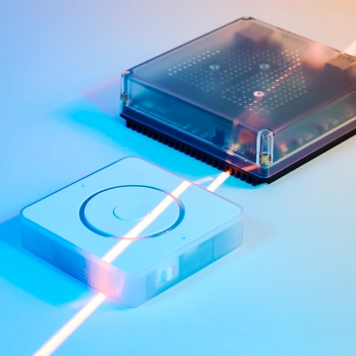
Home Assistant Voice Preview Edition, beside a Home Assistant computer.

Ooh dashboards
Home Assistant lets you build dashboards with buttons for your lights, sensor readings, and other controls. There is a large community of custom designs, including screens that look suspiciously like something from Star Trek. Apparently, a simple light switch was never going to be enough for me.
I have some old iPads lying around that I would like to turn into control panels for the kitchen and living room. That part is still on the list.
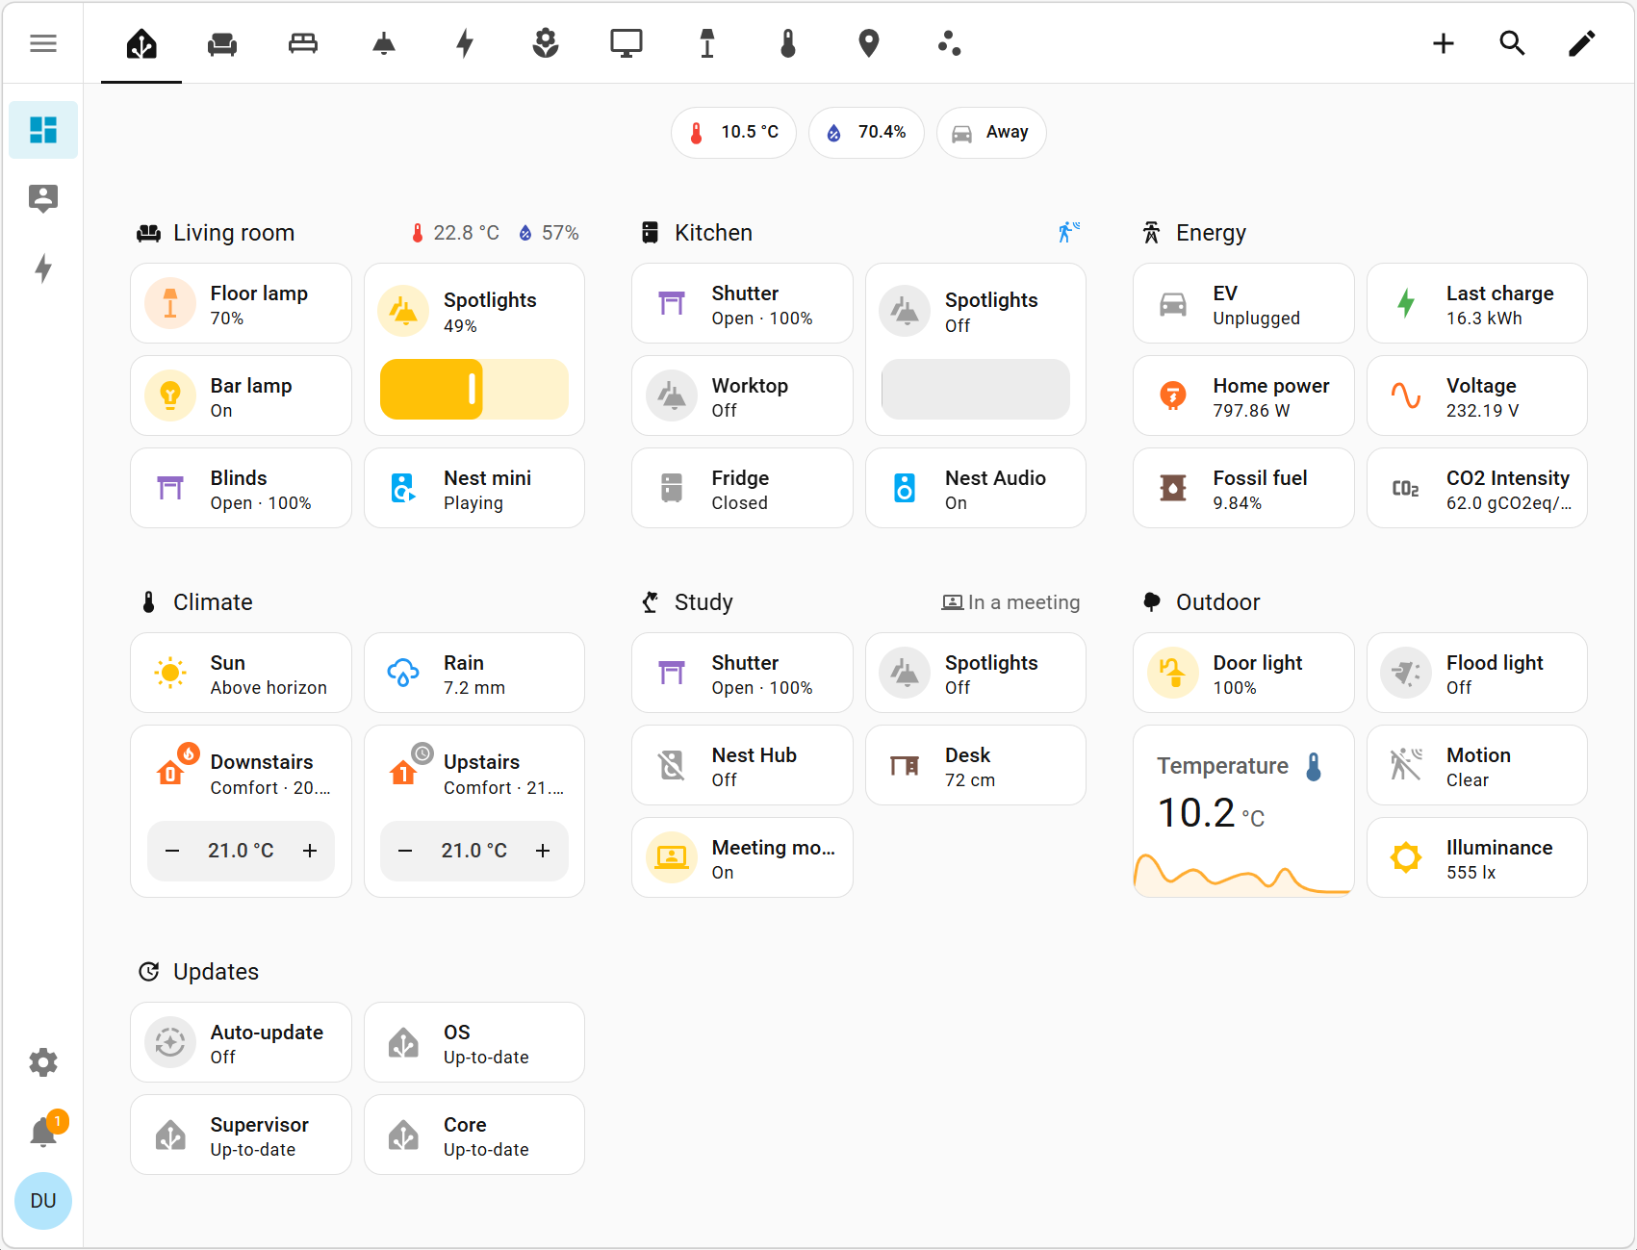
A standard Home Assistant dashboard, with room controls and sensor readings.
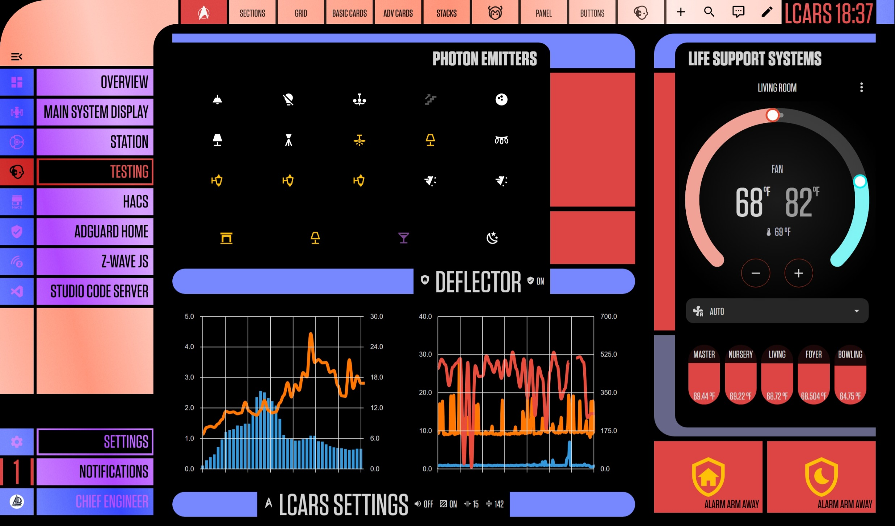
A Star Trek inspired LCARS dashboard. Same house, considerably more starship.

Was it worth it
For me, absolutely. The installation took some fiddling, and tightening my network security meant a little more adjustments. But after adding more than 20 devices, the routine parts are easy. The documentation and community have been enough to get me through the problems I encountered.
It takes more effort than Alexa. I am responsible for the computer, updates, and backups. In return, I have the local control I wanted, and my lights do not need to phone a company somewhere else to ask whether they can turn on.
And yes, there is still an Alexa in my kitchen for general questions. I expect to retire it once my local AI setup is ready. For now, Alexa can help with the goulash. Home Assistant can handle the lights.

Amazon, “Alexa Connected Devices Smart Home Skills,” explains how a manufacturer’s cloud service connects Alexa to a device. https://developer.amazon.com/en-US/alexa/connected-devices/development-resources/smart-home-skills (accessed October 10, 2026).
Amazon, “Alexa and Alexa Device FAQs,” documents voice audio sent to the cloud after wake-word detection. https://digprjsurvey.amazon.com/csad/help/node/201602230 (accessed October 10, 2026).
Home Assistant, project overview. https://www.home-assistant.io/ (accessed October 10, 2026). Logo: Home Assistant official assets.
Home Assistant, “Remote access to Home Assistant,” distinguishes home-network access from optional access away from home. https://www.home-assistant.io/docs/configuration/remote/ (accessed October 10, 2026).
Home Assistant, “Matter,” introduction and “What does Thread have to do with Matter”. https://www.home-assistant.io/integrations/matter/ (accessed October 10, 2026). Logos: Home Assistant brand assets.
Home Assistant, “Thread,” and Silicon Labs, “Thread Mesh Networking,” explain border routers and wireless mesh networking. https://www.home-assistant.io/integrations/thread/ and https://www.silabs.com/wireless/thread (accessed October 10, 2026).
Home Assistant, “Generic x86-64,” installation instructions. https://www.home-assistant.io/installation/generic-x86-64/ (accessed October 10, 2026).
Home Assistant, “Home Assistant Connect ZBT-2,” and “Thread,” setup guidance. https://www.home-assistant.io/connect/zbt-2/ and https://www.home-assistant.io/integrations/thread/ (accessed October 10, 2026).
IKEA, official GRILLPLATS, TIMMERFLOTTE, and KAJPLATS product pages. https://www.ikea.com/us/en/p/grillplats-plug-smart-70624740/ and https://www.ikea.com/us/en/p/timmerflotte-temperature-humidity-sensor-smart-50618957/ and https://www.ikea.com/us/en/p/kajplats-led-bulb-e12-450-lumen-smart-white-spectrum-clear-glass-10611496/ (accessed October 10, 2026).
Home Assistant, “Matter,” device-pairing instructions for the Companion app. https://www.home-assistant.io/integrations/matter/ (accessed October 10, 2026).
Product photographs: IKEA. GRILLPLATS US plug, TIMMERFLOTTE sensor, and KAJPLATS bulb example. https://www.ikea.com/us/en/p/grillplats-plug-smart-70624740/ ; https://www.ikea.com/ca/en/p/timmerflotte-temperature-humidity-sensor-smart-50618957/ ; https://www.ikea.com/no/en/p/kajplats-led-bulb-e27-470-lumen-smart-white-spectrum-globe-opal-white-00611307/ (accessed October 10, 2026).
Home Assistant, “Matter,” section “Matter OTA device updates,” describes supported devices and available updates. https://www.home-assistant.io/integrations/matter/ (accessed October 10, 2026).
Home Assistant, “Automation triggers,” documents sun and time triggers. https://www.home-assistant.io/docs/automation/trigger/ (accessed October 10, 2026).
Home Assistant, “Voice Preview Edition,” describes the device and local voice processing. https://www.home-assistant.io/voice-pe/ (accessed October 10, 2026).
Home Assistant, “Set up a fully local voice assistant,” explains local speech recognition and spoken replies. https://www.home-assistant.io/voice_control/voice_remote_local_assistant (accessed October 10, 2026).
Home Assistant, “Wyoming Protocol,” documents connections to external speech services. https://www.home-assistant.io/integrations/wyoming/ (accessed October 10, 2026).
Product photograph: Home Assistant, Voice Preview Edition media gallery. https://www.home-assistant.io/voice-pe/ (accessed October 10, 2026).
Home Assistant, “Dashboards,” documents dashboard controls and customization. https://www.home-assistant.io/dashboards/ (accessed October 10, 2026).
Dashboard screenshot: Home Assistant documentation, Sections view example. https://www.home-assistant.io/dashboards/sections/ (accessed October 10, 2026).
Dashboard screenshot: th3jesta, Home Assistant LCARS theme, dashboard example. https://github.com/th3jesta/ha-lcars (accessed October 10, 2026).

