(Concrete Syntax Tree)
An experiment. I fed a very simple grammar into Ohm, then used the JS debugger (node inspect junk.js) to dissect the results:

dissect.scm:

#t

dissect.ohm:
<$Scr_Ps::0>
Scm2JSBasic {
Program = Form+
Form = Atom
Atom = SBoolean
SBoolean = "#f" | "#t"
}

<!$Scr_Ps::0>dissect.js:
<$Scr_Ps::0>const fs = require ('fs')
const ohm = require ('ohm-js')
const grammarData = fs.readFileSync('dissect.ohm')
const grammar = ohm.grammar(grammarData)

const input = fs.readFileSync('dissect.scm')

const result = grammar.match(input)

if (result.succeeded()) {
console.log("Matching Succeeded")
} else {
console.log("Matching Failed")
}

const semantics = grammar.createSemantics()
const node_to_source = node => {
if (node.ctorName == "_terminal") {
return node.primitiveValue
} else {
return node.children.map(n => node_to_source(n)).join('')
}
}

semantics.addOperation(
'dump',
{
Program: (p) => {
return node_to_source(p)
}
}
)

console.log(semantics(result).dump())

function astString(obj) { return obj.toString() }

class Program {
constructor(p) { this.p = p }
astString () {
console.log("<" + this.constructor.name + ">: " + this.p.constructor.name) ;
return "P \n" + this.p.map((x) => x.astString()).join('\n')}}
class Form {
constructor(s) { this.s = s }
astString () {
return "<" + this.constructor.name + ">:" + this.s.constructor.name + " " + "[" + this.s.astString().constructor.name + "] " + this.s.astString();}}

class Atom { constructor(a) { this.a = a } astString() { return this.a.astString() }}
class SBoolean { constructor(b) { this.b = b } astString(){ return this.b }}

// an operation that uses the above classes
semantics.addOperation(
'ast',
{
Program: (p) => { return new Program(p.ast()) },
Form: (s) => {
console.log("Form " + this.s );},
Atom: (a) => {
console.log("Atom a=" + a);},
SBoolean: (b) => {
console.log("b is " + b._node.ctorName + " and b's ast is " + b.ast()) ; },
_terminal: () => { console.log("primitive " + this.primitiveValue); return this.primitiveValue }
}
)

console.log()
console.log("result")
console.log(result)
console.log()
console.log("semantics")
var sem = semantics(result)
var tree = sem.ast()
console.log()
console.log("tree")
console.log(tree)

<!$Scr_Ps::0>Fig. <$n:figure:OhmDataStructures> shows this data in diagrammatic form (some parts elided).

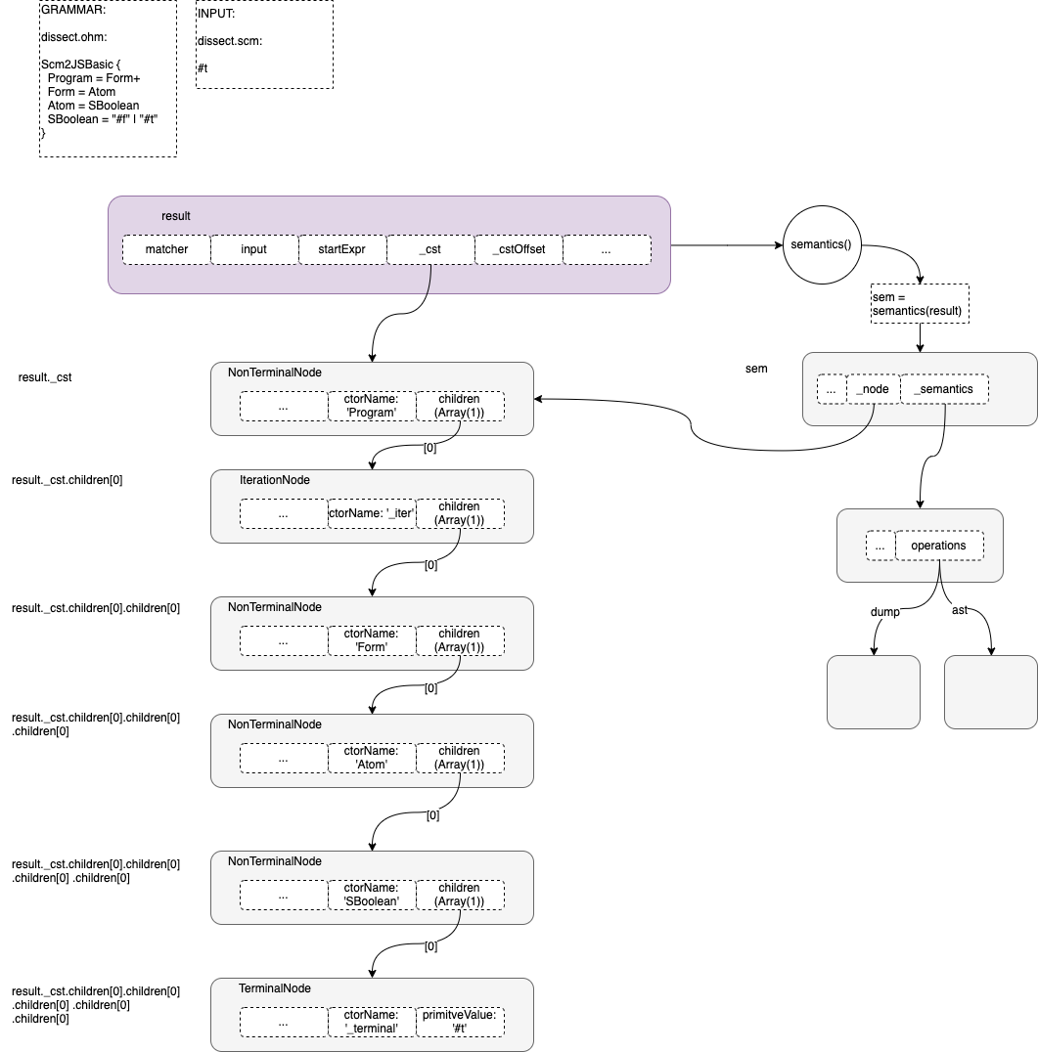
Fig. <$n:figure:OhmDataStructures> Overview of Ohm Parse Results

