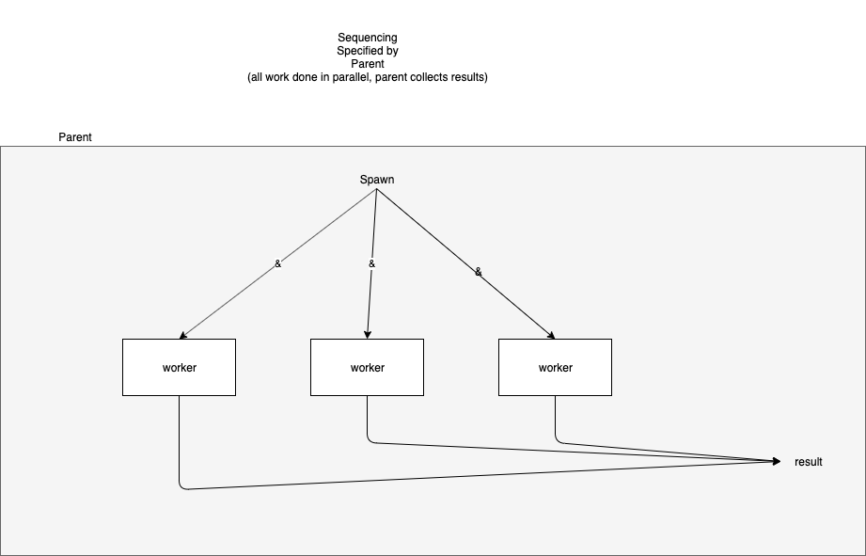

In spawn and wait sequencing, the caller "spawns" processes for each child/called routine and then waits until all of the child processes have died (and left results, if any, in distinguished locations).

Spawn and wait has been implemented in several forms:

- UNIX® fork() and waitpid()
- Bash (sh, etc.) & and wait commands
- hardware DMA (Direct Memory Access)
- "par" statement in several "parallel" languages
- node.js (anonymous functions provide wait() operation)
- etc.

Spawn and wait has been traditionally conflated with full-blown operating system processes (aka threads). Processes have been traditionally conflated with solutions to the (harder) problems of time-sharing and memory sharing.

