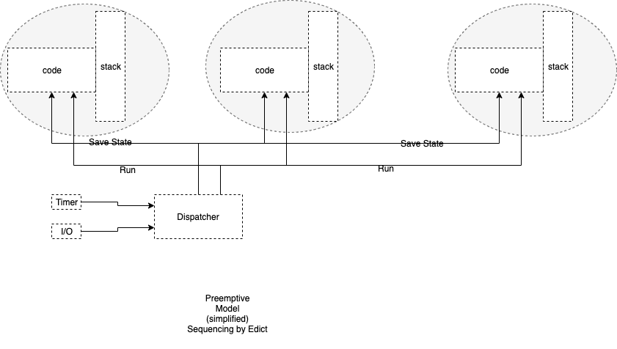

In a preemption-based sequence, each worker is given a private memory space and stack. A distinguished routine - the dispatcher - determines the order in which workers execute.

The dispatcher routine is, typically, supplied by the O/S.

