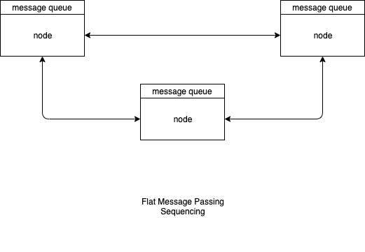

In message passing, every component has an input queue of messages. All components are asynchronous and can process messages at different speeds.

Flat message passing does not scale well to large systems (as is the case for anything that is designed in a flat manner). Flat message passing can be tamed and scaled using hierarchical scoping.

