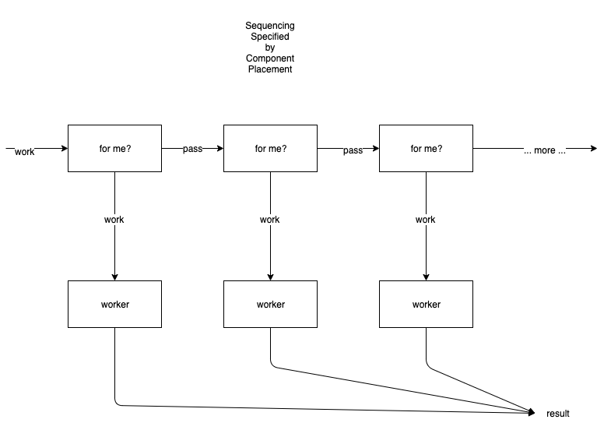

A daisy chain sequence arranges components in a chain.

Each component has a unique address.

Each component in the chain inspects incoming messages to determine if the message is addressed to them. If the message is not addressed to the given component, the message is forwarded to downstream components. If the message is addressed to the given component, the message is not forwarded and is processed by the component.

Component outputs are all tied together to form a result. One component processes the message and creates one result (which is fed to the common output).

If no component processes the message, either
- the message is completely ignored, or,
- the last component in the chain produces some sort of exception result.

A daisy chain system has, logically, two output ports - one is the result, another is an exception.

In a daisy chain, the earlier components in the chain receive priority over later components in the chain. In general, fairness doesn't matter as long as the "work" gets done.

