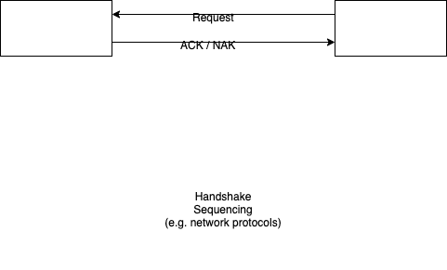

In handshake sequencing, a component sends a request to another component (instead of directly "calling" it).

The receiving component responds with a "handshake" message - usually an ACK in the case of successful receipt. The receiver might respond with a NAK (not acknowledge) if it deems that the message was garbled, or, the receiver might not respond at all.

The requestor expects one of 3 responses:

- ACK - means that the receiver received the message and is acting on it,
- NAK - means that the receiver received a message, but has deemed that the message has been damaged in transit - the requestor resends the message or, after several retries, declares a send error of some kind,
- silence - the requestor times-out waiting for an ACK/NAK from the receiver - the requestor resends the message, or, after several retries, declares a send error of some kind.

This handshake pattern is most often seen in network protocols.

I would expect to see this pattern arise more often with the advent of (more) distributed computing and IoT.

