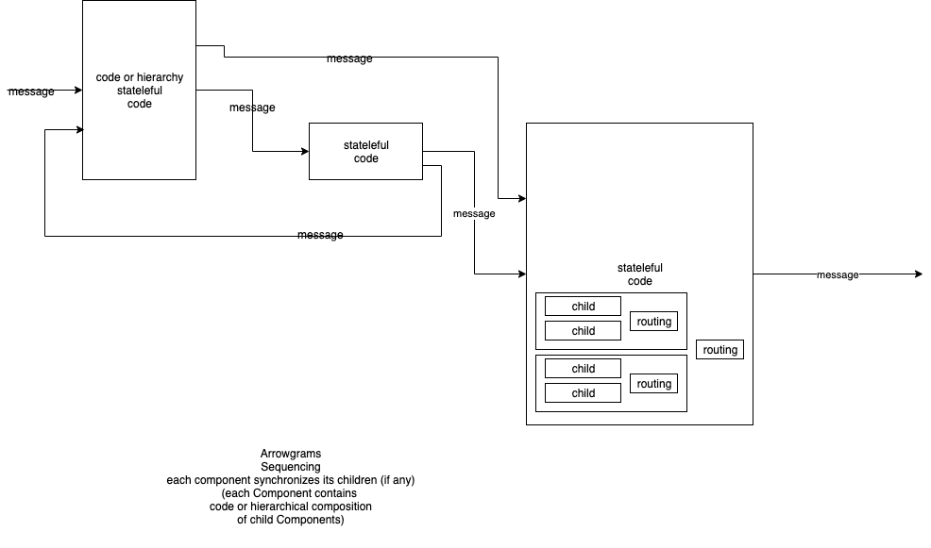

In the reactive pattern, components receive events (aka messages) and react to the messages.

Events (messages) are queued.

One message is processed, fully to completion, before another message is taken from the input queue.

A reactive system is a system of concurrent components wherein every component processes events in a hierarchical pattern.

Components are isolated from one another.

Components can be implemented as composites or leaves.

It is not possible to discern how a component is implemented without looking inside the component.

Components have multiple input ports and multiple output ports.

Input events are queued (on a single queue) and a component processes an event to completion before processing another event.

A leaf component processes an event using some other technology, e.g. by using a specific programming language.

A composite component contains children components. A composite component process input events by forwarding them to its children. A composite component is considered "busy" if any of its children are busy.

The reactive pattern is a realization of the divide and conquer paradigm. A problem can be dissected into two components - the leaf and the rest (conquer and divide, resp.).

