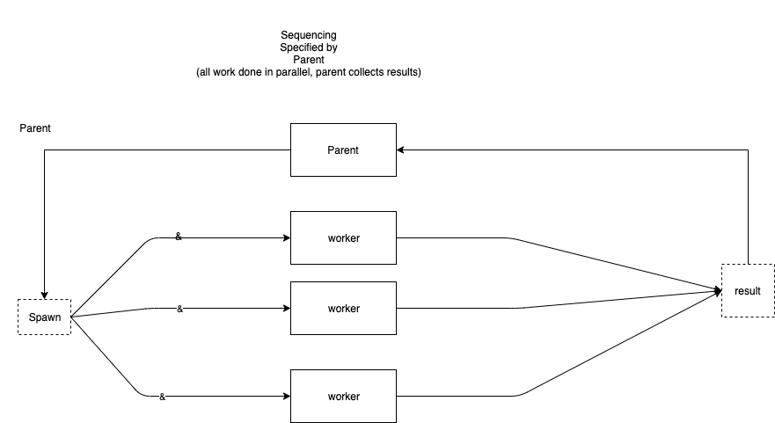

The above diagram is simply another way to diagram a spawn and wait design.

See spawn and wait.

