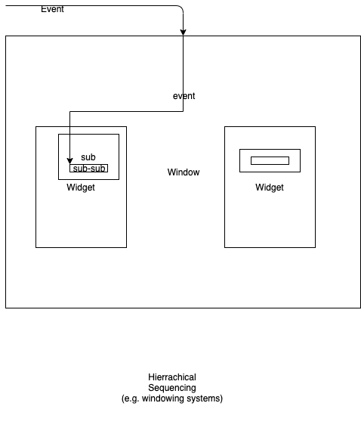
Hierarchical sequencing is a sequencing style where children components are contained within parents, like Russian dolls. As incoming events arrive, the parent gets first-right-of-refusal to act on the events. If the parent does not act on the events, the events are passed on to contained children, recursively.

This pattern is common in windowing systems.

