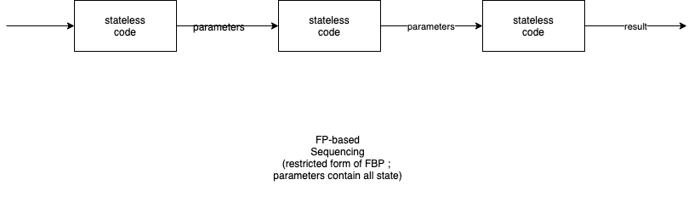

Filter pipelines form chains of routines. Each routine in the chain has no side-effects, or its side effects are isolated from the rest of the system.

Information flows strictly down the pipeline, e.g. from left to right. Feedback loops do not exist.

Pipeline sequencing has been implemented in:

- Bash pipelines
- FP filter chains
- Smalltalk ";" operators
- etc.

In a filter pipeline pattern, the data flowing between components contains all of the state.

(See, also, FBP, for a pattern of data flows which allows feedback).

