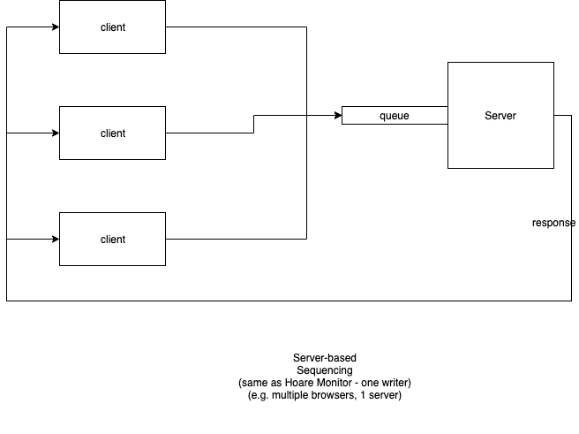

A server based sequencer is one where a single process contains and hides a resource. Client processes send requests for resource data.

[Note that a Hoare Monitor is a essentially a server-based sequencer in the context of time-sharing and memory sharing. See Hoare Monitor for further discussion.]

