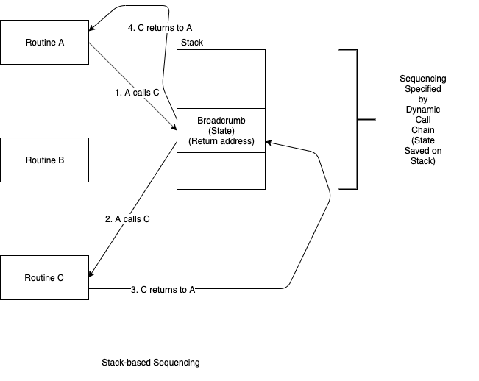

Stack-based sequencing is the common form of CALL/RETURN.

A routine transfers control to another routine and waits for it to complete its processing.

The caller uses a stack - i.e. an optimized collection - to create a list of parameters to the callee, then leaves a breadcrumb (return address) on the stack.

The callee performs processing and leaves a return value (usually a single value) and uses the stacked breadcrumb to return control to the caller.

Stack based sequencing is caused by text-only syntax.

