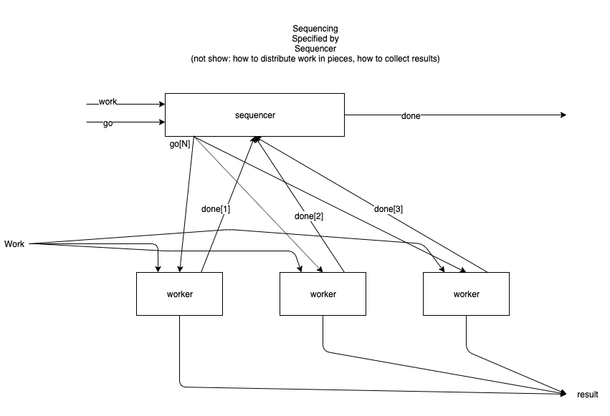

In the Explicit Sequencer design, work is sent to all workers, then a Sequencer process dictates the order in which each worker executes.

