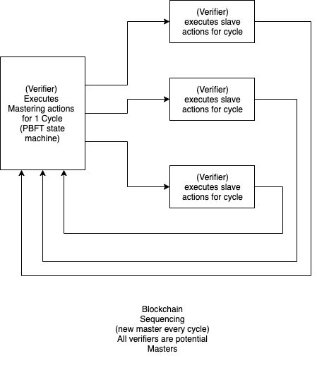
A blockchain, in current technology, is a spawn-and-wait system wherein the parent node is changed on every "cycle" (defined by the blockchain algorithm). The choice of "parent" is randomized to prevent attackers from guessing the future behaviour of the system.

Blockchains typically consist of two parts:
- cryptography
- sequencing.

