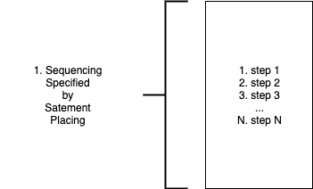

Statement-based sequencing is common in most current text-based PLs.

Statements are executed in an order based on their textual appearance.

Subroutines are executed in stack-based sequencing. (See "Stack").

Statement based sequencing is caused by text-only syntax.

Routines are called in a synchronous manner. See stack-based sequencing.

