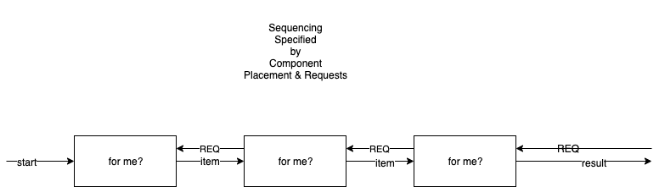

In a pull-based sequence, workers are arranged in a chain and respond to REQuests from downstream components.

