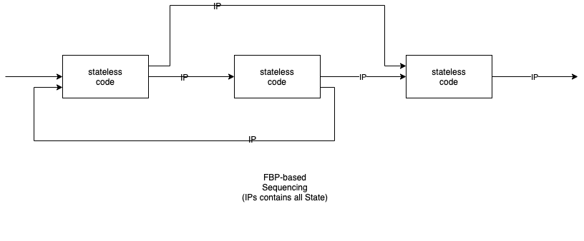

Each component is a concurrent machine.

Concurrent machines communicate with one another via bounded buffers.

Components have input and output ports that are connected to bounded buffers.

Data flowing between components is called IPs (Information Packets).

Components can read-from and write-to ports in a random manner.

A component suspends if it attempts to send to an output port which has a full buffer.

A component suspends if it attempts to read from an input port that has an empty buffer.

FBP can route IPs in a feedback and feedforward manner.

FBP is similar to FP, in that all state is contained in IPs.

FBP can be used to construct filter pipelines, but FBP is more general in that it allows feedback and feedforward. Unlike pipelines, FBP allows connections that "skip over" components in the chain and connections to components that come "earlier" in the chain.

FBP systems have been, traditionally, simulated on top of preemptive sequencing.

(See, also, https://groups.google.com/g/flow-based-programming/c/l5SkeB40iwE)

(See also https://jpaulm.github.io/fbp/).

