RUNNING HEAD: Community responses to warming

TITLE: Can trait patterns along gradients predict plant community responses to climate change?

AUTHORS: John Guittar1, Deborah Goldberg1 Kari Klanderud3, Richard Telford2, Vigdis Vandvik2,

1Ecology and Evolutionary Biology, University of Michigan

2Department of Biology, University of Bergen, Bergen, Norway

3Ecology and Natural Resource Management, Norwegian University of Life Sciences, Ås, Norway

Elements included in this submission:

1. This manuscript (*Guittar_etal_2016April.docx*).
2. Supporting information (*Guittar_etal_2016April_SupportingInformation.docx*).
3. Rmd/R Scripts: *TraitAnalysis_2016April.Rmd*: The R markdown document used to process the data and generate the tables and figures in this study. The file will not run without the raw data (not yet included). It sources code from seven other scripts (*Guittar_etal_Rscripts.zip*)..
4. *traitdataTable.csv*: a list of species found in this study and their accompanying trait data.

This submission is meant for consideration as an ‘article.’

**Abstract:** Plant functional traits vary consistently along climate gradients and are therefore potential predictors of plant community response to climate change. We test this space-for-time assumption by combining a spatial gradient study with whole-community turf transplantation along temperature and precipitation gradients in a network of twelve grassland sites in Southern Norway. Using data on eight traits for 169 species and annual vegetation censuses of 235 turfs over five years, we quantified trait-based responses to climate change by comparing observed community dynamics in transplanted turfs to field-parameterized null model simulations. Three traits related to species architecture (maximum height, number of dormant meristems, and ramet-ramet connection persistence) varied consistently along spatial temperature gradients and also correlated to changes in species abundances in turfs transplanted to warmer climates. Two traits related to growth (SLA, leaf area) varied with spatial temperature gradients but did not correlate to changes in species abundances following warming. No traits correlated consistently with precipitation. Our results support the hypothesis that spatial associations between plant traits and broad-scale climate variables can be predictive of community response to climate change, but illustrate that the strengths of trait patterns along gradients are not necessarily proportional to their responses under climate change.

**Keywords:** Plant functional traits, clonal traits, environmental gradient analysis, turf transplantation, grasslands, alpine plant communities, community response.

# INTRODUCTION

Plant functional traits, defined as measurable species characteristics with explicit connections to individual performance, reflect plant ecological strategy and associate with environmental factors at many spatial and ecological scales (Silvertown 2004, Wright et al. 2005, McGill et al. 2006, Violle et al. 2007). The role that environmental variables play in structuring community composition is often inferred from patterns of community-weighted mean trait values along spatial gradients (Kraft et al. 2008, Cornwell and Ackerly 2009). These trait-environment correlations can then be used as predictive tools (De Bello et al. 2005, Shipley et al. 2006). The ubiquity of many trait-environment correlations in space, and their apparent utility in predicting spatial patterns, suggest they would also be good predictors of community responses to climate change (Lavorel and Garnier 2002, Enquist et al. 2015).

However, there are also reasons why spatial trait gradient patterns may be poor predictors of community responses to climate change. First, it is not clear if species will migrate fast enough to maintain their current associations to climate given the unprecedented rate of anthropogenic climate change (Solomon et al. 2007) and the fact that these associations developed over much longer time scales (Post and Pedersen 2008, Visser 2008). Instead, species assemblages may be in continual flux as species respond and adapt differentially to changing climate conditions (Neilson et al. 2005). Second, rapid climate change could disrupt biotic interaction networks, leading to idiosyncratic species responses that are inconsistent with expectations based on broad-scale trait-environment relationships (Kudo et al. 2004, Post and Pedersen 2008). Third, species may respond to finer-scale changes in environmental variables that cannot be predicted using broad scale climate averages (Kimball et al. 2010, Graae et al. 2012). If the processes that led to current trait-climate patterns differ from those that will govern community response to climate change, predictions derived from general trait-environment relationships will perform poorly.

One way to directly evaluate the potential for spatial trait patterns to predict community responses to climate change is to experimentally manipulate climate *in situ* and observe community response (e.g. Hobbie and Chapin III 1998, Hudson et al. 2011). *In situ* approaches are invaluable in that they allow for precise manipulation of the desired climate variables, but also suffer from several drawbacks. Most notably, the arrival and establishment of immigrants adapted to the new climate conditions is sharply reduced, effectively removing an important driver of community response to climate change (Gottfried et al. 2012). *In situ* experiments may even *suppress* community responses if propagule pressure from locally abundant species is high enough to exert mass effects on the community compositions of experimental plots. *In situ* climate manipulations also have undesirable side effects related to their experimental methods (Aronson and McNulty 2009).

Here, we investigate the effects of climate change on plant communities using an alternative approach: transplantation of entire, intact communities to new climates. We conduct our experiment within a network of twelve grassland sites in southern Norway. These grasslands have shallow but thickly interwoven root networks that allow for the removal and transplantation of intact turf communities. Whole-community transplantation avoids the experimental artifacts of climate change manipulations, while exposing the community to immigration from species adapted to the new environment. In fact, transplantation lies at the other extreme of *in situ* climate manipulations: it provides a scenario in which immigration of climate-adapted species is higher than would be expected in communities subject to gradual environmental change. We monitored changes in the functional composition of 235 control and transplanted turf communities over five years using species-level averages of four commonly measured plant traits: leaf area, maximum vegetative height, seed mass, and specific leaf area (SLA), as well as four less commonly used traits relating to clonal growth strategy: number of offspring per parent, persistence of plant-offspring connection, rate of lateral spread, and bud number (i.e., the number of dormant meristems per ramet). Clonal traits are often overlooked as indicators of plant performance, despite their widespread prevalence and potential significance for community dynamics and ecosystem function, especially in herbaceous plant biomes like grasslands, wetlands, and tundra (Zobel et al. 2010, Cornelissen et al. 2014).

Our central goal was to test if the traits with broad spatial associations to climate also drive community responses to rapid climate change. To do this, we characterized baseline trait patterns across temperature and precipitation gradients in our system, and then determined if the relative strength of these trends was proportional to the apparent influence of these traits on community dynamics in turfs transplanted to warmer and/or wetter conditions. The fact that turf communities were open to immigration from the surrounding vegetation necessitated a careful evaluation of our null expectations. Even under trait-neutral dynamics, natural turnover combined with the immigration and proliferation of locally-abundant species leads transplanted communities to converge compositionally with local sites over time. Any test for trait-mediated dynamics must thus measure community responses against a null model that accounts for stochastic replacement and immigration. We used a Bayesian approach to estimate baseline immigration rates in control communities at each of our sites, and used these estimates in model simulations to generate null expectations of turf response to transplantation. We interpreted the deviation of responses in community trait composition from null expectations as evidence for trait-mediated interactions.

The unusual topography of southwestern Norway allowed us to address an additional shortcoming of most spatial gradient studies by methodologically separating temperature and precipitation as potential climate drivers. Ecological studies along climate gradients often use altitudinal transects that vary in both temperature and precipitation (Callaway et al. 2002, Djukic et al. 2010), although not always in a consistent manner (Körner 2007). This covariation makes it difficult to isolate the individual and interactive effects of temperature and precipitation and thus project how vegetation will respond to novel climates. In southwestern Norway, a west-to-east rainfall gradient interacts with a mosaic of fjords and mountain ridges to generate high climatic heterogeneity over a small geographic area. We exploited this natural heterogeneity to establish a “climate grid” in which temperature and precipitation vary orthogonally among twelve field sites, thereby allowing us to separate their effects and to identify potential interactions.

We use results from our gradient analysis, transplant experiment, and model simulations to address three questions: 1) What is the relative influence of spatial variation in temperature and precipitation on community trait composition? 2) Do the traits that respond to spatial climate gradients also drive community temporal response to climate change? 3) What is the influence of clonal traits relative to more commonly used leaf and canopy height traits in community response to climate gradients and climate change? We expect short species with conservative resource use strategies (low SLA, low leaf area) and high capacity for resource integration (high lateral spread, high connection persistence, many offspring per ramet, and high bud number) to predominate in unproductive climates (the coldest and driest sites) relative to more productive climates (the warmest and wettest sites). Our study is a rigorous experimental evaluation of the assumption that trait patterns along climate gradients reflect, and can therefore predict, how communities will respond to anthropogenic climate change.

# METHODS

The study area is an approximately 500 km x 500 km region in southern Norway with marked climatic heterogeneity (Figure 1). Twelve grassland sites were selected with one of three mean summer temperatures (ca. 6.0, 9.0, and 10.5°C) and one of four mean annual precipitations (ca. 600, 1200, 1900, and 2800mm), while other environmental variables were relatively consistent (calcareous soil, southwest aspect, slope of about 20 degrees, and comparable grazing and land-use history) (see: Klanderud et al. 2015 for additional site details). The grasslands’ short stature (usually < 0.3m at peak biomass) and shallow but thickly interwoven root and rhizome mats enabled the easy removal, transport, and replanting of soil ‘turfs’ and their attached flora to different hillsides. Each 0.25m x 0.25m turf contained tens to hundreds of individual stems with a mean canopy height of 9 cm ± 6 cm (1 SD). Turfs hosted 10-40 vascular plant species, a bryophyte layer, and the local soil and leaf litter biota (Klanderud et al. 2015). In accordance with predictions that climate change will cause southern Norway to become warmer and wetter (Hanssen-Bauer et al. 2009), 40 turfs were transplanted to warmer sites, 45 turfs were transplanted to wetter sites, 30 turfs were transplanted to warmer and wetter sites, 60 control turfs were replanted at the same site, and 60 control turfs were outlined but undisturbed. All non-local transplants were moved one ‘step’ warmer and /or wetter in the climate grid. Turfs were transplanted between sites in multiples of five; sample sizes differed by treatment because not all destination sites had cooler and/or drier sites to serve as turf origins (Figure 1). For control turfs, origin and destination sites are the same site. ‘Target controls’ refer to control turfs at transplant destination sites. Vascular plant turf community censuses were undertaken in 2009 (before transplantation), 2011, 2012, and 2013, for a total of 928 turf community time points (12 turf community time points were discarded due to physical damage to the turf). For each turf census, the percent cover of each species was estimated visually with the aid of a 5cm x 5cm grid. Given bare patches and/or overlapping species covers, total percent cover could fall below or above 100%.

**Trait data:** We built a custom database containing values for up to eight traits for the 169 species present in our turf communities from across the climate grid. Woody seedlings and unidentifiable individuals represented 1.1% total cover, and were discarded. We used four common traits: leaf area (mm2), specific leaf area (SLA) (m2/kg-1), maximum potential canopy height (m), and seed mass (mg), and four traits relating to clonal growth: number of offspring per parent per year (1 or ≥ 2), persistence of plant-offspring connection (< 2 years or ≥ 2 years), rate of lateral spread (≤ 1 cm/year or > 1 cm/year), and bud number, i.e. the number of aboveground and belowground dormant meristems per ramet. Leaf area and SLA were estimated using a combination of field data and data from the LEDA online trait database (Kleyer et al. 2008). Our field data derive from ~1200 leaves collected in the summer of 2012 for which SLA and leaf area were calculated using established protocols (Cornelissen et al. 2003). Maximum potential height data were mined from Lid and Lid (2007). We drew seed mass data from the Seed Information Database (SID) (Royal Botanic Gardens Kew 2014). All continuous trait values were log-transformed. Clonal trait data were extracted from the CLO-PLA database (Klimešová and Bello 2009) and, except for bud number, transformed from categorical to binary metrics to simplify statistical analysis. For bud number, each species was assigned a score of 0 (no buds) to 8 (dozens of buds) based on bud number estimates from Klimešová and Bello (2009). Data on individual traits represented 140 - 164 species (84% - 99% of total cover). Eight species, representing 3.9 % total cover, were identifiable only to genus but treated as species in downstream analyses. For these species, trait values were taken from our field measurements (SLA, leaf area), estimated by taking the median trait values of locally-present congeners (seed mass, maximum height, clonal traits), or left blank. Species lists and trait values are available on Dryad (*pending*). Correlation between the traits were relatively low, both across the species pool and in community-weighted analyses (Appendix A), and the trait responses can thus be interpreted as independent results..

**Community analyses:** Bray-Curtis dissimilarity was used to quantify differences in species composition. Community weighted means (CWMs) were used to quantify differences in functional composition. A CWM is calculated by averaging the values of a particular trait for all species in a community, weighted by their abundance (here, percent cover). For lateral spread, connection persistence, and offspring per ramet, CWMs reflected the proportion of the community with the higher value category (i.e. ≥ 2 offspring per parent, ≥ 2 years connection persistence, or > 1cm/year lateral spread). Spatial patterns of community trait variation were statistically assessed by regressing pre-transplant (2009) turf community CWMs onto site temperature and precipitation values. AIC values were used to determine when temperature, precipitation, and/or their interaction were significant predictors in our abundance-weighted multiple linear regression. For a deeper investigation into species-level variation in community composition see Klanderud et al. (2015).

Community change was quantified as the mean change over time in species or trait dissimilarity between a turf and its target site controls. This method factors out environmental stochasticity because dissimilarity is recalculated each year, i.e., control communities are treated as moving targets. Each site had five undisturbed controls and five controls replanted nearby which enabled us to test for the effects of transplantation per se. Dissimilarity in species composition among undisturbed controls was statistically different (p < 0.05) from the mean dissimilarity between undisturbed and replanted controls in only 5 of 48 of turf community time points, suggesting that transplantation per se did not noticeably affect species composition. Thus, replanted controls and undisturbed controls were combined to increase the control group sample size to ten per site.

**Null model rationale and process:** We used a simulation-based approach to generate explicit null expectations of turf community responses to transplantation, with the ultimate goal of determining when observed community responses deviated from these null expectations. The model is similar in principle to stochastic models of species abundances using Hubbell’s (2001) neutral local community model, but takes place on a smaller spatial scale. Specifically, for each step in the model, an individual is randomly removed from the turf community and either replaced with a randomly selected offspring from the same turf community (with probability *1 – m*), or replaced with a randomly selected offspring from the site-level community (with probability *m*). Each step is a ‘replacement event.’ The site-level community is conceptually equivalent to Hubbell’s ‘metacommunity’, and is defined as the net composition of the ten control turfs present at each site. The model has two parameters: replacement rate (*d*), which is the number of replacement events between each pair of consecutive years, and immigration rate (*m*), which is the probability that replacements are drawn from the site-level community as opposed to from within the turf-level community; see next section for parameter estimation. Even though turfs are only 25 x 25 cm in size, within-turf recruitment is expected to be high because most species in our system exhibit some degree of clonal growth (Klimešová and Bello 2009), and the majority of new stems derive from extant genets rather than seed germination (Guittar et al., *in prep*).

Our model differs from Hubbell’s community model in three important ways. First, rather than use births and deaths of individuals to quantify demographic changes, which would be meaningless and difficult to measure in our predominantly clonal system, we use increases and decreases in percent cover units. Again, to account for layered vegetation or bare ground, percent cover units need not sum to 100 (mean cover in control plots across sites and years ranged from 87 ± 25% to 127 ± 29.7%). Second, we relax the assumption of zero-sum replacement and instead force simulated percent cover to match observed percent cover over the duration of the experiment. Third, we allow site-level communities to vary by recalculating them after each census. In doing so, we account for any temporal variability in the site-level communities due to drift or short-term climatic variability.

We simulated community dynamics from 2009 to 2013 on an individual turf basis, calculating species and trait dissimilarities to target site controls each year. The simulation was repeated 100 times and the resulting values were averaged. Simulation data for 2010 were not presented because field observations do not exist for that year. Paired t-tests were used to determine when observed and simulated null expectations differed significantly.

**Estimating model parameters:** We used community census data from our control turfs to estimate replacement rate (*d*) and immigration rate (*m*) at each site. We set *d* equal to half the sum of differences in species covers in control turfs between years at each site. We divided by two because each replacement event constitutes two shifts in species covers, one increase and one decrease. Values of *d* ranged from 19.7 to 37.4. We used a Bayesian approach to estimate *m* based on shifts in species abundances in the five control turfs at each site over three consecutive years (2011-2013), assuming neutral dynamics. The net composition of the five remaining control turfs at each site was used as the site species pool. The expected cover λ of species *i* in a turf community at time *t* is formally defined as

λ*i,t* = *Jt-1*[(1 – *m*) × *Ci,t-1* + *m* × *Pi,t-1*]

where *Jt-1* is the total cover of the turf community in the previous year, *Ci,t-1* is the relative abundance of species *i* in the turf community the previous year, *Pi,t-1* is the relative abundance of the species in the site-level community at time *t*, and *m* is the immigration parameter. The percent cover *y*, rounded to the nearest whole number, of species *i* in turf community at time *t* was modelled assuming

*yi,t* ~ Poisson(λ*i,t*).

We gave *m* a uniform prior with a range from 0 to 1. We also explored using an informed prior for which *m* could not exceed *1 – m*, but this did not affect our results and was therefore dropped. We fit the model using MCMC implemented in JAGS 3.4.0 (Plummer 2003). We ran JAGS through the R package R2jags (Su and Yajima 2012). For each model fit, we ran three chains, used a burn-in of 1000 iterations, and chose initial values in different regions of parameter space. We confirmed model convergence using Gelman-Rubin diagnostics (Brooks and Gelman 1998). We assessed overall model fit by regressing mean posterior estimates for percent cover on observed data (R2 = 0.63). For a deeper exploration of how a Bayesian approach can be used to fit a trait-neutral model of community change to time series data see Mutshinda et al. (2008).

# RESULTS

Species-level trait values of leaf area, SLA, maximum height, and lateral spread increased with temperature along spatial gradients, whereas species-level values of bud number and connection persistence decreased (Table 1, Figure 2). In three of the eight traits, the best-fit weighted multiple linear model determined by AIC values included precipitation as a predictor variable, but the precipitation variable itself was never significant. The interaction of temperature and precipitation had a significant effect on SLA. Exponential curves with increasing temperature fit bud number and connection persistence patterns better than linear ones, reflecting stronger responses in the colder part of the climate grid (Figure 2). Based on these associations, we limited our analysis of trait convergence in transplanted turfs over time to the six traits with spatial associations to temperature, and to turfs transplanted to warmer climates.

Species and trait compositions of transplanted turfs converged towards target site controls over time, with the magnitude of convergence increasing with initial dissimilarity (Figure 3). In many cases, rates of convergence did not differ significantly from null model predictions that accounted for random replacement by local immigrants (Figure 4). Rates of convergence in species composition exceeded null model predictions only in 2011. Rates of convergence in maximum height, bud number, and connection persistence exceeded null model predictions in at least two of the three yearly pairwise comparisons.

# DISCUSSION

Our study uses observational and experimental data to test the assumption that associations between plant traits and climate patterns in space can be used to predict plant community response to climate changes in time. We find plant maximum height to increase and bud number and connection persistence to decrease in response to increases in temperature in both space and time. Leaf area, rate of lateral spread, and specific leaf area (SLA) trended with spatial temperature gradients but did not correlate to species response to climate warming. In other words, traits relating to plant architecture seemed to influence species performance more than traits traditionally associated with resource use efficiency and acquisition. Our study supports the assumption that traits influence community assembly processes, but warns that traits with broad-scale associations to climate are not necessarily the same as those driving short-term community responses to perturbations.

**Trait patterns along climate gradients:** Despite the large ranges in both mean summer temperature and annual precipitation across sites, community mean trait values trended only with temperature. The lack of functional turnover over almost a 2500 mm increase in precipitation is surprising given the consistent directional turnover in species composition along both temperature and precipitation gradients in our system (Klanderud et al. 2015), and underscores the fact that species turnover does not always beget functional turnover (Hooper et al. 2002). The finding contrasts with vegetation trait patterns found elsewhere over narrower ranges of precipitation (Fonseca et al. 2000, Wright et al. 2005). One possible explanation is that water simply is not a significant limiting resource for plants at our sites, and that rainfall counteracts soil moisture losses from evaporation and evapotranspiration to the extent that soils remain at or near field capacity throughout the growing season. Ultimately, the implication is that functional shifts in these grasslands are likely to occur in response to future changes in temperature, not precipitation.

The consistent shifts in species-level trait values with increasing temperature suggest concurrent shifts in optimal plant ecological strategy. Increases in leaf area and SLA suggest an increase in the abundances of species that preempt resources from competitors when conditions are amenable to growth, as seen on the ‘growth’ side of the growth-tolerance tradeoff (Sterck et al. 2006). Low leaf area and SLA values at the cooler ends of our gradients suggest an increase in the abundances of species more able to survive when conditions are harsh or resources are limited. The increase in maximum height likely reflects a tradeoff in the ability to compete for light at warm sites amenable to growth and the ability to tolerate wind stress and freezing temperatures at the coldest sites (Newman 1973, Westoby 1998, Falster and Westoby 2003).

The strengths of the trends in clonal traits were comparable to those in more commonly measured leaf and stem traits (Figure 2, Table 1), indicating that clonal traits may influence community assembly processes to a similar degree. Evidence connecting clonal traits to plant distributions is limited, but preliminary work suggests species with greater capacity for rapid vegetative spread and shorter persistence of clonal connections predominate in high-nutrient, mesic conditions (Groenendael et al. 1996, Halassy et al. 2005). Our gradient study corroborates this hypothesis, revealing higher rates of lateral spread and less persistent clonal connections at warmer sites. Assuming that environmental stress is greater at colder, higher altitude sites, the tendency for ramets to pack more tightly and to share resources through vegetative connections may increase survival and reproduction there. In addition, we found species with more vegetative buds to be more abundant at the coldest sites. Bud number is associated with species ability to recover from disturbances and better tolerate environmental variability (Klimešová and Klimes 2007). The putatively higher rates of abiotic disturbance (late spring frosts, wind, unstable soils due to rockier, less-developed soils) and, perhaps, higher relative rates of biotic disturbance at the coldest sites, could be related to the decrease in bud number with temperature, although additional work is needed to confirm this. We hypothesize that the increases in lateral spread and connection persistence, and the decrease in bud number with increasing temperature are indicative of a tradeoff in species ability to endure stress and species ability to rapidly acquire abundant resources in conditions amenable for rapid growth (see: Zobel et al. 2010).

**Community responses to warming:** The central goal of this study was to test the hypothesis that trait gradient relationships are predictive of temporal community response to rapid climate change, a common assumption in climate change research. Of the six traits with significant trends with temperature, maximum height, bud number, and connection persistence associated consistently with community response to transplantation to warmer conditions. The large deviation in maximum height from neutral expectations may have resulted from size-asymmetric competition for light (Schwinning and Weiner 1998). That is, taller species may have preempted access to light in transplanted turfs, shading out competitors, and earning disproportionate returns. The potential influence of bud number and connection persistence is harder to interpret but may involve the ability to recover from disturbances and tolerate environmental variability (Klimešová and Klimes 2007). It is unlikely this is an artifact related to the transplantation treatment, given that we detected no influence of disturbance in replanted controls. Instead, high bud number and high connection persistence – two architectural traits related to maternal subsidies and resource integration – may lend critical support for new ramets at the coldest sites, but incur costs at warmer temperatures. More research is needed to understand why maximum height and, especially, clonal traits like bud number and connection persistence influence community assembly.

That SLA and leaf area did not associate with community response to warming was unexpected, given that these growth-related traits showed strong shifts along temperature gradients. Perhaps, the capacity for rapid growth was not helpful to new ramets vying for resources in communities already packed with established individuals. Rapid growth may only be advantageous when gaps are available for colonization, and our experiment mostly ignores gap dynamics as the transplanted turfs were intact and largely protected from disturbances. Alternatively, SLA and leaf area may simply be poor predictors of growth in herbaceous species with photosynthetic stems. We are currently conducting a gap experiment in this system to explore the potential for trait-mediated recruitment dynamics (Guittar et al. *in prep*).

Modeling null model expectations was challenging given the lack of standard practices of how to model demographic stochasticity in predominantly clonal systems (Eriksson 1994). Traditionally, demographic approaches use population numbers and vital rates, but the concepts of individuals, populations, births, and deaths break down in clonal, modular organisms like plants. For instance, the number of ramets is not always feasible to measure and may not be demographically meaningful for graminoids that form hummocks with clumps of stems (e.g. *Festuca ovina*), nor is it possible to distinguish individuals in forbs with sprawling aboveground stems with adventitious roots (e.g. *Veronica biflora*), or species that divide via root splitting which results in fragmentation just below the litter layer (e.g. *Cerastium alpinum*). Our decision to simulate demographic changes using percent cover units therefore has both practical and conceptual appeal. The drawback, however, is that percent cover is sensitive to environmental factors that are not demographically significant, such as variation in phenological stage among individuals, species, and sampling times, and thus may overestimate shifts in abundance between years. Nevertheless, our approach effectively accounts for demographic stochasticity, annual variation in community-level composition, and the realities of dispersal limitation in a predominantly clonal system when generating explicit null expectations of community response to perturbation.

**Conclusions and future directions:** Using trait patterns along environmental gradients to forecast community response to climate change is an intuitively appealing approach. Our study provides qualified support for such an approach: three of the six traits with spatial associations to temperature in our system associated significantly with species success following transplantation to warmer climates. Evidently, spatial associations between plant traits and broad-scale climate variables can be predictive of community response to climate change, but their strength is not necessarily proportional to their predictive power.

Our results shed light on how our system is likely to respond to climate change in the coming decades. Despite surprisingly high rates of annual turnover, virtually all replacement stems are clonal outgrowths of extant genets rather than new seedlings, with new seedlings only establishing in gaps created by disturbances (Guittar et al. *in prep*). It follows that the rate of community response to climate change in our grasslands will be limited by the prevalence of gaps, and the proportion of the seed rain that contains immigrants rather than local species. Once established, immigrant species will likely proliferate successfully via new clonal ramets thanks to their optimal trait values. These conclusions underscore the importance of accounting for stochasticity and immigration when making predictions of community response (Tilman 2004, Shipley et al. 2011). One outstanding question is whether the species most capable of colonizing gaps via long-distance dispersal are those best suited to proliferate under new climate conditions. Future studies should also consider the effects of dispersal limitation on short-term transient responses, and how these may impact long-term equilibrium responses. Discussions about ‘extinction debts’ and ‘immigration credits’ in the field of habitat distribution modeling are a step in the right direction (Dirnböck and Dullinger 2004), but these approaches are still based on the notion that present day species distributions will reflect future species-climate relationships, a dubious premise given that current plant communities are already showing unpredictable responses to climatic changes (Gottfried et al. 2012).

**Acknowledgments:** We thank the Norwegian Research Council (project 184912/S30), NSF GRFP (JLG; Grant Number: 1256260), and Norge-Amerika Foreningen for funding. We thank Jitka Klimešová for advice relating to clonal traits, Emily Farrer for help on developing the Bayesian null model, and the SEEDclim team for general support.

# WORKS CITED

Alonso, D., R. S. Etienne, and A. J. McKane. 2006. The merits of neutral theory. Trends in Ecology and Evolution 21:451–457.

Aronson, E. L., and S. G. McNulty. 2009. Appropriate experimental ecosystem warming methods by ecosystem, objective, and practicality. Agricultural and Forest Meteorology 149:1791–1799.

De Bello, F., J. Lepš, and M. T. Sebastià. 2005. Predictive value of plant traits to grazing along a climatic gradient in the Mediterranean. Journal of Applied Ecology 42:824–833.

Brooks, S. P. B., and A. G. Gelman. 1998. General methods for monitoring convergence of iterative simulations. Journal of computational and graphical statistics 7:434–455.

Callaway, R., R. Brooker, and P. Choler. 2002. Positive interactions among alpine plants increase with stress. Nature 417:844–848.

Cornelissen, J. H. C., Y.-B. Song, F.-H. Yu, and M. Dong. 2014. Plant traits and ecosystem effects of clonality: a new research agenda. Annals of botany 114:369–376.

Cornelissen, J., S. Lavorel, E. Garnier, S. Díaz, Buchmann, D. Gurvich, P. Reich, H. ter Steege, M. HD, M. Van Der Heijden, J. Pausas, and H. Poorter. 2003. A handbook of protocols for standardised and easy measurement of plant functional traits worldwide. Australian Journal of Botany 51:335–380.

Cornwell, W., and D. Ackerly. 2009. Community assembly and shifts in plant trait distributions across an environmental gradient in coastal California. Ecological Monographs 79:109–126.

Dirnböck, T., and S. Dullinger. 2004. Habitat distribution models, spatial autocorrelation, functional traits and dispersal capacity of alpine plant species. Journal of Vegetation Science 15:77–84.

Djukic, I., F. Zehetner, A. Mentler, and M. Gerzabek. 2010. Microbial community composition and activity in different Alpine vegetation zones. Soil Biology and Biochemistry 42:155–161.

Enquist, B. J., J. Norberg, S. P. Bonser, C. Violle, C. T. Webb, A. Henderson, L. L. Sloat, and V. M. Savage. 2015. Scaling from traits to ecosystems: Developing a general Trait Driver Theory via integrating trait-based and metabolic scaling theories. Advances in Ecological Research 52:249–318.

Eriksson, O. 1994. Stochastic population dynamics of clonal plants: numerical experiments with ramet and genet models. Ecological Research 9:257–268.

Falster, D. S., and M. Westoby. 2003. Plant height and evolutionary games. Trends in Ecology and Evolution 18:337–343.

Fonseca, C. R., J. M. Overton, B. Collins, and M. Westoby. 2000. Shifts in trait-combinations along rainfall and phosphorus gradients. Journal of Ecology 88:964–977.

Gottfried, M., H. Pauli, A. Futschik, M. Akhalkatsi, P. Barančok, J. L. Benito Alonso, ..., and G. Grabherr. 2012. Continent-wide response of mountain vegetation to climate change. Nature Climate Change 2:111–115.

Graae, B. J., P. de Frenne, A. Kolb, J. Brunet, O. Chabrerie, K. Verheyen, N. Pepin, T. Heinken, M. Zobel, A. Shevtsova, I. Nijs, and A. Milbau. 2012. On the use of weather data in ecological studies along altitudinal and latitudinal gradients. Oikos 121:3–19.

Gravel, D., C. D. Canham, M. Beaudet, and C. Messier. 2006. Reconciling niche and neutrality: The continuum hypothesis. Ecology Letters 9:399–409.

Groenendael, J. M. V, L. Klimes, J. Klimesova, and R. J. J. Hendriks. 1996. Comparative Ecology of Clonal Plants. Philosophical Transactions of the Royal Society B 351:1331–1339.

Halassy, M., G. Campetella, R. Canullo, and L. Mucina. 2005. Patterns of functional clonal traits and clonal growth modes in contrasting grasslands in the central Apennines, Italy. Journal of Vegetation 16:29–36.

Hobbie, S. E., and F. S. Chapin III. 1998. The response of tundra plant biomass, aboveground production, nitrogen, and CO2 flux to experimental warming. Ecology 79:1526–1544.

Hooper, D. U., M. Solan, and A. Symstad. 2002. Species diversity, functional diversity and ecosystem functioning. Pages 195 – 208 In: Biodiversity and ecosystem functioning: synthesis and perspectives. Oxford University Press, Oxford, England.

Hubbell, S. P. 2001. The unified neutral theory of biodiversity and biography. Monographs in Population Biology. Princeton University Press.

Hudson, J. M. G., G. H. R. Henry, and W. K. Cornwell. 2011. Taller and larger: shifts in Arctic tundra leaf traits after 16 years of experimental warming. Global Change Biology 17:1013–1021.

Kimball, S., A. L. Angert, T. E. Huxman, and D. L. Venable. 2010. Contemporary climate change in the Sonoran Desert favors cold-adapted species. Global Change Biology 16:1555–1565.

Klanderud, K., V. Vandvik, and D. Goldberg. 2015. The Importance of Biotic vs. Abiotic Drivers of Local Plant Community Composition Along Regional Bioclimatic Gradients. Plos One 10:1–14.

Klimešová, J., and F. De Bello. 2009. CLO-PLA: The database of clonal and bud bank traits of Central European flora. Journal of Vegetation Science 20:511–516.

Klimešová, J., and L. Klimes. 2007. Bud banks and their role in vegetative regeneration – A literature review and proposal for simple classification and assessment. Perspectives in Plant Ecology, Evolution and Systematics 8:115–129.

Körner, C. 2007. The use of “altitude” in ecological research. Trends in Ecology & Evolution 22:569–574.

Kraft, N. J. B., R. Valencia, and D. D. Ackerly. 2008. Functional traits and niche-based tree community assembly in an Amazonian forest. Science 322:580.

Kudo, G., Y. Nishikawa, T. Kasagi, and S. Kosuge. 2004. Does seed production of spring ephemerals decrease when spring comes early? Ecological Research 19:255–259.

Lavorel, S., and E. Garnier. 2002. Predicting changes in community composition and ecosystem functioning from plant traits: revisiting the Holy Grail. Functional Ecology 16:545–556.

Lid, J., and D. T. Lid. 2007. Norsk flora. Det Norske Samlaget.

McGill, B. J., B. J. Enquist, E. Weiher, and M. Westoby. 2006. Rebuilding community ecology from functional traits. Trends in Ecology and Evolution 21:178–185.

Mutshinda, C. M., R. B. O’Hara, and I. P. Woiwod. 2008. Species abundance dynamics under neutral assumptions: a Bayesian approach to the controversy. Functional Ecology 22:340–347.

Neilson, R. R. P., L. L. F. Pitelka, A. M. Solomon, R. Nathan, G. F. Midgley, J. M. V. Fragoso, H. Lischke, and K. Thompson. 2005. Forecasting regional to global plant migration in response to climate change. BioScience 55:749.

Newman, E. 1973. Dr. Newman replies to Dr. Grime’s Competition and Diversity in Herbaceous Vegetation. Nature 244.

Plummer, M. 2003. JAGS: A program for analysis of bayesian graphical models using gibbs sampling. Proceedings of the 3rd International Workshop on Distributed Statistical Computing (DSC 2003). March:20–22.

Post, E., and C. Pedersen. 2008. Opposing plant community responses to warming with and without herbivores. Proceedings of the National Academy of Sciences of the USA 105:12353–12358.

Royal Botanic Gardens Kew. 2014. Seed Information Database (SID).

Schwinning, S., and J. Weiner. 1998. Mechanisms determining the degree of size asymmetry in competition among plants. Oecologia 113:447–455.

Shipley, B., C. E. T. Paine, and C. Baraloto. 2011. Quantifying the importance of local niche-based and stochastic processes to tropical tree community assembly. Ecology 93:760–769.

Shipley, B., D. Vile, and E. Garnier. 2006. From plant traits to plant communities: a statistical mechanistic approach to biodiversity. Science (New York, N.Y.) 314:812–4.

Silvertown, J. 2004. Plant coexistence and the niche. Trends in Ecology and Evolution 19:605–611.

Solomon, S., D. Qin, M. Manning, Z. Chen, M. L. Parry, O. F. Canziani, ..., and D. Martino. 2007. IPCC, 2007: summary for policymakers. In: Climate change 2007: the physical science basis. Contribution of working group I to the fourth assessment report of the intergovernmental panel on climate change. Cambridge University Press, Cambridge, UK.

Sterck, F., L. Poorter, and F. Schieving. 2006. Leaf traits determine the growth-survival trade-off across rain forest tree species. The American Naturalist 167:758–765.

Su, Y., and M. Yajima. 2012. R2jags: A Package for Running jags from R.

Tilman, D. 2004. Niche tradeoffs, neutrality, and community structure: a stochastic theory of resource competition, invasion, and community assembly. Proceedings of the National Academy of Sciences of the USA 101:10854–10861.

Violle, C., M. Navas, D. Vile, E. Kazakou, C. Fortunel, I. Hummel, and E. Garnier. 2007. Let the concept of trait be functional! Oikos 116:882–892.

Visser, M. E. 2008. Keeping up with a warming world; assessing the rate of adaptation to climate change. Proceedings of the Royal Society B 275:649–659.

Westoby, M. 1998. A leaf-height-seed (LHS) plant ecology strategy scheme. Plant and Soil 199:213–227.

Wright, I. J., P. B. Reich, J. H. C. Cornelissen, D. S. Falster, P. K. Groom, K. Hikosaka, ..., and M. Westoby. 2005. Modulation of leaf economic traits and trait relationships by climate. Global Ecology and Biogeography 14:411–421.

Zobel, M., M. Moora, and T. Herben. 2010. Clonal mobility and its implications for spatio-temporal patterns of plant communities: what do we need to know next? Oikos 119:802–806.

TABLE 1: Summary statistics for the best-fit weighted linear model for each trait

|  |  |  |  |  |  |  |
| --- | --- | --- | --- | --- | --- | --- |
| Trait | Variable | Estimate | SE | t-statistic | p-value | |
| Bud Number | exp(-Temp) | 118.15 | 52.83 | 2.24 | 0.049 |
| Lat. Spread | Temp | 0.04 | 0.01 | 2.50 | 0.031 |
| Leaf Area | Temp | 0.05 | 0.01 | 3.83 | 0.004 |
|  | Precip | < 0.01 | < 0.01 | -1.50 | 0.167 |
| Max. Height | Temp | 0.05 | 0.01 | 4.26 | 0.002 |
| Offspring | (none) |  |  |  |  |
| Persistence | exp(-Temp) | 109.14 | 19.28 | 5.66 | < 0.001 |
| Seed Mass | (none) |  |  |  |  |
| SLA | Temp | 0.02 | 0.00 | 5.35 | < 0.001 |
|  | Precip | < 0.01 | < 0.01 | -1.24 | 0.251 |
|  | Temp x Precip | < 0.01 | < 0.01 | 2.48 | 0.038 |

Summary statistics for the best-fit weighted linear model for each trait using mean summer temperature, annual precipitation, and their interaction as potential predictor variables, weighted by the sample size at each site (N ranges from 10 to 25). Best-fit models were determined using AIC values. For bud number and connection persistence, exponentially transforming the temperature axis resulted in better model fit. Site trait means and significant regressions are shown in Figure 2.

**Figure 1:** Panel A: a schematic illustration of the orthogonal nature of climate variables across experimental sites, with black arrows representing the directions of turf transplants in replicates of five. Panels B and C show the geographical locations of experimental sites in Southern Norway. Symbol shapes and shadings reflect mean summer temperature level and mean annual precipitation level, respectively, in accordance with panel A.

**Figure 2:** Trait patterns along natural gradients of mean summer temperature (left) and mean annual precipitation (right). Values represent community weighted mean (CWM) trait values of turf communities prior to transplantation; aggregated by site (N ranges from 10 to 25). Vertical lines show ± 1 S.D. Symbol shapes and shadings reflect temperature and precipitation levels, respectively, in accordance with Figure 1A. Best-fit lines are shown when trait-gradient relationships are significant; for simplicity, trend lines represent univariate regressions, even if multivariate regressions generated higher AIC values. The interactive effects of temperature and precipitation on SLA is shown using three regression lines (~9°C: dotted, ~6°C: dashed, ~3°C: dotdashed). CWMs in seed mass, offspring per ramet, and bud number do not exhibit significant trends along temperature or precipitation gradients and are therefore omitted. See Table 1 for model summary statistics.

**Figure 3:** Change in dissimilarity of turfs transplanted to warmer climates to target site controls from 2009 to 2013. The x-axis shows Bray-Curtis dissimilarity between turfs and the centroid of their control turfs in 2009, and the y-axis shows the change in that dissimilarity by 2013. Each symbol represents a turf community. Grey crosses represent control turfs; black circles represent transplanted turfs. Dissimilarity was calculated using Bray-Curtis distance for species composition (top left panel) or Euclidian distance of community weighted means (all remaining panels). Symbols below zero on the Y-axis reflect turf communities that converged compositionally towards target controls, whereas communities above zero on the Y-axis diverged compositionally. Dashed vertical lines are placed at 50% of mean dissimilarity among controls as an approximation of natural community stochasticity. Grey ellipses represent 95% confidence intervals of the centroids of control turf dissimilarities.

**Figure 4:** Mean trait dissimilarities of transplanted turf communities to target controls from 2009 to 2013. Solid lines represent observed field data. Dashed lines represent simulated null expectations based on the means of 100 null model simulation runs. Dotted lines represent the mean dissimilarity among control turfs within sites. Null model simulations use immigration rates estimated by fitting our model of trait-neutral community dynamics to observed control turf community dynamics using a Bayesian approach (see Methods). Error bars show 95% confidence intervals. Statistical differences between observed and simulated community weighted means are shown when p < 0.05 (*).

FIGURE 1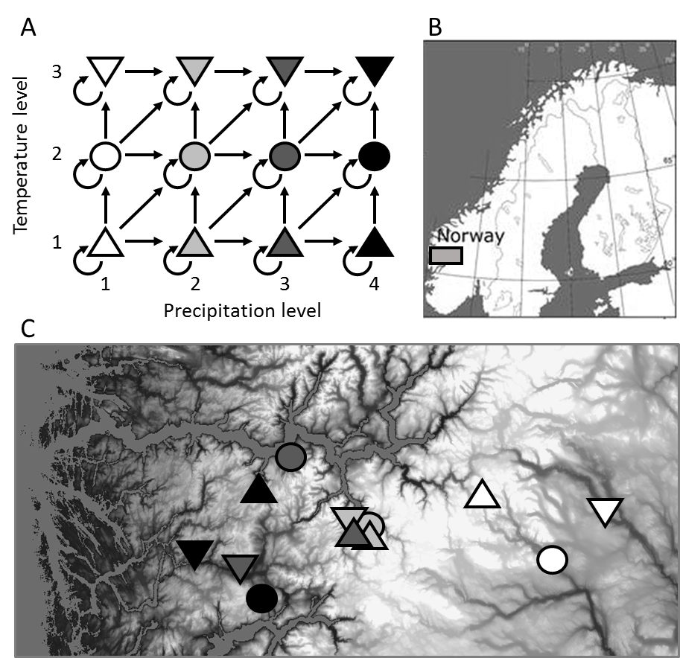

FIGURE 2 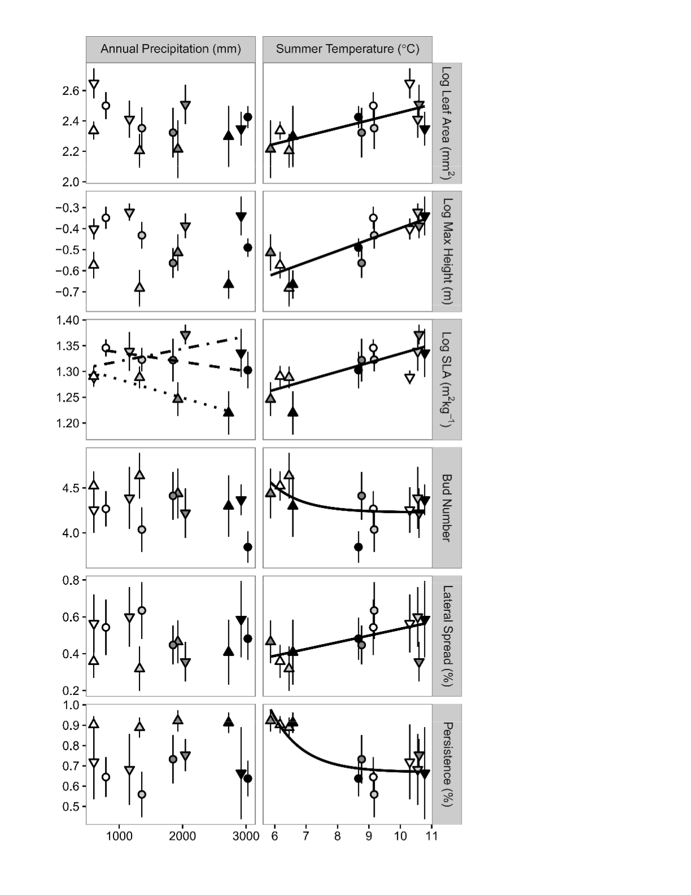

FIGURE 3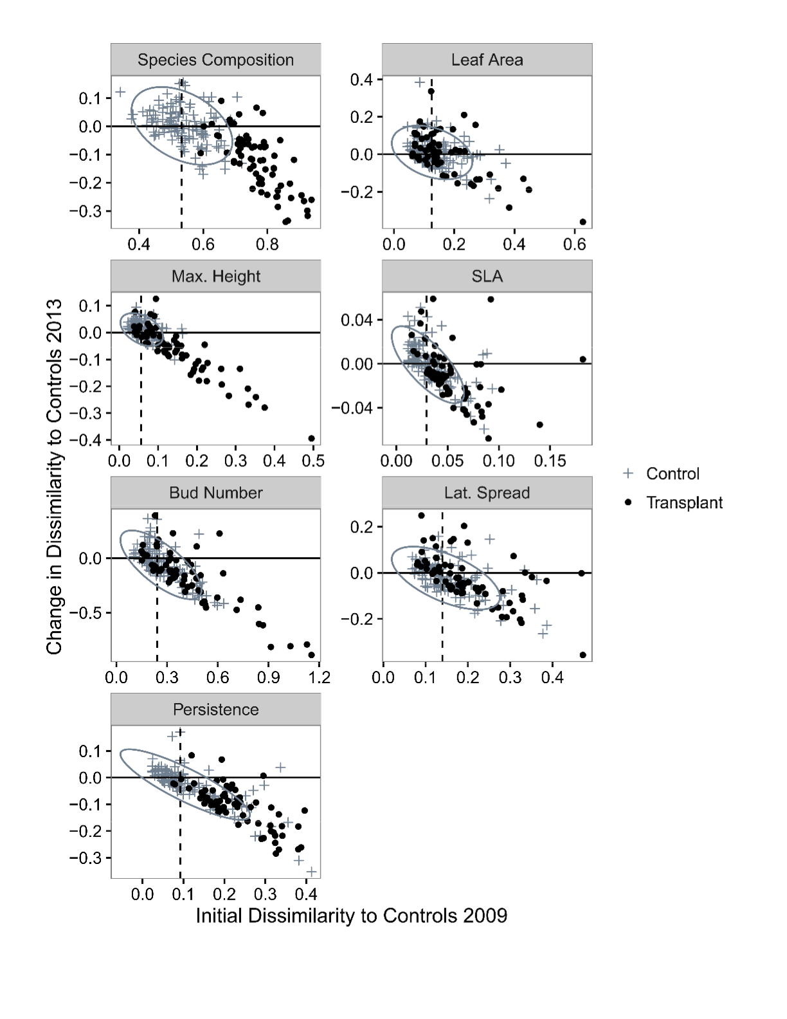

FIGURE 4

