TABLE S1

|  |  |  |  |  |  |  |  |
| --- | --- | --- | --- | --- | --- | --- | --- |
|  | Max. Height | Seed Mass | SLA | Bud Number | Lat. Spread | Offspring | Persistence |
| Leaf Area | 0.46 | 0.51 | 0.34 | -0.13 | -0.12 | -0.11 | -0.03 |
| Max. Height |  | 0.33 | 0.17 | 0.15 | -0.02 | -0.01 | 0.18 |
| Seed Mass |  |  | 0.16 | 0.06 | -0.12 | 0.05 | 0.16 |
| SLA |  |  |  | **-0.36** | -0.14 | 0.11 | **-0.40** |
| Bud Number |  |  |  |  | 0.30 | 0.00 | 0.30 |
| Lat. Spread |  |  |  |  |  | 0.16 | -0.08 |
| Offspring |  |  |  |  |  |  | -0.12 |

Pearson correlations of species trait values in the species pool. Bold indicates significance (p < 0.05). N ranges from 140 - 152.



TABLE S2

|  |  |  |  |  |
| --- | --- | --- | --- | --- |
| Site | Summer Temp. (C°) | Precipitation (mm) | d | m |
| Ulvhaugen | 6.17 | 596 | 31 | 0.064 |
| Låvisdalen | 6.45 | 1321 | 23 | 0.165 |
| Gudmedalen | 5.87 | 1925 | 26 | 0.280 |
| Skjellingahaugen | 6.58 | 2725 | 20 | 0.322 |
| Ålrust | 9.14 | 789 | 34 | 0.263 |
| Høgsete | 9.17 | 1356 | 31 | 0.356 |
| Rambæra | 8.77 | 1848 | 24 | 0.293 |
| Veskre | 8.67 | 3029 | 32 | 0.391 |
| Fauske | 10.30 | 600 | 37 | 0.175 |
| Vikesland | 10.55 | 1161 | 36 | 0.170 |
| Arhelleren | 10.60 | 2044 | 33 | 0.159 |
| Øvstedal | 10.78 | 2923 | 22 | 0.170 |

Site-level simulation parameters, sorted by temperature level (ca. 6.0, 9.0, and 10.5 C°) then precipitation level (ca. 600, 1200, 1900, and 2800 mm/year). Summer temperature is the mean of the four warmest months. Replacement rate (d) was estimated based on observed changes in cover between years. Immigration rate (m) was estimated in control turfs at each site using a Bayesian approach that assumed control turf dynamics were species-neutral. Parameter estimates are shown graphically in the top right panel of Figure S2.

**Figure S1:** Mean summer temperature values measured over the duration of the experiment at two heights (2m and 30cm). Summer temperatures reflect the mean of the four warmest months, calculated individually by site. Four site values are included in temperature level; error bars reflect 1SD.

**Figure S2:** A boxplot diagram depicting the mean increase in temperature experienced by turfs transplanted to warmer sites over the duration of the experiment. Measurements occurred at two heights (2m and 30cm). Temperature increase was determined by subtracting the mean temperature of the turf origin from the mean summer temperature each year. Summer temperatures reflect the mean of the four warmest months, calculated individually by site.

**Figure S3**: A contoured heat map showing the alignment of model simulations to field data in terms of species composition under a broad survey of replacement rates (*d*) and immigration rates (*m*). The heat map depicts the mean difference (“Mean Deviation”) in Bray-Curtis dissimilarity of species-level composition between observed field data and 100 simulation reps for each combination of parameters. In the top right panel, solid circles show the combinations of site-level immigration and replacement rates used in null model simulations.

**Figure S4:** Differences between predicted and observed species abundances in 2013, plotted by trait value using scatterplots (continuous traits) or boxplots (binary traits). Red lines and 95% confidence intervals are shown when there are significant (solid red line) or nearly significant (dashed red line) relationships. The diameter of each solid circle is proportional to its abundance in the region.

FIGURE S1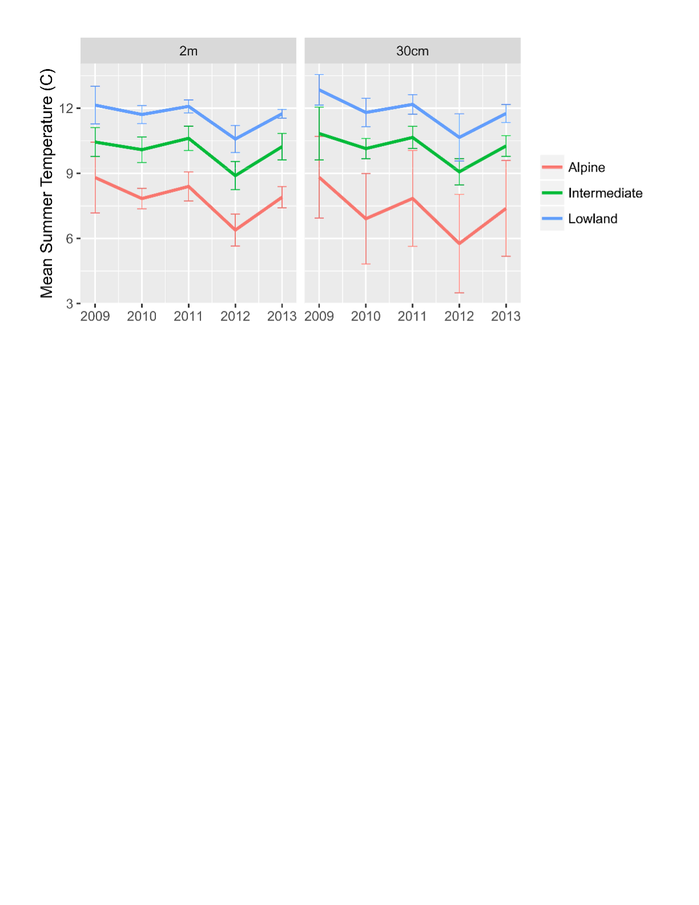FIGURE S2 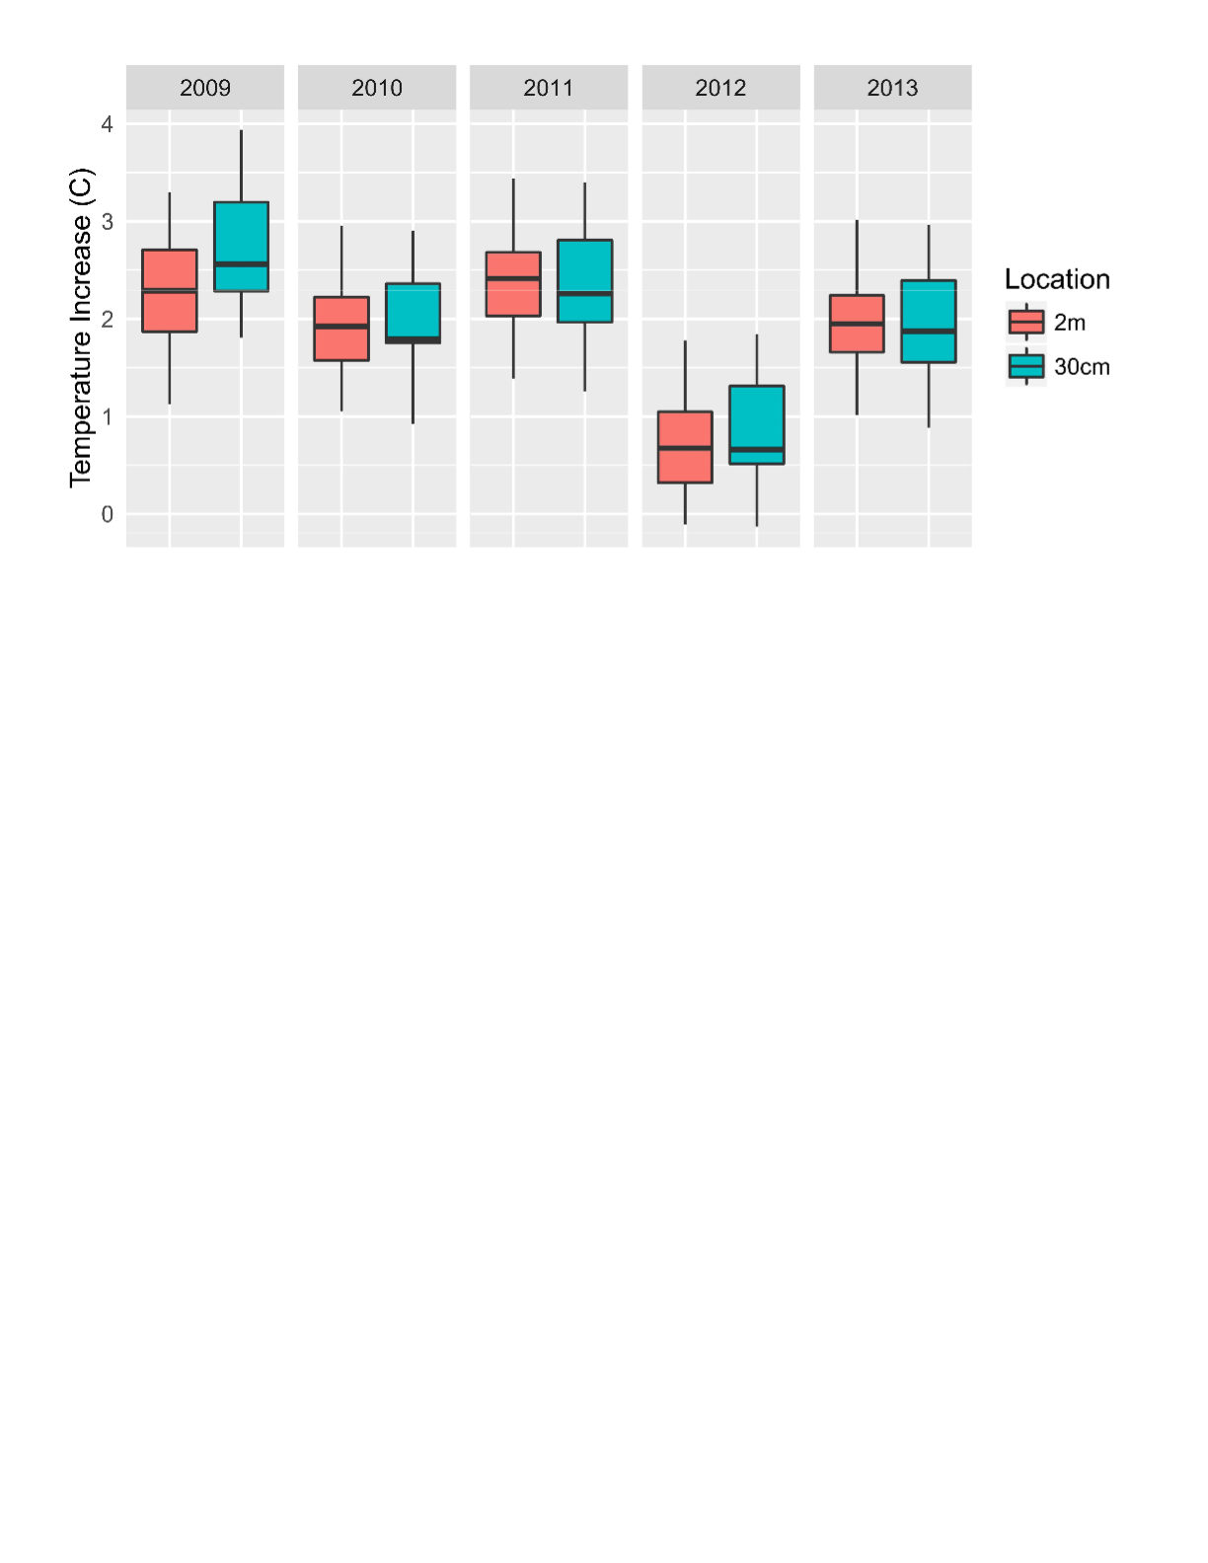

FIGURE S3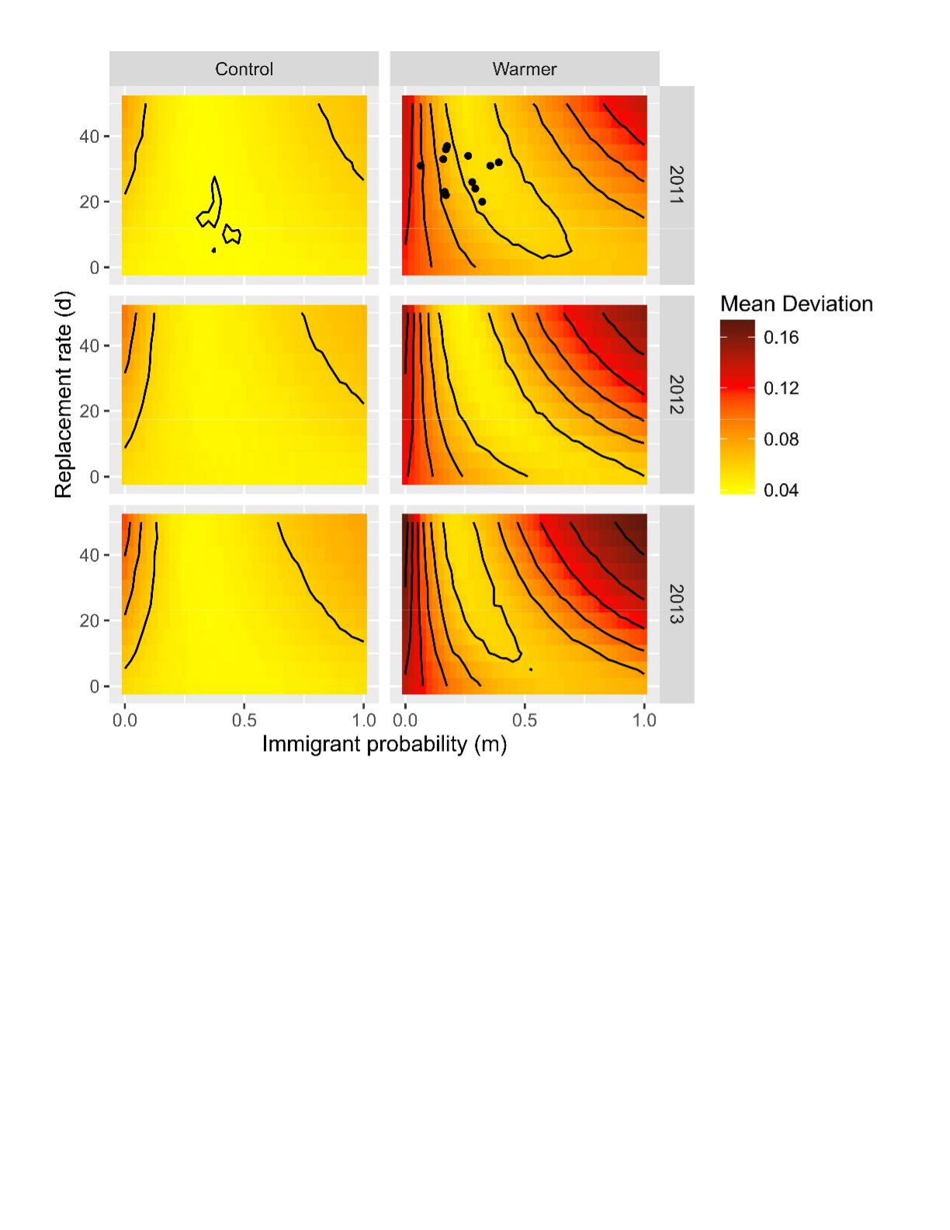FIGURE S4

