TABLE S1

|  |  |  |  |  |  |  |  |
| --- | --- | --- | --- | --- | --- | --- | --- |
|  | Max. Height | Seed Mass | SLA | Bud Number | Lat. Spread | Offspring | Persistence |
| Leaf Area | 0.46 | 0.51 | 0.34 | -0.13 | -0.12 | -0.11 | -0.03 |
| Max. Height |  | 0.33 | 0.17 | 0.15 | -0.02 | -0.01 | 0.18 |
| Seed Mass |  |  | 0.16 | 0.06 | -0.12 | 0.05 | 0.16 |
| SLA |  |  |  | **-0.36** | -0.14 | 0.11 | **-0.40** |
| Bud Number |  |  |  |  | 0.30 | 0.00 | 0.30 |
| Lat. Spread |  |  |  |  |  | 0.16 | -0.08 |
| Offspring |  |  |  |  |  |  | -0.12 |

Pearson correlations in species trait values. Bold indicates significance. N ranges from 140 - 152.

TABLE S2

|  |  |  |  |  |  |  |  |
| --- | --- | --- | --- | --- | --- | --- | --- |
|  | Max. Height | Seed Mass | SLA | Bud Number | Lat. Spread | Offspring | Persistence |
| Leaf Area | 0.52 | 0.32 | 0.31 | **-0.31** | 0.17 | 0.11 | -0.28 |
| Max. Height |  | -0.08 | **0.48** | **-0.17** | **0.55** | **0.35** | **-0.37** |
| Seed Mass |  |  | -0.02 | -0.15 | -0.50 | 0.09 | 0.10 |
| SLA |  |  |  | -0.12 | 0.11 | 0.15 | **-0.47** |
| Bud Number |  |  |  |  | -0.17 | -0.10 | 0.64 |
| Lat. Spread |  |  |  |  |  | **0.35** | -0.35 |
| Offspring |  |  |  |  |  |  | -0.15 |

Pearson correlations in community weighted means. Bold indicates significance. N = 232.

APPENDIX S1

In our second, independent method of estimating immigration rate, we identified *m* values that resulted in the greatest amount of explained variation in observed rates of species-based change, given our estimated values for replacement rate (*d*). This method is more conservative than the Bayesian approach because it ignores the possibility for trait-mediated interactions to accelerate rates of species-based change. Despite their differences, the two approaches yielded similar immigration rate estimates (Table S3), and nearly identical simulation results (compare Figure 4 and Figure S1).

We ran model simulations using a wide range of parameter combinations to assess general model behavior (*d* values from 0 to 50 in increments of five, and *m* values from 0 to 1 in increments of 0.025, replicated 100 times). Replacement rate (*d*) and immigration rate (*m*) interactively affected turf compositional change (Figure S2). Despite this interactive influence, model performance was relatively invariant over the range of site-level estimates of *d* (20 to 37) and *m* (0.233 to 0.387) in our study (Figure S2, panel 2), underscoring the robustness of our results and conclusions.

TABLE S1

|  |  |  |  |  |  |  |
| --- | --- | --- | --- | --- | --- | --- |
| Site | Summer Temp. (C°) |  | Precipitation (mm) | d | m.fit | m.bayes |
| Ulvhaugen | 6.17 |  | 596 | 31 | 0.350 | 0.223 |
| Lavisdalen | 6.45 |  | 1321 | 23 | 0.375 | 0.295 |
| Gudmedalen | 5.87 |  | 1925 | 26 | 0.300 | 0.377 |
| Skjellingahaugen | 6.58 |  | 2725 | 20 | 0.275 | 0.338 |
| Alrust | 9.14 |  | 789 | 34 | 0.475 | 0.364 |
| Hogsete | 9.17 |  | 1356 | 31 | 0.225 | 0.310 |
| Rambera | 8.77 |  | 1848 | 24 | 0.250 | 0.342 |
| Veskre | 8.67 |  | 3029 | 32 | 0.300 | 0.340 |
| Fauske | 10.30 |  | 600 | 37 | 0.225 | 0.291 |
| Vikesland | 10.55 |  | 1161 | 36 | 0.450 | 0.387 |
| Arhelleren | 10.60 |  | 2044 | 33 | 0.250 | 0.261 |
| Ovstedal | 10.78 |  | 2923 | 22 | 0.075 | 0.304 |

Site-level simulation parameters, sorted by temperature level (ca. 6.0, 9.0, and 10.5 C°) then precipitation level (ca. 600, 1200, 1900, and 2800 mm/yr). Summer temperature is the mean of the four warmest months. Replacement rate (d) was estimated based on observed changes in cover between years. Immigration rate (m) was estimated using two methods: mfit was selected to maximize closeness of fit with observed rates of species-based change (Appendix S1), and mbayes was derived using a Bayesian approach to estimating immigration in control turfs assuming they exhibited trait-neutral dynamics. Parameter estimates are also shown graphically in the top right panel of Figure S2.

**Figure S1:** Identical to Figure 3 but showing simulations based on the maximum-rate method of estimating immigration rate. Specifically, the model was parameterized such that simulated community change aligned with observed community change in terms of species composition (see Appendix S1). Parameter values are shown in Table S3.

**Figure S2**: A contoured heat map showing the alignment of model simulations to field data in terms of species composition under a range of replacement rates (*d*) and immigration rates (*m*). The heat map depicts the mean difference (“Mean Deviation”) in Bray-Curtis dissimilarity of species-level composition between observed field data and 100 simulation reps for each combination of parameters. In the top right panel, circles show the combinations of site-level immigration and replacement rates used in null model simulations, as determined using the Bayesian (solid) and best-fit (hollow) methods of parameter.

FIGURE S1 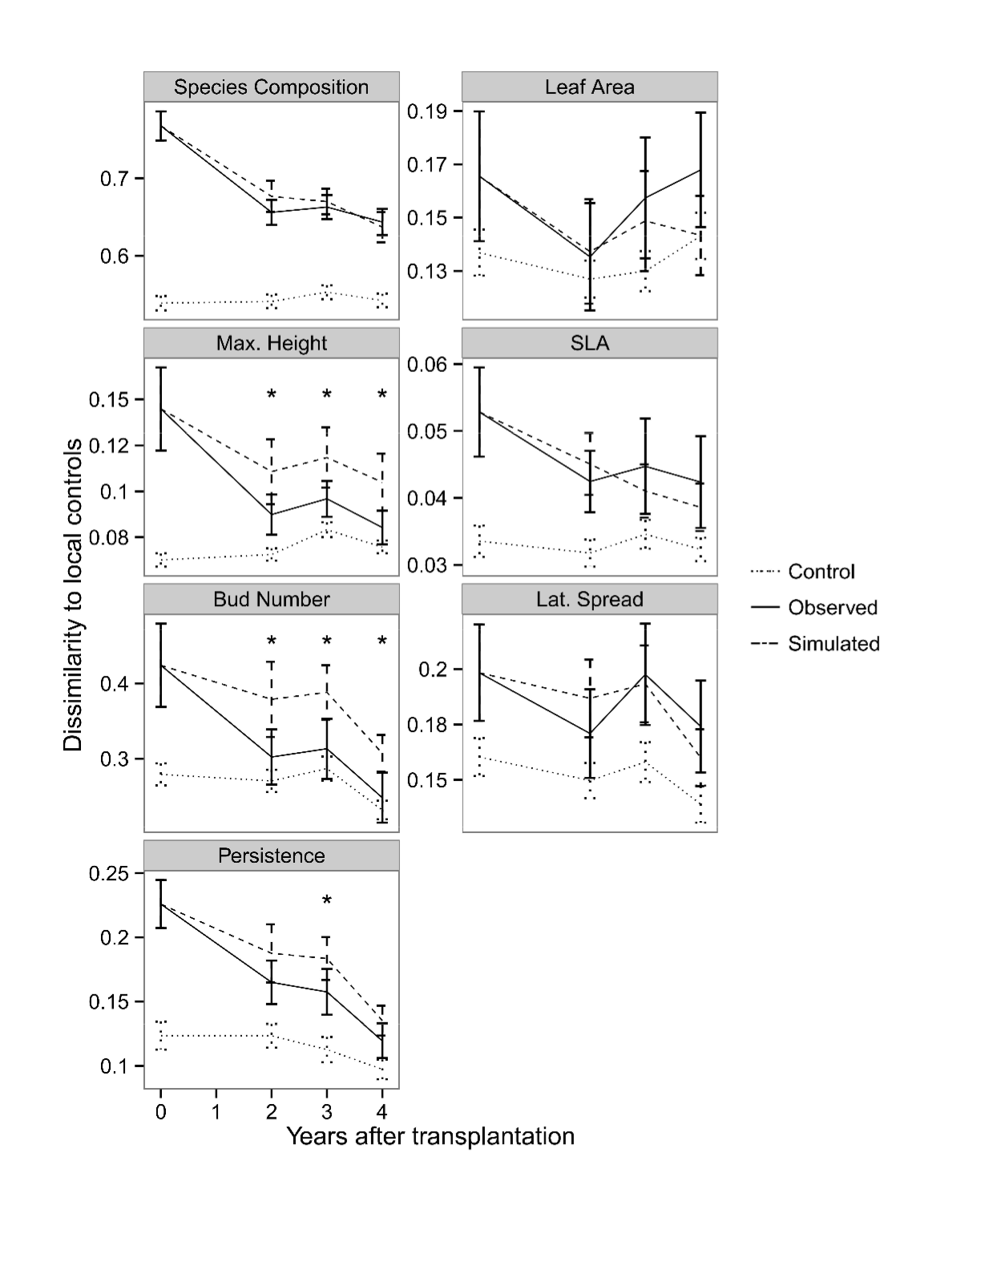

FIGURE S2