RUNNING HEAD: Community responses to warming

TITLE: Can trait patterns along gradients predict plant community responses to climate change?

AUTHORS: John Guittar1, Deborah Goldberg1 Kari Klanderud3, Richard Telford2, Vigdis Vandvik2,

1Ecology and Evolutionary Biology, University of Michigan

2Department of Biology, University of Bergen, Bergen, Norway

3Ecology and Natural Resource Management, Norwegian University of Life Sciences, Ås, Norway

Elements included in this submission:

1. This manuscript (*traits_transplants_2016-06-04.docx*).
2. AppendixS1 (*AppendixS1.docx*).
3. Supplementary files: The metadata file (*supplementary_file_metadata.docx*) lists and describes the supplementary files, which include the central R Markdown file used in the analysis (*traits_transplants.Rmd*), the scripts that it sources (*custom_functions.R*, *bayesian_immigration_estimates.R*, *neutral_simulation.R*, *simdat_processing_veg.R*, *simdat_processing_traits.R*, *simdat_spp.R*), and a table of the species found in this study and their associated trait data (*species_data.csv*).

This submission is meant for consideration as an ‘article.’

**Abstract:** Plant functional traits vary consistently along climate gradients and are therefore potential predictors of plant community response to climate change. We test this space-for-time assumption by combining a spatial gradient study with whole-community turf transplantation along temperature and precipitation gradients in a network of twelve grassland sites in Southern Norway. Using data on eight traits for 169 species and annual vegetation censuses of 235 turfs over five years, we quantify trait-based responses to climate change by comparing observed community dynamics in transplanted turfs to field-parameterized null model simulations. Three traits related to species architecture (maximum height, number of dormant meristems, and ramet-ramet connection persistence) varied consistently along spatial temperature gradients and also correlated to changes in species abundances in turfs transplanted to warmer climates. Two traits associated with resource acquisition strategy (SLA, leaf area) increased along spatial temperature gradients but did not correlate to changes in species abundances following warming. No traits correlated consistently with precipitation. Our study supports the hypothesis that spatial associations between plant traits and broad-scale climate variables can be predictive of community response to climate change, but illustrates that not all traits with clear patterns along climate gradients influence community response to an equal degree.

**Keywords:** Plant functional traits, clonal traits, environmental gradient analysis, turf transplantation, grasslands, alpine plant communities, community response.

# INTRODUCTION

Plant functional traits, defined as measurable species characteristics with explicit connections to individual performance, reflect plant ecological strategy and associate with environmental factors at many spatial and ecological scales (Silvertown 2004, Wright et al. 2005, McGill et al. 2006, Violle et al. 2007). The roles that environmental variables play in structuring community composition are often inferred from patterns of community-weighted mean trait values along spatial gradients (De Bello et al. 2005, Shipley et al. 2006, Kraft et al. 2008, Cornwell and Ackerly 2009). The consistency and prevalence of many trait-climate correlations over space suggests they could be good predictors of community responses to climate change (Lavorel and Garnier 2002, Enquist et al. 2015).

However, there are also reasons why spatial trait gradient patterns may be poor predictors of community responses to climate change. First, it is not clear if species will migrate quickly enough to maintain their current associations to climate (Post and Pedersen 2008, Visser 2008). Instead, species assemblages may be in continual flux as species respond and adapt differentially to changing climate conditions (Neilson et al. 2005). Second, rapid climate change could disrupt biotic interaction networks, leading to idiosyncratic species responses that are inconsistent with expectations based on broad-scale trait-environment relationships (Kudo et al. 2004, Post and Pedersen 2008). Third, species may respond to finer-scale changes in environmental variables that cannot be predicted using climate averages (Kimball et al. 2010, Graae et al. 2012).

One way to directly evaluate the potential for spatial trait patterns to predict community responses to climate change is to experimentally manipulate climate *in situ* and observe community response (e.g. Hobbie and Chapin III 1998, Hudson et al. 2011). *In situ* approaches allow for precise manipulation of the desired climate variables but suffer from several drawbacks. Most notably, the arrival and establishment of immigrants adapted to the new climate conditions is sharply reduced, effectively removing an important driver of community response to climate change (Gottfried et al. 2012). *In situ* experiments may even *suppress* community responses if propagule pressure from locally abundant species is high enough to exert mass effects on the community compositions of experimental plots. *In situ* climate manipulations also often have undesirable side effects related to their experimental methods (Aronson and McNulty 2009).

Here, we investigate the effects of climate change on plant communities using an alternative approach: transplantation of entire, intact communities to new climates. Whole-community transplantation avoids the experimental artifacts of climate change manipulations, while exposing the community to immigration from species adapted to the new environment. In fact, transplantation lies at the other extreme of *in situ* climate manipulations: it provides a scenario in which immigration of climate-adapted species is higher than would be expected in communities subject to gradual environmental change. We monitored changes in the functional composition of 235 control and transplanted turf communities over five years within a network of twelve grassland sites in southern Norway. Our measures of functional composition rely on species-level averages of four commonly measured plant traits: leaf area, maximum vegetative height, seed mass, and specific leaf area (SLA), and four less commonly used traits relating to clonal growth strategy: number of offspring per parent, persistence of plant-offspring connection, rate of lateral spread, and bud number (i.e., the number of dormant meristems per ramet). Clonal traits are often overlooked as indicators of plant performance, despite their widespread prevalence and potential significance for community dynamics and ecosystem function, especially in herbaceous plant biomes like grasslands, wetlands, and tundra (Zobel et al. 2010, Cornelissen et al. 2014).

Our central goal was to test if traits with broad spatial associations to climate also drive community responses to rapid climate change. To do this, we characterized baseline trait patterns across temperature and precipitation gradients in our system, and then determined if these traits correlated with species performance in turf communities transplanted to warmer and/or wetter conditions. The fact that turf communities were open to immigration from the surrounding vegetation necessitated a careful evaluation of our null expectations. Even under trait-neutral dynamics, natural turnover combined with the immigration and proliferation of locally-abundant species leads transplanted communities to converge compositionally with local sites over time. Thus, any test for trait-mediated dynamics must measure community responses against null expectations that account for stochastic replacement and immigration. We use shifts in species abundances in control turfs to estimate stochastic replacement and immigration at each site, and then use these estimates in model simulations to generate null expectations of turf response to transplantation. Observed deviations from these null expectations are interpreted as evidence for trait-mediated interactions.

The unusual topography of southern Norway allowed us to address an additional shortcoming of most spatial gradient studies by methodologically separating temperature and precipitation as potential climate drivers. Ecological studies along climate gradients often use altitudinal transects that vary in both temperature and precipitation (Callaway et al. 2002, Djukic et al. 2010), although not always in a consistent manner (Körner 2007). This covariation makes it difficult to isolate the individual and interactive effects of temperature and precipitation and thus project how vegetation will respond to novel climates. In southern Norway, a west-to-east rainfall gradient interacts with a mosaic of fjords and mountain ridges to generate high climatic heterogeneity over a small geographic area. We exploited this natural heterogeneity to establish a “climate grid” in which temperature and precipitation vary orthogonally among the twelve field sites, thereby allowing us to separate their effects and to identify potential interactions.

We use results from our gradient analysis, transplant experiment, and model simulations to address three questions: 1) What is the relative influence of spatial variation in temperature and precipitation on community trait composition? 2) Do the traits that respond to spatial climate gradients also drive community temporal response to climate change? 3) What is the influence of clonal traits relative to more commonly used leaf, seed, and canopy height traits in community response to climate gradients and climate change? We expect short species with conservative resource use strategies (low SLA, low leaf area, slow lateral spread) and/or high capacity for resource integration (persistent ramet-ramet connections, more offspring per ramet, more buds per ramet) to predominate in unproductive climates (the coldest and driest sites) relative to more productive climates (the warmest and wettest sites). Our study is a rigorous experimental evaluation of the assumption that trait patterns along climate gradients reflect, and can therefore predict, how communities will respond to anthropogenic climate change.

# METHODS

The study area is an approximately 500 km x 500 km region in southern Norway with marked climatic heterogeneity (Figure 1). Twelve grassland sites were selected with one of three mean summer temperatures (ca. 6.0, 9.0, and 10.5 °C) and one of four mean annual precipitations (ca. 600, 1200, 1900, and 2800 mm), while other environmental variables were relatively consistent (calcareous soil, southwest aspect, slope of about 20 degrees, and comparable grazing and land-use history) (see Table S2 for precise climate data, and Klanderud et al. 2015 for additional site details). The grasslands’ short stature (usually < 0.3 m at peak biomass) and shallow but thickly interwoven root and rhizome mats enabled the easy removal, transport, and replanting of ‘turfs’ and their attached flora to different hillsides. Each 25 x 25 cm turf contained tens to hundreds of individual stems, representing 10 - 40 vascular plant species, with a mean canopy height of 9 ± 6 cm (1 SD). In accordance with predictions that climate change will cause southern Norway to become warmer and wetter (Hanssen-Bauer et al. 2009), 40 turfs were transplanted to warmer sites, 45 turfs were transplanted to wetter sites, 30 turfs were transplanted to warmer and wetter sites, 60 control turfs were replanted at the same site, and 60 control turfs were delineated but left undisturbed. All non-local transplants were moved one ‘step’ warmer and /or wetter in the climate grid. Turfs were transplanted between sites in multiples of five; sample sizes differed by treatment because not all destination sites had cooler and/or drier sites to serve as turf origins (Figure 1). For control turfs, origin and destination sites are the same site. We refer to transplant destinations as 'target sites'; thus ‘target controls’ refers to control turfs at transplant destination sites. Vascular plant turf community censuses were conducted in 2009 (before transplantation), 2011, 2012, and 2013, for a total of 928 turf community time points. Twelve turf community time points were discarded due to damaged turfs. Percent cover of each species was estimated visually with the aid of a 5 x 5 cm grid. Total percent cover was allowed to fall below or exceed 100% to account for bare patches and/or overlapping species covers (mean cover in control plots across sites and years ranged from 87 ± 25% to 127 ± 30%).

**Trait data:** We built a custom database containing values for up to eight traits for the 169 species present in our turf communities from across the climate grid. Woody seedlings and unidentifiable individuals represented 1.1% total cover and were discarded. We used four common traits: leaf area (mm2), specific leaf area (SLA) (m2 kg-1), maximum potential canopy height (m), and seed mass (mg), and four traits relating to clonal growth: number of offspring per parent per year (1 or ≥ 2), persistence of plant-offspring connection (< 2 years or ≥ 2 years), rate of lateral spread (≤ 1 cm year-1 or > 1 cm year-1), and bud number, i.e., the prevalence of aboveground and belowground dormant meristems. Leaf area and SLA were estimated using a combination of field data and data from the LEDA online trait database (Kleyer et al. 2008). Our field data derive from ~1200 leaves collected in the summer of 2012 for which SLA and leaf area were calculated using established protocols (Cornelissen et al. 2003). We used Pearson correlations to assess the extent to which LEDA species trait values matched field gathered trait values (SLA: ρ = 0.69; leaf area: ρ = 0.73). Maximum potential height data were mined from Lid and Lid (2007). We drew seed mass data from the Seed Information Database (Royal Botanic Gardens Kew 2014). All continuous trait values were log-transformed. Clonal trait data were extracted from the CLO-PLA database (Klimešová and Bello 2009) and, except for bud number, transformed from categorical to binary metrics to simplify statistical analysis. For bud number, species were assigned a score of 0 (no buds) to 8 (dozens of buds) based on estimates from Klimešová and Bello (2009). Data on individual traits represented 140 - 164 species (84% - 99% of total cover). Eight species (3.9% total cover) were identifiable only to genus but treated as species in downstream analyses. For these species, trait values were either measured in the field (SLA, leaf area), estimated by taking the median trait values of locally-present congeners (seed mass, maximum height, clonal traits), or left blank. Species names and their trait values are provided as a supplementary table (*species_data.csv*). Only two of 28 pairwise comparisons of species trait values were significantly correlated (SLA and bud number, SLA and connection persistence; see Table S1); apart from these two exceptions, we consider trait responses to be statistically independent.

**Community analyses:** We quantified differences in species composition using Bray-Curtis dissimilarity. Community weighted means (CWMs) were used to quantify differences in functional composition. We used species-level trait values in these calculations; thus, changes in CWM reflect changes in species composition, not trait plasticity. A CWM is calculated by averaging the values of a trait for all species in a community, weighted by their abundance (here, percent cover). For lateral spread, connection persistence, and offspring per ramet, CWMs reflected the proportion of the community with the higher value category (≥ 2 offspring per parent, ≥ 2 years connection persistence, or > 1cm year-1 lateral spread). Pre-transplant (2009) turf CWMs were regressed onto temperature and precipitation site means to assess community trait patterns in environmental space. AIC values were used to determine when temperature, precipitation, and/or their interaction were significant predictors (p < 0.05) in abundance-weighted multiple linear regressions. For a deeper investigation of species-level variation in community composition see Klanderud et al. (2015).

We quantified community change as shifts in dissimilarity over time between a turf and its target site controls. Each site had five undisturbed controls and five controls replanted nearby which enabled us to test for the effects of transplantation *per se*. Dissimilarity in species composition among undisturbed controls was only statistically different (p < 0.05) from the mean dissimilarity between undisturbed and replanted controls in 5 of 48 of turf community time points, suggesting that transplantation *per se* did not noticeably affect species composition. Thus, in some analyses, replanted controls and undisturbed controls are combined to increase the control group sample size to ten per site.

**Null model rationale and process:** We used simulations to generate null expectations of turf community responses to transplantation, and then determined when observed community responses deviated from these null expectations. Our model is similar in principle to stochastic models of species abundances using Hubbell’s (2001) neutral local community model, but is applied to a smaller spatial scale. For each step in the model, an individual is randomly removed from the turf community and either replaced with a randomly selected offspring from the same turf community (with probability *1 – m*), or replaced with a randomly selected offspring from the site-level community (with probability *m*). Each step is a ‘replacement event.’ The site-level community is conceptually equivalent to Hubbell’s ‘metacommunity’, and is defined as the net composition of the ten control turfs present at each site. The model has two parameters: replacement rate (*d*), the number of replacement events that occur between consecutive years, and immigration rate (*m*), the probability that replacements are drawn from the site-level community pool as opposed to from within the turf-level community pool (see next section for parameter estimation). Even though turfs are only 25 x 25 cm in size, we expected within-turf recruitment to be high because most species in our system exhibit some degree of clonal growth (Klimešová and Bello 2009), and nearly all new stems are vegetative outgrowths from extant genets rather than seed germination events (Berge, Klanderud, Vandvik, unpublished data).

Our model differs from Hubbell’s community model in three important ways. First, rather than using births and deaths of individuals to quantify demographic changes, which would be impractical to measure in our predominantly clonal system, we use increases and decreases in percent cover units. Second, we relax the assumption of zero-sum replacement and instead force simulated percent cover to match observed percent cover in each year of the experiment. Third, we allow site-level communities, i.e., the source pools for migrants entering experimental turfs, to vary by recalculating them after each census. The latter two modifications account for temporal variability in the productivity or composition of site-level communities due to drift or short-term climatic variability.

We simulated community dynamics from 2009 to 2013 on an individual turf basis, calculating species and trait dissimilarities to target site controls each year. Compositional changes in each turf were simulated 100 times and the resulting values were averaged. Simulation data for 2010 were not presented because field observations do not exist for that year. Paired t-tests were used to determine when observed and simulated null expectations differed significantly.

**Estimating model parameters:** We used community census data from our control turfs to estimate replacement rate (*d*) and immigration rate (*m*) at each site. We set *d* equal to half the sum of differences in species covers in control turfs between years at each site. We divided by two because each replacement event constitutes two shifts in species covers, one increase and one decrease. Values of *d* ranged from 19.7 to 37.4. Our method of estimating *d* ignores self-replacement and thus likely underestimates actual replacement rates; however, a visual inspection of model fit under a broad range of parameter values illustrates that our results are robust to moderate increases in replacement rate (Figure S3). Furthermore, it should be noted that any potential underestimates in replacement rates do not affect estimates of immigration rates.

We estimated *m* using a Bayesian approach based on shifts in species abundances in the five replanted control turfs at each site over three consecutive years (2011-2013), assuming neutral dynamics. The net composition of the five undisturbed control turfs at each site was used as the site-level community. The expected cover λ of species *i* in a turf community at time *t* is formally defined as

λ*i,t* = *Jt-1*[(1 – *m*) × *Ci,t-1* + *m* × *Pi,t-1*]

where *Jt-1* is the total cover of the turf community in the previous year, *Ci,t-1* is the relative abundance of species *i* in the turf community the previous year, *Pi,t-1* is the relative abundance of the species in the site-level community at time *t*, and *m* is the immigration parameter. The percent cover *y*, rounded to the nearest whole number, of species *i* in turf community at time *t* was modelled assuming

*yi,t* ~ Poisson(λ*i,t*).

We gave *m* a uniform prior with a range from 0 to 1. We also explored using an informed prior (m < 0.5) based on the expected predominance of clonal growth and within-turf recruitment, but this led to identical results and was dropped. We fit the model using MCMC implemented in JAGS 3.4.0 (Plummer 2003). We ran JAGS through the R package R2jags (Su and Yajima 2012). For each model fit, we ran three chains, used a burn-in of 1000 iterations, and chose initial values in different regions of parameter space. We confirmed model convergence using Gelman-Rubin diagnostics (Brooks and Gelman 1998). We assessed overall model fit by regressing mean posterior estimates for percent cover on observed data (R2 = 0.63). See Table S2 for parameter estimates. For a deeper exploration of how a Bayesian approach can be used to fit a trait-neutral model of community change to time series data see Mutshinda et al. (2008).

# RESULTS

Community weighted means (CWMs) of leaf area, SLA, maximum height and lateral spread increased with temperature along spatial gradients, and CWM values of bud number and connection persistence decreased with temperature along spatial gradients (Table 1, Figure 2). In three of the eight traits, the best-fit weighted multiple linear regression model included precipitation as a predictor variable, but the coefficient of the precipitation variable itself was never significantly different from 0. The interaction of temperature and precipitation had a significant effect on SLA. Exponential curves with increasing temperature fit bud number and connection persistence patterns better than linear ones, reflecting stronger responses in the colder part of the climate grid (Figure 2). Based on these associations, we limited our analysis of trait convergence in transplanted turfs over time to the six traits with spatial associations to temperature, and to turfs transplanted to warmer climates.

Species and trait compositions of transplanted turfs converged towards target site controls over time, with the magnitude of convergence increasing with initial dissimilarity (Figure 3). Rates of convergence in species composition only exceeded null model predictions that accounted for random replacement by local immigrants in 2011 (Figure 4). In contrast, rates of convergence in maximum height, bud number, and connection persistence consistently exceeded null model predictions (Figure 4). These deviations from null expectations were driven by responses across many species rather than responses in just a few of the most abundant taxa (Figure S4). Site-level climate data confirm that transplanted turfs experienced consistently warmer temperatures as intended (Figure S1, Figure S2).

# DISCUSSION

Our study uses observational and experimental data to test the assumption that traits with broad-scale associations to climate in space are predictive of plant community response to climate change in time. This space-for-time assumption is supported when using three traits related to species architecture, but not supported when using three traits related to species resource use strategy. Our results underscore the importance of using ecologically relevant traits when making predictions of community response, and suggest that in our grassland system, architectural traits may exert more influence on initial species response to rapid warming than the more commonly used growth-related traits.

**Trait patterns along climate gradients:** Despite the large range in both mean summer temperature and annual precipitation across sites, CWMs trended only with temperature. The lack of functional turnover over a nearly 2500 mm year-1 increase in precipitation is surprising given the consistent directional turnover in species composition along both temperature and precipitation gradients in our system (Klanderud et al. 2015), underscoring the fact that species turnover does not always beget functional turnover (Hooper et al. 2002). This finding contrasts with vegetation trait patterns found elsewhere over narrower ranges of precipitation (Fonseca et al. 2000, Wright et al. 2005). A lack of precipitation effects could occur if soil moisture is similar at all sites and/or not limiting at any sites, however this seems unlikely given the large range in mean annual precipitation and the otherwise similar site abiotic conditions. Regardless of the mechanism, the implication is that functional shifts in these grasslands are likely to occur in response to changes in temperature, not precipitation.

The consistent shifts in CWMs with increasing temperature in our system signify shifts in plant ecological strategy. Increases in leaf area, SLA, and the rate of lateral spread with temperature suggest a shift from slow-growing stress-tolerant species to fast-growing species with acquisitive resource use strategies (Sterck et al. 2006, Rusch et al. 2011). Also increasing with temperature are maximum height, duration of connection persistence, and bud number, three traits related to plant architecture. The increase in CWMs of maximum height may reflect a tradeoff in the ability to compete for light at warm sites amenable to growth and the ability to tolerate wind stress and freezing temperatures at the coldest sites (Westoby 1998, Falster and Westoby 2003). Higher CWMs of bud number and connection persistence at the coldest sites may reflect an increased importance of resource integration and/or recovery from disturbances (Klimešová and Klimes 2007), although we see no obvious reasons why resources would be patchier and/or disturbances more common at the coldest sites. More work is needed to confirm the functional roles of these understudied clonal traits and their role in organizing grassland species along gradients.

**Community responses to warming:** The central goal of this study was to test the hypothesis that trait-climate relationships over space are predictive of temporal community response to climate change in time, a common assumption in climate change research. Of the six traits with significant trends with temperature in space, maximum height, bud number, and connection persistence - three traits related to species architecture - associated consistently with turf community response to warming in time. The large deviation in maximum height from neutral expectations may be have resulted from competition for light being more intense in more productive, warmer conditions, and taller species preempting access to light, shading out competitors, and earning disproportionate returns due to size-asymmetric competition (Schwinning and Weiner 1998). Species with fewer buds and reduced connection persistence succeeded disproportionately following warming, suggesting that the development and maintenance of these clonal traits, which are believed to support new ramets under stressful conditions (Klimešová and Klimes 2007), comes at a cost when conditions are more amenable to growth. That CWMs of architectural traits deviated from neutral expectations of community response while CWMs of growth-related traits (SLA, leaf area, lateral spread) did not, despite showing strong trends along spatial temperature gradients, is unexpected and interesting. Perhaps, the capacity for rapid growth is not useful to new ramets vying for resources in grassland communities already packed with established individuals (but see: Wildová et al. 2007). Alternatively, SLA and leaf area may be poor predictors of growth in herbaceous species with photosynthetic stems. The strong responses of clonal traits to changes in temperature highlight the need for more emphasis on clonal traits in studies of community response to climate change and herbaceous community assembly in general.

Defining null expectations was challenging given the lack of standard practices of how to model demographic stochasticity in predominantly clonal systems (Eriksson 1994). Traditionally, demographic analyses rely on population numbers and vital rates, but the concepts of individuals, populations, births, and deaths break down in clonal, modular organisms. For instance, ramet number is impractical to measure and may not be demographically meaningful for graminoids that form hummocks with clumps of stems (e.g. *Festuca ovina*), nor is it possible to distinguish individuals in forbs with sprawling aboveground stems with adventitious roots (e.g. *Veronica biflora*), or species that divide via root splitting which results in fragmentation just below the litter layer (e.g. *Cerastium alpinum*). Our decision to simulate demographic changes using percent cover units therefore has both practical and conceptual appeal. The drawback, however, is that percent cover is sensitive to factors that are not demographically significant, such as variation in phenological stage among individuals, species, and sampling times, and thus may inaccurately reflect shifts in abundance between years. Nevertheless, our approach accounts for demographic stochasticity, annual variation in community-level composition, and the realities of dispersal limitation in a predominantly clonal system to generate explicit null expectations of community response to perturbation.

**Conclusions and future directions:** Using patterns in CWMs along environmental gradients to forecast community response to climate change is an intuitively appealing approach. Our study provides qualified support for such an approach: three of the six traits with spatial associations to temperature in our system associated significantly with species success following transplantation to warmer climates. Evidently, spatial associations between plant traits and broad-scale climate variables can be predictive of community response to climate change, but are not always so.

Our results shed some light on how our system could respond to climate change in the coming decades. Despite high rates of annual turnover, without gaps created by disturbances, virtually all replacement stems are clonal outgrowths of extant genets rather than new seedlings (Bullock et al. 1995; Berge, Klanderud, Vandvik, unpublished data). Thus, the potential for community change is largely limited by the prevalence of gaps and the proportion of species in the seed rain that are immigrants rather than local species. Once established, warmer-adapted immigrants will likely proliferate vegetatively, outcompeting species adapted to cooler temperatures (Olsen et al. 2016). Our approach and conclusions underscore the importance of accounting for stochasticity and immigration when making predictions of community response (Tilman 2004, Shipley et al. 2011). Future studies should consider the effects of dispersal limitation on short-term transient responses, and how disturbances and dispersal limitation will affect long-term equilibrium responses. Predictions of ‘extinction debts’ and ‘immigration credits’ in the field of habitat distribution modeling are an important step in the right direction (Dirnböck and Dullinger 2004), but could be developed further by considering how and when traits modulate species interactions.

**Acknowledgments:** We thank the Norwegian Research Council (project 184912/S30), NSF GRFP (JLG; Grant Number: 1256260), and Norge-Amerika Foreningen for funding. We thank Jitka Klimešová for advice relating to clonal traits, Emily Farrer for help on developing the Bayesian null model, and the SEEDclim team for technical and emotional support.

# WORKS CITED

Alonso, D., R. S. Etienne, and A. J. McKane. 2006. The merits of neutral theory. Trends in Ecology and Evolution 21:451–457.

Aronson, E. L., and S. G. McNulty. 2009. Appropriate experimental ecosystem warming methods by ecosystem, objective, and practicality. Agricultural and Forest Meteorology 149:1791–1799.

De Bello, F., J. Lepš, and M. T. Sebastià. 2005. Predictive value of plant traits to grazing along a climatic gradient in the Mediterranean. Journal of Applied Ecology 42:824–833.

Brooks, S. P. B., and A. G. Gelman. 1998. General methods for monitoring convergence of iterative simulations. Journal of computational and graphical statistics 7:434–455.

Bullock, J., B. Hill, J. Silvertown, and M. Sutton. 1995. Gap colonization as a source of grassland community change: effects of gap size and grazing on the rate and mode of colonization by different species. Oikos 2:273–282.

Callaway, R., R. Brooker, and P. Choler. 2002. Positive interactions among alpine plants increase with stress. Nature 417:844–848.

Cornelissen, J. H. C., Y.-B. Song, F.-H. Yu, and M. Dong. 2014. Plant traits and ecosystem effects of clonality: a new research agenda. Annals of botany 114:369–376.

Cornelissen, J., S. Lavorel, E. Garnier, S. Díaz, Buchmann, D. Gurvich, P. Reich, H. ter Steege, M. HD, M. Van Der Heijden, J. Pausas, and H. Poorter. 2003. A handbook of protocols for standardised and easy measurement of plant functional traits worldwide. Australian Journal of Botany 51:335–380.

Cornwell, W., and D. Ackerly. 2009. Community assembly and shifts in plant trait distributions across an environmental gradient in coastal California. Ecological Monographs 79:109–126.

Dirnböck, T., and S. Dullinger. 2004. Habitat distribution models, spatial autocorrelation, functional traits and dispersal capacity of alpine plant species. Journal of Vegetation Science 15:77–84.

Djukic, I., F. Zehetner, A. Mentler, and M. Gerzabek. 2010. Microbial community composition and activity in different Alpine vegetation zones. Soil Biology and Biochemistry 42:155–161.

Enquist, B. J., J. Norberg, S. P. Bonser, C. Violle, C. T. Webb, A. Henderson, L. L. Sloat, and V. M. Savage. 2015. Scaling from traits to ecosystems: Developing a general Trait Driver Theory via integrating trait-based and metabolic scaling theories. Advances in Ecological Research 52:249–318.

Eriksson, O. 1994. Stochastic population dynamics of clonal plants: numerical experiments with ramet and genet models. Ecological Research 9:257–268.

Falster, D. S., and M. Westoby. 2003. Plant height and evolutionary games. Trends in Ecology and Evolution 18:337–343.

Fonseca, C. R., J. M. Overton, B. Collins, and M. Westoby. 2000. Shifts in trait-combinations along rainfall and phosphorus gradients. Journal of Ecology 88:964–977.

Gottfried, M., H. Pauli, A. Futschik, M. Akhalkatsi, P. Barančok, J. L. Benito Alonso, ..., and G. Grabherr. 2012. Continent-wide response of mountain vegetation to climate change. Nature Climate Change 2:111–115.

Graae, B. J., P. de Frenne, A. Kolb, J. Brunet, O. Chabrerie, K. Verheyen, N. Pepin, T. Heinken, M. Zobel, A. Shevtsova, I. Nijs, and A. Milbau. 2012. On the use of weather data in ecological studies along altitudinal and latitudinal gradients. Oikos 121:3–19.

Gravel, D., C. D. Canham, M. Beaudet, and C. Messier. 2006. Reconciling niche and neutrality: The continuum hypothesis. Ecology Letters 9:399–409.

Hobbie, S. E., and F. S. Chapin III. 1998. The response of tundra plant biomass, aboveground production, nitrogen, and CO2 flux to experimental warming. Ecology 79:1526–1544.

Hooper, D. U., M. Solan, and A. Symstad. 2002. Species diversity, functional diversity and ecosystem functioning. Pages 195 – 208 In: Biodiversity and ecosystem functioning: synthesis and perspectives. Oxford University Press, Oxford, England.

Hubbell, S. P. 2001. The unified neutral theory of biodiversity and biography. Monographs in Population Biology. Princeton University Press.

Hudson, J. M. G., G. H. R. Henry, and W. K. Cornwell. 2011. Taller and larger: shifts in Arctic tundra leaf traits after 16 years of experimental warming. Global Change Biology 17:1013–1021.

Kimball, S., A. L. Angert, T. E. Huxman, and D. L. Venable. 2010. Contemporary climate change in the Sonoran Desert favors cold-adapted species. Global Change Biology 16:1555–1565.

Klanderud, K., V. Vandvik, and D. Goldberg. 2015. The Importance of Biotic vs. Abiotic Drivers of Local Plant Community Composition Along Regional Bioclimatic Gradients. Plos One 10:1–14.

Klimešová, J., and F. De Bello. 2009. CLO-PLA: The database of clonal and bud bank traits of Central European flora. Journal of Vegetation Science 20:511–516.

Klimešová, J., and L. Klimes. 2007. Bud banks and their role in vegetative regeneration – A literature review and proposal for simple classification and assessment. Perspectives in Plant Ecology, Evolution and Systematics 8:115–129.

Körner, C. 2007. The use of “altitude” in ecological research. Trends in Ecology & Evolution 22:569–574.

Kraft, N. J. B., R. Valencia, and D. D. Ackerly. 2008. Functional traits and niche-based tree community assembly in an Amazonian forest. Science 322:580.

Kudo, G., Y. Nishikawa, T. Kasagi, and S. Kosuge. 2004. Does seed production of spring ephemerals decrease when spring comes early? Ecological Research 19:255–259.

Lavorel, S., and E. Garnier. 2002. Predicting changes in community composition and ecosystem functioning from plant traits: revisiting the Holy Grail. Functional Ecology 16:545–556.

Lid, J., and D. T. Lid. 2007. Norsk flora. Det Norske Samlaget.

McGill, B. J., B. J. Enquist, E. Weiher, and M. Westoby. 2006. Rebuilding community ecology from functional traits. Trends in Ecology and Evolution 21:178–185.

Mutshinda, C. M., R. B. O’Hara, and I. P. Woiwod. 2008. Species abundance dynamics under neutral assumptions: a Bayesian approach to the controversy. Functional Ecology 22:340–347.

Neilson, R. R. P., L. L. F. Pitelka, A. M. Solomon, R. Nathan, G. F. Midgley, J. M. V. Fragoso, H. Lischke, and K. Thompson. 2005. Forecasting regional to global plant migration in response to climate change. BioScience 55:749.

Olsen, S. L., J. P. Töpper, O. Skarpaas, V. Vandvik, and K. Klanderud. 2016. From facilitation to competition: temperature-driven shift in dominant plant interactions affects population dynamics in semi-natural grasslands. Global Change Biology:n/a–n/a.

Plummer, M. 2003. JAGS: A program for analysis of bayesian graphical models using gibbs sampling. Proceedings of the 3rd International Workshop on Distributed Statistical Computing (DSC 2003). March:20–22.

Post, E., and C. Pedersen. 2008. Opposing plant community responses to warming with and without herbivores. Proceedings of the National Academy of Sciences of the USA 105:12353–12358.

Royal Botanic Gardens Kew. 2014. Seed Information Database (SID).

Rusch, G. M., B. Wilmann, J. Klimešová, and M. Evju. 2011. Do Clonal and Bud Bank Traits Vary in Correspondence with Soil Properties and Resource Acquisition Strategies? Patterns in Alpine Communities in the Scandian Mountains. Folia Geobotanica 46:237–254.

Schwinning, S., and J. Weiner. 1998. Mechanisms determining the degree of size asymmetry in competition among plants. Oecologia 113:447–455.

Shipley, B., C. E. T. Paine, and C. Baraloto. 2011. Quantifying the importance of local niche-based and stochastic processes to tropical tree community assembly. Ecology 93:760–769.

Shipley, B., D. Vile, and E. Garnier. 2006. From plant traits to plant communities: a statistical mechanistic approach to biodiversity. Science (New York, N.Y.) 314:812–4.

Silvertown, J. 2004. Plant coexistence and the niche. Trends in Ecology and Evolution 19:605–611.

Sterck, F., L. Poorter, and F. Schieving. 2006. Leaf traits determine the growth-survival trade-off across rain forest tree species. The American Naturalist 167:758–765.

Su, Y., and M. Yajima. 2012. R2jags: A Package for Running jags from R.

Tilman, D. 2004. Niche tradeoffs, neutrality, and community structure: a stochastic theory of resource competition, invasion, and community assembly. Proceedings of the National Academy of Sciences of the USA 101:10854–10861.

Violle, C., M. Navas, D. Vile, E. Kazakou, C. Fortunel, I. Hummel, and E. Garnier. 2007. Let the concept of trait be functional! Oikos 116:882–892.

Visser, M. E. 2008. Keeping up with a warming world; assessing the rate of adaptation to climate change. Proceedings of the Royal Society B 275:649–659.

Westoby, M. 1998. A leaf-height-seed (LHS) plant ecology strategy scheme. Plant and Soil 199:213–227.

Wildová, R., L. Gough, T. Herben, C. Hershock, and D. E. Goldberg. 2007. Architectural and growth traits differ in effects on performance of clonal plants: an analysis using a field-parameterized simulation model. Oikos 116:836–852.

Wright, I. J., P. B. Reich, J. H. C. Cornelissen, D. S. Falster, P. K. Groom, K. Hikosaka, ..., and M. Westoby. 2005. Modulation of leaf economic traits and trait relationships by climate. Global Ecology and Biogeography 14:411–421.

Zobel, M., M. Moora, and T. Herben. 2010. Clonal mobility and its implications for spatio-temporal patterns of plant communities: what do we need to know next? Oikos 119:802–806.

TABLE 1: Summary statistics for best-fit weighted linear models for each trait

|  |  |  |  |  |  |  |
| --- | --- | --- | --- | --- | --- | --- |
| Trait | Variable | Estimate | SE | t-statistic | p-value | |
| Bud Number | exp(-Temp) | 118.15 | 52.83 | 2.24 | 0.049 |
| Lat. Spread | Temp | 0.04 | 0.01 | 2.50 | 0.031 |
| Leaf Area | Temp | 0.05 | 0.01 | 3.83 | 0.004 |
|  | Precip | < 0.01 | < 0.01 | -1.50 | 0.167 |
| Max. Height | Temp | 0.05 | 0.01 | 4.26 | 0.002 |
| Offspring | (none) |  |  |  |  |
| Persistence | exp(-Temp) | 109.14 | 19.28 | 5.66 | < 0.001 |
| Seed Mass | (none) |  |  |  |  |
| SLA | Temp | 0.02 | 0.00 | 5.35 | < 0.001 |
|  | Precip | < 0.01 | < 0.01 | -1.24 | 0.251 |
|  | Temp x Precip | < 0.01 | < 0.01 | 2.48 | 0.038 |

Summary statistics for best-fit weighted multiple linear regression models for each trait using mean summer temperature, annual precipitation, and their interaction as potential predictor variables, weighted by the sample size at each site (N ranges from 10 to 25). Model fit was determined using AIC values. For bud number and connection persistence, exponentially transforming the temperature axis resulted in better model fit. Turf-level community weighted trait means and significant regressions are shown in Figure 2.

**Figure 1:** Panel A: a schematic illustration of the orthogonal nature of climate variables across experimental sites, with black arrows representing the directions of turf transplants in replicates of five. Panels B and C show the geographical locations of experimental sites in southern Norway. Symbol shapes and shadings reflect mean summer temperature levels and mean annual precipitation levels, respectively, in accordance with panel A.

**Figure 2:** Community weighted trait means (CWMs) of turfs before transplantation along natural gradients of mean summer temperature (left) and mean annual precipitation (right). CWMs are aggregated by site (N ranges from 10 to 25). Vertical lines show ± 1 S.D. Symbol shapes and shadings reflect temperature and precipitation levels, respectively, in accordance with Figure 1A. Best-fit lines are shown as solid lines when trait-gradient relationships are significant; for simplicity, trend lines represent univariate regressions, even if multivariate regressions led to higher AIC values. The interactive effects of temperature and precipitation on SLA is shown using three trend lines (~3°C: dotted, ~6°C: dashed, ~9°C: dot-dashed). CWMs in seed mass and offspring per ramet did not exhibit significant trends along temperature or precipitation gradients and are therefore omitted. See Table 1 for model summary statistics.

**Figure 3:** Changes in dissimilarity of turfs transplanted to warmer climates and target site controls from 2009 to 2013. The x-axis shows Bray-Curtis dissimilarity between turfs and the centroids of their control turfs in 2009; the y-axis shows how that dissimilarity changed by 2013. Each symbol represents a turf community. Grey crosses represent control turfs; black circles represent transplanted turfs. Dissimilarity was calculated using Bray-Curtis distance for species composition (top left panel) or Euclidian distance of community weighted means (all remaining panels). Symbols below zero on the y-axis reflect turf communities that converged compositionally towards target controls, whereas communities above zero on the y-axis diverged compositionally. Dashed vertical lines are placed at 50% of mean dissimilarity among controls as an approximation of natural community stochasticity. Grey ellipses represent 95% confidence intervals of the centroids of control turf dissimilarities.

**Figure 4:** Mean trait dissimilarities of transplanted turf communities and target controls from 2009 to 2013. Solid lines represent observed field data. Dashed lines represent simulated null expectations based on the means of 100 null model simulation runs. Dotted lines represent mean dissimilarity among control turfs within sites. Null model simulations use estimates of replacement and immigration rates derived from our field data (see Methods). Error bars show 95% confidence intervals. Statistical differences between observed and simulated community weighted means are shown when p < 0.05 (*).

FIGURE 1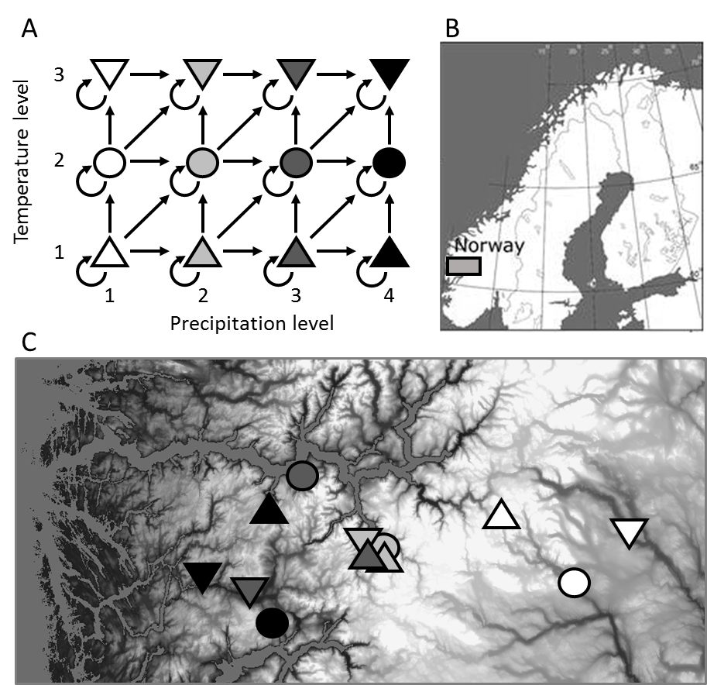

FIGURE 2 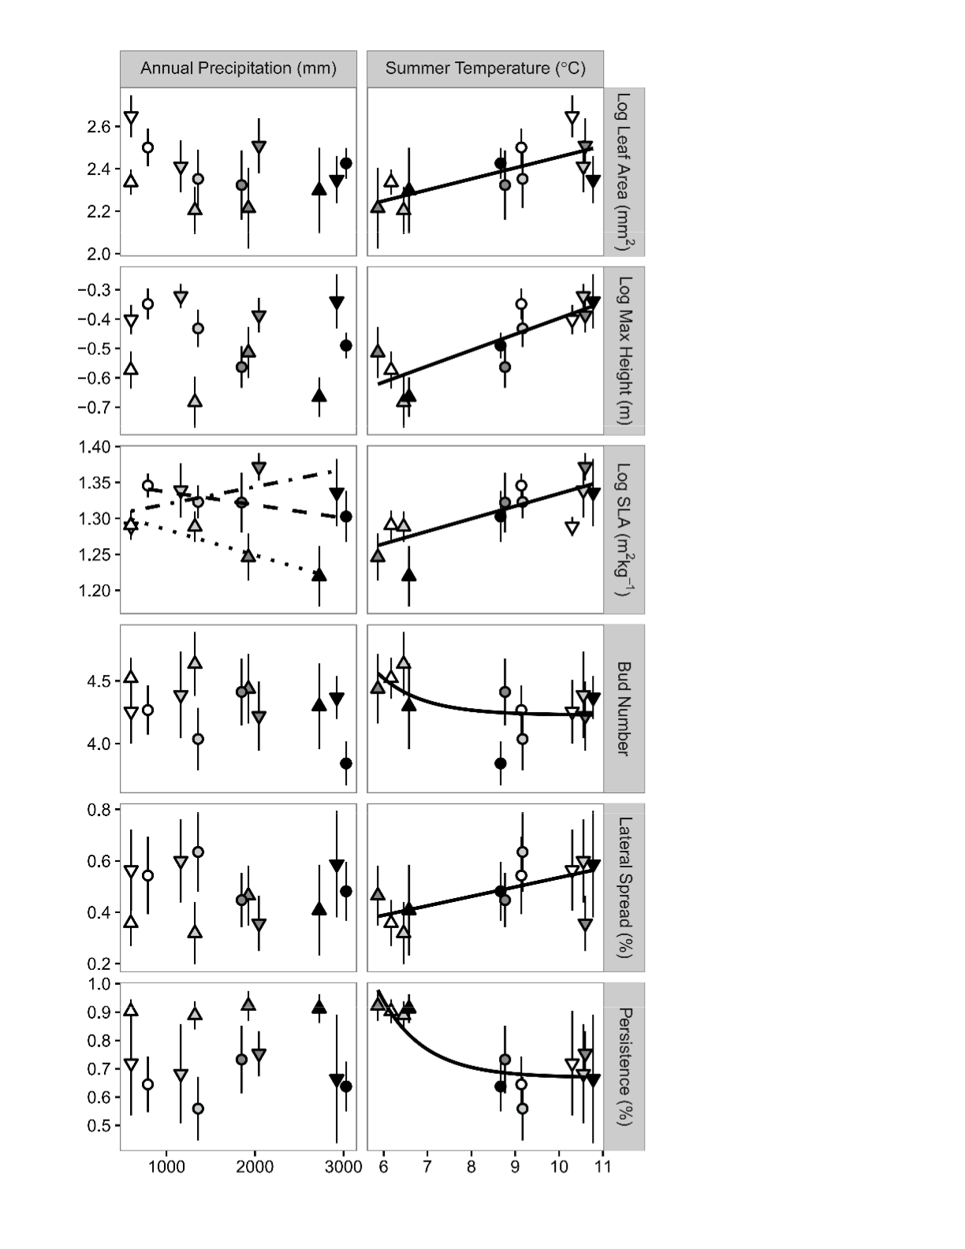

FIGURE 3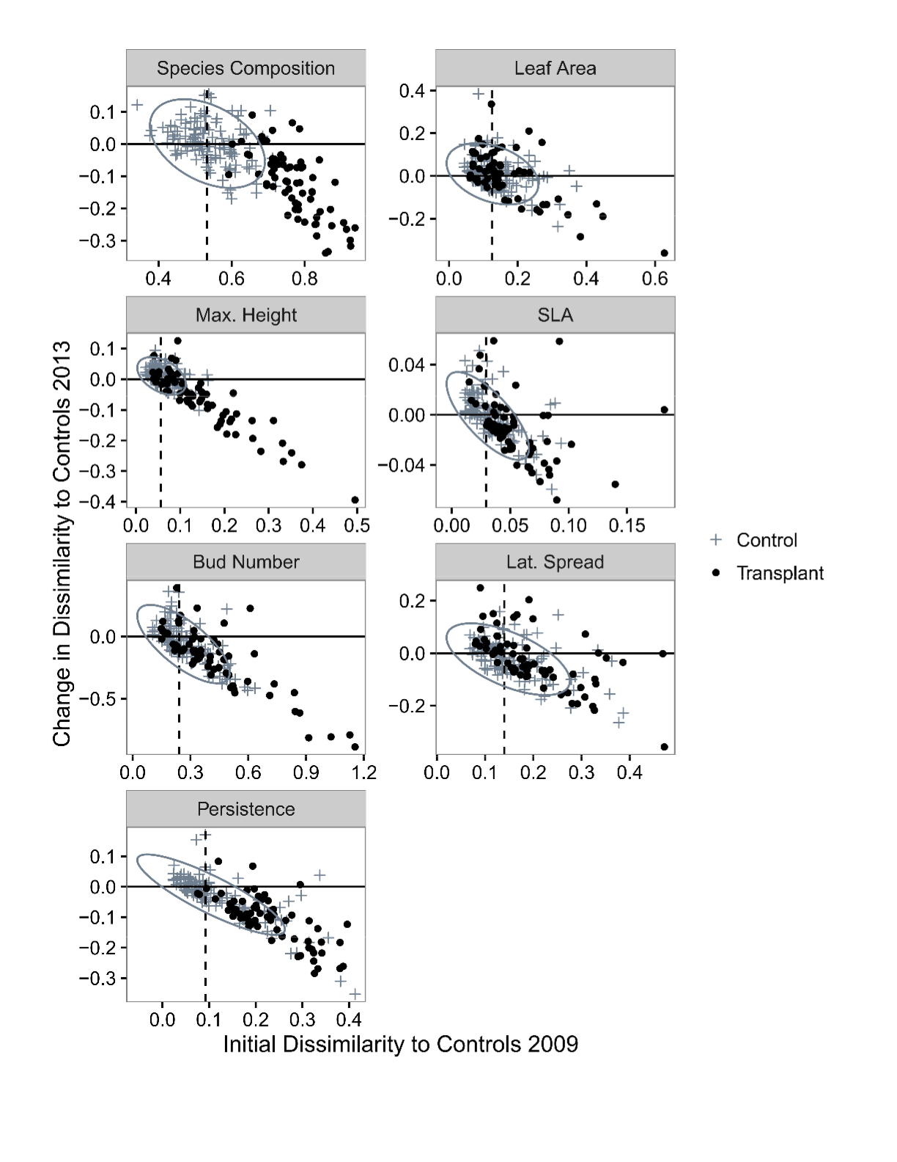

FIGURE 4

