When activation readers agree, are they right?
Guiv Farmanfarmaian, Suraj Prasad
TLDR:
- On Qwen3.6-27B, activation readers (J-lens, Oracle Lens, NLA and a skip lens) behave like one instrument. On the model's errors they pick the same wrong answer about twice as often as independent readers would, and on raw scores, rating readers by majority agreement ranks them backwards (rank correlation −0.8; −0.2 after removing reader biases).
- Readers report what is linearly present in the vector, not how much the model relies on it. Scaled to the same size, the part of an edit inside the J-space moves the model's answer about 6× less than the rest, yet readers follow both about equally (78–91%). They mostly miss the direction a trained probe relies on.
- They can report something the prompt doesn't say. A fact placed only in the system turn is reported 81–94% of the time, against a 50% prompt-only baseline.
- Where and how you read changes the answer. At layer 42 no reader names who holds what in free text, but at layer 56 the Oracle does 86% of the time; prefilling an answer doesn't help, and a prefill that names a candidate just gets copied. Two-candidate log-odds oversell the readers, and the model's upcoming wrong answer only shows up in the J-lens and Oracle from layer 52, four layers after a probe.

Setup
We read Qwen3.6-27B at block 42, last prompt token, thinking off. The J-lens is a cosine readout, the Oracle Lens a LoRA that takes the activation in place of a marker token, and the NLA writes an explanation from the activation injected at block 1. Prompts come in synthetic pairs differing in one fact: language, tense, who holds an object ("ownership"), or which letter an arrow chain ends on ("mapping"). Scored from free text at layer 42, no reader named who holds what, and a prompt-only baseline got all 32 states. That blind spot was a scoring and layer artefact: scored by native log-odds between two candidates, readers carry the binding 72–94% of the time (two candidates flatter them; see Misc), and read at layer 56 the Oracle names it in free text (section 3). The Oracle Lens was trained on every fourth layer from 20 to 60, so 42 is off its grid; rerunning the main comparisons at 44 changed no conclusion (Misc).

1. A majority of similar readers measures their shared training
Rating readers by majority agreement ranks them backwards on the model's errors (rank correlation −0.8 between the majority grade and an independent key). For each reader and state we compared two grades: agreement with an independent key, and agreement with the majority of the other readers. The keys were the fact built into the prompt (280 states), the planted fact where it actually flipped the model (126 states), and the model's own answer on its errors and self-choice disagreements (330 states).
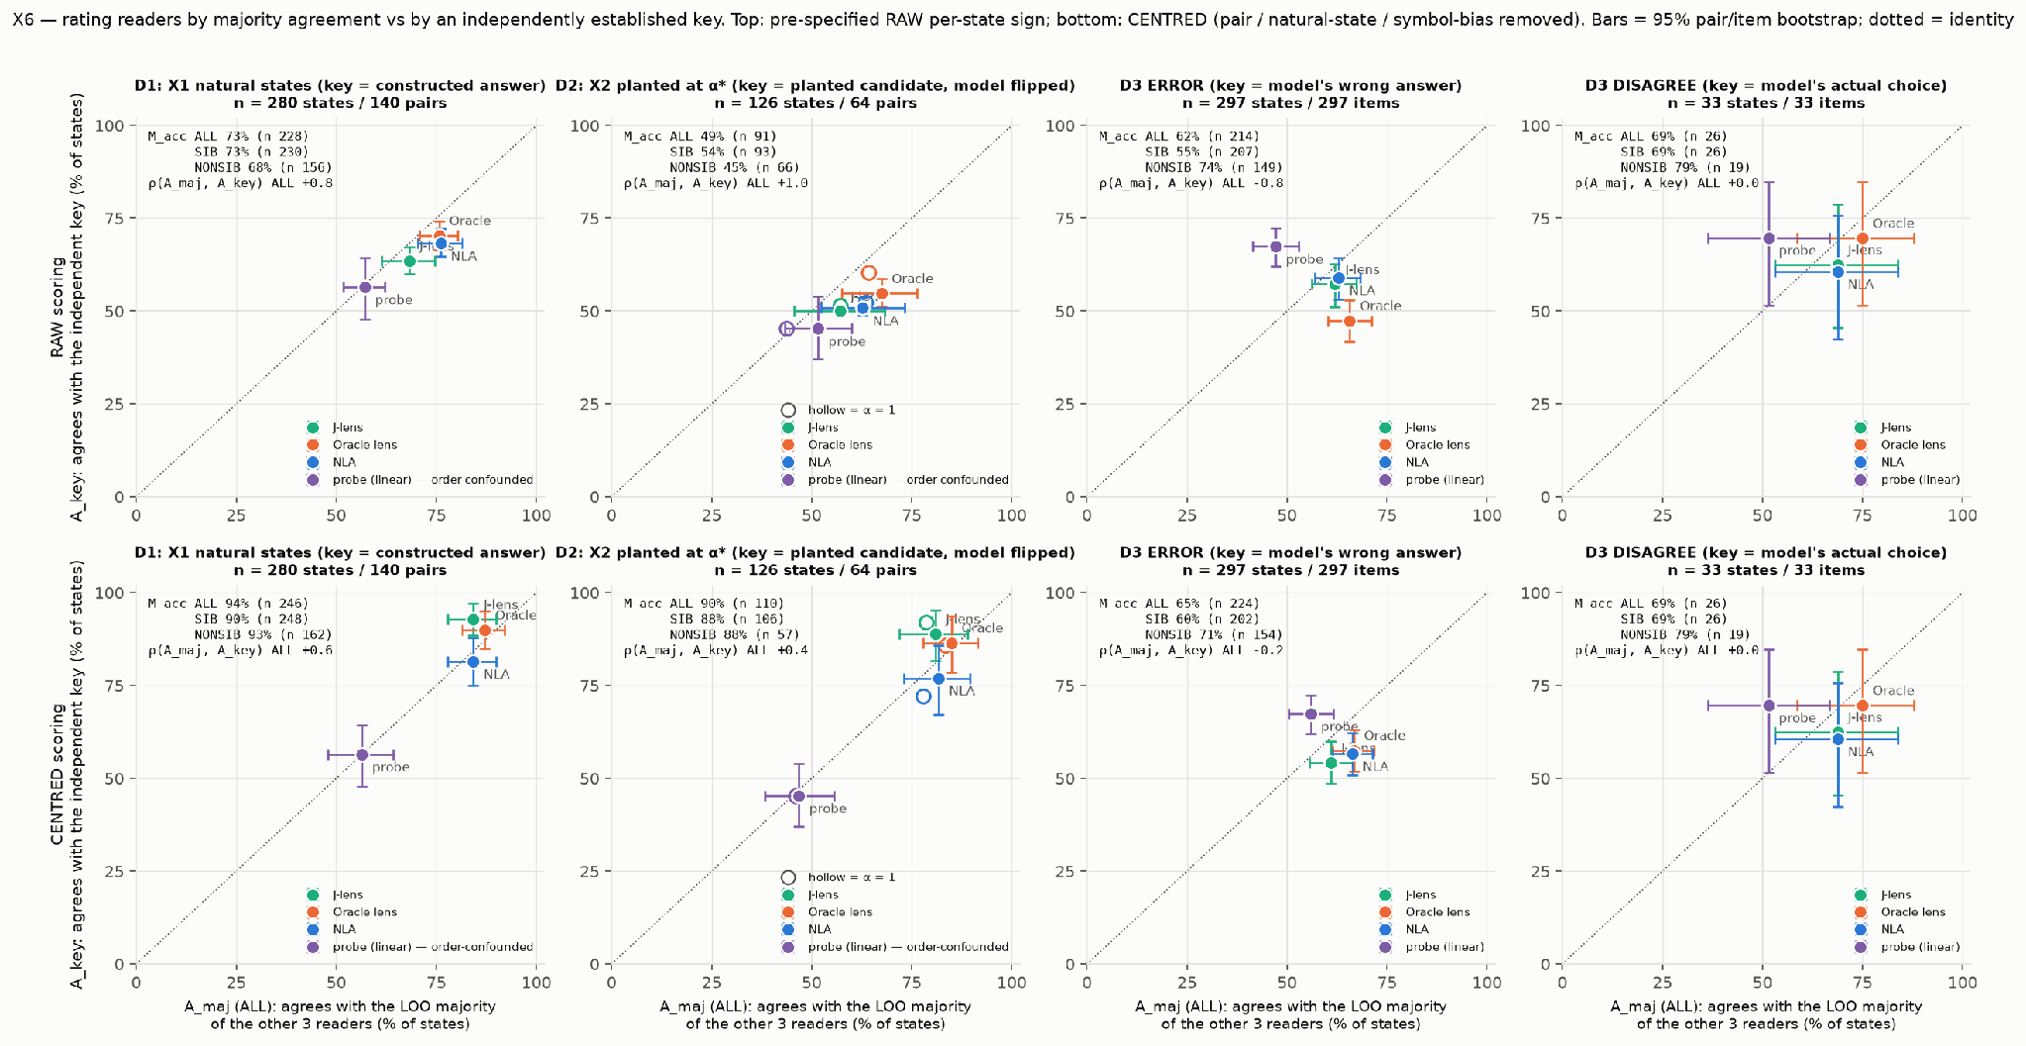
Agreement with the key (y) against agreement with the majority of the other readers (x). Look at the third column, the model's errors: the probe sits top-left, best by the key and worst by majority.
Where every reader is already right, majority grading looks fine (88 to 94% correct once reader biases are removed). On the model's errors it inverts: on raw scores the probe is best against the key (67%) but worst by majority (47%), with a rank correlation of −0.8 between the two grades (−0.2 once biases are removed). The Oracle and NLA, which share a base model, agree with each other (70%) more than with the key (47 to 59%). All three readers pick the same wrong answer 17.5% of the time, against 9.2% if they were independent (1.9 times as often); in the latest round the ratio is 2.05.
In free text the picture is different: on the 32 pilot states no two readers ever named the same wrong answer. They fail together by naming neither candidate.
Kim et al. and Goel et al. show the same mechanism for LLM judges; as far as we can tell, the inversion on activation readers is new.

2. Readers report what is in the vector, not what the model uses
We planted facts by blending a pair's two states, h' = h_A + α(h_B − h_A). Editing the last token alone never flipped the model's answer, even at dose 3, yet the readers moved towards the planted answer. Editing every position at layer 38 or 42 flipped 98% of answers by dose 0.75, against 0 of 768 for random directions.
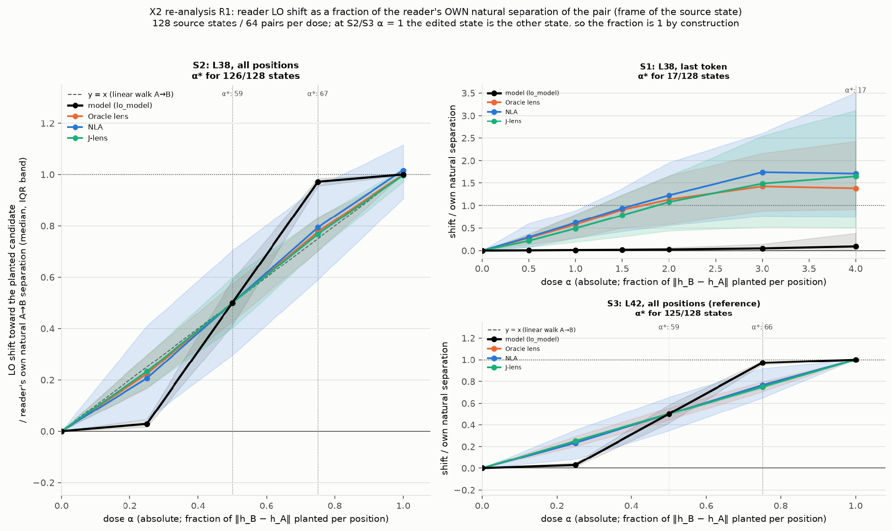
Edits at layer 38 (bottom right: layer 42 reference). Left: with all positions edited, the model (black) behaves like a switch while readers move smoothly with the dose. Top right: at the last token only, readers report the planted answer and the model doesn't move.
We then split the edit into pieces (64 states per cell). On ownership, the top-384 J-space component and the remainder outside J-space each flip the model's answer 0% of the time, yet readers move towards them 80–94% and 67–88% of the time. That could just mean the readers are more sensitive than the model, so we rescaled each piece to the full edit's size at every position. The J-space piece still flips 0 of 64 answers at full strength and half of them only at twice that, while the rest flips all 64; the model's answer log-odds move 6× less for the J-space piece (+3.9 vs +24.8 nats). Readers follow both pieces about equally, 78–91% already at a quarter of the strength. The direction a trained probe uses, which the probe follows 96% of the time, barely moves the model (0–5%) and leaves the readers inside the random band (45–56%); on the Oracle's own training layer it does partly follow it (66%).
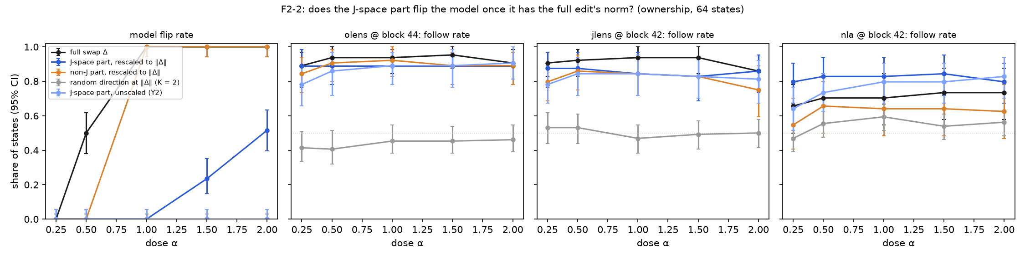
Same-size pieces of the ownership edit. Left: the model flips with the non-J piece (orange) as with the full edit, and with the J-space piece (blue) only at twice the dose. Right: readers follow every piece about equally from the lowest dose; random directions stay near 50%.
Our reading: the model under-weights directions that the readers weight fully, so a reader's score tells you what is linearly present, not how much the model relies on it. Part of the gap is sensitivity: on this edit the readers respond at a dose at least 8× smaller than the one that flips the model. One honest hedge: readers moving smoothly with the dose is partly expected by construction, since any roughly linear score will do that.

3. At layer 42 readers miss things they catch a few layers later
The cell our design was built to find, a fact present and load-bearing but unreported, is empty at layer 42. Every fact a probe finds, all three readers report. On the model's errors, probe and readers are both weak.
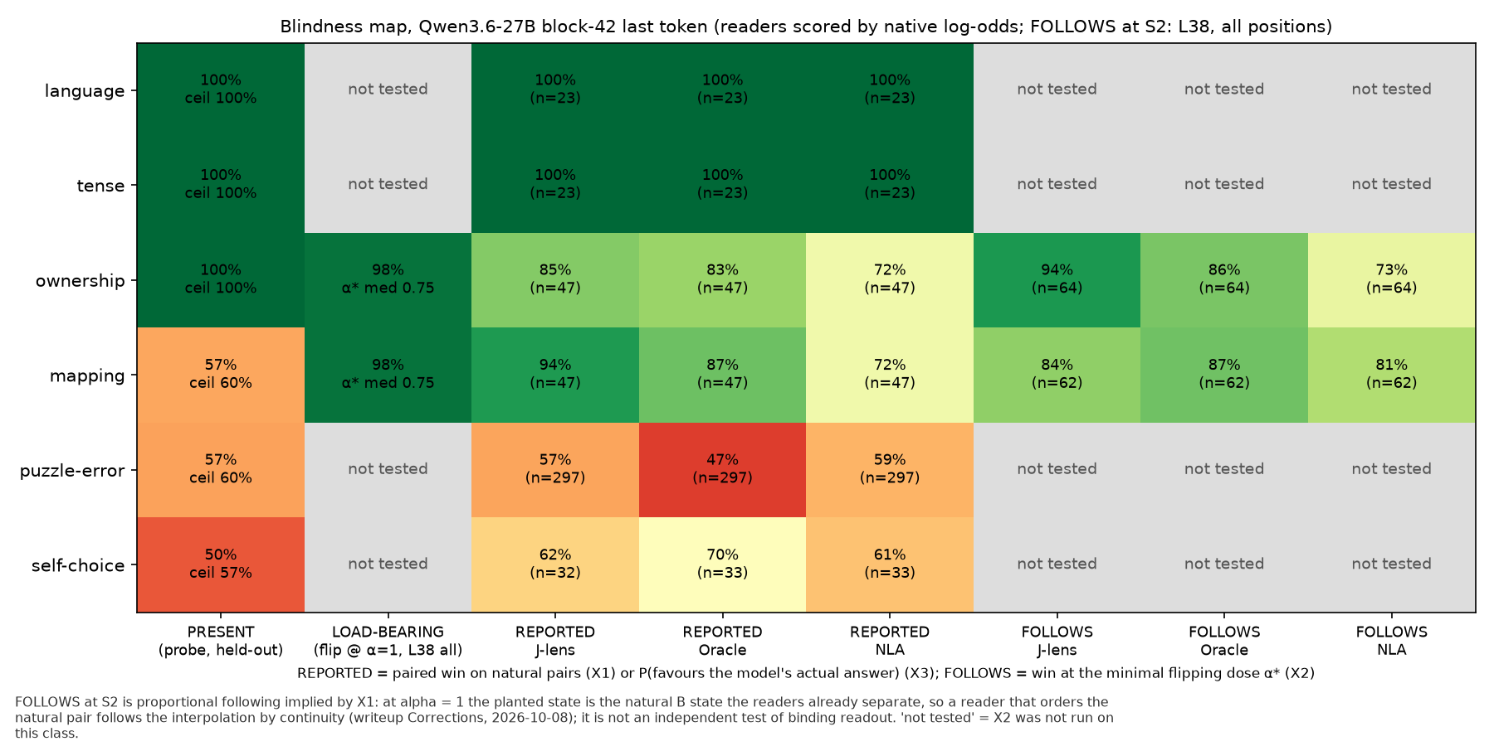
Blindness map at layer 42. Every fact the probe finds (PRESENT), the readers report; the puzzle-error and self-choice rows are weak for probe and readers alike.
Reading at more layers changes the picture. On the 297 arrow puzzles the model gets wrong, a probe reads the upcoming wrong answer from layer 48 (79%). The J-lens and Oracle don't at layers 42 to 48 (41 to 57%), but from layer 52 they do (77 to 86%). At layer 48 the J-lens even prefers the correct answer, the one the model goes on to abandon, by 17 points. This looks like lag rather than blindness, but we haven't yet fit readers at layers 52 to 56 against a probe there.
The same holds for the bindings that started the project. With the plain chat template, the Oracle names who holds the object or where the arrows end in free text 86% of the time at layer 56, against 12% at layer 44, and gets both versions of each pair right; the J-lens names them at layers 56–60 (25–62%) and never below 52. Prefilling an answer stem ("The person who carries the lantern is") does not help at any layer, and a stem that names a candidate ("The answer, in Italian, is") is simply copied: readers name the stem's word 59–95% of the time even when it is wrong.
Some facts stay hidden even so. Mapping every prompt position at layers 36–60, we found 60 cells where a trained probe reads the answer (80% or more) while the J-lens and Oracle sit at chance, all on template and instruction tokens just before the answer (such as "<think>" and "Reply"); by the last token the readers catch up. We haven't yet tested whether the model uses those positions. On the puzzles the model gets wrong, the Oracle doesn't look more confused than on ones it gets right (1.35 vs 1.29 candidate answers per readout); from layer 52 it reports the model's wrong choice rather than weighing options.

4. Readers can report what the prompt doesn't say
Until now, every fact the readers reported could also be read off the prompt. So we put the ownership fact only in a system-turn preamble and kept the visible prompt identical within each pair. On 48 pre-registered pairs, every reader reports who owns the object: Oracle 94%, NLA 94%, J-lens 88% and a skip lens 81%, against a 50% prompt-only baseline and a 100% model ceiling.
It's the first positive case in the project. Two unplanned effects also showed up (readers did better with the fact in the system turn, and with the holder mentioned second); we're treating both as hypotheses until they replicate. We also aren't sure yet whether a fact the model was told counts, or whether it has to be one the model inferred.

Misc
- Two candidates flatter the readers: the same readers that win 85–94% of two-candidate mapping items score 12–21% with eight candidates (chance 12.5%).
- On Michael Kenney's data, consistency across samples sorts input claims well (AUROC 0.90) but not confidently repeated wrong internal claims (0.56).
- On Qwen3.6-27B, judged precision on claims about the input is low for both free-text readers: NLA 27%, Oracle 40%.
- Suraj's companion project: the Oracle Lens's published lead comes from best-of-11-layers scoring, and at layer 42 alone the NLA ties or beats it.
- In the same project, WorkspaceBench targets are recoverable from the prompt alone (0.89, against 0.60 and 0.56 from the NLA and Oracle readouts).
- The same correlated-evaluator failure shows up in Guiv's post-training work: an aligned LLM judge grading summary faithfulness produced spurious 5–19 pp gaps, even on base models, because it shares the bias it is measuring.
- Suraj's newline feature (characters since the last newline) stays unreadable at new read sites. With "<|im_end|>" appended, a counting instruction, or both, no reader separates long-line from short-line reads (48–65%), while a probe does (85–97%). With the counting instruction the Oracle talks about line length, but equally for long and short lines.
- The NLA's own reconstructor recovers 50–70% of the variance at the last token but goes negative on template tokens, and it doesn't tell the NLA's right readouts from wrong ones within a family.
- The Oracle Lens is trained on every fourth layer and 42 isn't one of them. Rerunning the main comparisons at 44 changed no conclusion; it raised two ownership cells (class-mean direction 77% → 92%, probe direction 52% → 66%).

What we'd do next
First, test whether the template positions where a probe reads what the readers miss are used by the model, by editing only there. Second, redo the main free-text comparisons at layer 56, where the readers report bindings, and re-score every earlier two-way test with the full candidate set. Third, replicate the two system-turn effects, then use a preamble that contradicts world knowledge to separate "reads the context" from "reads the model's belief". SAEs are still not in the comparison.
Caveats: the prompts are synthetic with rule-based keys, and there is one model. Reads are at the last token unless stated, each steering cell has 64 states, claim precision rests on 32 + 8 states, the prefill and stem results rest on 16 pairs, and the stem test was scored by rules after our judge credits ran out (rules and judge agreed on 92% of readouts in the first prefill test).

Questions for a mentor
- Should a reader be judged at its training site, or wherever the fact is load-bearing? At layer 56 the Oracle reports bindings it misses at 42.
- Is "follows a direction the model under-weights" a reader failure, or a correct report of a vector the model relies on less?
- Does a reader reporting a system-turn fact count as "reads what the prompt doesn't say", or does the fact have to be one the model inferred rather than was told?

Refs
Kim et al. 2025 – Correlated Errors in Large Language Models – https://arxiv.org/abs/2506.07962
Goel et al. 2025 – Great Models Think Alike and this Undermines AI Oversight – https://arxiv.org/abs/2502.04313
Elazar et al. 2021 – Amnesic Probing – https://arxiv.org/abs/2006.00995
Li et al. 2025 – Do Activation Verbalization Methods Convey Privileged Information? – https://arxiv.org/abs/2509.13316
Orgad et al. 2025 – LLMs Know More Than They Show – https://arxiv.org/abs/2410.02707
+ thanks to Michael Kenney for the consistency-filtering data.

