Cross-referencing activation readers on Qwen3.6-27B
What J-lens, NLA and Oracle Lens agree on, what a causal edit says about it, and whether agreement can be ground truth
Code and artefacts: projects/g_agreement and results/g_agreement in the mats-minis repository.

1. Question and motivation
Our goal is to cross-reference interpr techniques J-lens, NLAs, Oracle Lens, Skip Lens, SAEs and discover:
- What they agree on
- What can some find that others miss
- do NLAs and SAEs find "non-workspace" content that J-lens and Oracle Lens do not, and can their agreement serve as a tentative ground truth, for example by rating each technique by its agreement with the majority?
We use activation readers. All were built for Qwen3.6-27B at the output of decoder block 42.
Current Method (used – not sure if this is flawed): Grading by majority ;
Idea: no human-labelled ground truth exists for what hidden vector contais
Main Risk:
- Circularity, share the same mistakes (2 readers built from the same base model with similar training can)
- Majority of similar readers then measrues shared trainig rather than truth

2 phases:
- Pilot (G1 to G6) : measure agreement directly and test whether it came frim the activations
- After Independent methods review: “agreement with the majority” by “agreement with fact established withotu readers” (fact constructed into the prompt: plan fact into the activation and verfieid by change in model’s own behavior where it departs from the text (Phase X); and testg majority proposal head-on against those keys

2. Setup
- Target. Qwen/Qwen3.6-27B at the pinned revision the NLA was trained on (64 decoder blocks, d = 5120). The read site is the output of block 42 at the last prompt token, captured before any answer token is generated, with the chat template and thinking disabled.
- Readers. J-lens (neuronpedia/jacobian-lens, cosine readout, top-10), Oracle Lens (agu18dec/olens_and_ar, LoRA, the activation replaces a marker embedding), NLA (ceselder/qwen3.6-27b-nla-rl, injected at block 1, writes an <explanation>). The reference implementation for all three is the workspace-bench producer; our setup reproduces Suraj's layer check and his bench numbers within their confidence intervals (R0).
- Scoring. Free text was parsed by a fixed rubric in the pilot. From Phase X on, every reader is scored by its native log-odds: for the two candidate answers of a state, lp(candidate A) minus lp(candidate B) in the reader's own output format (Oracle bullet, NLA explanation template, J-lens cosine). This removes the parsing step entirely.
- Datasets. Paired synthetic prompts whose two versions differ in one fact: response language, tense, object ownership (which name holds the asked object), symbol mapping (which letter a short arrow chain reaches). The pilot used 20 pairs (4 dev, 16 test); Phase X used 48 + 48 + 24 + 24 pairs. Two further sets where the answer is not stated in the text: arrow puzzles the model answers wrongly (297 of 400) and two-option choices where the model's prediction of its own choice disagrees with its actual choice (33 of 245 parsed).
- Discipline. Every phase has a pre-registration (BRIEF.md, BRIEF_G5G6.md, BRIEF_X.md, BRIEF_Y.md) with endpoints, decision rules and kill criteria written before compute; dataset, rubric and code are frozen by hash before test collection; every effect is reported against a control arm with 95% pair-level bootstrap or Wilson intervals; deviations are dated in the briefs. Compute to date: about 7 pod-hours on one H100 (roughly 25 USD).

3. Main experimental results

3.1 Pilot (G1 to G4): what the readers report, and whether it comes from the activation
G1 mapped coverage and accuracy of the three readers on the 32 test states (16 pairs), with free text parsed by the frozen rubric. G2 asked whether any reader named the relation (who owns what) rather than only the vocabulary. G3 tested activation dependence by handing each reader a different item's cached vector (donor reassignment), by a prompt-only baseline (the same model answering from the prompt text), and by a state-free prior. G4 compared three readers against three samples of one reader on 8 preselected states.
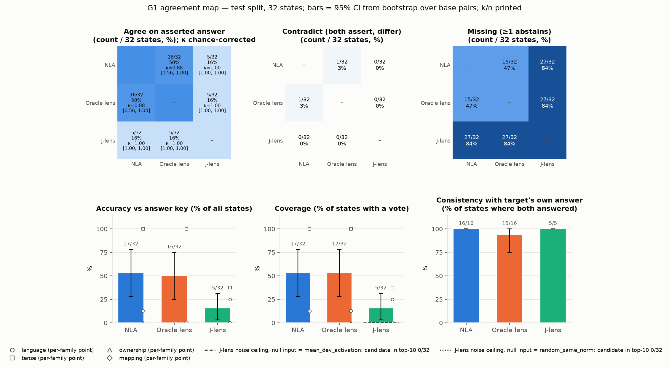
Figure 1. G1 agreement map. Coverage and accuracy per reader and family on the 32 test states, free-text scoring. NLA and Oracle Lens cover language and tense completely and nothing of ownership or mapping; J-lens covers 5 of 32.
Finding | Number | Control / comparison
NLA and Oracle report language and tense | 8/8 and 8/8 each, ~100% accurate when they speak, kappa 0.88 | J-lens 5/32
Nobody names a binding in free text | ownership 0/8, mapping 1/8; G2 entities/relations named: 0 | free-text artefact, see 3.3
Consensus of 2 or 3 vs best single reader | +0 pp [0, 0] | ceiling: 100% accuracy on covered items
Readouts come from the vector (G3) | genuine 17/32 vs donor-reassigned 4/32 (coincidences) | state-free prior 3 to 4/32
Prompt gives it away (G3) | prompt-only baseline 32/32 | agreement cannot beat the text here
Three readers vs re-sampling one (G4) | within-reader samples 3/3 consistent on all 4 covered states | cross-reader agreement adds no information

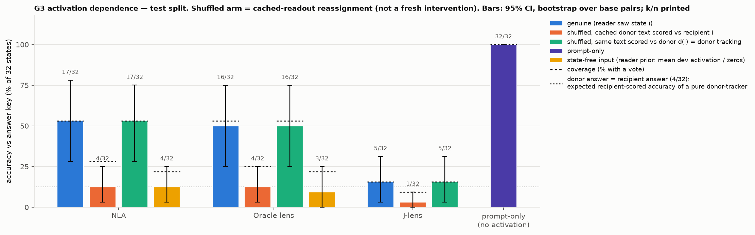
Figure 2. G3 activation dependence. Genuine readouts versus donor-reassigned readouts, the prompt-only baseline and the state-free prior.
Reading of the pilot: the two verbalizers agree on the surface facts a text reader also recovers, abstain together on bindings, and agreement adds nothing over one reader because the covered items are at ceiling and the uncovered ones are shared blind spots. The prompt-only arm at 100% means that on natural prompts "readers agree with each other" can never be worth more than reading the prompt.

3.2 G5 and G6: planting at the last token, and a family the text does not settle
G5 moved the block-42 last-token vector along each pair's own swap direction (from the state where Mira holds the red key toward the state where Leo does), with the prompt unchanged, and asked whether the model's one-word answer flips and whether the readers follow. G6 built eight self-choice pairs where the key is the model's own greedy choice.
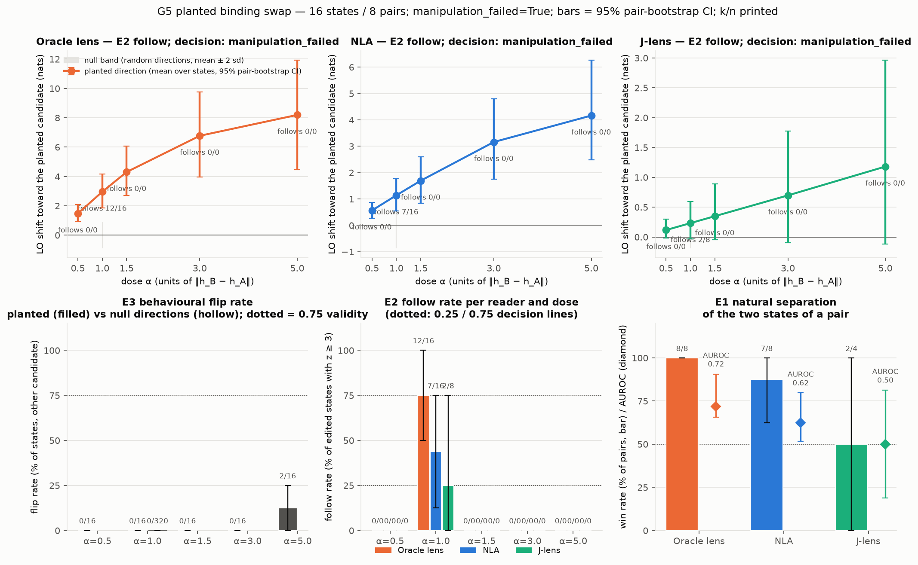
Figure 3. G5 planted binding swap at the last token. The model's answer never flips at the pre-registered doses (0/16; random directions 0/320) while the readers' native log-odds move with the planted direction.
The behavioural gate failed: 0/16 flips at dose 0.5, 1 and 1.5 (2/16 at an exploratory dose of 5). The readers' native log-odds nonetheless separated the natural pairs (Oracle 8/8, NLA 7/8, J-lens 2/4 scorable) and moved toward the planted candidate. G6 lowered the prompt-only floor from 100% to 75% only because the prompt-only arm is the same model with the same position bias, and no reader approached it (Oracle 5/16, NLA 0/16, J-lens 0/16). These two results motivated the reframing: score natively, and intervene where the edit is causal.

3.3 Phase X: three independent columns per feature class
After a three-reviewer methods review (results/g_agreement/direction_review.md) we replaced the agreement question by a blindness map with three columns per feature class: PRESENT (a held-out linear probe recovers the fact, against a two-half ceiling), LOAD-BEARING (editing the fact in the activation changes the model's own answer) and REPORTED (each reader's native log-odds favour the fact). Agreement becomes a derived quantity. Pre-registration: BRIEF_X.md; 46 minutes of pod time.

X1. Native log-odds on a larger bank
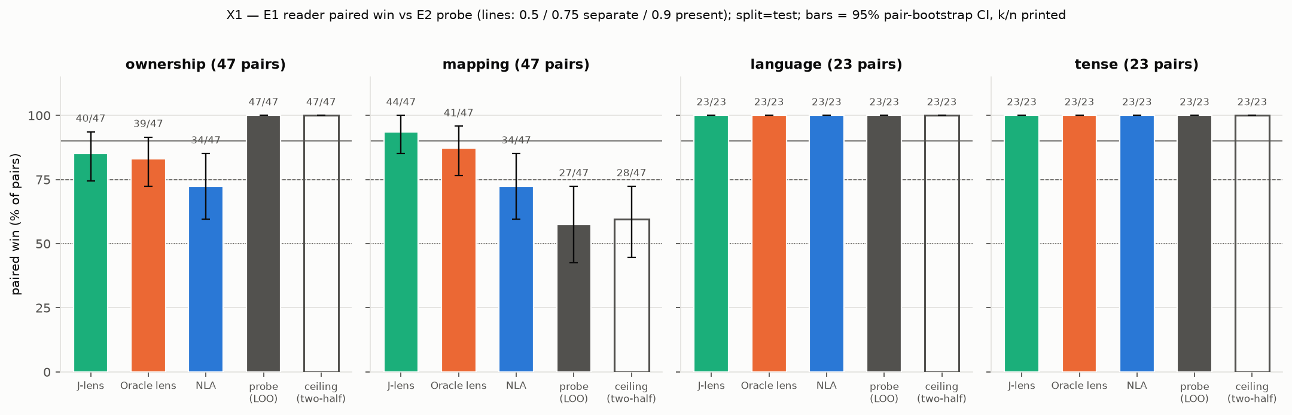
Figure 4. X1 within-pair win per reader and family (reader favours each state's own answer), with the held-out probe and its two-half ceiling.
Reader | Ownership (47 pairs) | Mapping (47) | Language (23) | Tense (23)
J-lens | 85% [74, 94] | 94% [85, 100] | 100% | 100%
Oracle Lens | 83% [72, 92] | 87% [77, 96] | 100% | 100%
NLA | 72% [60, 85] | 72% [60, 85] | 100% | 100%

Scored by their own log-odds, all three readers carry the bindings that free text never named, J-lens included. Paired sign tests on identical pairs show J-lens and Oracle beat the NLA (p = 0.002 and 0.004, driven by mapping) while J-lens and Oracle do not differ (p = 0.42). The pilot's "blind to bindings" was an artefact of free-text elicitation, which is the first methodological result: verbalizers should be scored natively.

X2. Planting until the model's answer flips
For 32 ownership and 32 mapping pairs we interpolated the block output between the two states of a pair, h' = h_A + alpha (h_B minus h_A), at three sites: S1 = layer 38, last token only (the collaborator's recipe); S2 = layer 38, all positions; S3 = layer 42, all positions. For every edited state we recorded the model's greedy answer, its first-token answer log-odds, and the block-42 last-token vector read back from the same forward, on which all three readers were scored. 4,736 edited decodes.
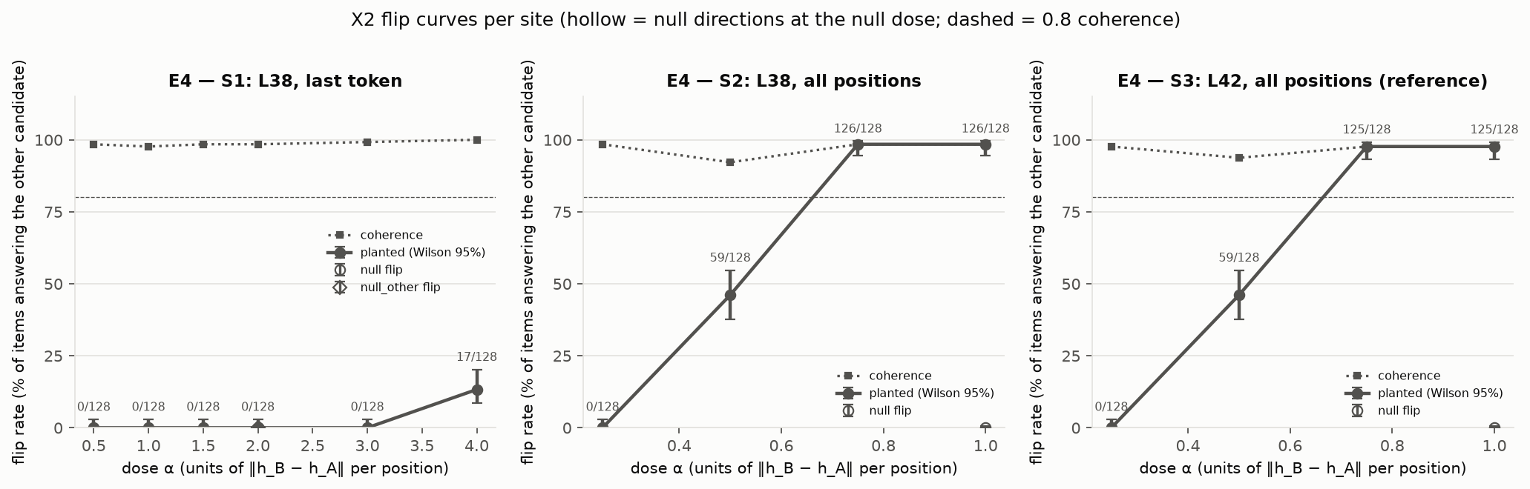
Figure 5. X2 flip curves. Editing the last token alone never flips the answer up to dose 3; editing all positions at layer 38 or 42 flips 98% of states by dose 0.75. Random directions: 0 of 768.
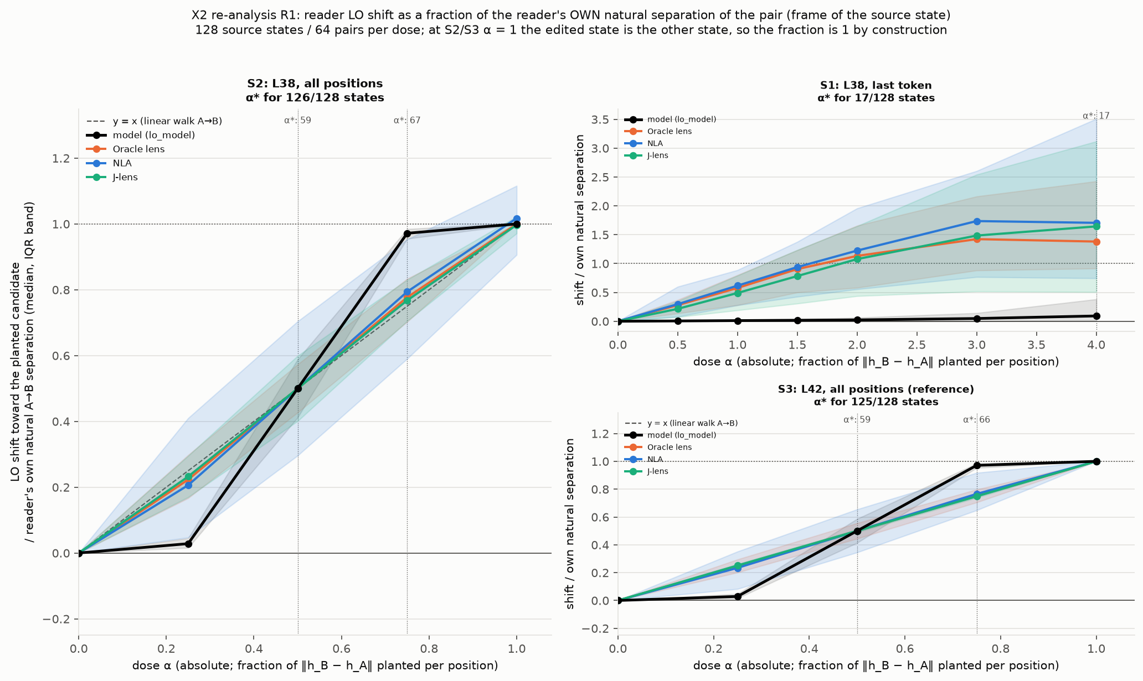
Figure 6. X2 re-analysis. Reader log-odds shift as a fraction of the reader's own natural separation of the pair (median and interquartile band), against the model's own answer log-odds (black). At the causal site the readers walk the straight line between the two states while the model is a threshold; at the inert last token the readers report the planted candidate at 1.1 to 1.7 times their own separation while the model does not move.
Reader (S2, layer 38 all positions) | Win at the item's flip dose | Null win | Fraction of own separation at dose 0.25 / 0.5 / 0.75 / 1
Oracle Lens | 86.5% [78.6, 93.7] | 16.5% | 0.22 / 0.50 / 0.78 / 1.00
NLA | 77.0% [67.2, 85.7] | 29.2% | 0.21 / 0.50 / 0.79 / 1.02
J-lens | 88.9% [81.7, 95.3] | 21.2% | 0.23 / 0.50 / 0.77 / 1.00
Model's own answer log-odds | flips 98% at dose 0.75 | 0/768 | 0.03 / 0.50 / 0.97 / 1.00

The last-token vector at layer 38 is not load-bearing (0 of 128 flips up to dose 3, 17 of 128 at dose 4); the all-position state is (median flip dose 0.75; the kill criterion K5 passed with 64 of 64 pairs). Along the causal ladder each reader's score moves by exactly the dose fraction of its own natural separation, for all three readers alike. This is what continuity predicts: at dose 1 the read vector is the other state's vector, which the readers already separate in X1. It therefore does not yet distinguish "follows the binding" from "reads the interpolated state", and because the two versions of a pair are token permutations, the all-position swap also plants the names' token identity. At the inert last token the readers report the planted candidate strongly while the model ignores it: the readers report what is in the vector whether or not the model uses that vector.

X3. Where the answer is not in the text
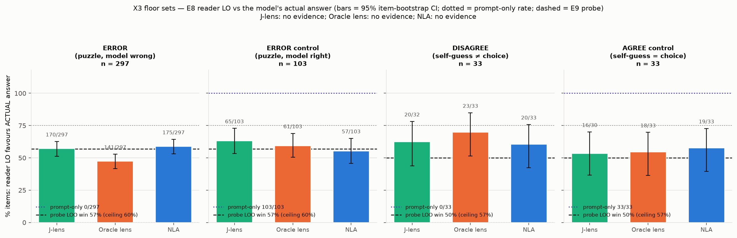
Figure 7. X3 floor sets. Probability that each reader's log-odds favour the model's actual answer on puzzle errors, self-choice disagreements and their size-matched controls; the prompt-only arm is at 0 on the two test sets by construction.
Of 400 arrow puzzles the model answers 297 wrongly, all coherently. A re-analysis showed that 267 of those errors are a symbol on the model's own trace (151 the k minus 1 symbol: the model stops one step early), so only 30 are genuinely off-text. After removing each reader's additive symbol priors (the Oracle's span 5.5 nats across the eight symbols), the readers favour the model's actual wrong answer in 54 to 57% of errors against 47 to 51% on correct controls. An 8-way logistic probe for the upcoming symbol reaches 68% on errors (permutation null 61%, two-half ceiling 36%), while a probe for the correct symbol is at 50%. On the 33 self-choice disagreements the readers are at 61 to 70% with wide intervals. All are below the pre-registered 0.75 bar: the model's upcoming answer is weakly present at this site and the readers sit at the probe's level.

The blindness map
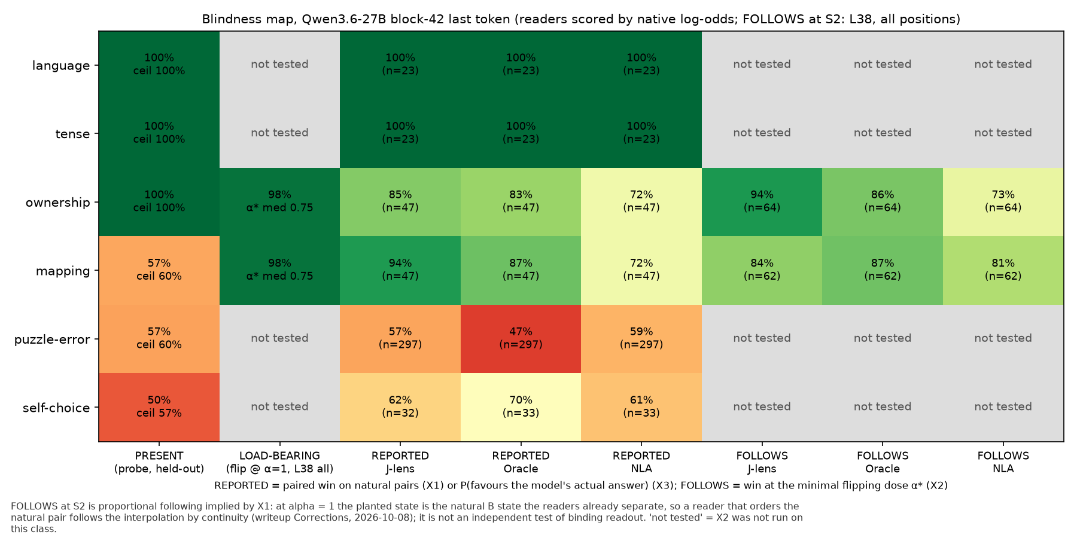
Figure 8. Blindness map. Rows are feature classes, columns PRESENT (held-out probe), LOAD-BEARING (flip rate under the all-position layer-38 edit), REPORTED per reader (X1 within-pair win or X3 favours-actual) and FOLLOWS per reader (win at the flip dose; proportional following implied by X1).
The cell the design was built to find, present and load-bearing but unreported, is empty at the pre-registered thresholds. Everything a linear probe finds at this site, all three readers report; the two classes none of them reports above threshold, the probe barely finds either. Mapping is the one inversion, where the readers (72 to 94%) beat the class-mean identity probe (57%); a proper logistic probe later showed a linear within-pair letter readout does exist (paired-sum win 98%), so this is a statement about the weak probe, not about the readers.

3.4 X6: rating readers by the majority versus by an independent key
This is the original proposal tested directly. For every state we computed, per reader, A_key (its log-odds favour the key) and A_maj (its sign agrees with the leave-one-out majority of the other readers), under three majority definitions: all readers, the two sibling verbalizers only (Oracle and NLA, same base model), and the non-sibling pair (J-lens plus a linear probe). Keys: D1 the constructed answer on 280 natural states; D2 the planted candidate on 126 states where the model's answer flipped at the causal site; D3 the model's own answer on its 297 errors and 33 self-choice disagreements.
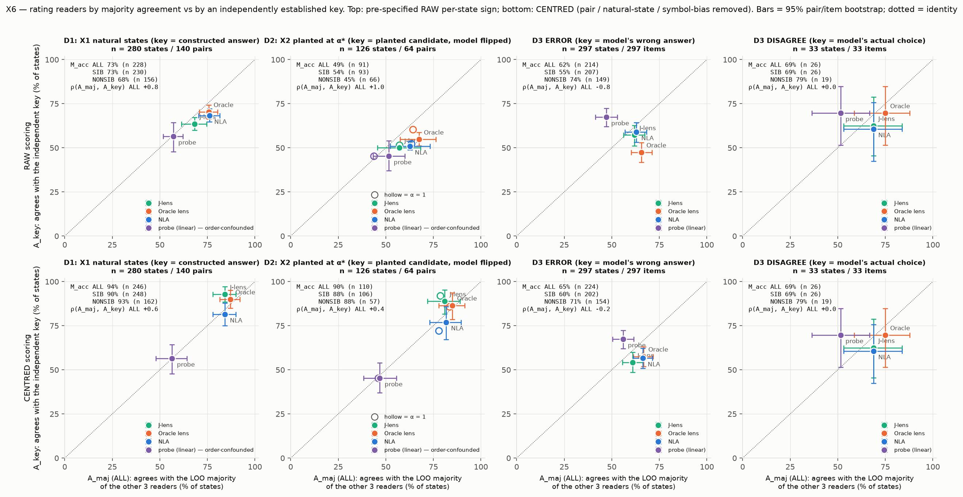
Figure 9. X6. Agreement with the independent key (y) against agreement with the leave-one-out majority (x), one point per reader per dataset; top row the pre-specified raw per-state sign, bottom row with candidate and symbol biases removed. The diagonal is where the two gradings coincide.
Dataset | What happens | Numbers
D1 natural, D2 planted (centred) | Majorities are right, but only because each reader is individually right | majority accuracy 88 to 94%; J-lens / Oracle / NLA vs key 93 / 90 / 81% (D1), 89 / 87 / 77% (D2)
D3 model's own errors | The ranking inverts | probe: best vs key (67%), worst by majority (47%); Oracle: worst vs key raw (47%), second by majority (66%); Spearman(A_maj, A_key) = -0.8
D3, sibling majority | Siblings agree with each other more than with the key | Oracle agrees with NLA 70%, with the key 47 to 59%; where they agree they are right 55%; non-sibling majority right 74%
D3, shared errors | All three readers pick the same wrong candidate too often | 17.5% vs 9.2% under independence (ratio 1.9); unanimous either way 46% vs 25%

Majority agreement ranks the readers like the key only where every reader is already right, and inverts the ranking where it would matter. A majority of similar readers measures shared training.

3.5 Corrections after independent review
Three independent reviewer passes over the Phase X write-up found two readings that were wrong, both verified on the raw rows and recorded with a date in the write-up. (1) "Readers follow the sign but not the magnitude" was a scale artefact: normalised by each reader's own natural separation the shift is exactly the dose fraction, for every reader. (2) "The model's off-text answer is absent at the site" was not established: most puzzle errors are text-derivable, the first probe tested correctness rather than identity, and symbol priors contaminated the reader scores. The corrected statements are the ones used in this report.

4. Interpretation
- The three readers behave as one instrument at this site. They agree on every class a linear probe sees, fail together on the classes it does not, and share wrong answers at twice the independent rate. "What can some find that others miss" has no positive instance in six feature classes.
- Free-text elicitation, not the activation, was the limiting factor. The same readers that named zero bindings in free text carry them at 72 to 94% in their native log-odds. Any evaluation of verbalizers that parses their prose will understate what they encode.
- Agreement with the majority is not ground truth. It is circular where the readers share training, saturated where the prompt already states the fact, and inverted on the model's own errors. The replacement, agreement with a fact established without the readers, is cheap to build: constructed prompts, planted activations verified by a behavioural flip, and the model's own behaviour.
- Readers report what is in the vector, whether or not the model uses that vector. At the inert last token they track the planted candidate strongly while the model ignores it; at the causal site they move in exact proportion to the interpolation. The value of a reader is therefore decided by the choice of site and scoring format, not by which reader one picks.
- The discriminating information is not at this site. The only thing that could separate a good reader from a bad one, the model's actual upcoming answer when it departs from the text, is at most weakly present at block 42, last token. The open question is where it is.
Untested parts of the original prompt: SAEs, Skip Lens and the "non-workspace" clause. Assets for all three exist (a Qwen-Scope layer-42 SAE for Qwen3.5-27B whose transfer is untested, four layer-42 skip-lens LoRAs that use our NLA's injection convention, and the collaborator's J-space basis) and are part of the phase now running.

5. Next steps
Thesis for the next phase: at a fixed site the readers are calibrated reporters of what is linearly present there and nothing more, so the project now looks for a site where a load-bearing, off-text fact is present and asks who reports it. Pre-registered in BRIEF_Y.md and running at the time of writing.
- Y1, site search. Capture layers 42 to 62 at the last twelve positions and the candidate-token positions on the puzzle-error and self-choice sets (choice pool extended by 900 prompts), fit cross-validated logistic probes for the model's actual answer at every cell with permutation nulls and two-half ceilings, find the earliest site where it is present, and re-read there with J-lens natively, Oracle on its training grid, and the NLA as a gated transfer test. Kill criterion: no site before answer formation.
- Y2, identity-free nulls at the causal site. Plant only at the name positions, only at the non-name positions, another pair's direction, and the J-space and non-J-space components of the swap direction, with random equal-rank subspace controls. This separates "reads the binding" from "reads the name" and tests the non-workspace clause directly.
- Y3, new reader families in the same harness. Skip-lens arms A and D (arm D was trained on spans the J-lens misses and is the pre-registered candidate for non-J reading), an R-lens, and the Qwen-Scope SAE after a transfer test, each gated by the X1 bank before entering the map. This breaks the two-siblings-versus-one structure.
- Stronger PRESENT column. Logistic probes with inner cross-validation everywhere, so that no cell of the map rests on a class-mean direction.
- Headline figure aimed for. Left: a site map (layer by position) of where the model's off-text answer is linearly present, with each reader's rate printed at the first positive site. Right: at the causal site, the model's flip rate and each reader's follow rate under the full swap, the name-only and name-removed components, the J-space split and the other-pair null.
Questions we would put to a mentor: should readers be judged only at their training site or wherever the fact is load-bearing; which operational definition of "non-workspace" is acceptable (J-space complement at a chosen rank, or a behavioural one); and whether the right ground truth is the best linear probe or a causal flip only, since the two disagree on mapping.

6. Caveats
- Synthetic prompts with rule-based keys; 136 blind free-text rows from the pilot remain unadjudicated.
- Ownership binding is confounded with mention order in our bank (one direction carries 66% of the within-pair variance); the mapping bank has no such confound but its identity probe is small-sample.
- "Consensus adds 0 pp" is a ceiling artefact, not a result about agreement; it is untestable on these items.
- Following at the layer-42 all-position site is by construction, and layer 38 is only four blocks upstream; the identity-free nulls are pending.
- Permutation nulls used 10 permutations; X6 adds a post-hoc centred variant because the raw per-state sign is dominated by candidate bias (both recorded as deviations).
- Readers compared at one site and one model; SAE and Skip Lens not yet in the map.

Appendix: where things are
Item | Path (under results/g_agreement unless noted)
Full write-up with all numbers, corrections and the Friday re-analyses | writeup.md
Pre-registrations | projects/g_agreement/BRIEF.md, BRIEF_G5G6.md, BRIEF_X.md, BRIEF_Y.md
Methods and direction reviews | projects/g_agreement/REVIEW.md; direction_review.md
Pilot figures and tables | g1/ to g6/ (fig_main.png, csv, summary.json)
Phase X | x1/, x2/ (fig_main, fig_flips, fig_fraction, per_pair.csv), x3/, x/ (blindness_map.csv, fig_main.png)
Friday re-analyses and worked cases | x/friday/ (R1.md, R2R4.md, friday_cases.md, csv)
X6 majority vs key | x6/ (x6.md, x6.csv, fig_main.png)
Plan and mentor summary | NEXT_STEPS.md, summary_for_agam.md, summary_for_suraj.md
Raw outputs and state caches | cache/g_agreement (gens, states, x/, readvecs, full captures)
Run log and compute ledger | log.md, compute.jsonl

