[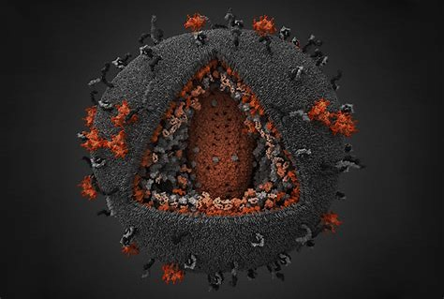](http://cn.bing.com/images/search?view=detailV2&ccid=GiBzLuqi&id=5020AACEA45C4DD3513A04CCC14E40629EFE19D0&thid=OIP.GiBzLuqiDCSLCzSiycE4YgHaFA&mediaurl=http://mediad.publicbroadcasting.net/p/shared/npr/styles/x_large/nprshared/201207/156846815.jpg&exph=1385&expw=2048&q=hiv&simid=608006082573893944&selectedIndex=100)



**How scary are viruses?**

By Lebron Wei (魏旭晨), Kyrie Zhong (钟赟),

Red Liu (刘晨阳), Tom Xu (胥夫鹏)

from Media Literacy Class #3

20 June 2018