2017/7/4日打卡

阅读

内容：Tpo2阅读3篇

正确率：29/39 得分21

做题时间：1h

改正时间：40分钟

错误题目：4/13，14，15/26，/32，33，34/ 38，39

单词背诵

内容：托福词汇一本通，level 5 list1

背诵时间：约1h

背诵遍数：2遍

反思

1.本次出现的连续错误，连在一起的三个题目理解错了就错一串。

2.做题要注意关键词定位！！！一般答案都在某一句话中，不要因为那一句读不懂就去前面找答案

3.拿不准的题目可以在纸上用排除法

阅读改错：

4.During the dry periods that are common phenomena along the desert margins, though, the pressure on the land is often far in excess of its diminished capacity, and desertification results.

没看清A选项 adjusting to stresses created by settlement

14.Their streamlined bodies, the absence of hind legs, and the presence of a fluke and blowhole cannot disguise their affinities with land dwelling mammals

15.unlike the cases of sea otters and pinnipeds (seals, sea lions, and walruses, whose limbs are functional both on land and at sea), it is not easy to envision what the first whales looked like.

前面说sea otters，后面说鲸

32.But the movies differed significantly from these other forms of entertainment, which depended on either live performance or (in the case of the slide-and-lantern shows) the active involvement of a master of ceremonies who assembled the final program.

33.Although early exhibitors regularly accompanied movies with live acts, the substance of the movies themselves is mass-produced, prerecorded material that can easily be reproduced by theaters with little or no active participation by the exhibitor. Even though early exhibitors shaped their film programs by mixing films and other entertainments together in whichever way they thought would be most attractive to audiences or by accompanying them with lectures, their creative control remained limited.

34.With the advent of projection, the viewer's relationship with the image was no longer private, as it had been with earlier peepshow devices such as the Kinetoscope and the Mutoscope, which was a similar machine that reproduced motion by means of successive images on individual photographic cards instead of on strips of celluloid.

2017/7/6日打卡

阅读

内容：Tpo3阅读3篇

正确率：28/42 得分18

做题时间：1h

改正时间：1h

错误题目：第一篇2，6，10，11，14，

第二篇17，18，20，21, 25，28，

第三篇31，35,42

总结：

1.单词错误5题，是一些常见的单词的另外一层意思

2.6选3错误三题，选的时候基本都是凭感觉，因为怕时间不够，没法去原文寻找。三个里面经常选错一个就功亏一篑。感觉说的都是对的，目前还不知道怎么解决。

3. 知道意思，但是总是过多意会，选择了错误的那一个

错误单词：

Feasible 可行的 achievable

Integral 必须的，完整的 essential

Virtually 清晰的，几乎是 almost

Ensue 跟随，接下来 subsequent

Unprecedented 空前的 没看清题目

Midcore

Throughout

for practical and symbolic purposes.

It works in compression to divert the weight above it out to the sides, where the weight is borne by the vertical elements on either side of the arch. The arch is among the many important structural breakthroughs that have characterized architecture throughout the centuries.

Releasing capillary water and introduing drought ---resistant crops are less –promising solutions to the water supply crisis than bringing in river water.

太细节不选

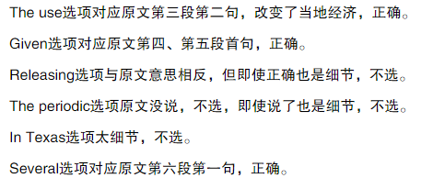

Estimates indicate that the aquifer contains enough water to fill Lake Huron, but unfortunately, under the semiarid climatic conditions that presently exist in the region, rates of addition to the aquifer are minimal, amounting to about half a centimeter a year.

在半干旱的气候条件下，蓄水层蓄水能力极低，每年仅半厘米左右

25. 知道意思，但是意会错误

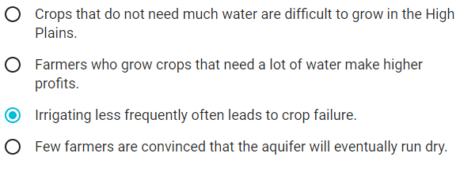



31

A&D，选A

We can say that the properties of an ecosystem are more stable than the individual organisms that compose the ecosystem.

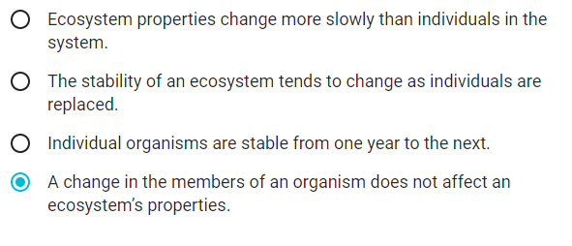

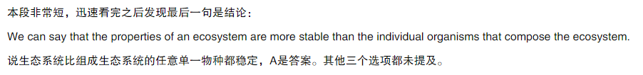

35 没懂。

At least in temperate zones（温带）, maximum diversity is often found in mid-successional stages, not in the climax community.

最多的物种发现在演替过程中，而不是在顶级群落中。

Once a redwood forest matures, for example, the kinds of species and the number of individuals growing on the forest floor are reduced.并没有提到稳定性。

 In general, diversity, by itself, does not ensure stability.

红木成熟后多样性下降，多样性不保证稳定，所以下降后应该是更稳定了，我选了更不稳定，有点绕

2017/7/8日打卡

阅读

内容：Tpo2阅读3篇

正确率：24/42 得分14

做题时间：1h

改正时间：

错误题目：第一篇：没时间做完

第二篇：15,19,21

第三篇：29,31,35,38,40,42

单词背诵

内容：托福词汇一本通，level 5 list3

背诵时间：约1h

背诵遍数：1遍

复习list2单词

总结

本次基本上剩余一篇没做，原因，昨天没休息好，中午也没睡着，导致盯着屏幕眼神根本无法聚焦，思考速度也变慢，托福阅读绝对是很耗脑力的一件事情，需要旺盛的精力，要不然眼动速度根本不行,以后要注意睡眠！。

以后可以先把排序的做了 ,单词一看就懂的也先做了，看不懂的就留着。