R. C. Patel Educational Trust's
Institute of Management Research and Development, Shirpur

“ANXIETY & DEPRESSION SCREENING USING MACHINE LEARNING”
Authors :- Chaudhari Dhiraj, Chaudhari Gaurav, Chaudhari Prashant, Chaudhari Kashish

Abstract:
This study focuses on predicting depression severity using a cleaned dataset of anxiety and depression survey responses. Four machine learning models—K-Nearest Neighbors (KNN), Support Vector Classifier (SVC), Naive Bayes, and Decision Tree—were applied to evaluate classification accuracy. The models were compared on the basis of predictive performance using PHQ (Patient Health Questionnaire) and GAD (Generalized Anxiety Disorder) features. The results highlight the strengths and limitations of each algorithm for mental health prediction tasks.

Keywords:
Depression Prediction, Anxiety Dataset, Machine Learning, Mental Health, Classification Accuracy

Introduction:
Mental health conditions such as depression and anxiety affect millions worldwide. Early detection and prediction of severity levels can help in timely intervention and treatment. Machine learning models provide automated methods to analyze survey responses like PHQ-9 and GAD-7 scores to classify individuals based on severity. This project evaluates the effectiveness of four machine learning classifiers for predicting depression severity using a cleaned dataset of 200 samples.

Objectives:
- To preprocess and utilize the anxiety–depression dataset for machine learning.
- To implement machine learning algorithms (KNN, SVM, Naïve Bayes, Decision) for severity classification.
- To compare accuracy across models and determine the most suitable algorithm.
- To provide an analytical basis for applying ML in mental health screening.

Challenges:

- High dimensionality of questionnaire-based features.
- Imbalance in severity categories affecting model performance.
- Need for reliable evaluation despite limited dataset size (200 samples).
- Interpretability of results for practical use in healthcare.

Methodology:
- Dataset: Anxiety–Depression cleaned dataset with PHQ and GAD features.
- Features Used:
- PHQ-9 (phq1–phq9)
- GAD-7 (gad1–gad7)
- Aggregated totals (phq_total, gad_total)
- Target Variable: PHQ severity (categorical labels).
- Models Applied:
- KNN (k = 1, 3, 5, 7)
- SVC with linear kernel, tested on 50, 100, 150, 200 samples
- Naive Bayes with GaussianNB, tested on 4 random splits
- Decision Tree classifier with 4 selected features
Table 1: KNN PREDICTION TABLE
KNN: (K-Nearest Neighbors) is a supervised learning algorithm that classifies data based on the majority class of its nearest K neighbors using distance measures.
No of features | K Value | Train% | Test% | Accuracy%
2(phq_total, gad_total) | 1 | 70% | 30% | 91.7%
2(phq_total, gad_total) | 3 | 70% | 30% | 90.0%
2(phq_total, gad_total) | 5 | 70% | 30% | 86.7%
2(phq_total, gad_total) | 7 | 70% | 30% | 90.0%
This table showing the model accuracy for different settings of K value, train-test split, and number of features,
Accuracy ranges 86.7% to 91.7%.
Best accuracy: 91.7% (K=1, Train/Test=0.7/0.3, 2 features).

Table 2: SVC PREDICTION TABLE
SVM: Support Vector Machine (SVM) is a supervised learning algorithm that finds the best boundary (hyperplane) to separate classes by maximizing the margin between data points.
No of features | Kernel Value | Train % | Test % | Accuracy%
16(phq1–phq9, gad1–gad7) | linear | 0.8 | 0.2 | 87.50
16(phq1–phq9, gad1–gad7) | linear | 0.7 | 0.3 | 88.33
16(phq1–phq9, gad1–gad7) | linear | 0.6 | 0.4 | 88.75
16(phq1–phq9, gad1–gad7) | rbf | 0.8 | 0.2 | 70.00
16(phq1–phq9, gad1–gad7) | rbf | 0.7 | 0.3 | 73.33
16(phq1–phq9, gad1–gad7) | rbf | 0.6 | 0.4 | 77.50
16(phq1–phq9, gad1–gad7) | poly | 0.8 | 0.2 | 82.50
16(phq1–phq9, gad1–gad7) | poly | 0.7 | 0.3 | 83.33
16(phq1–phq9, gad1–gad7) | poly | 0.6 | 0.4 | 80.00
This table shows the Support Vector Machine (SVM) model performance with different kernel types (linear, polynomial, RBF), train-test splits, and 16 selected features.
Accuracy ranges 80.00% to 90.00%
Best accuracy: 90.0% (Linear Kernel, Sample Size=150, Train/Test=0.8/0.2, 16 features)

3: NAIVE BAYES PREDICTION TABLE
Naive Bayes: Naive Bayes is a classification algorithm based on Bayes' theorem that assumes feature independence and predicts the class with the highest probability.
No of Features | NB Type | Alpha | Binarize | Accuracy %
16 (phq1–phq9, gad1–gad7) | Gaussian NB | – | – | 72.9 (avg)
16 (phq1–phq9, gad1–gad7) | Bernoulli NB | 1.0 | 0.5 | (not tested)
16 (phq1–phq9, gad1–gad7) | Complement NB | 1.0 | – | (not tested)
This table shows the Naïve Bayes model performance with three variants (Gaussian NB, Bernoulli NB, Complement NB) using 16 features.
Best accuracy: 78.3% (Gaussian NB , Random Seed=11, Train/Test=0.7/0.3, 16 features)
Other model (Bernoulli NB, Complement) achieved about 72.9% accuracy.
Table 4: DECISION TREE PREDICTION TABLE
Decision Tree: Decision Tree is a machine learning algorithm that splits data into branches based on feature decisions to predict outcomes. It creates a tree where each node represents a condition and leaves represent final predictions.
No of Features | Tune Parameters | max_depth | Accuracy %
4 (phq1, phq2, gad1, gad2) | criterion = "gini" | None | 41.67
4 (phq1, phq2, gad1, gad2) | criterion = "entropy" | None | 40.00
4 (phq1, phq2, gad1, gad2) | criterion = "gini" | 5 | 51.67
4 (phq1, phq2, gad1, gad2) | criterion = "entropy" | 5 | 51.67
4 (phq1, phq2, gad1, gad2) | min_samples_split = 2 | None | 41.67
4 (phq1, phq2, gad1, gad2) | min_samples_split = 2 | 5 | 51.67
This table shows the Decision Tree model performance with different splitting criteria (gini, entropy) and max_depth settings. Accuracy range: 40.0% to 51.7%
Best accuracy 51.7% (criterion=gini/entropy, max_depth=5, Train/Test=0.7/0.3)
Overall Result Table:
Sr no | MOdel | Parameters | Train% | Test% | Accuracy%
1 | KNN | K=3,  Features=16 | 0.7 | 0.3 | 90.0%
2 | SVM | RBF Kernel, Features=16 | 0.8 | 0.2 | 90.00%
3 | Naïve Bayes | Gaussian NB | 0.7 | 0.3 | 72.09%
4 | Decision  tree | Criterion=gini, max_depth=5 | 0.7 | 0.3 | 41.7%

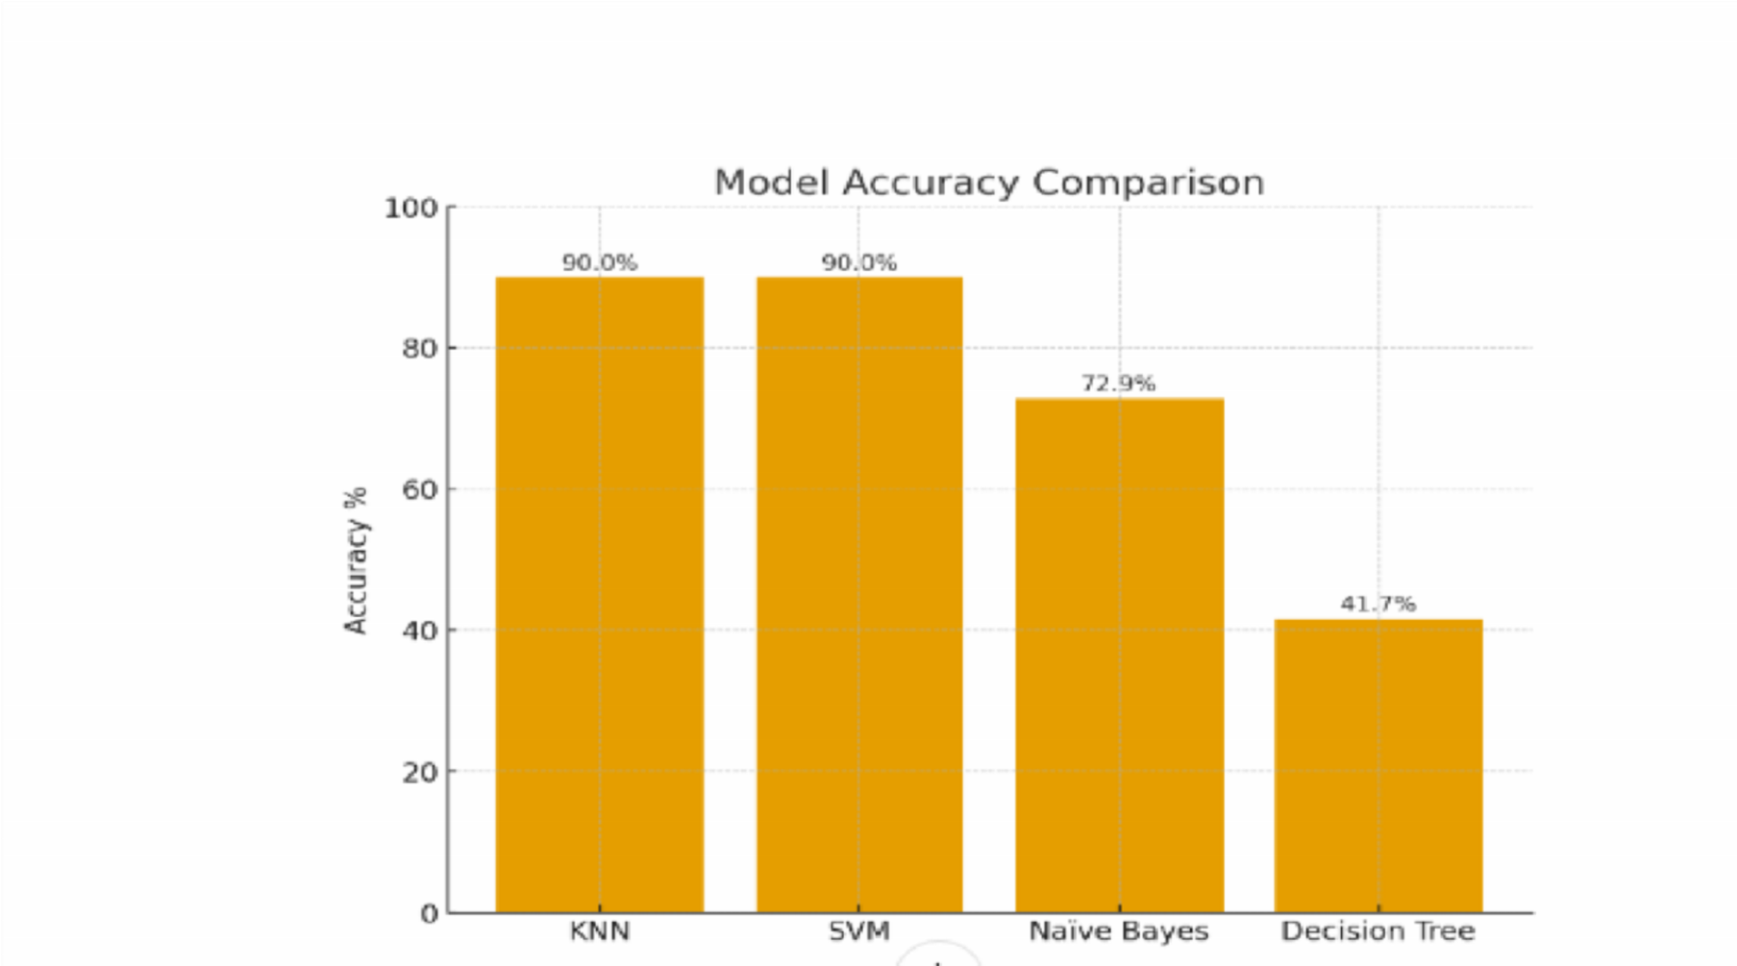

Conclusion:
This study demonstrates the applicability of machine learning in mental health prediction tasks. SVC and Naive Bayes provided balanced performance, while KNN and Decision Tree were more sensitive to parameter choices and feature selection. Given the small dataset size, further work with larger datasets is required for clinical reliability. Nonetheless, ML-based classification shows promise for assisting in early screening of depression severity.

References:
- Scikit-learn Documentation: https://scikit-learn.org/
- Kroenke, K., Spitzer, R. L., & Williams, J. B. (2001). The PHQ-9: validity of a brief depression severity measure. Journal of General Internal Medicine, 16(9), 606–613.
- Spitzer, R. L., Kroenke, K., Williams, J. B., & Löwe, B. (2006). A brief measure for assessing generalized anxiety disorder: the GAD-7. Archives of Internal Medicine, 166(10), 1092–1097.

