Cybersecurity Framework for Small Businesses

Table of Contents
1.Introduction 3
2.Lab Environment Setup 5
2.1 Virtual Machine Setup 5
2.2 Network Configuration 6
2.3 Connectivity Verification 7
3. Cybersecurity Threat Discovery 9
3.1 Host Connectivity Test 9
3.2 Network Host Discovery 10
3.3 Port Scanning and Service Detection 11
4. Attack Simulation 12
4.1 Denial-of-Service (DoS) Attack Simulation 12
4.2 Malicious Traffic Monitoring 13
4.3 System Resource Impact Analysis 14
5. Defense Implementation 16
5.1 Firewall Rule Configuration 16
5.2 Attack Mitigation Verification 17
6. Cybersecurity Framework & Action Plan 19
6.1 Security Framework Overview 19
6.2 Security Controls Implemented 20
6.3 Action Plan for Small Businesses 20
7. Conclusion 22

1. Introduction
In the modern digital landscape, small businesses increasingly rely on information technology systems to manage operations, store sensitive data, and communicate with customers. However, these organizations often lack the financial resources and technical expertise required to implement comprehensive cybersecurity defenses. As a result, small businesses have become frequent targets for cyber threats such as phishing attacks, ransomware, denial-of-service attacks, and unauthorized access attempts.
Cyber attackers often exploit weak security configurations, unmonitored networks, and outdated systems to gain access to valuable data or disrupt business operations. Therefore, implementing an effective cybersecurity framework is essential for protecting digital infrastructure and ensuring business continuity. Security frameworks provide structured guidelines that help organizations identify vulnerabilities, implement security controls, detect malicious activities, and respond to cyber incidents.
The objective of this project is to design and demonstrate a practical cybersecurity framework tailored for small businesses. A simulated network environment was created to replicate a small organizational infrastructure consisting of multiple systems such as an attacker machine, an employee workstation, and a company server. Within this controlled environment, various cybersecurity techniques were implemented to analyze threats, simulate cyber attacks, monitor network traffic, and deploy defensive security mechanisms.
The project focuses on identifying common cybersecurity threats that affect small businesses and demonstrating how these threats can be detected and mitigated using open-source security tools. Network scanning techniques were used to identify active hosts and exposed services within the simulated environment. Attack simulations were performed to demonstrate how malicious actors can disrupt services or exploit vulnerabilities. In response to these simulated threats, defensive mechanisms such as firewall rules were implemented to block malicious traffic and protect the server from further attacks.

By combining threat analysis, attack simulation, monitoring techniques, and defensive strategies, this project illustrates how small businesses can adopt cost-effective cybersecurity practices. The implementation of these security controls demonstrates the importance of proactive monitoring, network visibility, and defensive configurations in maintaining a secure digital environment.
Overall, this project highlights the significance of structured cybersecurity frameworks and practical security implementations in protecting small business infrastructures from modern cyber threats. The findings of this project also emphasize how open-source security tools can be effectively utilized to improve security posture without requiring significant financial investment.

2. Lab Environment Setup
2.1 Virtual Machine Setup
To simulate a realistic small business network environment, a virtual lab infrastructure was created using virtualization technology. Virtual machines allow multiple operating systems to run on a single physical computer, making it possible to simulate an entire network environment safely without affecting real systems.

Three virtual machines were created to represent different roles within the simulated organization. The first machine was configured using Kali Linux and served as the attacker system. Kali Linux is widely used in cybersecurity testing and penetration testing due to its extensive collection of security assessment tools.

The second machine was configured using Ubuntu Server and represented the organization’s primary server. This server was used to simulate business services and acted as the target system during security testing and attack simulations.

The third machine was configured using Ubuntu Desktop to represent a typical employee workstation within the organization. This system was included to demonstrate how multiple devices exist within a corporate network and how attackers can identify these systems during network reconnaissance.

By creating these virtual machines, a controlled and isolated environment was established where different cybersecurity scenarios could be safely simulated and analyzed without impacting real-world systems.

Poc : VM setup


2.2 Network Configuration
After creating the virtual machines, network connectivity was configured to simulate a small business local area network (LAN). All systems were connected using a shared virtual network adapter to allow communication between machines while maintaining isolation from external networks.

The network configuration enabled the attacker system to communicate with the simulated business infrastructure. Each machine was assigned a specific IP address within the same subnet, allowing them to interact as if they were part of the same organizational network.

The server machine was configured with a static IP address to ensure consistent communication during testing activities. This configuration is common in enterprise environments where servers must maintain fixed addresses to support services and monitoring systems.

Through this network configuration, a simulated business network environment was successfully established, enabling further cybersecurity testing and threat analysis activities.
Poc: Systems Running
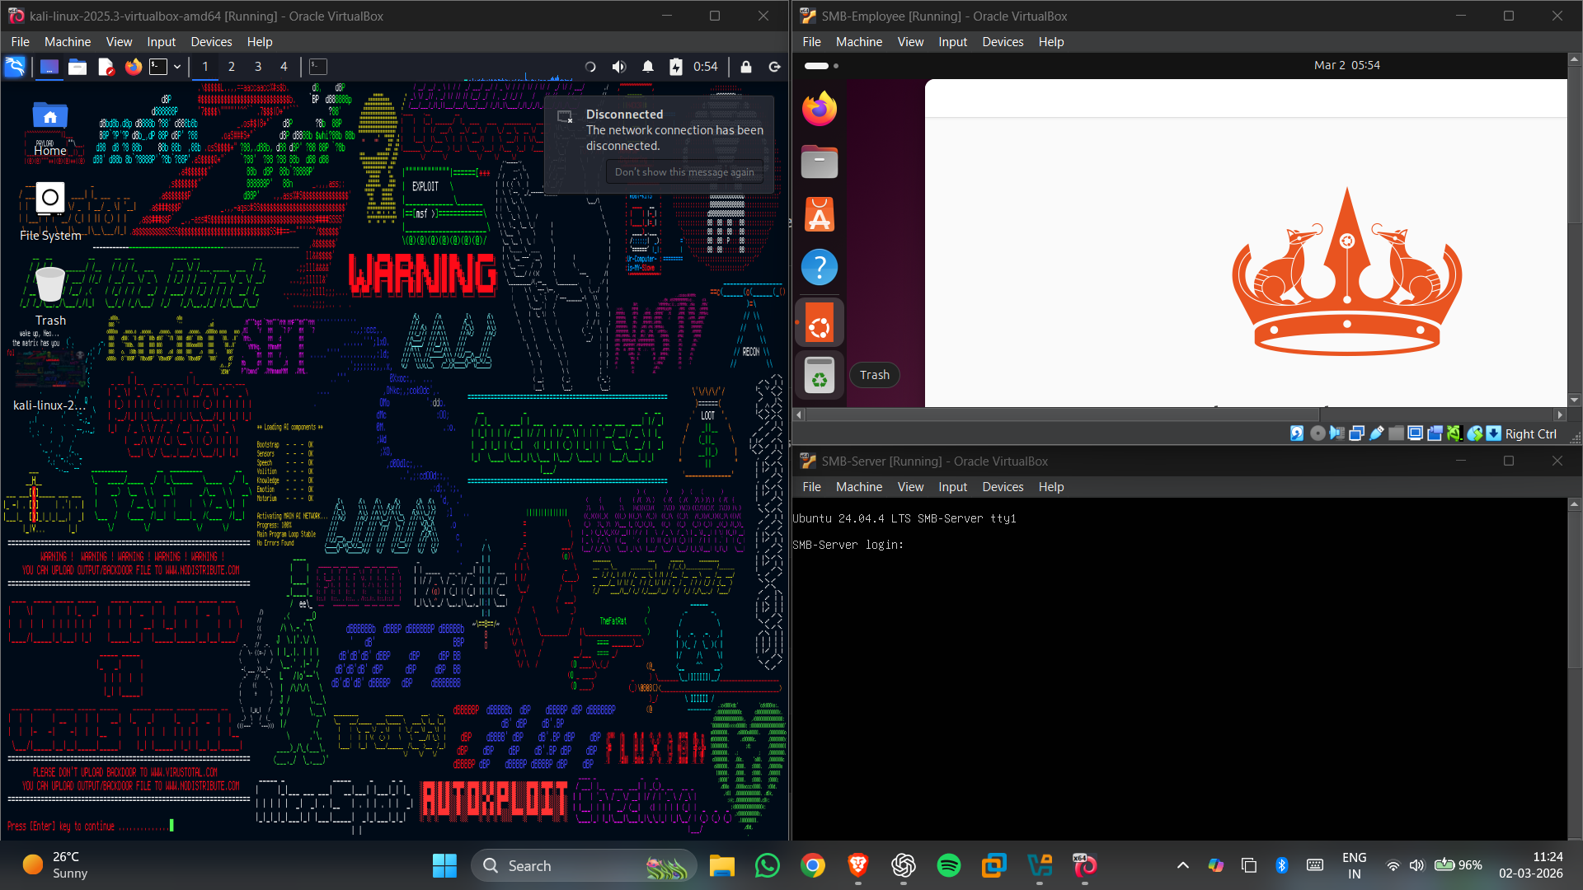

2.3 Connectivity Verification
Once the network environment was established, connectivity between the machines was verified to ensure proper communication across the simulated network. Network connectivity testing was performed using Internet Control Message Protocol (ICMP) requests.

The attacker machine was used to send ping requests to the server in order to confirm that the systems could communicate successfully. Successful responses from the server indicated that the network configuration was correctly implemented and that the machines were reachable within the same network.

Verifying connectivity is an important step before conducting any cybersecurity testing, as it ensures that all systems are accessible and that network traffic can be properly analyzed during later stages of the project.

Poc: Server IP Configuration
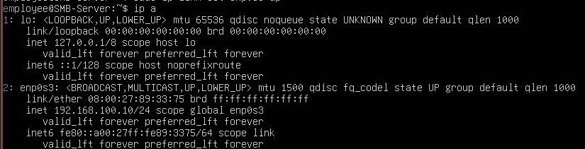

Poc: Ping Connectivity Test
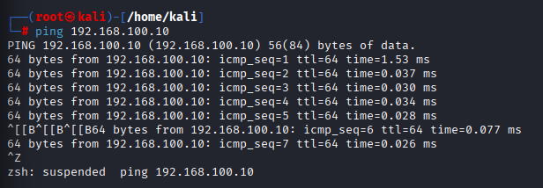

3. Cybersecurity Threat Discovery
3.1 Host Connectivity Test
Before performing detailed network reconnaissance, it is important to confirm that the target system is reachable within the network. In cybersecurity testing, attackers often begin by verifying whether a target host is active and capable of responding to network requests.

In this project, connectivity testing was performed using ICMP ping requests from the attacker machine to the target server. The purpose of this step was to verify that the server system was online and capable of communicating within the simulated network environment.

Successful ping responses indicated that the server was active and reachable from the attacker machine. This confirmed that the attacker could proceed with further reconnaissance activities such as host discovery and port scanning.

Host connectivity testing is a common reconnaissance technique used by attackers to quickly determine whether a system exists within a network and whether it can be targeted for further analysis.

Poc: Host Connectivity Test
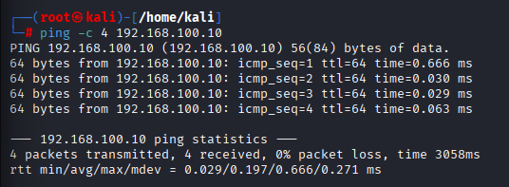

3.2 Network Host Discovery
Once connectivity to the server was confirmed, the next step involved discovering active systems within the network. Attackers often perform network scanning to identify devices connected to the same network segment.

In this project, the Nmap scanning tool was used to perform host discovery within the network. The purpose of this scan was to identify active hosts and determine which systems were available within the simulated business environment.

The host discovery scan sent network probes across the subnet to detect systems that responded to the requests. Through this scanning process, the attacker system successfully identified the active server machine within the network.

Host discovery is a critical step in the reconnaissance phase of cyber attacks because it helps attackers map the network infrastructure and identify potential targets for further exploitation.

Poc: Network Host Discovery
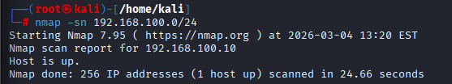

3.3 Port Scanning and Service Detection
After identifying active hosts within the network, the next step was to determine which services were running on the target server. Attackers often perform port scanning to identify open ports and services that may provide potential entry points into a system.

Port scanning was performed using Nmap to analyze the server and identify any accessible services. The scan examined multiple ports to determine whether they were open, closed, or filtered by firewall configurations.

Through this scanning process, the attacker was able to analyze the network exposure of the server and evaluate whether any services were available that could be targeted during later attack simulations.

Port scanning plays a critical role in cybersecurity threat analysis because it reveals which services are exposed to the network and whether additional security controls are required to protect these services from malicious activity.
Poc: Port Scanning Result
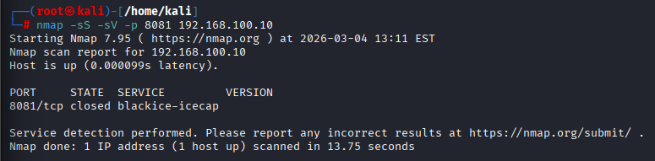

4. Attack Simulation
4.1 Denial-of-Service (DoS) Attack Simulation
After identifying the target server and analyzing its network exposure, the next step involved simulating a cyber attack to evaluate the security posture of the system. One of the most common attacks targeting online services is a Denial-of-Service (DoS) attack.

A DoS attack attempts to overwhelm a system by sending a large number of network requests within a short period of time. This excessive traffic can consume system resources such as CPU, memory, and network bandwidth, potentially making the service unavailable to legitimate users.

In this project, a simulated DoS attack was performed using the hping3 tool from the attacker machine. The tool was used to generate a flood of TCP SYN packets directed toward the target server. This allowed the attacker system to simulate high traffic volume directed at the server.

The purpose of this attack simulation was not to damage the system but to demonstrate how attackers can generate large volumes of malicious traffic that could potentially disrupt business services if proper defensive mechanisms are not implemented.

Poc: DoS Attack Simulation
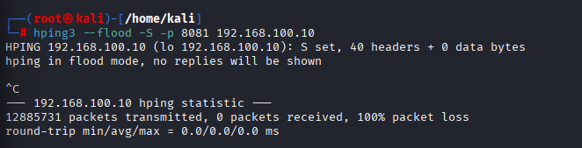

4.2 Malicious Traffic Monitoring
Once the attack was initiated, it became necessary to observe the network traffic reaching the server in order to analyze the behavior of the simulated attack. Monitoring network traffic allows security professionals to detect unusual activity and identify potential threats in real time.

In this phase, the tcpdump tool was used on the server to capture and analyze incoming network packets. Tcpdump is a packet capture utility that allows administrators to inspect network traffic and monitor communication between systems.

During the attack simulation, tcpdump displayed a continuous stream of packets arriving from the attacker machine. This confirmed that the server was receiving a high volume of network requests generated by the attack tool.

Traffic monitoring tools such as tcpdump are essential for detecting abnormal traffic patterns and investigating suspicious network activity within an organization's infrastructure.

Poc: Malicious Traffic Monitoring
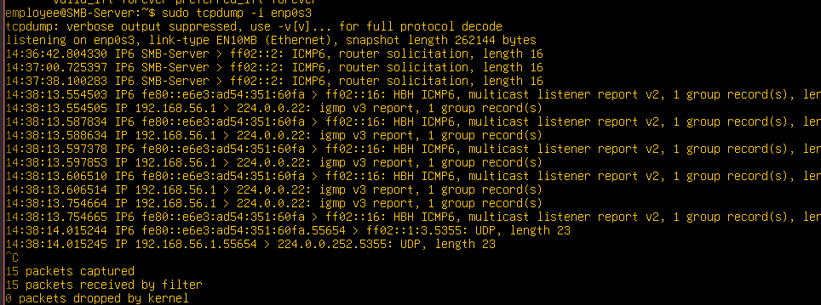

4.3 System Resource Impact Analysis
In addition to monitoring network traffic, it is also important to observe how an attack affects system performance. Cyber attacks such as DoS floods can place significant strain on system resources, potentially slowing down services or causing system instability.

To analyze system performance during the simulated attack, the system monitoring tool was used on the server. This tool provides real-time information about CPU usage, memory consumption, and running processes within the operating system.

By observing system resource usage during the attack simulation, it was possible to analyze how excessive traffic could affect server performance. Monitoring system resources is a key part of incident response because it helps administrators detect abnormal system behavior and identify the impact of malicious activity.

Poc: System Resource Impact
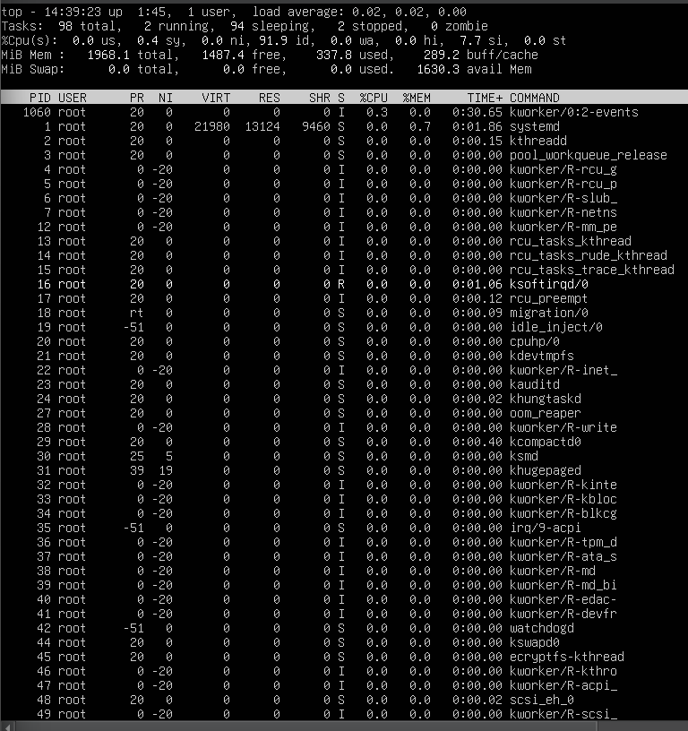

5. Defense Implementation
5.1 Firewall Rule Configuration
After observing the simulated attack and analyzing the generated network traffic, the next step involved implementing a defensive security mechanism to protect the server from malicious activity. One of the most common and effective security controls used in network security is a firewall.

A firewall is responsible for monitoring incoming and outgoing network traffic and applying security rules that determine whether specific traffic should be allowed or blocked. By properly configuring firewall rules, administrators can prevent unauthorized access and block malicious traffic directed toward critical systems.

In this project, firewall protection was implemented using the iptables utility on the server. Iptables is a widely used firewall management tool in Linux-based systems that allows administrators to define filtering rules for network packets.

A firewall rule was created to block incoming TCP traffic directed toward the vulnerable service port used during the attack simulation. By configuring the firewall to drop packets targeting this port, the server was able to prevent further malicious requests generated by the attacker machine.

Implementing firewall rules is an essential security practice because it helps control network access and protects systems from unauthorized or excessive traffic that could potentially disrupt services.

Poc: Firewall Rule Implementation
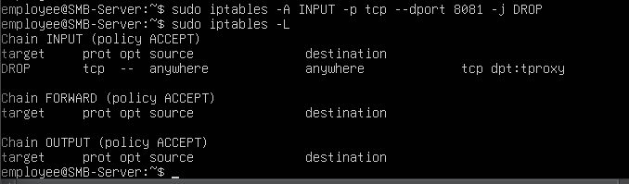

5.2 Attack Mitigation Verification
After implementing the firewall rule, the attack was executed again from the attacker machine to verify whether the defensive mechanism was effective. This step was performed to confirm that the configured firewall rule successfully blocked the malicious traffic generated during the attack simulation.

When the attack tool was executed again, the attacker machine attempted to send large volumes of TCP packets to the server. However, because the firewall rule was configured to drop incoming traffic targeting the specific service port, the malicious packets were blocked before reaching the server.

The attacker system observed packet loss during the attack attempt, which indicated that the firewall was successfully filtering the malicious traffic. This confirmed that the defensive mechanism effectively mitigated the simulated attack.

Testing defensive configurations after implementation is an important step in cybersecurity because it ensures that security controls are functioning correctly and that systems are properly protected against potential threats.

Poc: Attack Mitigation Test
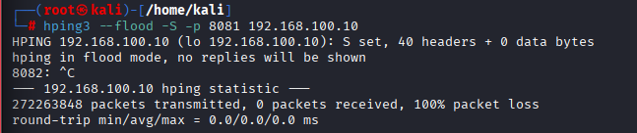

6. Cybersecurity Framework & Action Plan
6.1 Security Framework Overview
To improve the cybersecurity posture of small businesses, it is important to follow structured security frameworks that provide guidelines for identifying threats, protecting systems, detecting attacks, responding to incidents, and recovering from security events. These frameworks help organizations implement standardized security practices and ensure that important security controls are not overlooked.

In this project, the implemented security practices align with widely recognized cybersecurity frameworks such as the NIST Cybersecurity Framework and CIS Critical Security Controls. These frameworks provide structured recommendations that organizations can use to improve their cybersecurity defenses.

The NIST Cybersecurity Framework focuses on five key functions: Identify, Protect, Detect, Respond, and Recover. These functions help organizations understand their security risks and implement controls that minimize the impact of cyber threats.

Similarly, the CIS Critical Security Controls provide a prioritized set of defensive measures that organizations can use to protect their systems and networks. These controls emphasize monitoring network activity, securing systems, implementing access control policies, and responding to incidents effectively.

By aligning the project implementation with these cybersecurity frameworks, the simulated business environment demonstrates how small organizations can adopt structured security practices using affordable and open-source tools.

6.2 Security Controls Implemented
Security Area | Implementation
Network Discovery | Nmap scanning
Attack Simulation | hping3 DoS testing
Traffic Monitoring | tcpdump packet analysis
System Monitoring | top command resource monitoring
Attack Mitigation | iptables firewall rule implementation

Explanation:
During the project implementation, several security controls were applied to analyze threats and protect the simulated network environment. Network discovery techniques were used to identify active hosts and exposed services. Attack simulations were conducted to evaluate system vulnerabilities and observe malicious behavior. Network monitoring tools were used to capture and analyze traffic patterns, while firewall rules were implemented to mitigate malicious traffic and protect the server from potential attacks.

6.3 Action Plan for Small Businesses
Step | Action
1 | Establish secure network infrastructure
2 | Identify active hosts and services within the network
3 | Monitor network traffic for suspicious activities
4 | Simulate potential attack scenarios for testing
5 | Implement firewall rules and security controls
6 | Continuously monitor and improve security defenses

Explantion:
Small businesses often operate with limited cybersecurity resources, making it important to adopt simple but effective security strategies. The action plan presented above demonstrates how organizations can improve their security posture by implementing structured monitoring, threat detection, and defensive controls. By following these steps, small businesses can significantly reduce their exposure to cyber threats and maintain a secure operational environment.

7. Conclusion
This project successfully demonstrated the implementation of a cybersecurity framework designed to protect small business environments from common cyber threats. A simulated network infrastructure was created using virtual machines to represent a typical organizational setup consisting of an attacker system, an employee workstation, and a company server.

Throughout the project, multiple cybersecurity techniques were implemented to analyze network activity and evaluate the security posture of the simulated environment. Network reconnaissance was performed using scanning tools to identify active hosts and exposed services within the network. These discovery techniques demonstrated how attackers can map a network and locate potential targets.

To further analyze security risks, a simulated Denial-of-Service attack was conducted against the server system. The attack generated a large volume of network traffic in order to demonstrate how attackers can overwhelm system resources and disrupt services. During the attack simulation, network monitoring tools were used to observe the traffic generated by the attacker system and analyze its impact on the server.

Following the attack simulation, defensive security measures were implemented to protect the server from malicious activity. Firewall rules were configured to block incoming traffic targeting the vulnerable service port. After implementing these security controls, the attack was executed again to verify that the firewall successfully mitigated the malicious traffic.

The project also demonstrated how small businesses can adopt structured cybersecurity practices by aligning their security strategies with established frameworks such as the NIST Cybersecurity Framework and CIS Critical Security Controls. These frameworks provide organizations with practical guidance for identifying threats, protecting systems, detecting malicious activity, and responding effectively to security incidents.

Overall, this project highlights the importance of proactive security monitoring, threat detection, and defensive configuration in maintaining a secure network environment. By utilizing open-source security tools and structured cybersecurity frameworks, small businesses can significantly improve their security posture while maintaining cost-effective protection against modern cyber threats.

