Implementing a Secure Firmware Update Mechanism for IoT Devices

Prepared by:
Harsh Dankhra

Table of Contents:

1. Title Page 1
2. Table of Contents 2
3. Executive Summary 3
4. Project Objectives 4
5. Scope of the Project 5
6. System Architecture Design 6
7. Secure Boot & Chain of Trust 9
8. Cryptography & Code Signing Implementation 11
9. Firmware Integrity Validation 16
10.Implementation, Testing & Validation 20
11. Compliance & Standards Alignment 29
12. Conclusion 31
13. Future Enhancements 32

3.Executive Summary

Firmware updates are a critical aspect of IoT device lifecycle management, but insecure update mechanisms can expose devices to unauthorized code execution, malware injection, and large-scale attacks. This project focuses on designing and validating a secure firmware update mechanism that ensures only authenticated and untampered firmware is executed on IoT devices.

The proposed solution integrates secure boot architecture, cryptographic code signing, and firmware integrity verification. Secure boot establishes a trusted chain of execution, while cryptographic mechanisms such as SHA-256 hashing and RSA-based digital signatures ensure firmware authenticity and integrity.

All activities were performed in a controlled laboratory environment using open-source tools and simulated firmware files. The results demonstrate that modified or unauthorized firmware is successfully detected and blocked, validating the effectiveness of the proposed security controls.

4.Project Objectives

The key objectives of this project are as follows:
- To design a secure firmware update architecture for IoT devices
- To prevent execution of unauthorized firmware using secure boot principles
- To implement cryptographic code signing for firmware authentication
- To verify firmware integrity using hashing techniques
- To detect and block tampered or unauthorized firmware updates
- To validate the solution through controlled testing in a lab environment

5. Scope of the Project

5.1 In Scope
- Secure firmware update architecture design
- Secure boot and chain of trust implementation (design level)
- Firmware hashing and digital signature generation
- Firmware signature verification and tamper detection
- Testing using simulated firmware images

5.2 Out of Scope
- Physical IoT hardware flashing
- Production deployment on real devices
- Paid or proprietary security tools
- This project focuses on design and validation, not production deployment.

6.System Architecture Design

The system architecture is designed to ensure secure delivery and execution of firmware updates for IoT devices. The architecture consists of an IoT device with a secure bootloader, a secure firmware update server, and an update management interface used by authorized administrators.

Firmware images are digitally signed before distribution and stored on a secure update server. IoT devices retrieve firmware updates over encrypted communication channels and verify their authenticity before execution. The secure bootloader acts as the root of trust by validating the firmware signature during device startup.

The architecture also supports role-based access control, audit logging, delta firmware updates, rollback protection, and secure recovery mechanisms to ensure reliability and compliance with IoT security standards.

Figure 6.1: High-Level Secure Firmware Update Architecture
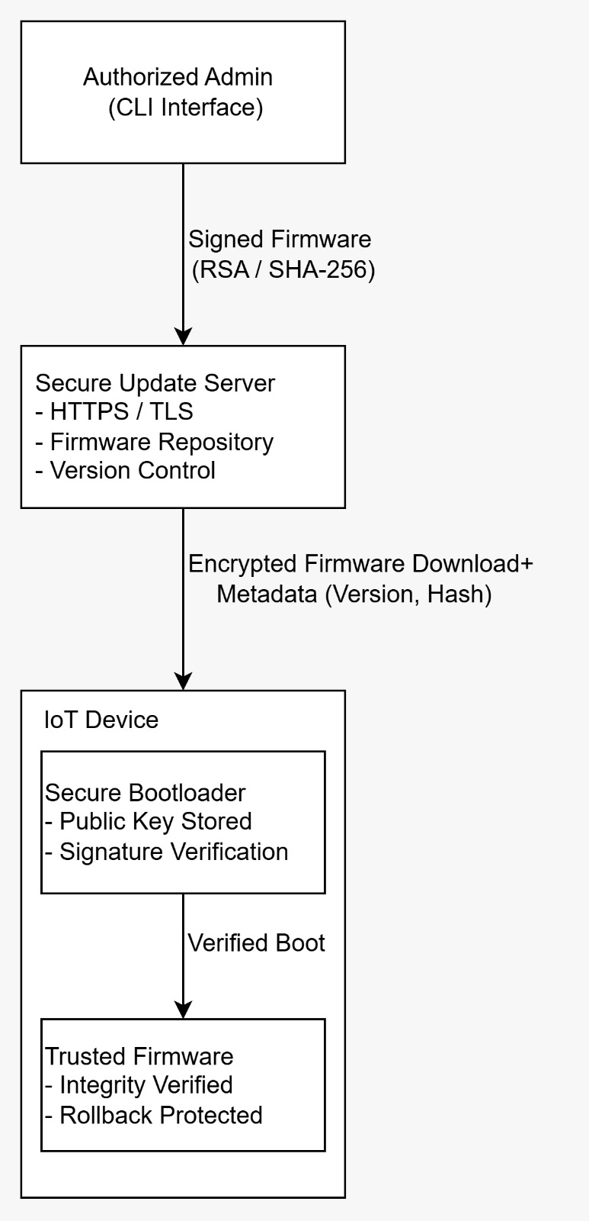
Figure 6.1 illustrates the high-level architecture of the secure firmware update mechanism. Firmware is digitally signed by an authorized administrator and distributed via a secure update server using encrypted communication. The IoT device verifies firmware authenticity and integrity using a secure bootloader before execution, ensuring protection against unauthorized or tampered firmware.

Figure 6.2: Secure Firmware Update Architecture
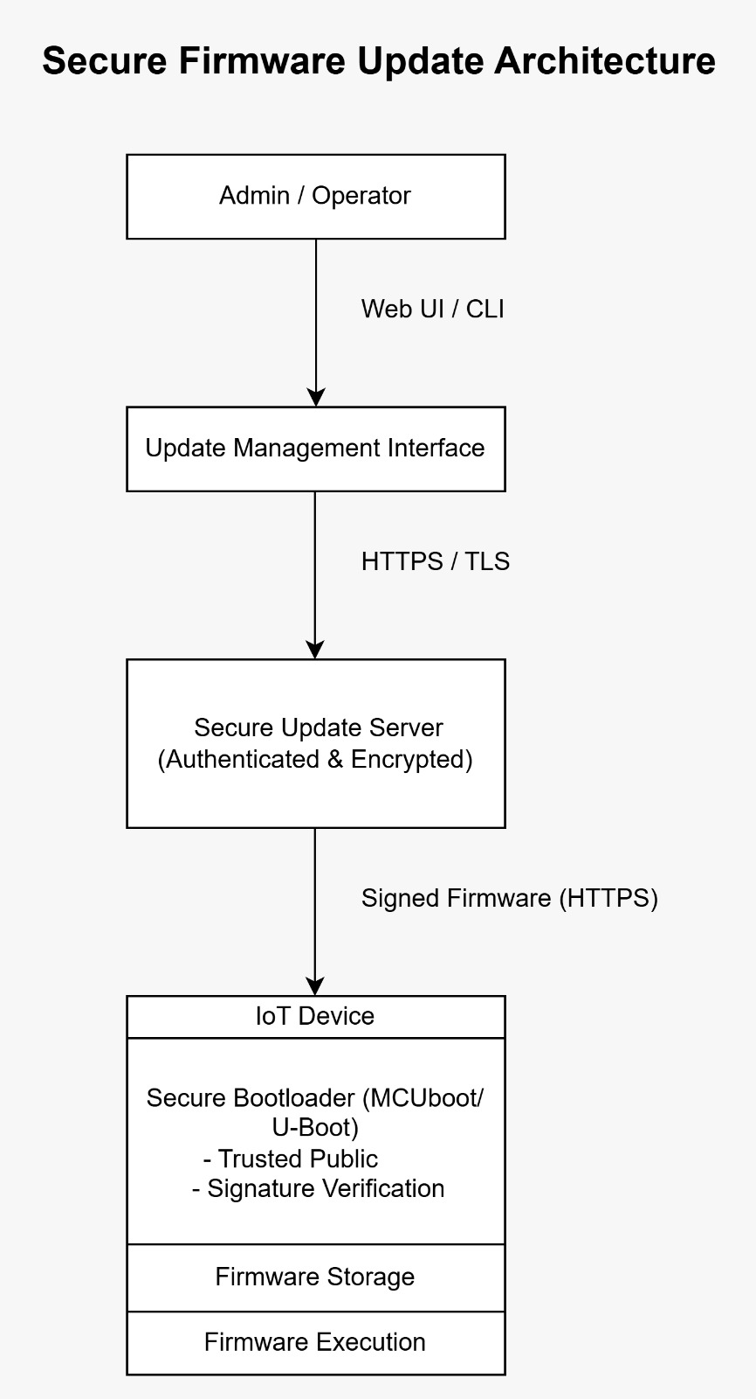

As illustrated in Figure 6.1, the architecture ensures that firmware authenticity and integrity are validated before execution, thereby preventing unauthorized or malicious firmware from running on the device.

7. Secure Boot and Chain of Trust

Secure boot establishes a chain of trust that begins at the bootloader and extends to the firmware. When the IoT device is powered on, the secure bootloader is executed first. The bootloader contains a trusted public key that is used to verify the digital signature of the firmware image.

If the firmware signature and integrity checks are successful, execution is transferred to the firmware. If verification fails, the boot process is halted or redirected to a recovery mechanism. This prevents the execution of unauthorized or tampered firmware.

Figure 7.1: Secure Boot and Firmware Verification Flowchart
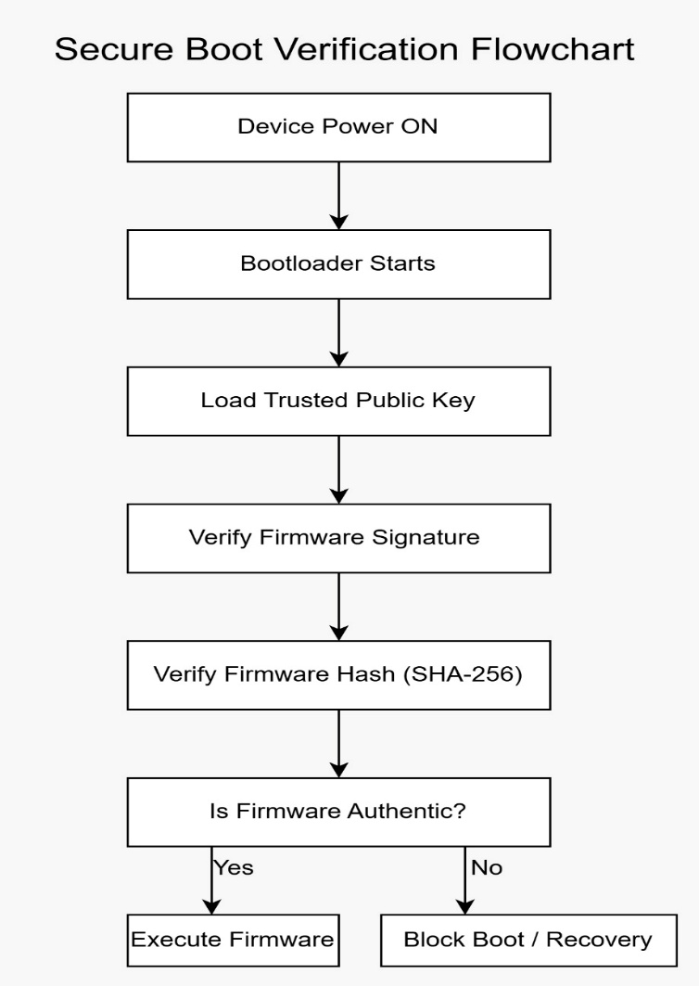

In addition to secure boot, firmware authentication is enforced through cryptographic hashing and digital signatures. Any modification to the firmware image results in verification failure.

Figure 7.2: Firmware Authentication Using Digital Signatures
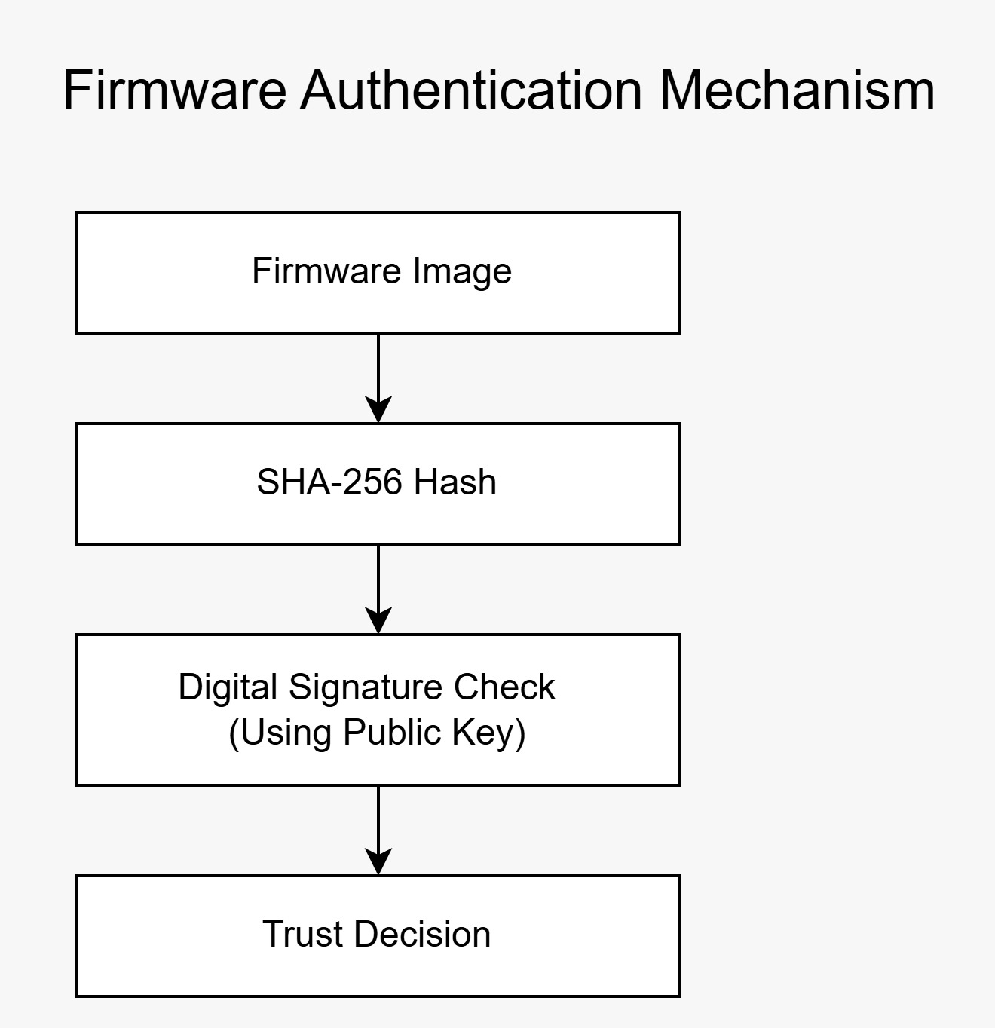

8. Cryptography & Code Signing Implementation

Cryptographic techniques are used to ensure firmware authenticity and integrity. In this project, SHA-256 hashing and RSA-based digital signatures were implemented using open-source cryptographic tools.

A simulated firmware file was created to represent an IoT firmware image. The firmware was hashed using SHA-256, and the resulting hash was digitally signed using an RSA private key. The corresponding public key represents the verification key stored on the IoT device.

The implementation process included:

Generation of RSA-2048 private and public key pairs
Hashing the firmware using SHA-256
Signing the firmware hash using the private key
Verifying the firmware signature using the public key
This mechanism ensures that firmware images can only be validated if they originate from a trusted source and remain unaltered.

Figure 8.1: Firmware Code Signing Process
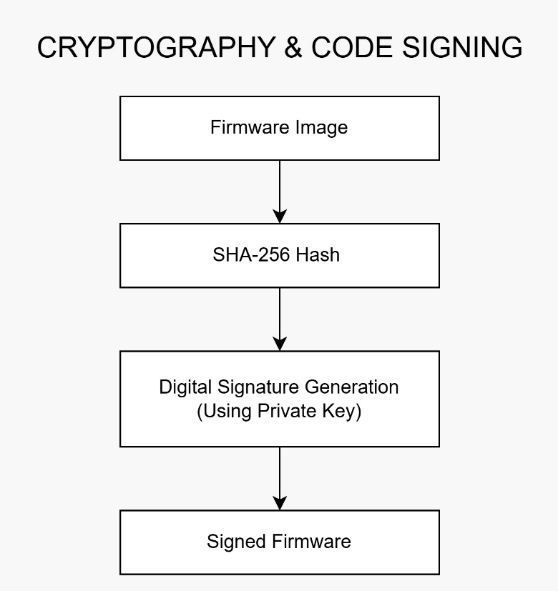

This section demonstrates the practical implementation of cryptographic controls used to ensure firmware authenticity and integrity. RSA-based digital signatures and SHA-256 hashing were applied to firmware images using open-source cryptographic tools.
Figure 8.2: Public Key–Based Signature Verification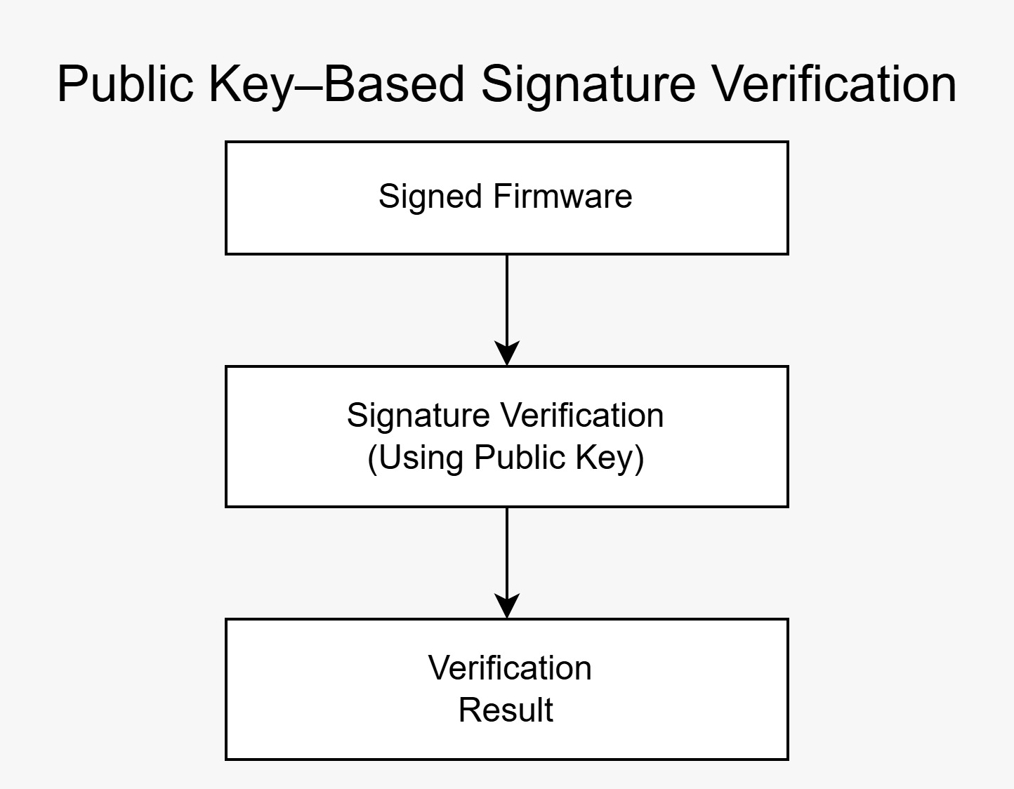

The following proof-of-concept steps illustrate firmware preparation, cryptographic key generation, digital signing, and verification processes carried out in a controlled lab environment.

Figure 8.3 – Firmware Workspace Creation
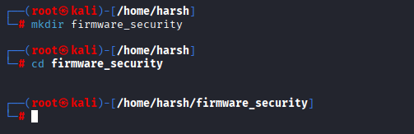
A dedicated workspace was created to isolate firmware files, cryptographic keys, and signing artifacts.

Figure 8.4 – Simulated Firmware File Creation
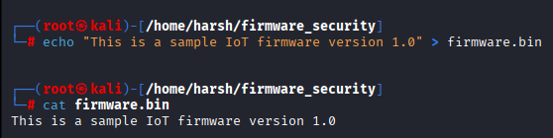
A sample firmware binary was generated to represent an IoT firmware image used for signing and verification.

Figure 8.5 – RSA-2048 Key Pair Generation 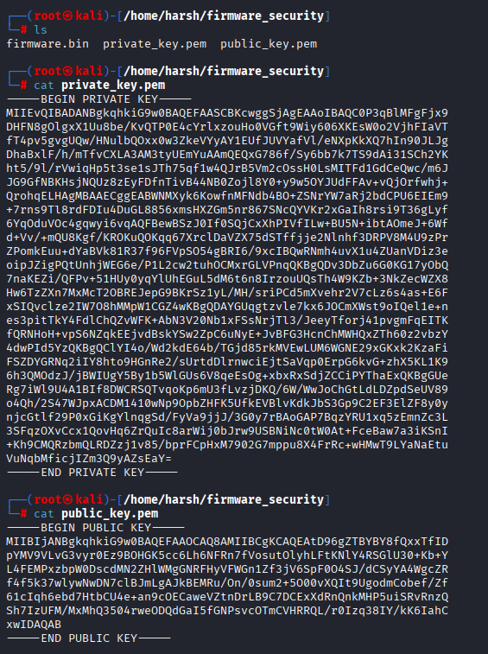
An RSA-2048 key pair was generated using OpenSSL, where the private key is used for signing and the public key for verification.

Figure 8.6 – SHA-256 Firmware Hash Generation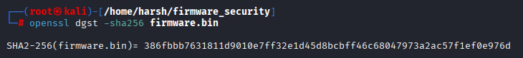
A SHA-256 hash was computed to ensure firmware integrity prior to digital signature generation.

Figure 8.7 – Firmware Digital Signature Creation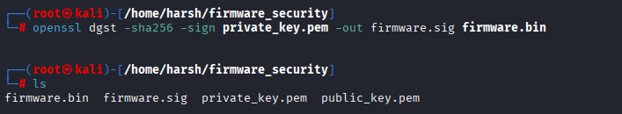
The firmware image was digitally signed using the private key, producing a signature file used during verification.

Figure 8.8 – Successful Firmware Signature Verification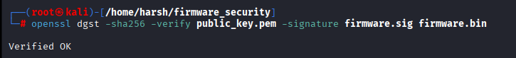
The firmware signature was verified using the corresponding public key, confirming authenticity and integrity.

9. Firmware Integrity Validation

To validate the cryptographic controls, both valid and tampered firmware scenarios were tested.

- Valid firmware test:
The signed firmware was successfully verified using the public key, confirming its authenticity and integrity.

- Tampered firmware test:
After modifying the firmware content, signature verification failed, demonstrating that the system correctly detects unauthorized modifications.

These tests confirm that the implemented cryptographic mechanisms effectively protect against firmware tampering and unauthorized updates.

9.1 Firmware Update Verification (Pre & Post Installation)
To ensure firmware integrity throughout the update lifecycle, verification checks are performed both before installation and after installation. Prior to installation, the downloaded firmware image undergoes cryptographic validation, including digital signature verification using the trusted public key and SHA-256 hash comparison. This ensures that the firmware has not been tampered with during transmission or storage.

After successful installation, the integrity of the installed firmware is verified again by recalculating its cryptographic hash and comparing it with the expected value. This post-installation validation confirms that the firmware was installed correctly and remains unmodified on the device.

These dual verification stages significantly reduce the risk of unauthorized firmware execution and ensure continuous device trust.

Figure 9.1 – Firmware Update Verification (Pre & Post Install) 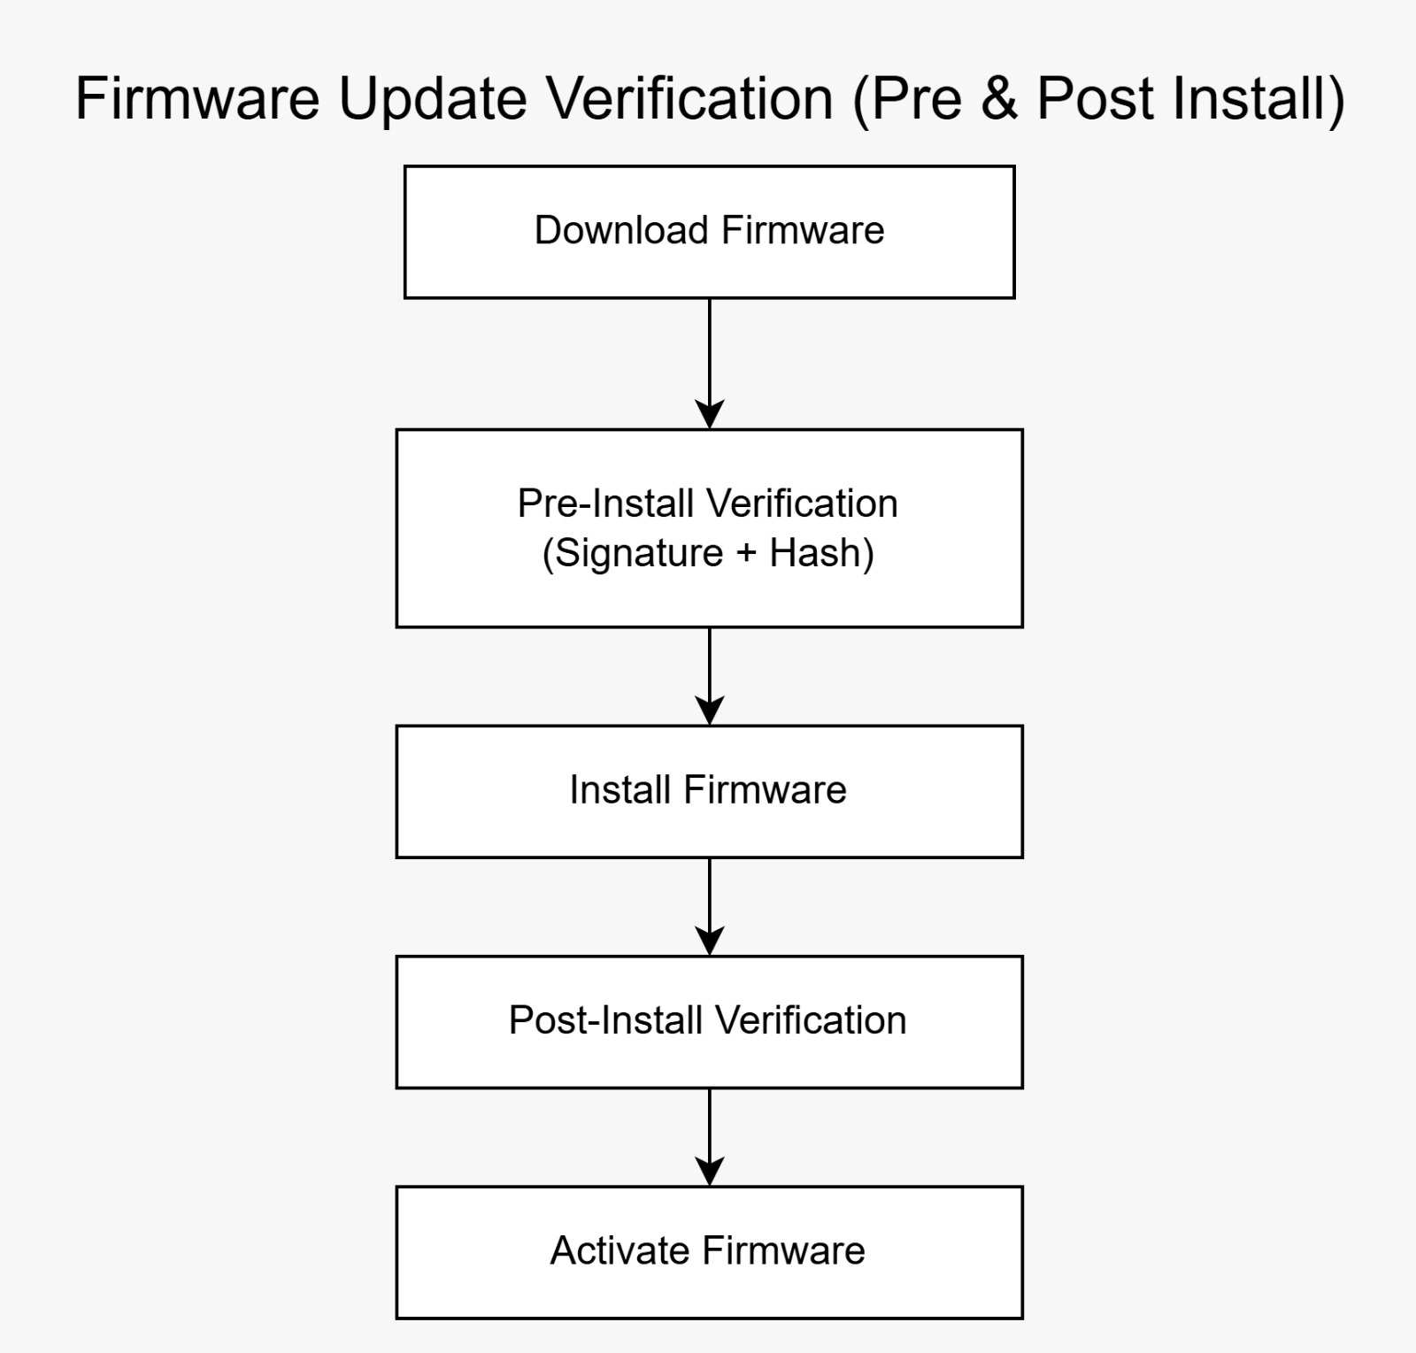

9.2 Rollback Protection Mechanism
Rollback protection is implemented to prevent attackers from downgrading devices to older, vulnerable firmware versions. Each firmware image contains version metadata that is checked during the update process. The system compares the version of the incoming firmware with the currently installed version.

If the new firmware version is equal to or higher than the current version, the installation is allowed. If the version is lower, the update is rejected and rollback is blocked. This mechanism ensures that previously patched vulnerabilities cannot be reintroduced through malicious downgrade attempts.

Figure 9.2 – Rollback Protection Mechanism
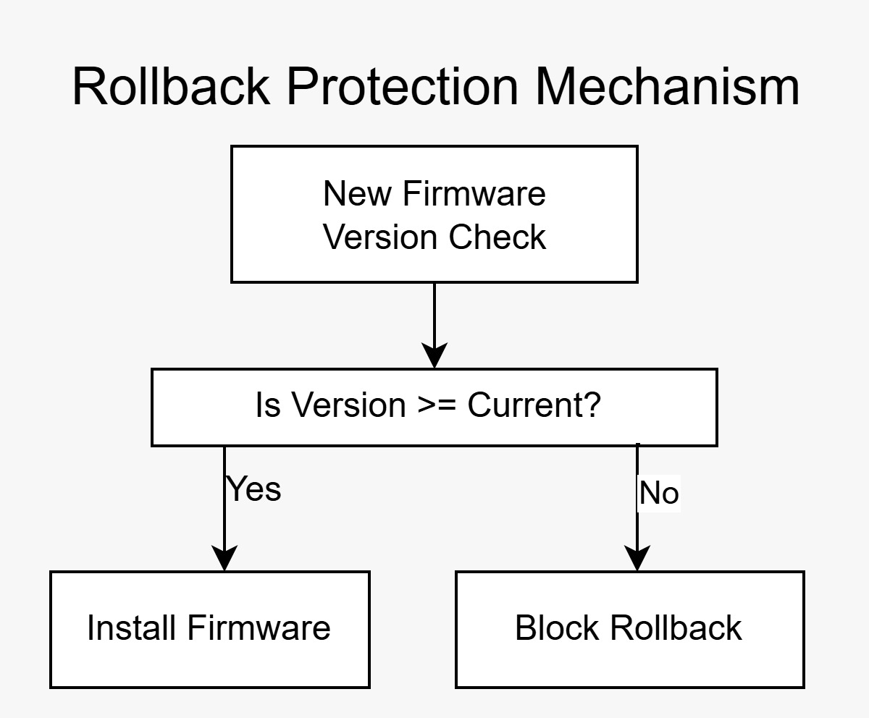

9.3 Tampered Firmware Detection
To validate the effectiveness of integrity checks, a tampering scenario was simulated by modifying the firmware after it had been digitally signed. When verification was attempted on the altered firmware, the signature validation failed due to a hash mismatch, demonstrating that even minor modifications invalidate the firmware’s authenticity.

This confirms that the cryptographic verification process reliably detects unauthorized changes and prevents execution of compromised firmware.
Figure 9.3 – Tampered Firmware Detection
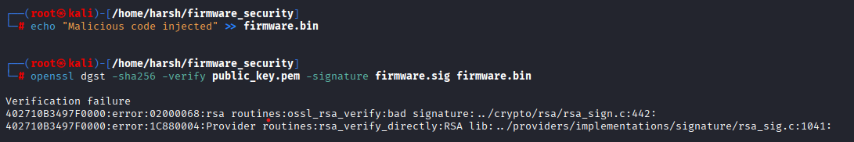

9.4 Security Impact
The implemented integrity validation and rollback protection mechanisms ensure that:
- Only authentic and untampered firmware is executed
- Downgrade attacks are effectively prevented
- Firmware update failures do not compromise device security

Together, these controls strengthen the overall firmware security posture and form a critical part of the secure firmware update framework.

10. Implementation, Testing & Validation
Test Case |  | Description | Result
Firmware hash generation |  | SHA-256 hash computation | Successful
Firmware signing |  | Digital signature using private key | Successful
Signature verification |  | Verification using public key | Verified OK
Tampered firmware |  | Modified firmware verification | Blocked
Unauthorized firmware |  | Unsigned firmware execution attempt | Blocked
This section describes the practical implementation and validation of the secure firmware update mechanism. The testing was conducted in a controlled lab environment to verify firmware integrity, authenticity, logging, and recovery behavior using real Proof-of-Concept (PoC) evidence.

10.1 Secure Firmware Update Testing Workflow
The secure firmware update workflow was tested to validate pre-installation verification, firmware installation, and post-installation integrity checks. The workflow ensures that only authenticated and untampered firmware is accepted by the system.

Figure 10.1 – Secure Firmware Update Testing Workflow
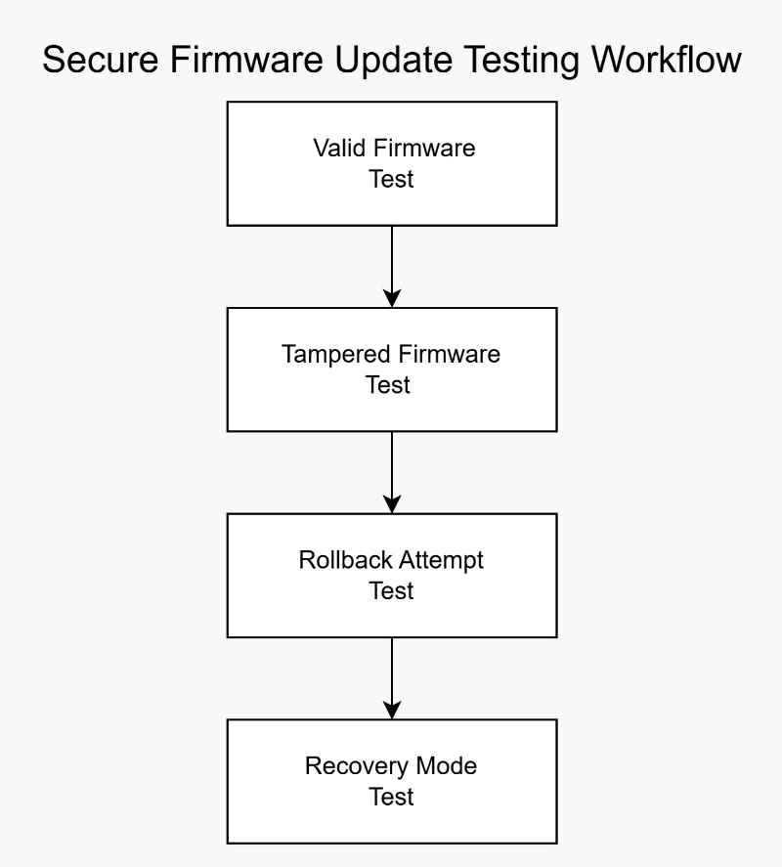

10.2 Firmware Update Failure Recovery Workflow
Failure recovery mechanisms were validated to ensure system stability during update errors. In case of verification failure or installation issues, the system enters recovery mode and restores the last known secure firmware.

Figure 10.2 – Firmware Update Failure Recovery Workflow
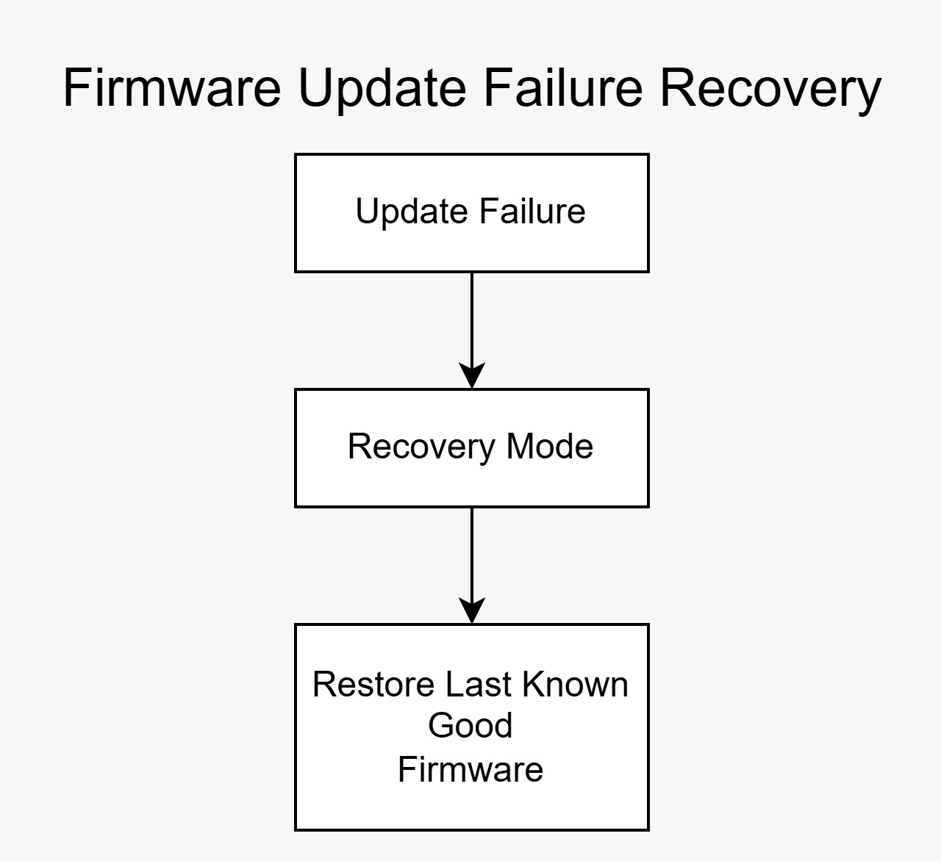

10.3 Firmware Update Audit Logging Workflow

Audit logging was implemented to track firmware update requests, approval actions, installation results, and security alerts. This enables traceability and security monitoring.

Figure 10.3 – Firmware Update Audit Logging Workflow
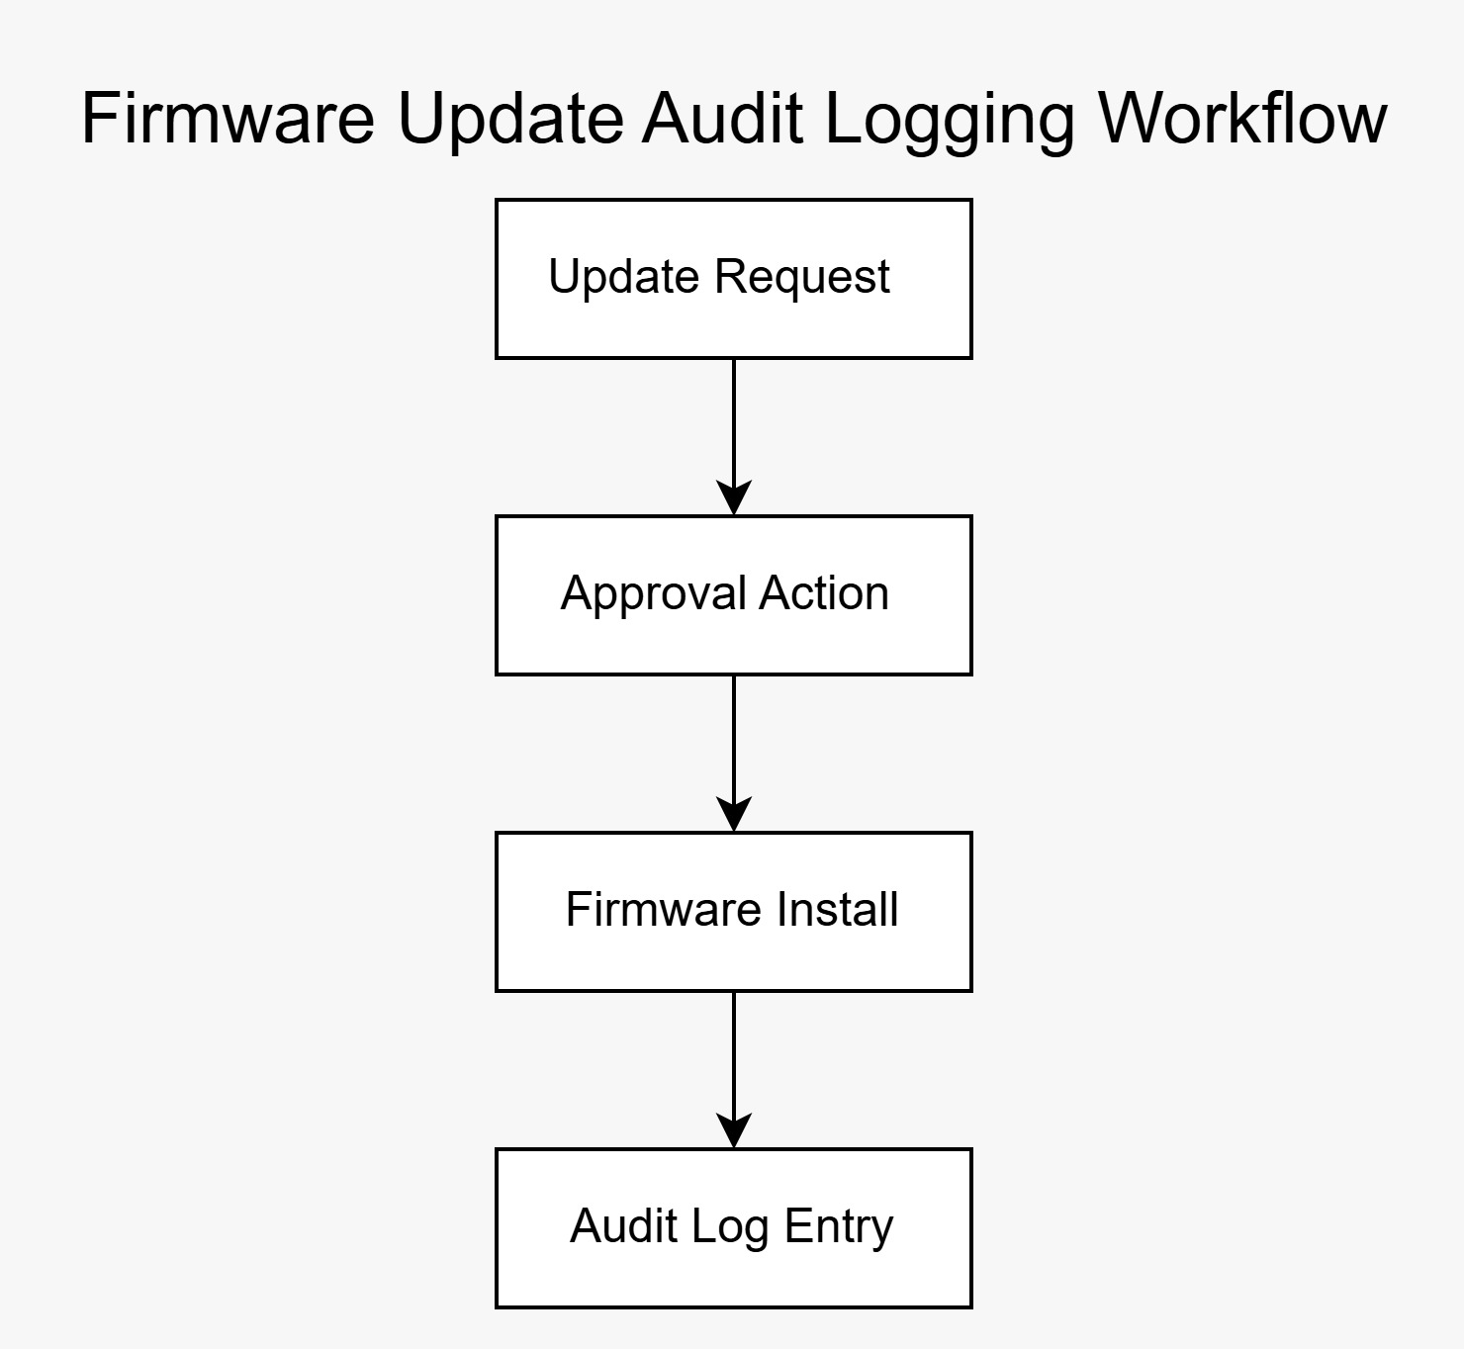

10.4 Test Environment Validation
The testing environment was validated to confirm the availability of required tools such as Kali Linux, OpenSSL, Python, and Git for secure firmware operations.

Figure 10.4 – Test Environment Validation (Kali, OpenSSL, Python, Git)
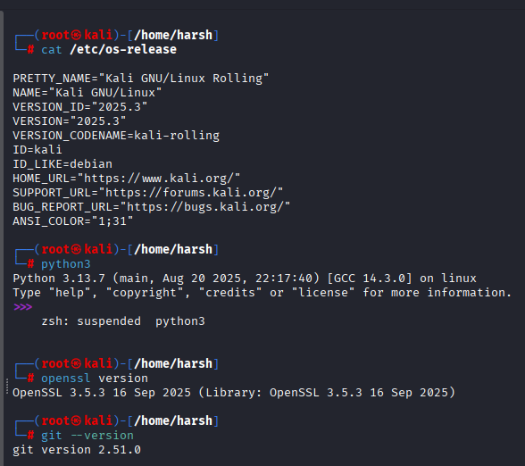

10.5 Firmware Hash Verification Before Installation
Before installation, the firmware hash was generated and verified using SHA-256 to confirm integrity prior to deployment.

Figure 10.5 – Firmware Hash Verification Before Installation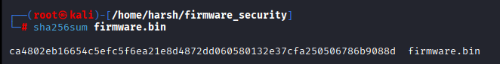

10.6 Firmware Integrity Verification After Installation
After installation, the firmware integrity was verified again to ensure that the firmware remained unchanged during the update process.

Figure 10.6 – Firmware Integrity Verification After Installation
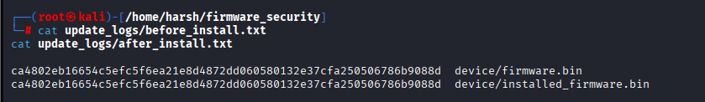

10.7 Firmware Update Logs (Success & Failure)
Firmware update logs were reviewed to validate successful updates and detect verification failures caused by tampered firmware.
Figure 10.7 – Firmware Update Logs (Success & Failure)
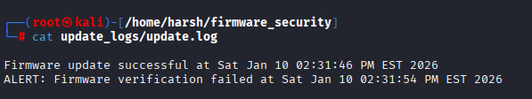
10.8 Firmware Rollback Attempt Detection
Rollback protection was tested by attempting to install unauthorized or modified firmware. The system correctly detected the rollback attempt and blocked the update.

Figure 10.8 – Firmware Rollback Attempt Detection
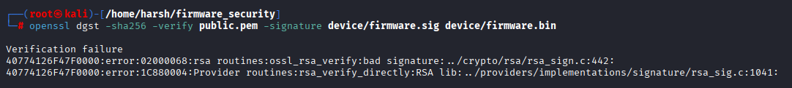

10.9 Secure Firmware Project Folder Structure
All firmware artifacts, cryptographic keys, signatures, device files, and logs were organized in a structured directory layout for maintainability and traceability.

Figure 10.9 – Secure Firmware Project Folder Structure
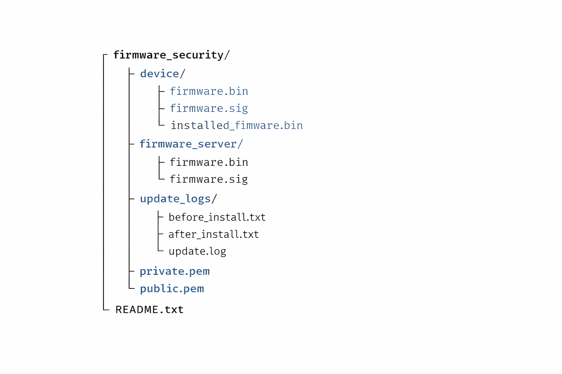

10.10 Firmware Update Management Interface (CLI-Based)

To manage firmware updates in a controlled and secure manner, a Command Line Interface (CLI)–based update management system was implemented and simulated as part of this project. The CLI serves as the primary interface for authorized administrators to schedule updates, initiate deployments, monitor update status, and review audit logs.
A CLI-based interface was selected due to its simplicity, security, and suitability for controlled lab environments and embedded IoT systems. This approach also aligns with industry practices where firmware updates are often managed through automated scripts and command-line tools.

Key Features of the CLI Update Interface
The CLI interface supports the following update management functions:

- Firmware Upload & Registration
Authorized administrators can register new firmware images by uploading signed firmware files to the update server repository.

- Manual Update Deployment
Administrators can manually initiate firmware updates for selected devices or device groups.

- Update Scheduling
Firmware updates can be scheduled to occur during predefined maintenance windows to minimize device downtime.

- Update Status Monitoring
The CLI allows monitoring of update progress, success, or failure through real-time status messages and log entries.

- Audit Logging & Traceability
All firmware update actions, including approvals, deployments, and failures, are recorded in centralized audit logs for security monitoring and compliance purposes.

11. Compliance & Standards Alignment

This project aligns with widely accepted IoT security standards, particularly the NIST IoT Cybersecurity Framework, to ensure device integrity, secure software updates, protected communications, and controlled access.
The implemented security mechanisms are mapped to NIST IoT security principles as shown in Figure 11.1.

Figure 11.1 – Compliance Mapping to NIST IoT Guidelines
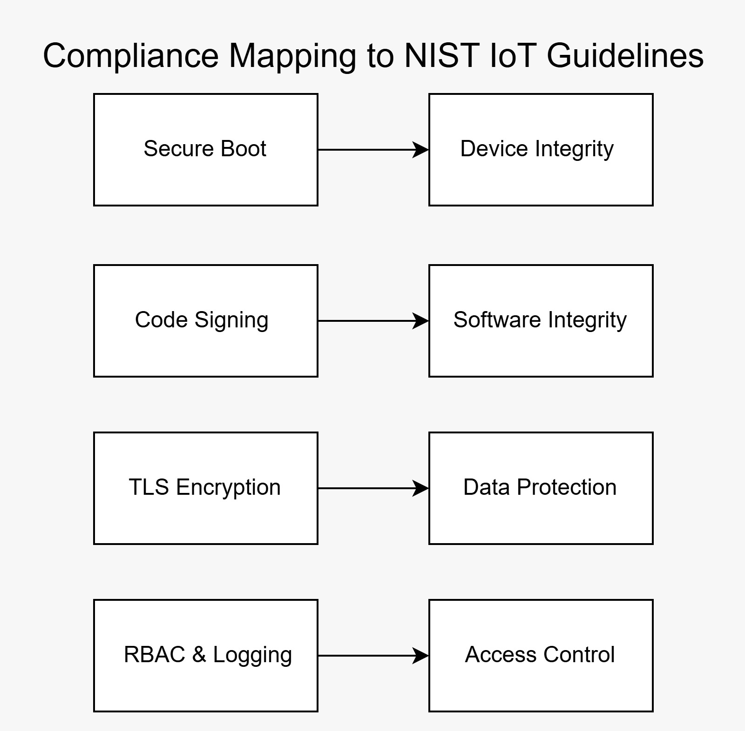
Compliance Mapping Explanation:
Secure Boot → Device Integrity
Ensures that only trusted and verified firmware is executed during device startup, protecting the device from unauthorized or malicious code.
Code Signing → Software Integrity
Guarantees that firmware images are authentic and have not been altered by verifying digital signatures before execution or installation.
TLS Encryption → Data Protection
Secures firmware transmission between the update server and IoT device using encrypted communication channels.
RBAC & Audit Logs → Access Control
Implements role-based access control and logging to ensure only authorized users can initiate or approve firmware updates, with full traceability.

This compliance alignment demonstrates that the proposed secure firmware update solution follows industry-recognized best practices for IoT security.

12. Conclusion

This project successfully demonstrates a secure firmware update mechanism for IoT devices by combining secure boot principles with cryptographic code signing and integrity verification. The implementation ensures that only authenticated and untampered firmware is executed on IoT devices.

Although the solution was validated in a simulated lab environment, it closely reflects real-world IoT security practices. The results highlight the importance of secure boot and cryptographic controls in protecting IoT devices from firmware-based attacks.

13. Future Enhancements

- Integration of hardware-backed key storage such as HSMs or TPMs
- Automated OTA update platforms for large-scale deployments
- Firmware rollback protection implementation
- Deployment and testing on real IoT hardware
- Continuous monitoring and compliance validation

