MEMORANDUM
Assignment 2 | CIS 579
Abigail Gujuluva
06/21/26

1. Introduction
This memo documents the design and implementation of a genetic algorithm utilizing crossover and mutation functions. The objective is to compare the effectiveness of crossover with a usage rate of 0.7 verses a rate of 0.0.

A genetic algorithm uses the features of evolution to create an ideal ‘child node’. This is often used in machine learning. Every genetic algorithm has a fitness function or a set of rules for picking the best offspring. For our project, the goal of the fitness function is to get every bit in the genome to equal 1, often called the classic “counting-ones” problem. The length of the genome we are using is 10, so the ideal genome is 1111111111. The population size we are using is 50, as defined in the assignment description. We will run the genetic algorithm 30 times for each condition; one with a crossover rate percentage of 70% and another with 0%.

For each condition we recorded the generation at which the all-ones genome was first discovered, then compared the average (and distribution) of that generation count across the 30 runs. The central question the assignment poses is whether mutation with crossover outperforms mutation alone — and, if so, why.

2. Methods
2.1 Genome Representation and Parameters
Each genome is represented as a Python list of 10 integers, each 0 or 1. Table 1 summarizes the GA configuration used in both conditions.
Parameter | Value
Population size | 50
Genome length | 10 bits
Fitness function | f(x) = number of 1s in x (max = 10)
Selection method | Fitness-proportionate (roulette-wheel)
Crossover rate, pc (Condition A) | 0.7
Crossover rate, pc (Condition B) | 0.0 (crossover disabled)
Mutation rate, pm | 0.001 per bit
Independent runs per condition | 30
Termination condition | All-ones genome (1111111111) found, or 2000-generation safety cap
Table 1. Genetic algorithm configuration.
The type of mutation being used is bitwise mutation, simply flipping the bit. Single-point crossover is the type of crossover used. This takes 2 parents and picks a random point in the genome. The children of the 2 parents are created by swapping their genome data, starting at the random point.

I would also like to draw attention to the fitness-proportionate selection. The parent genomes are being selected with fitness included as a factor. Genomes with higher fitness have a higher chance of being selected as parents.

2.2 Required Functions
The implementation (file ga.py) provides each of the building-block functions specified in the assignment:
- randomGenome(length) — returns a random bit string of the given length.
- makePopulation(size, length) — returns a list of size random genomes.
- fitness(genome) — returns the count of 1 bits in the genome.
- evaluateFitness(population) — returns (averageFitness, bestFitness) for a population.
- selectPair(population) — selects two parents via fitness-proportionate (roulette-wheel) sampling, with replacement.
- crossover(genome1, genome2) — single-point crossover at a randomly chosen locus, returning two children.
- mutate(genome, mutationRate) — returns a new genome with each bit independently flipped with probability mutationRate.
- runGA(populationSize, crossoverRate, mutationRate) — the main generational loop, returning the generation at which the optimum was found.

2.3 Main Loop Logic
Each generation, the algorithm evaluates and prints the population's average and best fitness, then (if the optimum has not yet been found) builds the next generation: it repeatedly calls selectPair to draw two parents proportional to fitness, applies crossover with probability pc (otherwise the parents are copied unchanged), and finally applies bitwise mutation with probability pm to every offspring bit. This repeats until a full new population of 50 has been produced. A representative excerpt of the core loop:
while True:
averageFitness, bestFitness = evaluateFitness(population)
print(f"Generation {generation}: average fitness "
f"{averageFitness:.2f}, best fitness {bestFitness:.2f}")
if bestFitness == genomeLength or generation >= maxGenerations:
return generation
newPopulation = []
while len(newPopulation) < populationSize:
parent1, parent2 = selectPair(population)
if random.random() < crossoverRate:
child1, child2 = crossover(parent1, parent2)
else:
child1, child2 = parent1[:], parent2[:]
child1 = mutate(child1, mutationRate)
child2 = mutate(child2, mutationRate)
newPopulation.append(child1)
if len(newPopulation) < populationSize:
newPopulation.append(child2)
population = newPopulation
generation += 1
The full annotated source is provided in the attached ga.py (core implementation) and experiment.py (experiment driver used to run all 60 trials and generate the figures in this report).

2.4 Sample Run Output
As a sanity check, the program prints per-generation statistics in the format requested by the assignment. Both excerpts below started from the identical randomly-seeded initial population, differing only in whether crossover was enabled, which makes the contrast in convergence speed directly comparable.
With crossover (pc = 0.7) — solution found at generation 2:
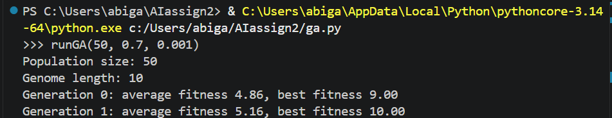Figure 1: ga.py run
Without crossover (pc = 0.0) — solution found at generation 181:
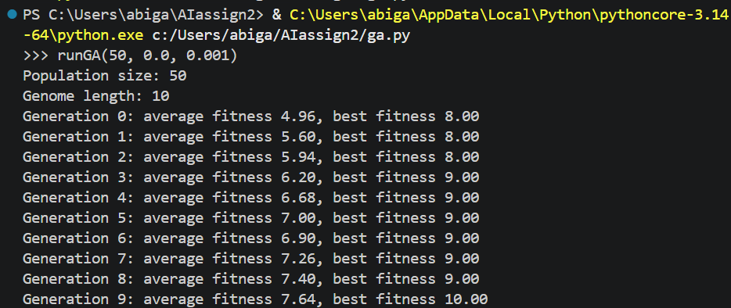
Figure 2: ga.py run

3. Results
Each condition was run 30 times. Table 2 summarizes the generation at which the all-ones genome was first discovered, across all 30 runs, for each condition.

Condition | Mean | Std. Dev. | Median | Min | Max
With crossover (pc = 0.7) | 6.03 | 4.78 | 4.0 | 0 | 22
Without crossover (pc = 0.0) | 80.93 | 71.99 | 65.0 | 0 | 288
Table 2. Summary statistics for generation-of-discovery, by condition (n = 30 runs each).

On average, the GA with crossover found the optimal genome at generation 6.03, compared to generation 80.93 for mutation alone — roughly an 13.4x speedup. Crossover also dramatically reduced run-to-run variance (standard deviation 4.78 generations vs. 71.99 generations), making the algorithm’s behavior far more predictable.

3.2 A* Search
A* uses a min-heap priority queue ordered by f = g + h, where g is the accumulated cost and h is an admissible heuristic estimate of the remaining distance to the goal. The node with the lowest f value is always expanded first. Because the heuristic never overestimates the true remaining cost, A* is guaranteed to find the optimal solution.
Priority function: f(n) = g(n) + h(n) where g = moves so far, h = heuristic estimate

4. Discussion

4.1 Choice of Heuristic
The heuristic selected is the sum of minimum knight moves each piece needs to reach its nearest goal square, computed assuming the board is empty (no blocking pieces). This value is precomputed once at startup using BFS from every square to every other square on the 3x3 board, producing a lookup table of minimum distances.
For each color, knights are greedily assigned to unique goal squares. The knight closest to any goal square is assigned first. The total heuristic value, h, is the sum of these individual minimum move costs across all four knights.

4.2 Admissibility Proof
A heuristic is admissible if it never overestimates the true remaining cost. This heuristic satisfies admissibility for two reasons:
- Blocking is ignored — the BFS distances assume an empty board, so the real cost (with blocking) can only be equal to or greater than the heuristic estimate.
- Each knight is assigned its best-case destination — no knight is penalized by being forced toward a farther goal square.

Therefore: h(n) <= true remaining cost for all nodes n, guaranteeing A* finds the optimal path.

4.3 Why Not Manhattan Distance?
Manhattan distance was considered but rejected because knights move in L-shapes, not straight lines. Manhattan distance can overestimate the number of moves required for a knight, violating admissibility and potentially causing A* to miss the optimal solution.

4.4 Why Not Misplaced Knights?
Simply counting how many knights are not yet on their goal square is admissible but very weak — it provides almost no guidance since it does not account for how far each knight actually needs to travel. The BFS-based minimum moves heuristic is strictly more informed and produces a tighter estimate, resulting in fewer nodes expanded.

5. Conclusion
Both algorithms were run on identical start and goal states for a fair comparison. The following results were recorded from program output:

Metric | Branch and Bound | A* Search
Solution Cost (moves) | 16 | 16
Nodes Expanded | 274 | 229
Time (seconds) | 0.0029 | 0.0123

Table 1: Comparison of Branch and Bound vs A* on the Four Knights puzzle.

6. Attached Files

