**HTML**

* HTML stands for Hyper Text Markup Language
* HTML is the standard markup language for creating Web pages
* HTML describes the structure of a Web page
* HTML consists of a series of elements.

**HTML BOILERPLATE**

<!DOCTYPE html>  
<html lang=”en” dir=”ltr”> - lang is language with English(en) and dir is direction with left to right(ltr)  
<head>

<meta charset=”utf-8”>  
<title>Page Title</title>  
</head>  
<body>  
  
<h1>My First Heading</h1>  
<p>My first paragraph.</p>  
  
</body>  
</html>

* The <!DOCTYPE html> declaration defines that this document is an HTML5 document
* The <html> element is the root element of an HTML page
* The <head> element contains meta information about the HTML page
* The <title> element specifies a title for the HTML page (which is shown in the browser's title bar or in the page's tab)
* The <body> element defines the document's body, and is a container for all the visible contents, such as headings, paragraphs, images, hyperlinks, tables, lists, etc.
* The <h1> element defines a large heading
* The <p> element defines a paragraph.

**HTML ELEMENT**

An HTML element is defined by a start tag, some content, and an end tag:

<tagname> Content goes here... </tagname>

The HTML **element** is everything from the start tag to the end tag:

<h1>My First Heading</h1>- this is one HTML element

<p>My first paragraph.</p>.

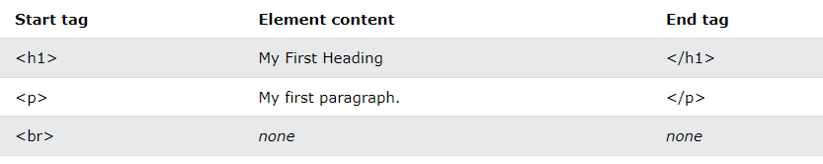

**NESTED HTML ELEMENTS**

HTML elements can be nested (this means that elements can contain other elements).

<!DOCTYPE html>  
<html>  
<body>  
  
<h1>My First Heading</h1>  
<p>My first paragraph.</p>  
  
</body>  
</html>

**NOTE: Never skip the end tag**

**HTML tag names are not case-sensitive (recommended lowercase).**

**EMPTY HTML ELEMENT**

HTML elements with no content are called empty elements.

The <br> tag defines a line break, and is an empty element without a closing tag

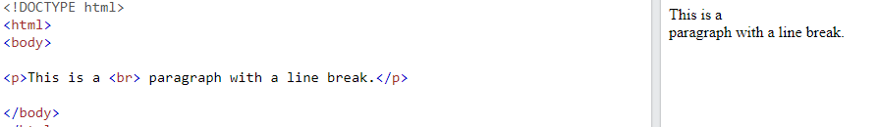

**HTML ATTRIBUTES**

* All HTML elements can have **attributes**
* Attributes provide **additional information** about elements
* Attributes are always specified in **the start tag**
* Attributes usually come in name/value pairs like: **name="value".**

**href attribute:**

The <a> tag defines a hyperlink. The href attribute specifies the URL of the page the link goes to:

<a href="https://www.w3schools.com">Visit W3Schools</a>

**Src attribute**

The <img> tag is used to embed an image in an HTML page. The src attribute specifies the path to the image to be displayed:

<img src="img_girl.jpg">

There are two ways to specify the URL in the src attribute:

**1. Absolute URL** - Links to an external image that is hosted on another website. Example: src="https://www.w3schools.com/images/img_girl.jpg".

**Notes:** External images might be under copyright. If you do not get permission to use it, you may be in violation of copyright laws. In addition, you cannot control external images; it can suddenly be removed or changed.

**2. Relative URL** - Links to an image that is hosted within the website. Here, the URL does not include the domain name. If the URL begins without a slash, it will be relative to the current page. Example: src="img_girl.jpg". If the URL begins with a slash, it will be relative to the domain. Example: src="/images/img_girl.jpg".

**Tip:** It is almost always best to use relative URLs. They will not break if you change domain.

**Width and height attribute**

The <img> tag should also contain the width and height attributes, which specify the width and height of the image (in pixels):

<img src="img_girl.jpg" width="500" height="600"> (or)

< img src="img_girl.jpg" style=”width:500px;height:600px;>

**Alt attribute**

The required alt attribute for the <img> tag specifies an alternate text for an image, if the image for some reason cannot be displayed. This can be due to a slow connection, or an error in the src attribute, or if the user uses a screen reader.

<img src="img_typo.jpg" alt="Girl with a jacket">

**Style attribute**

The style attribute is used to add styles to an element, such as color, font, size, and more.

<p style="color:red;">This is a red paragraph.</p>

**Lang attribute**

You should always include the lang attribute inside the <html> tag, to declare the language of the Web page. This is meant to assist search engines and browsers.

<html lang="en">

Country codes can also be added to the language code in the lang attribute. So, the first two characters define the language of the HTML page, and the last two characters define the country.

<html lang="en-US">

**Title attribute**

The title attribute defines some extra information about an element.

The value of the title attribute will be displayed as a tooltip when you mouse over the element.

<p title="I'm a tooltip">This is a paragraph.</p>

**Single quotes or double quotes**

<p title='John "ShotGun" Nelson'>

<p title="John 'ShotGun' Nelson">

**HTML HEADINGS**

HTML headings are titles or subtitles that you want to display on a webpage.

HTML headings are defined with the <h1> to <h6> tags.

<h1> defines the most important heading. <h6> defines the least important heading. Search engines use the headings to index the structure and content of your web pages.

Users often skim a page by its headings.

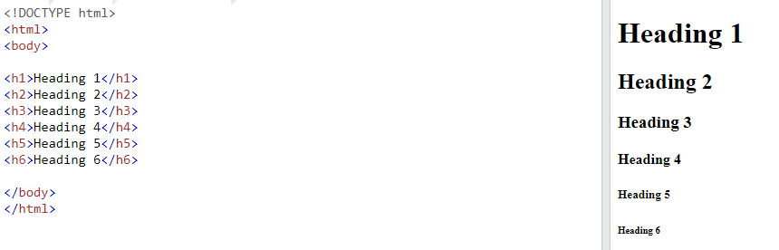

Each HTML heading has a default size. However, you can specify the size for any heading with the style attribute, using the CSS font-size property.

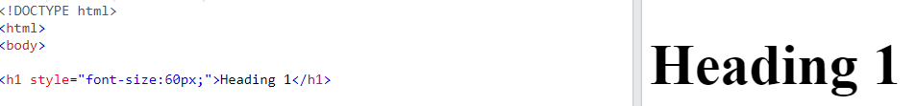

**HTML PARAGRAPH**

The HTML <p> element defines a paragraph.

A paragraph always starts on a new line, and browsers automatically add some white space (a margin) before and after a paragraph.

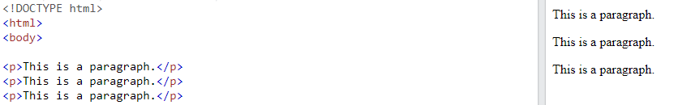

**NOTE: the content in the <p> is automatically formatted (i.e.) any spaces or newline are all considered as single paragraph.**

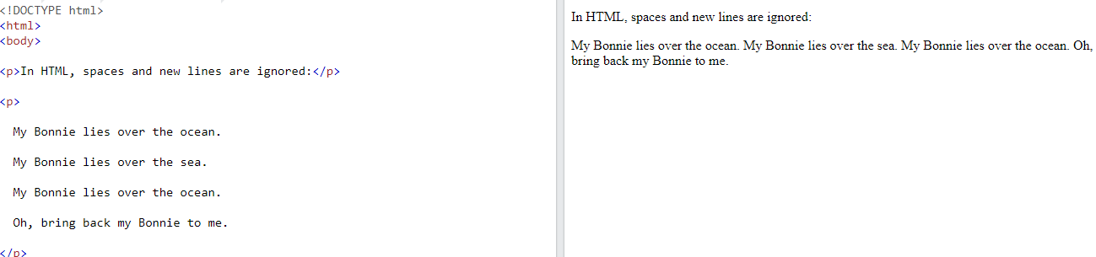

**<pre> ELEMENT**

The HTML <pre> element defines preformatted text.

The text inside a <pre> element is displayed in a fixed-width font (usually Courier), and it preserves both spaces and line breaks

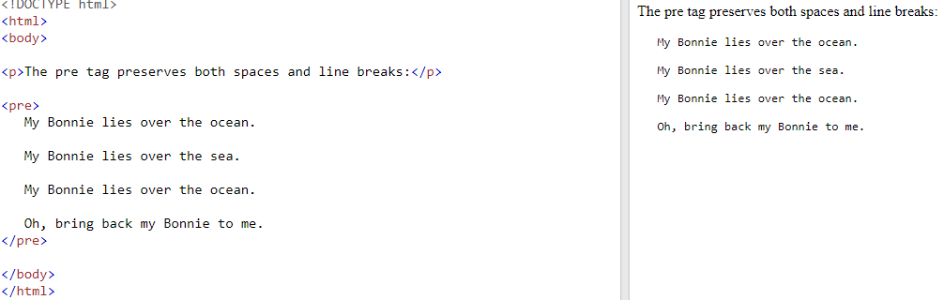

**HTML STYLES**

The HTML style attribute is used to add styles to an element, such as color, font, size, and more.

The HTML style attribute has the following syntax:

<tagname style="property:value;">

The ***property*** is a CSS property. The ***value*** is a CSS value.

**BACKGROUND-COLOR**

The CSS background-color property defines the background color for an HTML element.

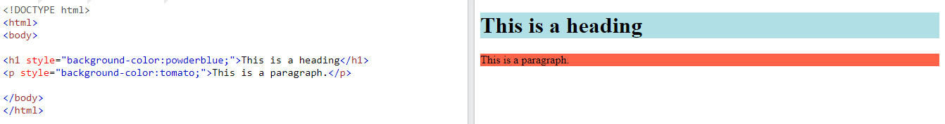

**TEXT COLOR**

The CSS color property defines the text color for an HTML element

<h1 style="color:blue;">This is a heading</h1>  
<p style="color:red;">This is a paragraph.</p>

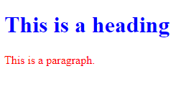

**FONT-FAMILY**

The CSS font-family property defines the font to be used for an HTML element

<h1 style="font-family:verdana;">This is a heading</h1>  
<p style="font-family:courier;">This is a paragraph.</p>

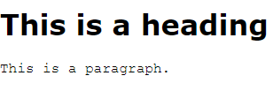

**FONT-SIZE**

The CSS font-size property defines the text size for an HTML element.

<h1 style="font-size:300%;">This is a heading</h1>  
<p style="font-size:60px;">This is a paragraph.</p>

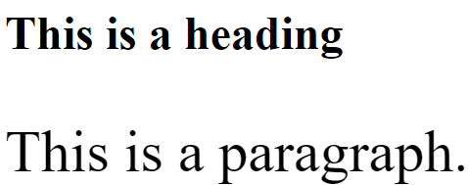

**TEXT ALIGNMENT**

The CSS text-align property defines the horizontal text alignment for an HTML element.

<h1 style="text-align:center;">Centered Heading</h1>  
<p style="text-align:center;">Centered paragraph.</p>

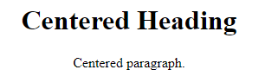

**HTML TEXT FORMATTING**

HTML contains several elements for defining text with a special meaning.

HTML FORMATTING ELEMENTS

Formatting elements were designed to display special types of text:

* <b> - Bold text
* <strong> - Important text
* <i> - Italic text
* <em> - Emphasized text
* <mark> - Marked text
* <small> - Smaller text
* <del> - Deleted text
* <ins> - Inserted text
* <sub> - Subscript text
* <sup> - Superscript text

**<b> AND <strong> ELEMENTS**

The HTML <b> element defines bold text, without any extra importance.

<b>This text is bold</b>



The HTML <strong> element defines text with strong importance. The content inside is typically displayed in bold.

<strong>This text is important!</strong>



**<i> AND <em> ELEMENTS**

The HTML <i> element defines a part of text in an alternate voice or mood. The content inside is typically displayed in italic.

**Tip:** The <i> tag is often used to indicate a technical term, a phrase from another language, a thought, a ship name, etc.

<i>This text is italic</i>



The HTML <em> element defines emphasized text. The content inside is typically displayed in italic.

**Tip:** A screen reader will pronounce the words in <em> with an emphasis, using verbal stress.

<em>This text is emphasized</em>



**<small> ELEMENT**

The HTML <small> element defines smaller text

<small>This is some smaller text.</small>



**<mark> ELEMENT**

The HTML <mark> element defines text that should be marked or highlighted.

<p>Do not forget to buy <mark>milk</mark> today.</p>



**<del> ELEMENT**

The HTML <del> element defines text that has been deleted from a document. Browsers will usually strike a line through deleted text.

<p>My favorite color is <del>blue</del> red.</p>



**<ins> ELEMENT**

The HTML <ins> element defines a text that has been inserted into a document. Browsers will usually underline inserted text.

<p>My favorite color is <del>blue</del> <ins>red</ins>.</p>



**<sub> ELEMENT**

The HTML <sub> element defines subscript text. Subscript text appears half a character below the normal line, and is sometimes rendered in a smaller font. Subscript text can be used for chemical formulas, like H2O.

<p>This is <sub>subscripted</sub> text.</p>



**<sup> ELEMENT**

The HTML <sup> element defines superscript text. Superscript text appears half a character above the normal line, and is sometimes rendered in a smaller font. Superscript text can be used for footnotes, like WWW[1]

<p>This is <sup>superscripted</sup> text.</p>



**HTML QUOTATIONS AND CITATIONS**

<blockquote>,<q>, <abbr>, <address>, <cite>, and <bdo>

**<blockquote> for quotations**

The HTML <blockquote> element defines a section that is quoted from another source. Browsers usually indent <blockquote> elements.

<p>Here is a quote from WWF's website:</p>  
<blockquote cite="http://www.worldwildlife.org/who/index.html">  
For 50 years, WWF has been protecting the future of nature.  
</blockquote>

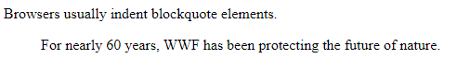

**<q> for short quotations**

The HTML <q> tag defines a short quotation.

Browsers normally insert quotation marks around the quotation.

<p>WWF's goal is to: <q>Build a future where people live in harmony with nature.</q></p>

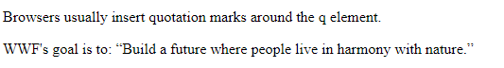

**<abbr> for abbreviation**

The HTML <abbr> tag defines an abbreviation or an acronym, like "HTML", "CSS", "Mr.", "Dr.", "ASAP", "ATM".

Marking abbreviations can give useful information to browsers, translation systems and search-engines.

**Tip:** Use the global title attribute to show the description for the abbreviation/acronym when you mouse over the element.

<p>The <abbr title="World Health Organization">WHO</abbr> was founded in 1948.</p>



**<address> for contact information**

The HTML <address> tag defines the contact information for the author/owner of a document or an article.

The contact information can be an email address, URL, physical address, phone number, social media handle, etc.

The text in the <address> element usually renders in *italic,* and browsers will always add a line break before and after the <address> element.

<address> 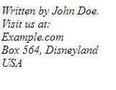  
Written by John Doe.<br>   
Visit us at:<br>  
Example.com<br>  
Box 564, Disneyland<br>  
USA  
</address>

**<bdo> for bi-directional override**

BDO stands for Bi-Directional Override.

The HTML <bdo> tag is used to override the current text direction:

<bdo dir="rtl">This text will be written from right to left</bdo>



**HTML COMMENTS**

HTML comments are not displayed in the browser, but they can help document your HTML source code.

<!-- Write your comments here -->

**HTML COLORS**

HTML colors are specified with predefined color names, or with RGB, HEX, HSL, RGBA, or HSLA values. HTML supports [140 standard color names](https://www.w3schools.com/colors/colors_names.asp).

**Background-color**

You can set the background color for HTML elements:

<h1 style="background-color:DodgerBlue;">Hello World</h1>



**Text color**

You can set the color of text: 

<h1 style="color:Tomato;">Hello World</h1>

**Border-color**

You can set the color of borders

<h1 style="border:2px solid Tomato;">Hello World</h1>



## **Color Values**

In HTML, colors can also be specified using RGB values, HEX values, HSL values, RGBA values, and HSLA values.

**HTML RGB and RGBA Colors** An RGB color value represents RED, GREEN, and BLUE light sources.

An RGBA color value is an extension of RGB with an Alpha channel (opacity).

## **RGB Color Values**

In HTML, a color can be specified as an RGB value, using this formula:

**rgb(red, green, blue)**

Each parameter (red, green, and blue) defines the intensity of the color with a value between 0 and 255.

This means that there are 256 x 256 x 256 = 16777216 possible colors!

For example, rgb(255, 0, 0) - red, because red is set to its highest value (255), and the other two (green and blue) are set to 0.

rgb(0, 255, 0) - green

rgb(0, 0, 0) - black

rgb(255, 255, 255) – white

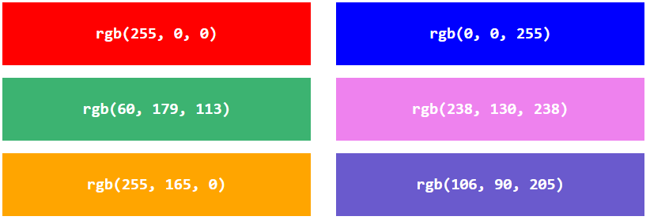

## **Shades of Gray**

Shades of gray are often defined using equal values for all three parameters

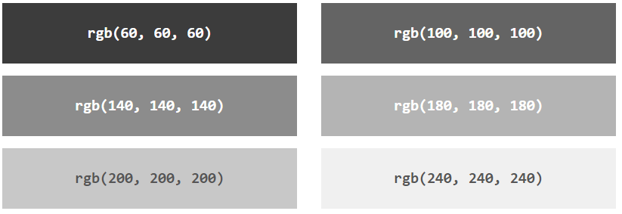

## **RGBA Color Values**

RGBA color values are an extension of RGB color values with an Alpha channel - which specifies the opacity for a color. An RGBA color value is specified with: **rgba(red, green, blue, alpha)**

The alpha parameter is a number between 0.0 (fully transparent) and 1.0 (not transparent at all)

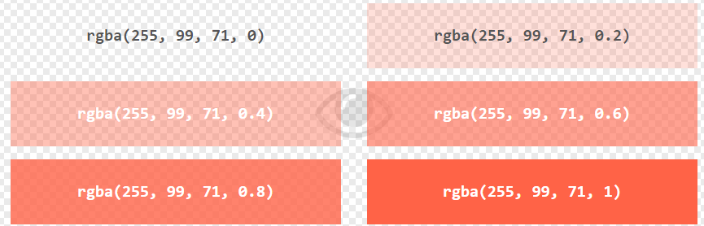

# **HTML HEX Colors**

A hexadecimal color is specified with: #RRGGBB, where the RR (red), GG (green) and BB (blue) hexadecimal integers specify the components of the color.

**HEX Color Values**

In HTML, a color can be specified using a hexadecimal value in the form: **#rrggbb** Where rr (red), gg (green) and bb (blue) are hexadecimal values between 00 and ff (same as decimal 0-255).

For example, #ff0000 is displayed as red, because red is set to its highest value (ff), and the other two (green and blue) are set to 00.

#00ff00 - green

#000000 - black

#ffffff – white.

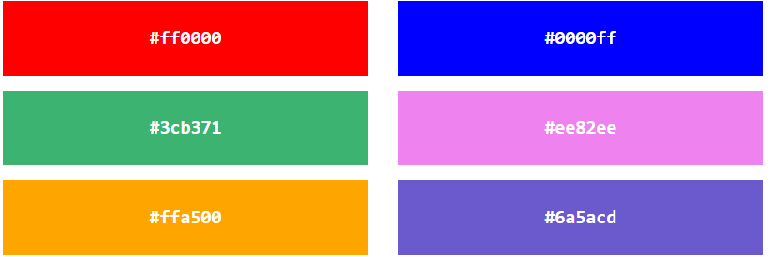

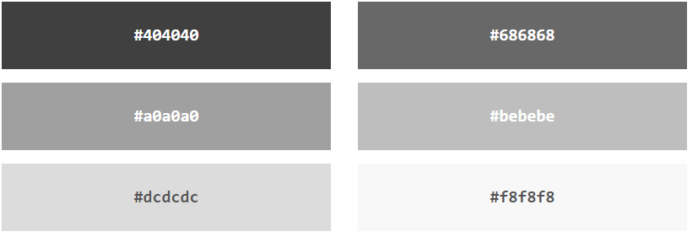

**HTML HSL and HSLA Colors**

HSL stands for hue, saturation, and lightness.

HSLA color values are an extension of HSL with an Alpha channel (opacity).

**HSL Color Values**

In HTML, a color can be specified using hue, saturation, and lightness (HSL) in the form: **hsl(hue, saturation, lightness)**

Hue is a degree on the color wheel from 0 to 360. 0 is red, 120 is green, and 240 is blue.

Saturation is a percentage value. 0% means a shade of gray, and 100% is the full color.

Lightness is also a percentage value. 0% is black, and 100% is white.

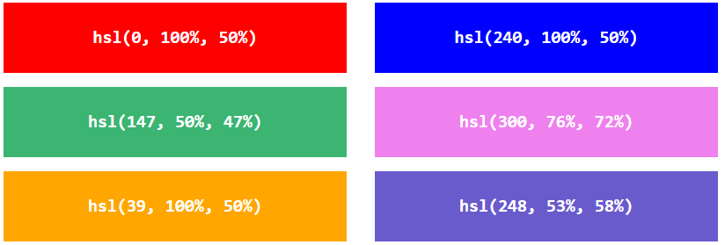

### Saturation

Saturation can be described as the intensity of a color.

100% is pure color, no shades of gray.

50% is 50% gray, but you can still see the color.

0% is completely gray; you can no longer see the color.

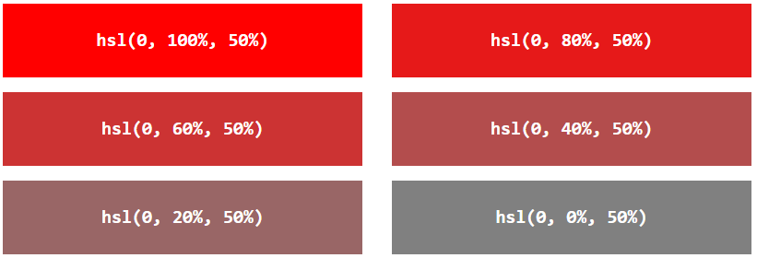

**Lightness**

The lightness of a color can be described as how much light you want to give the color, where 0% means no light (black), 50% means 50% light (neither dark nor light), and 100% means full lightness (white).

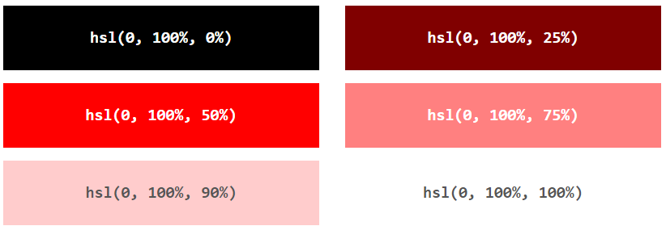

## **Shades of Gray**

Shades of gray are often defined by setting the hue and saturation to 0, and adjusting the lightness from 0% to 100% to get darker/lighter shades:

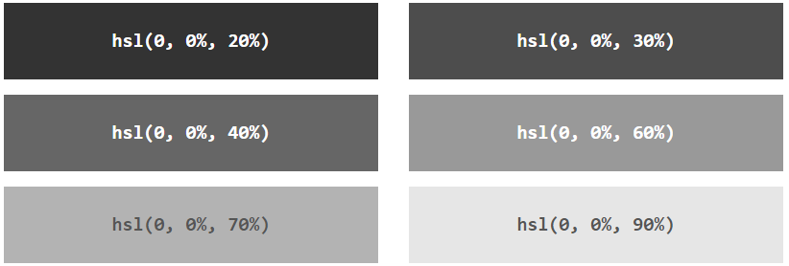

## **HSLA Color Values**

HSLA color values are an extension of HSL color values, with an Alpha channel - which specifies the opacity for a color.

An HSLA color value is specified with: **hsla(hue, saturation, lightness, alpha)**

The alpha parameter is a number between 0.0 (fully transparent) and 1.0 (not transparent at all).

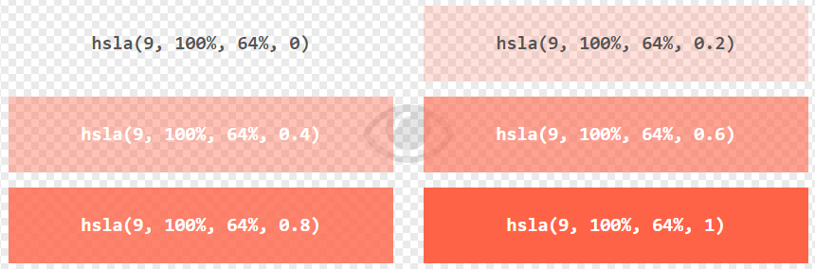

# **HTML Styles - CSS**

CSS stands for Cascading Style Sheets.

CSS saves a lot of work. It can control the layout of multiple web pages all at once.

Cascading Style Sheets (CSS) is used to format the layout of a webpage.

With CSS, you can control the color, font, the size of text, the spacing between elements, how elements are positioned and laid out, what background images or background colors are to be used, different displays for different devices and screen sizes, and much more!

**Tip:** The word **cascading** means that a style applied to a parent element will also apply to all children elements within the parent. So, if you set the color of the body text to "blue", all headings, paragraphs, and other text elements within the body will also get the same color (unless you specify something else)!

## **Using CSS**

CSS can be added to HTML documents in 3 ways:

* **Inline** - by using the style attribute inside HTML elements
* **Internal** - by using a <style> element in the <head> section
* **External** - by using a <link> element to link to an external CSS file

## **Inline CSS**

An inline CSS is used to apply a unique style to a single HTML element.

An inline CSS uses the style attribute of an HTML element.

<h1 style="color:blue;">A Blue Heading</h1>  
  
<p style="color:red;">A red paragraph.</p>

## **Internal CSS**

An internal CSS is used to define a style for a single HTML page.

An internal CSS is defined in the <head> section of an HTML page, within a <style> element.

<!DOCTYPE html>  
<html>  
<head>  
<style>  
body {background-color: powderblue;}  
h1   {color: blue;}  
p    {color: red;}  
</style>  
</head>  
<body>  
  
<h1>This is a heading</h1>  
<p>This is a paragraph.</p>  
  
</body>  
</html>

## **External CSS**

An external style sheet is used to define the style for many HTML pages.

To use an external style sheet, add a link to it in the <head> section of each HTML page.

<!DOCTYPE html>  
<html>  
<head>  
  <link rel="stylesheet" href="styles.css">  
</head>  
<body>  
  
<h1>This is a heading</h1>  
<p>This is a paragraph.</p>  
  
</body>  
</html>

The external style sheet can be written in any text editor. The file must not contain any HTML code, and must be saved with a .css extension.

"styles.css":

body {  
  background-color: powderblue;  
}  
h1 {  
  color: blue;  
}  
p {  
  color: red;  
}

**Tip:** With an external style sheet, you can change the look of an entire web site, by changing one file!

## **Link to External CSS**

External style sheets can be referenced with a full URL or with a path relative to the current web page.

<link rel="stylesheet"href="https://www.w3schools.com/html/styles.css">

<link rel="stylesheet" href="styles.css">

# **HTML Links**

Links allow users to click their way from page to page.

## **HTML Links - Hyperlinks**

HTML links are hyperlinks. You can click on a link and jump to another document.

When you move the mouse over a link, the mouse arrow will turn into a little hand.

**Note:** A link does not have to be text. A link can be an image or any other HTML element!

The HTML <a> tag defines a hyperlink.

<a href="*url*">*link text*</a>

The most important attribute of the <a> element is the href attribute, which indicates the link's destination.

The link text is the part that will be visible to the reader.

Clicking on the link text, will send the reader to the specified URL address.

<a href="https://www.w3schools.com/">Visit W3Schools.com!</a>

## **HTML Links - The target Attribute**

By default, the linked page will be displayed in the current browser window. To change this, you must specify another target for the link.

The target attribute specifies where to open the linked document.

The target attribute can have one of the following values:

* _self - Default. Opens the document in the same window/tab as it was clicked
* _blank - Opens the document in a new window or tab
* _parent - Opens the document in the parent frame
* _top - Opens the document in the full body of the window

<a href="https://www.w3schools.com/" target="_blank">Visit W3Schools!</a>

## **Absolute URLs vs. Relative URLs**

Both examples above are using an **absolute URL** (a full web address) in the href attribute.

A local link (a link to a page within the same website) is specified with a **relative URL** (without the "https://www" part)

<h2>Absolute URLs</h2>  
<p><a href="https://www.w3.org/">W3C</a></p>  
<p><a href="https://www.google.com/">Google</a></p>  
  
<h2>Relative URLs</h2>  
<p><a href="html_images.asp">HTML Images</a></p>  
<p><a href="/css/default.asp">CSS Tutorial</a></p>

## **HTML Links - Use an Image as a Link**

To use an image as a link, just put the <img> tag inside the <a> tag:

<a href="default.asp">  
<img src="smiley.gif" alt="HTML tutorial" style="width:42px;height:42px;">  
</a>

## **Link to an Email Address**

Use mailto: inside the href attribute to create a link that opens the user's email program (to let them send a new email)

<a href="mailto:someone@example.com">Send email</a>

## **Button as a Link**

To use an HTML button as a link, you have to add some JavaScript code.

JavaScript allows you to specify what happens at certain events, such as a click of a button.

<button onclick="document.location='default.asp'">HTML Tutorial</button>

## **Link Titles**

The title attribute specifies extra information about an element. The information is most often shown as a tooltip text when the mouse moves over the element.

<a href="https://www.w3schools.com/html/" title="Go to W3Schools HTML section">Visit our HTML Tutorial</a>

# **HTML Links - Different Colors**

An HTML link is displayed in a different color depending on whether it has been visited, is unvisited, or is active.

By default, links will appear as follows in all browsers:

* An unvisited link is underlined and blue
* A visited link is underlined and purple
* An active link is underlined and red

**Tip:** Links can of course be styled with CSS, to get another look!

<style>  
a:link {  
  color: green;  
  background-color: transparent;  
  text-decoration: none;  
}  
  
a:visited {  
  color: pink;  
  background-color: transparent;  
  text-decoration: none;  
}  
  
a:hover {  
  color: red;  
  background-color: transparent;  
  text-decoration: underline;  
}  
  
a:active {  
  color: yellow;  
  background-color: transparent;  
  text-decoration: underline;  
}  
</style>

## **Link Buttons**

A link can also be styled as a button, by using CSS

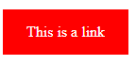<style>  
a:link, a:visited {  
  background-color: #f44336;  
  color: white;  
  padding: 15px 25px;  
  text-align: center;  
  text-decoration: none;  
  display: inline-block;  
}  
  
a:hover, a:active {  
  background-color: red;  
}  
</style>

# **HTML Links - Create Bookmarks**

HTML links can be used to create bookmarks, so that readers can jump to specific parts of a web page.

## **Create a Bookmark in HTML**

Bookmarks can be useful if a web page is very long.

To create a bookmark - first create the bookmark, then add a link to it.

When the link is clicked, the page will scroll down or up to the location with the bookmark.

First, use the id attribute to create a bookmark:

<h2 id="C4">Chapter 4</h2>

Then, add a link to the bookmark ("Jump to Chapter 4"), from within the same page:

<a href="#C4">Jump to Chapter 4</a>

You can also add a link to a bookmark on another page: <a href="html_demo.html#C4">Jump to Chapter 4</a>

* Use the id attribute (id="*value*") to define bookmarks in a page
* Use the href attribute (href="#*value*") to link to the bookmark