Messaging Application
This application is a client-server messaging application which supports 3 users in the local computer. C++ is used as the programming language. This application uses TCP and Socket technologies.

1.0 General Properties
This application consists of 2 different projects which are server and client. It enables 3 local users to message with each other. However, extra users can join if one of the current users quits or goes offline temporarily. The application provides 6 actions to the users:
- Entering the message mode
- Choosing message destinations
- Checking unseen messages
- Listing all the available users
- Checking all the message history
- Going offline
The server handles the storage and functionality via creating “Message” and “ClientUser” objects which are indicated in Table 1 Message Object Structure and Table 2 ClientUser Object Structure. These objects are only included and used in the server project.
Table 1 Message Object Structure
Name of the component | Type | Function
Msg | string | The message it self
Time | string | The time of the message that it received from the server
Sender | string | The sender client’s name
Destination | string | The destination client’s name
Table 2 ClientUser Object Structure
Name of the component | Type | Function
clientName | string | Username of the client
destinations | vector <string> | Names of the destination clients
inMessageMode | bool | Indicates is the client in message mode
isActive | bool | Indicates whether the client is active
clientSocket | SOCKET | Socket for TCP communication

1.1 Communication Between Server-Client
The server and client program communicate through 2 ways:
-Packet sending
-Single byte signal sending

1.1.1 Communication Through Sending Packets
Server and client send each other the same type of packets to communicate and transfer data via TCP. The structure of the packet is created in the project in the name of “MessageFormat” which is indicated in the Table 3 MessageFormat Structure. The server and clients send each other this packet in all the cases where a string message should be transferred. After the transfer, the receiver side reads the packet, receives the data and check for errors.
Table 3 MessageFormat Structure
Name of The Packet Component | Type-Size | Function
h1 | char-1 byte | Header that indicates whether the sender is a client or the server. If a client is the sender, it is ‘c’. If it is the server that sends it is ’s’.
length | uint16_t-2 bytes | Length of the data to be read.
checksum | uint32_t-4 bytes | The checksum value for error detection.
data | char [1024]-128 bytes maximum | The string data to be sent.

1.1.2 Communication Through Sending Single Byte Signal
In addition to the packet sending, server and clients also communicate via sending a single byte signal. This communication is needed for both sides to identify whether they should move forward or stay. For example, when a client is being register, it should input a valid username which is not duplicated. So, client side should know whether the entered username is valid or not. The server side accomplishes this via sending a single byte validation signal. In this application, if an action has the opportunity to be made successfully, the sender side sends ‘1’ signal. Otherwise, the sender always sends ‘0’ signal.

1.2 General FSM Structure of the Client Program
The client program consists of 9 general states which is explained on the Table 4 States of the Client and the picture below.
Table 4 States of the Client
Name of State | Explanation
REGISTER | First state of the client. Includes connecting, registering and joining the server processes.
MENU | This state includes the point where the menu is displayed to the client and client enters an action input. If the input is successful, the state changes according to the input.
MESSAGING_MODE | Indicates the first option in the menu which is the message mode. In this mode, users can send messages to their chosen destinations and display messages instantaneously. If the client doesn’t have a chosen destination before, an error message displays every time the user tries to message. When user inputs “/exit”, the client returns to MENU.
CHOOSE_DESTINATION | On this state, the client displays all the usernames and sends destination input to the server. Until choosing a successful destination, the client stays on this state. Then, the client returns to MENU state.
UNSEEN_MESSAGES | On this state, the client displays all the unseen messages which is the messages send to the client when the client is offline or quit.
ACTIVE_USERS | On this state, the user displays all the clients.
MESSAGE_HISTORY | On this state the client displays all the messages includes him as sender or destination.
DISCONNECT | This state makes the client offline on the server which enables another user to join if the server is full. The client can return to server via writing “/return” if the server is available. If not, the client tries again until success.
TERMINATE | The state that indicates the server is shut down or offline. This state can be reached from all the other states.
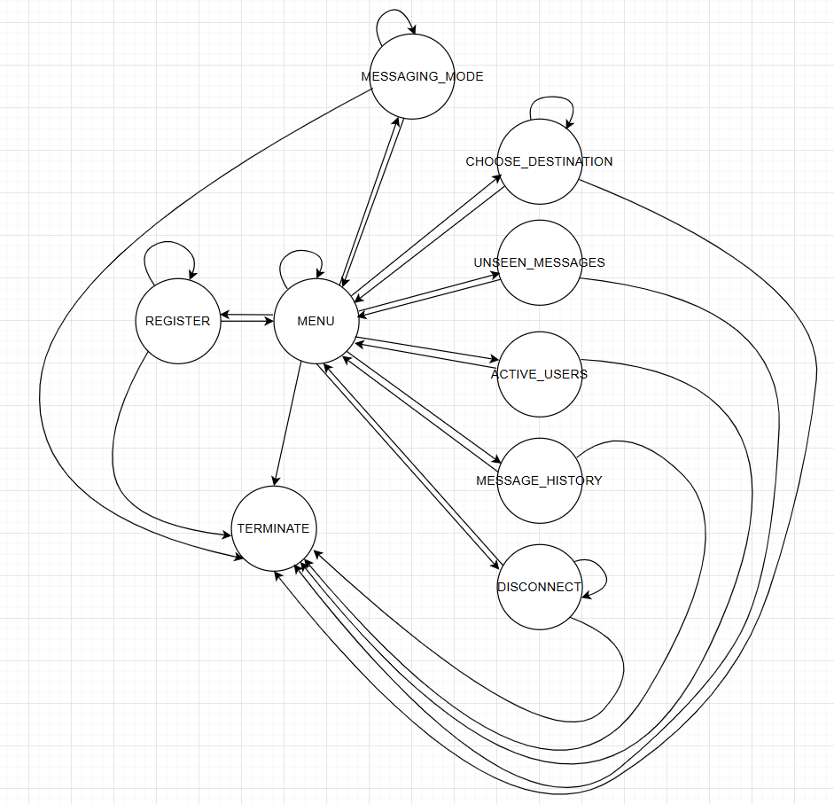

1.3 Registration - Joining the Server Process
When a client starts the program, the client establishes a connection with the server. After the establishment, the server opens a new thread for to handle this client. Until user quits the program, this thread handles all the actions for the client. First the client program asks

